**SCADA与AGV对接协议**

编 制： 彭树琴

**京信通信系统（中国）有限公司**

**2019年5月**

**文件历史记录**

|  |  |  |  |  |
| --- | --- | --- | --- | --- |
| 文件编号 | |  | | |
| 文件标题 | |  | | |
| **文件履历** | | | | |
| 版本 | 编制 | | 日期 | 更改内容（条款） |
| A | 彭树琴 | | 2019-05-09 | 首发 |
|  |  | |  |  |
|  |  | |  |  |
|  |  | |  |  |
|  |  | |  |  |
|  |  | |  |  |
|  |  | |  |  |
|  |  | |  |  |
|  |  | |  |  |
|  |  | |  |  |
|  |  | |  |  |
|  |  | |  |  |
|  |  | |  |  |
|  |  | |  |  |
|  |  | |  |  |

# 一．流程定义

**任务执行流程：**

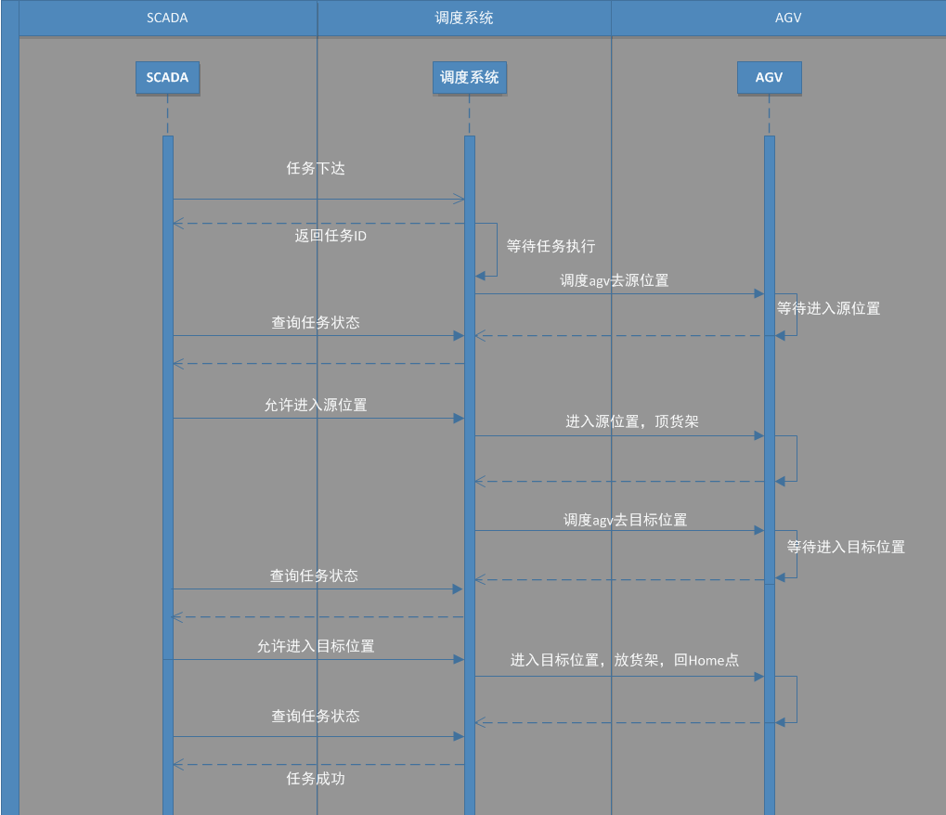

# 二．协议定义

## 任务下发

**url:** [agvserver]/api/scada/addTask

参数：

|  |  |  |  |
| --- | --- | --- | --- |
| 名称 | 类型 | 是否必须 | 描述 |
| source | string | 是 | 源位置 |
| target | string | 是 | 目标位置 |
| payloadId | string | 是 | 载具ID |
| priority | int | 是 | 优先级 |

返回值：

|  |  |  |  |
| --- | --- | --- | --- |
| 名称 | 类型 | 是否必须 | 描述 |
| taskId | string | 是 | 任务ID |
| errorno | int | 是 |  |
| errormsg | string | 是 |  |

## 任务状态查询

**url:** [agvserver]/api/scada/getTask

参数：

|  |  |  |  |
| --- | --- | --- | --- |
| 名称 | 类型 | 是否必须 | 描述 |
| taskList | arrays | 否 | 任务列表 |

返回值：

示例：

{

“taskList”: [

{

“taskId”: “5cb3fa1ce27b630f18e181ad”,

“agvId”: “AGV01”,

“source”: “C01”,

“target”: “A01”,

“curTarget”: “C01”,

“payloadId”: 'A081',

“priority”: 1,

“status” : “waiting”,

“startTime”: ,

“endTime”: “”,

“step”: “moveSource”,

“failMsg”: “”

},

.....

}

|  |  |  |  |
| --- | --- | --- | --- |
| 名称 | 类型 | 是否必须 | 描述 |
| taskList | arrays | 是 | 任务状态列表 |
| agvId | string | 是 | 小车ID |
| taskId | string | 是 | 任务ID |
| source | string | 是 | 源位置 |
| target | string | 是 | 目标位置 |
| payloadId | string | 是 | 载具ID |
| priority | int | 是 | 优先级 |
| status | string | 是 | 任务状态 |
| startTime | string | 是 | 任务开始时间 |
| endTime | string | 是 | “” |
| step | string | 是 |  |
| failMsg | string | 是 | “” |
| errorno | int | 是 |  |
| errormsg | string | 是 |  |

status:

waiting 任务等待调度

running 任务执行

success 任务完成

error 任务异常会手动完成

fail 任务失败

step:

waiting

moveSource 去源位置

waitSource 等待进入源位置

loadPlayload 进入源位置取货架

movePreSource 从工作站出来到源工作站前置点

moveTarget 去目标位置

waitTarget 等待进入目标位置

dropPayload 进入目标位置放货架

finish

errorno errormsg

-1 读取不到二维码

-2 没有货架

-3 读取到二维码数据但是数据库没有数据

-4 读取到的二维码数据与发送的货架编号不匹配

10 apply AGV 异常

11 等待apply小车

12 apply小车超时失败

40 升降机构异常

41 顶升异常

42 下降异常

50 旋转异常

51 左旋异常

52 右旋异常

## 允许进入源、目标位置

**url:** [agvserver]/api/scada/allowTask

参数：

|  |  |  |  |
| --- | --- | --- | --- |
| 名称 | 类型 | 是否必须 | 描述 |
| taskId | string | 是 | 任务ID |
| locId | string | 是 | 位置ID |

返回值：

|  |  |  |  |
| --- | --- | --- | --- |
| 名称 | 类型 | 是否必须 | 描述 |
| errorno | int | 是 |  |
| errormsg | string | 是 |  |

## 报警查询

**url:** [agvserver]/api/scada/activeAlarm

参数：无

返回值：

示例：

{

“alarmList”: [

{

“alarmId”: “A033”,

“desc”: “小车被阻挡”,

“level”: “critical”,

“time”: '2018-04-28 00:00:00',

“type”: “agv异常”

},

{

“alarmId”: “A032”,

“desc”: “小车被阻挡”,

“level”: “major”,

“time”: '2018-04-28 00:00:00',

“type”: “agv异常”

}

}

|  |  |  |  |
| --- | --- | --- | --- |
| 名称 | 类型 | 是否必须 | 描述 |
| alarmList | arrays | 是 | 报警列表 |
| alarmId | string | 是 | 报警ID |
| desc | string | 是 | 报警描述 |
| level | string | 是 | 报警级别 |
| time | string | 是 | 报警时间 |
| type | string | 是 | 报警类型 |
| errorno | int | 是 |  |
| errormsg | string | 是 |  |

报警级别：

critical 严重告警

major 重要告警

minor 普通告警

waring 普通提醒

## 位置设置

**url:** [agvserver]/api/scada/setLoc

参数：

|  |  |  |  |
| --- | --- | --- | --- |
| 名称 | 类型 | 是否必须 | 描述 |
| locId | string | 是 | 位置ID |
| payloadId | string | 否 | 载具ID（为空或无则清除） |

返回值：

|  |  |  |  |
| --- | --- | --- | --- |
| 名称 | 类型 | 是否必须 | 描述 |
| errorno | int | 是 |  |
| errormsg | string | 是 |  |

## 位置查询

**url:** [agvserver]/api/scada/getLoc

参数：无

返回值：

|  |  |  |  |
| --- | --- | --- | --- |
| 名称 | 类型 | 是否必须 | 描述 |
| locList | arrays | 是 | 位置列表 |
| errorno | int | 是 |  |
| errormsg | string | 是 |  |

示例：

{

“locList” : [{“locId”: “C01”, “payloadId”: “A011”},

{“locId”: “C02”, “payloadId”: “A012”},

{“locId”: “C03”, “payloadId”: “A013”}]

}

## AGV信息查询

**url:** [agvserver]/api/agv/status

参数：

|  |  |  |  |
| --- | --- | --- | --- |
| 名称 | 类型 | 是否必须 | 描述 |
| agv | string | 是 | agvId |

返回值：

{

errorno: 0,

data: {

info: [

    {"name": "上锁状态","fieldId": "isLocked","value": boolean)},

    {"name": "模式","fieldId": "mode","value": string},//手动，自动

    {"name": "急停","fieldId": "emergency","value": boolean},

    {"name": "充电状态","fieldId": "charging","value": boolean},

    {"name": "电压（V）","fieldId": "voltage","value": number},

     {"name": "电流（A）","fieldId": "current","value": number},

    {"name": "累计里程(m)","fieldId": "odo","value": string}, // "%.2f"

    {"name": "本次运行(ms)","fieldId": "time","value": number},

    {"name": "累计运行(ms)","fieldId": "total_time","value":number},

    {"name": "电池电量","fieldId": "battery_level","value": string}, // "%.2f"

    {"name": "电池温度(℃)","fieldId": "battery_temp","value": number},

    {"name": "x 坐标(m)","fieldId": "x","value": string},// "%.2f"

    {"name": "y 坐标(m)","fieldId": "y","value": string},// "%.2f"

    {"name": "angle 坐标(rad)","fieldId": "angle","value":string]},// "%.2f"

    {"name": "置信度","fieldId": "confidence","value": string},

    {"name": "x 速度(m/s)","fieldId": "vx","value":string},// "%.2f"

    {"name": "y 速度(m/s)","fieldId": "vy","value": string},// "%.2f"

    {"name": "角速度(rad/s)","fieldId": "w","value": string},// "%.2f"

    {"name": "舵角","fieldId": "steer","value":number},

    {"name": "DI数据","fieldId": "DI","value": array[boolean],"isArrary": True},

    {"name": "DO数据","fieldId": "DO","value": array[boolean],"isArrary": True},

    {"name": "DI激活状态","fieldId": "DI_valid","value":array[boolean]},

    {"name": "任务状态","fieldId": "task_status","value": string}, // NONE, WAITING, RUNNING, SUSPENDED, COMPLETED, FAILED, CANCELED

    {"name": "任务类型","fieldId": "task_type","value": string}, // 没有任务, 自由导航到任意点, 自由导航到站点, 固定路径导航到站点, 其他

    {"name": "任务目标站点","fieldId": "target_id","value":string},

    {"name": "任务目标坐标","fieldId": "target_point","value": array[number],

"isArrary": True},

    {"name": "路径已过站点","fieldId": "finished_path","value": array[string],

"isArrary": True},

    {"name": "路径未经站点","fieldId": "unfinished_path","value": array[string],

"isArrary": True},

    {"name": "重定位状态","fieldId": "reloc_status","value": string}, //重定位失败, 重定位正确,正在重定位, 重定位完成

    {"name": "载入地图状态","fieldId": "loadmap_status","value": string}, // 载入地图失败, 载入地图成功, 正在载入地图

    {"name": "扫图状态","fieldId": "slam_status","value": string}, //没有扫图, 正在扫图, 正在实时扫图否

    {"name": "任务列表状态","fieldId": "tasklist_status","value": object},

    {"name": "阻挡","fieldId": "blocked","value": boolean},

    {"name": "阻挡原因","fieldId": "block_reason","value": string}, //超声检测到被阻挡, 激光检测到被阻挡, 防跌落传感器检测到被阻挡, 碰撞传感器检测到被阻挡,红外传感器检测到被阻挡, 锁车开关被触

{"name": "阻挡位置的 x 坐标(m)","fieldId": "block_x","value": number}, //可缺省

    {"name": "阻挡x坐标(m)","fieldId": "block_x","value": number,

    {"name": "阻挡y坐标(m)","fieldId": "block_y","value": number},

    {"name": "阻挡DI的ID","fieldId": "block_di","value": number},

    {"name": "阻挡超声 的 ID","fieldId": "block_ultrasonic_id","value": number},

    {"name": "控制器温度(℃)","fieldId": "controller_temp","value":number},

    {"name": "控制器湿度(%)","fieldId": "controller_humi","value":number},

    {"name": "控制器电压(V)","fieldId": "controller_voltage","value": number},

    {"name": "是否抱闸","fieldId": "brake","value": boolean},

    {"name": "所在区域id","fieldId": "area_ids","value": array[object],

"isArrary": True},

    {"name": "Fatal数组","fieldId": "fatals","value": array[object],

"isArrary": True},

    {"name": "Error数组","fieldId": "errors","value": array[object],

"isArrary": True},

    {"name": "Warning数组","fieldId": "warnings","value": array[object],

"isArrary": True},

    {"name": "错误码","fieldId": "ret_code","value": number},

    {"name": "错误信息","fieldId": "err_msg","value": string}

  ]

}

}