一、选择题

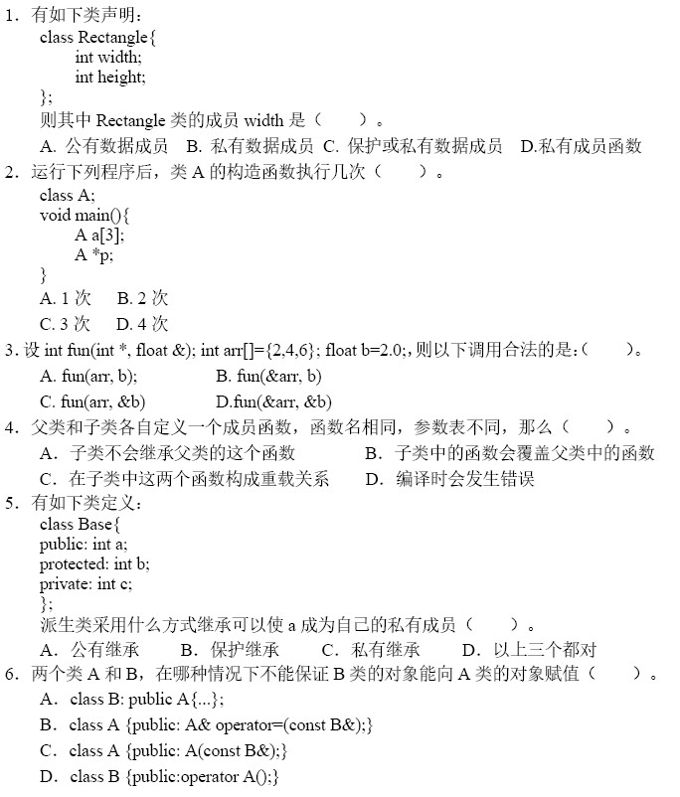

答案：BABBBB

二、填空题

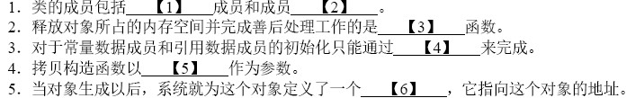

1. 变量 函数
2. 析构
3. 构造
4. 另一个同类型的对象
5. this指针

三、编程题

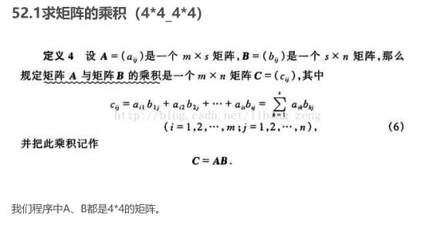

（1）设计一个支持矩阵乘运算的类或类模板；

（2）从文件中读取测试数据，输入到矩阵对象中，编制测试程序进行调用。

#include<iostream>

#include<fstream>

#include<typeinfo>

using namespace std;

class matrix {

public:

int a[4][4] = {0};

//构造函数;

matrix() {

for (int i = 0; i < 4; i++) {

for (int j = 0; j < 4; j++) {

a[i][j] = 0;

}

}

};

//复制构造函数；

matrix(const matrix& c) {

for (int i = 0; i < 4; i++) {

for (int j = 0; j < 4; j++) {

a[i][j] = c.a[i][j];

}

}

}

//乘法运算；

matrix operator\*(const matrix&c);

};

matrix matrix::operator\*(const matrix& c) {

matrix num;

for (int i = 0; i < 4; i++) {

for (int j = 0; j < 4; j++) {

for (int k = 0; k < 4; k++) {

num.a[i][k] += a[i][k] \* c.a[k][i];

}

}

}

return num;

}

int main() {

matrix c1;

ifstream n1;

n1.open("C:\\Users\\76005\\Desktop\\c1.txt");

for (int i = 0; i < 4; i++) {

for (int j = 0; j < 4; j++) {

n1>>c1.a[i][j];

}

}

matrix c2;

ifstream n2;

n2.open("C:\\Users\\76005\\Desktop\\c2.txt");

for (int i = 0; i < 4; i++) {

for (int j = 0; j < 4; j++) {

n2 >> c2.a[i][j];

}

}

matrix c3;

c3 = c1 \* c2;

for (int i = 0; i < 4; i++) {

for (int j = 0; j < 4; j++) {

cout << c3.a[i][j]<<" ";

if (j == 3)

cout << " " << endl;

}

}

return 0;

}

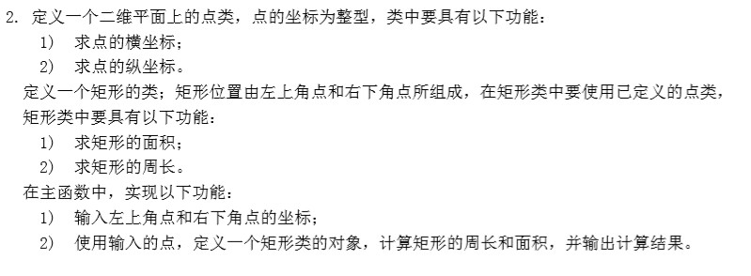

#include<iostream>

using namespace std;

class dot {

public:

int x;

int y;

dot();

dot(int a, int b);

};

dot::dot(){}

dot::dot(int a, int b) {

x = a;

y = b;

}

class squareness {

public:

dot a1;//左下角点；

dot a2;//右上角点;

int size(dot a1, dot a2);

int cir(dot a1,dot a2);

squareness(dot c1, dot c2) {

a1 = c1;

a2 = c2;

}

};

int squareness::size(dot a1, dot a2) {

return (a1.x-a2.x)\*(a2.y-a2.y);

}

int squareness::cir(dot a1, dot a2) {

return 2 \* (a1.y-a2.y+a2.x-a1.x);

}

int main() {

dot c1,c2;

cin >> c1.x >> c1.y>>c2.x>>c2.y;

cout << "横坐标为：" << c1.x << " 纵坐标为：" << c1.y << endl;

cout << "横坐标为：" << c2.x << " 纵坐标为：" << c2.y << endl;

squareness a1(c1,c2);

cout << "该矩形的周长为:" << a1.cir(c1,c2) << " " << "该矩形的面积为:" <<a1.size(c1, c2);

return 0;

}