Projected number of students for each city for the next 20 years
1. Haray
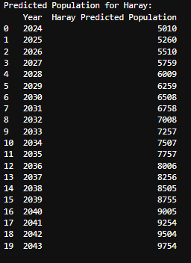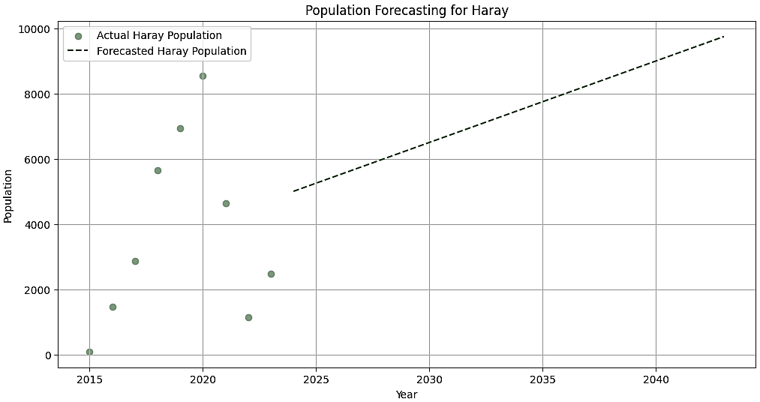
Graph showing projections for the city of Haray for the next 20 years, estimating total students of 9754 by the year 2043
2. Gudbay
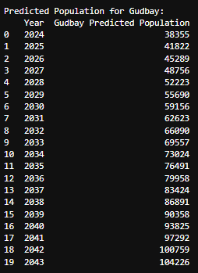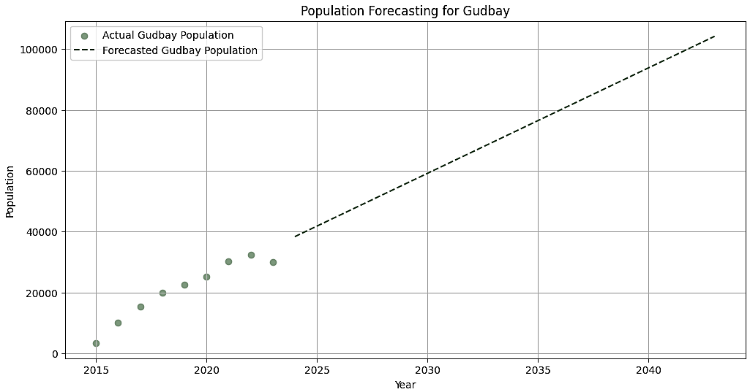

Graph showing projections for the city of Gudbay for the next 20 years, estimating total students of 104226 by the year 2043

3. Wadar
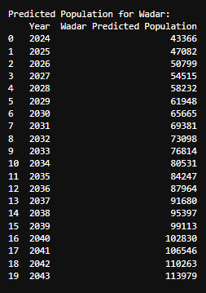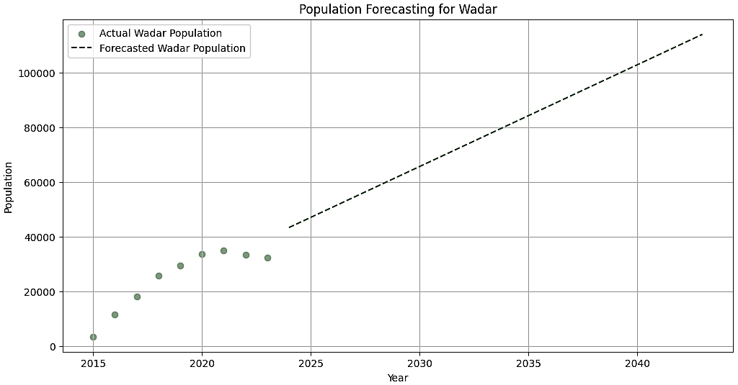
Graph showing projections for the city of Wadar for the next 20 years, estimating total students of 113979 by the year 2043

