BFISH Length Comp Investigations

Meg Oshima

5/21/2021

## Camera Lengths

## X PSU DROP_CD SPECIES_CD   
## Min. : 1.0 Min. : 18 Length:976 Length:976   
## 1st Qu.:244.8 1st Qu.: 8961 Class :character Class :character   
## Median :488.5 Median :23017 Mode :character Mode :character   
## Mean :488.5 Mean :21961   
## 3rd Qu.:732.2 3rd Qu.:35943   
## Max. :976.0 Max. :45499   
## SCIENTIFIC_NAME COMMON_NAME BFISH OFFICIAL_DEPTH_M  
## Length:976 Length:976 Length:976 Min. : 77.16   
## Class :character Class :character Class :character 1st Qu.:114.76   
## Mode :character Mode :character Mode :character Median :152.00   
## Mean :155.41   
## 3rd Qu.:192.00   
## Max. :274.00   
## LENGTH_CM Island   
## Min. : 5.40 Length:976   
## 1st Qu.: 25.73 Class :character   
## Median : 37.34 Mode :character   
## Mean : 38.30   
## 3rd Qu.: 51.73   
## Max. :111.60

## Warning: Removed 1 rows containing non-finite values (stat_density).

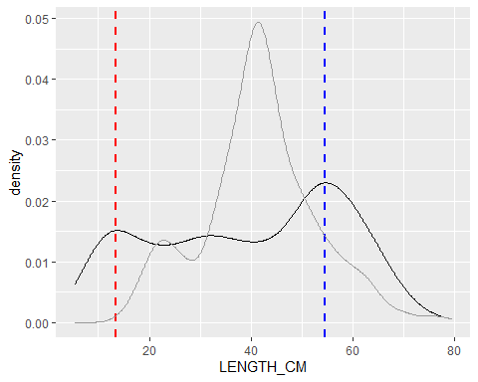

#### What is causing the mode in the smaller size classes in the BFISH camera data?

* Which sites are most of these samples coming from?
* Which islands are these samples from?
* What depth are these samples from?

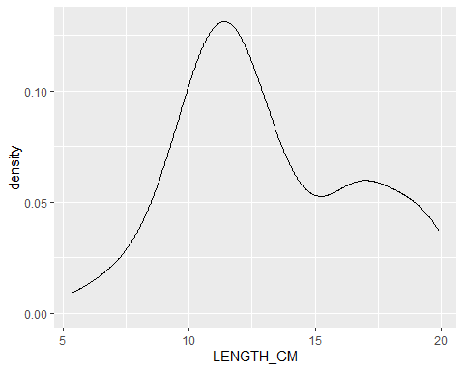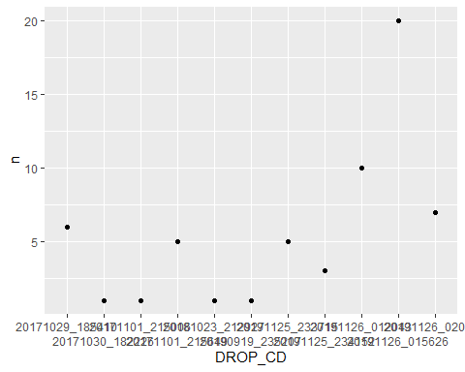

#### Sites that caught 5 or more fish less than 20cm

## # A tibble: 6 x 2  
## DROP_CD n  
## <chr> <int>  
## 1 20191126_015626 20  
## 2 20191126_012043 12  
## 3 20171029_185410 7  
## 4 20191126_020320 7  
## 5 20191125_233715 6  
## 6 20171101_215649 5

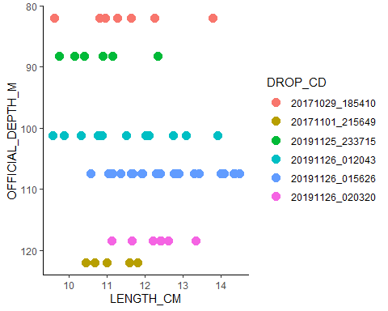

6 camera drops had 5 or more fish between 10 - 15 cm. The samples came from Oahu and all were caught between 100 - 110 m deep (which is the first quantile of depths sampled).

#### What is causing the mode in the larger size classes in the BFISH camera data?

* Which sites are most of these samples coming from?
* Which islands are these samples from?
* What depth are these samples from?

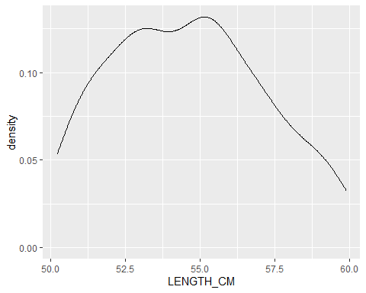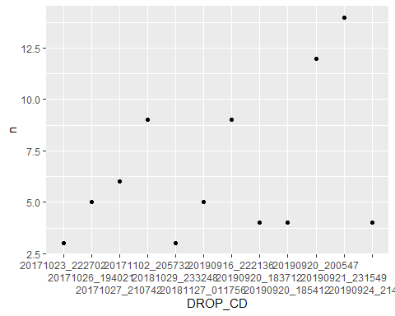

#### Sites that caught more than 5 fish between 50 and 60 cm

## # A tibble: 5 x 2  
## DROP_CD n  
## <chr> <int>  
## 1 20190921_231549 14  
## 2 20190920_200547 12  
## 3 20171102_205732 9  
## 4 20190916_222136 9  
## 5 20171027_210742 6

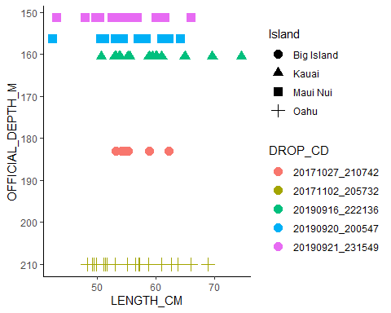

5 camera drops had more than 5 fish between 50 and 60 cm. The samples came from the Big Island (n = 1), Kauai (n = 1), Maui Nui (n = 2), and Oahu (n =1) were caught at depths of 150 to 210 m. The two highest catches occurred in 2019, and all occurred in 2019 or 2017.

## Fishing Lengths

## PSU SAMPLE_ID SPECIES_CD SCIENTIFIC_NAME   
## Min. : 271 Length:293 Length:293 Length:293   
## 1st Qu.:11839 Class :character Class :character Class :character   
## Median :16916 Mode :character Mode :character Mode :character   
## Mean :19741   
## 3rd Qu.:32422   
## Max. :43397   
##   
## COMMON_NAME LENGTH_CM WEIGHT_LB BFISH   
## Length:293 Min. :16.00 Min. :0.000 Length:293   
## Class :character 1st Qu.:35.50 1st Qu.:1.408 Class :character   
## Mode :character Median :41.50 Median :2.546 Mode :character   
## Mean :41.54 Mean :3.300   
## 3rd Qu.:48.00 3rd Qu.:4.877   
## Max. :77.00 Max. :9.900   
## NA's :1 NA's :253   
## SAMPLE_MEAN_DEPTH_M Island   
## Min. : 79.0 Length:293   
## 1st Qu.:116.0 Class :character   
## Median :137.0 Mode :character   
## Mean :139.3   
## 3rd Qu.:158.0   
## Max. :260.0   
##

#### Sites that caught more than 1 fish between 20 and 25 cm

## # A tibble: 4 x 2  
## SAMPLE_ID n  
## <chr> <int>  
## 1 201708310930LANA 5  
## 2 201708310749LANA 4  
## 3 201910060752JOMO 4  
## 4 201709101027ROMO 3

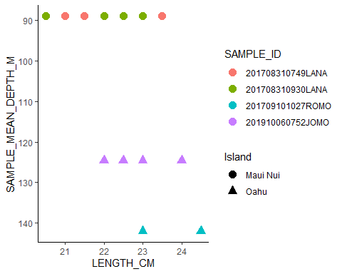

4 fishing events had more than 1 fish between 20 and 25 cm. The samples came from Oahu (n = 2) and Maui Nui (n = 2) and were caught at depths 89 to 142 m. The catches occurred in 2017 (n = 3) and 2019 (n = 1).

## Camera Lengths by Island and Year

* 5 Islands - Big Island, Maui Nui, Oahu, Ni’ihau, Kauai
* 4 Years - 2016, 2017, 2018, 2019

#### Number of Samples per Year

## # A tibble: 4 x 2  
## Year n  
## <chr> <int>  
## 1 2016 39  
## 2 2017 138  
## 3 2018 96  
## 4 2019 262

#### Density Plot by Year

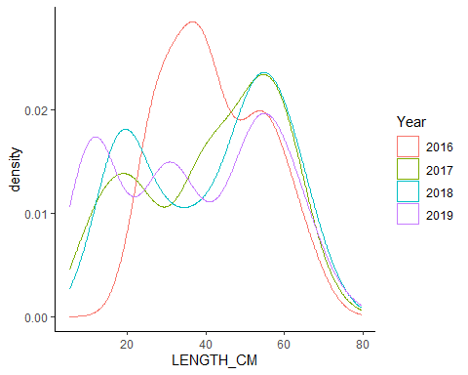

* All years have a bimodal (or tri) distribution, but small modes differ.
* 2019 has three modes, with middle one being the smallest.
* 2017 and 2018 are very similar to each other and 2016 is the most distinct from the other years.

#### Number of Samples per Island

## # A tibble: 5 x 2  
## Island n  
## <fct> <int>  
## 1 Maui Nui 209  
## 2 Big Island 157  
## 3 Oahu 120  
## 4 Kauai 39  
## 5 Niihau 10

#### Density Plot by Island

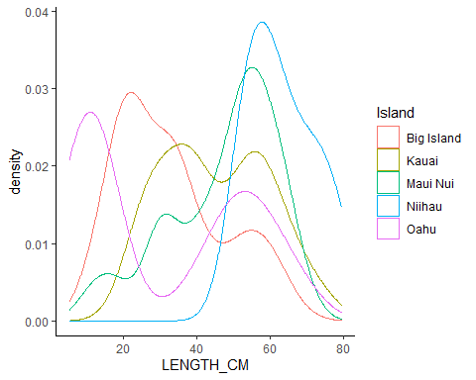

* Big Island and Oahu have more smaller fish and less bigger fish than the other islands.
* Niihau only had larger fish.
* Kauai had an almost even split between smaller and larger fish (with bigger small fish so less of a difference between modes).

#### Number of Samples per Island/Year

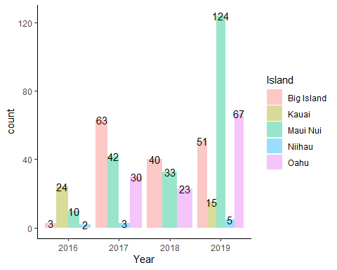

#### Density Plot by Island and Year

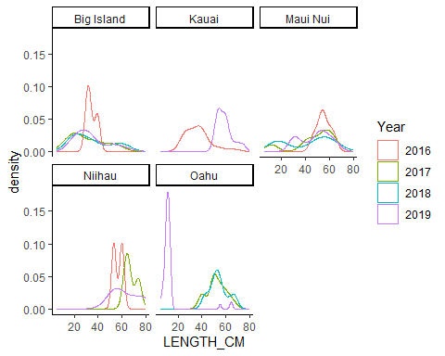

* In the Big Island, catches were pretty consistent between 2017-2019 but 2016 was very different, probably because n = 3. Also, depth was more in the mid-range of sampled depths. They did not sample in the shallower range, unlike other years.
* Kauai only had 2 years of data (2016 n = 24, and 2019 n = 15) and the distributions were different, 2016 had mostly smaller fish whereas 2019 had more larger fish.
* Maui Nui catches all had the same mode for larger sizes (between 40 - 70 cm) but the modes for the smaller sized fish fluctuated each year.
* Niihau had very small sample sizes (n = 2 - 5) for the 3 years sampling occurred there so distributions are not that reliable but size range is fairly consistent. Also, the distributions are consistent with the 2019 lengths in Kauai (support for combining those regions?).
* Oahu had consistent length distributions for 2017 and 2018 but 2019 was almost exclusively small fish (< 20 cm, n = 67)

#### Density Plot by Year and Island

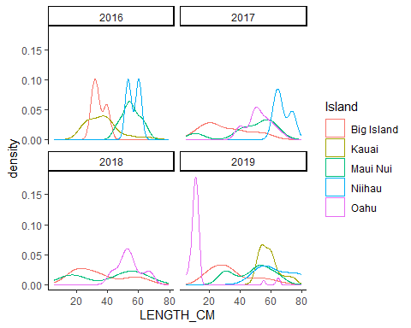

* In 2016, Big Island (n = 3) and Kauai (n = 24) were similar and Niiahu (n = 2) and Maui Nui (n = 10) were similar.
* In 2017, mostly smaller fish caught off Big Island compared to the other islands.
* In 2018, there is a bimodal distribution for Maui Nui and less pronouced for the Big Island. Oahu has only larger fish (> 40 cm).
* In 2019, the first mode is almost exclusively from Oahu samples, the second mode is from Big Island and Maui Nui samples, and the third mode is from all islands.

Depths Sampled

## # A tibble: 16 x 7  
## # Groups: Island [5]  
## Island Year min Q1 Q2 Q3 max  
## <fct> <chr> <dbl> <dbl> <dbl> <dbl> <dbl>  
## 1 Big Island 2016 124. 152. 180. 189. 198.  
## 2 Big Island 2017 82 110 130 138. 203   
## 3 Big Island 2018 97 121. 134 154 224   
## 4 Big Island 2019 91.9 94.4 94.6 143. 224.  
## 5 Kauai 2016 114. 114. 114. 114. 177.  
## 6 Kauai 2019 161. 161. 161. 161. 161.  
## 7 Maui Nui 2016 91.4 138. 167. 185. 204.  
## 8 Maui Nui 2017 95 108 131 194 238   
## 9 Maui Nui 2018 102 111 111 141 180   
## 10 Maui Nui 2019 103. 112. 146. 155. 202.  
## 11 Niihau 2016 150. 150. 150. 150. 150.  
## 12 Niihau 2017 148 148 148 192. 235   
## 13 Niihau 2019 112. 112. 112. 113. 113.  
## 14 Oahu 2017 139 177 210 210 210   
## 15 Oahu 2018 95 126 133 192 210   
## 16 Oahu 2019 79.8 79.8 101. 107. 127.