BFISH_Deep_7_Length_Comps

Meg Oshima

6/21/2021

### Camera Survey

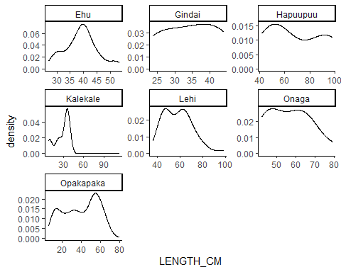

#### Length Distributions by Year

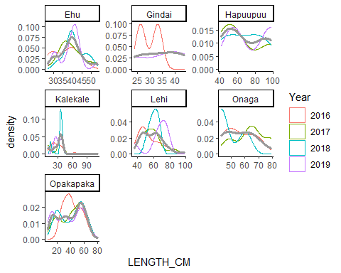

#### Length Distributions by Island

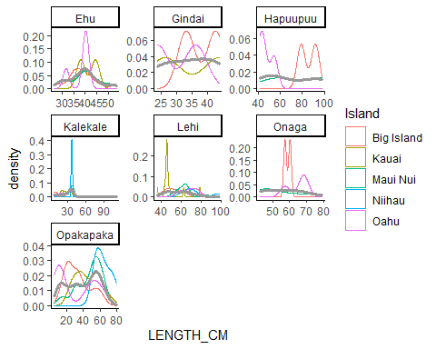

### Research Fishing

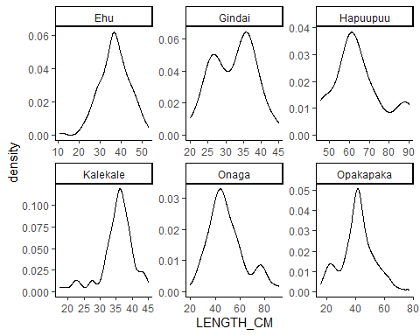

#### Length Distributions by Year

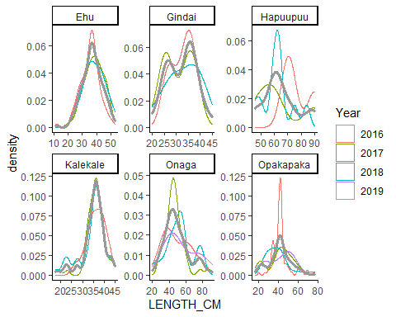

#### Length Distributions by Island

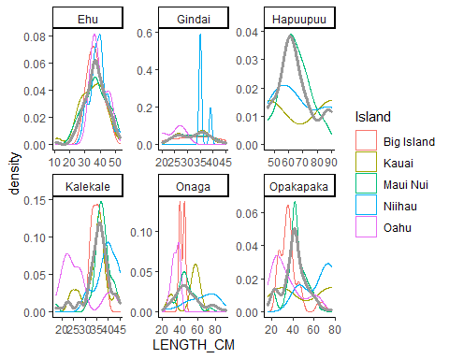

### Camera vs Research

##### Length Distributions

