Opaka Length Comp Investigations

Meg Oshima

5/21/2021

## Camera Lengths

## X PSU DROP_CD SPECIES_CD   
## Min. : 1.0 Min. : 18 Length:976 Length:976   
## 1st Qu.:244.8 1st Qu.: 8961 Class :character Class :character   
## Median :488.5 Median :23017 Mode :character Mode :character   
## Mean :488.5 Mean :21961   
## 3rd Qu.:732.2 3rd Qu.:35943   
## Max. :976.0 Max. :45499   
## SCIENTIFIC_NAME COMMON_NAME BFISH OFFICIAL_DEPTH_M  
## Length:976 Length:976 Length:976 Min. : 77.16   
## Class :character Class :character Class :character 1st Qu.:114.76   
## Mode :character Mode :character Mode :character Median :152.00   
## Mean :155.41   
## 3rd Qu.:192.00   
## Max. :274.00   
## LENGTH_CM Island   
## Min. : 5.40 Length:976   
## 1st Qu.: 25.73 Class :character   
## Median : 37.34 Mode :character   
## Mean : 38.30   
## 3rd Qu.: 51.73   
## Max. :111.60

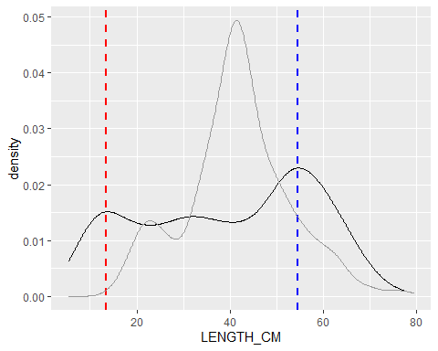

#### What is causing the mode in the smaller size classes in the BFISH camera data?

* Which sites are most of these samples coming from?
* Which islands are these samples from?
* What depth are these samples from?

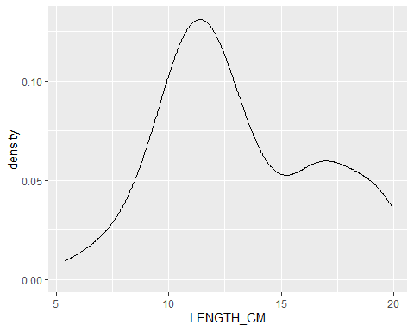

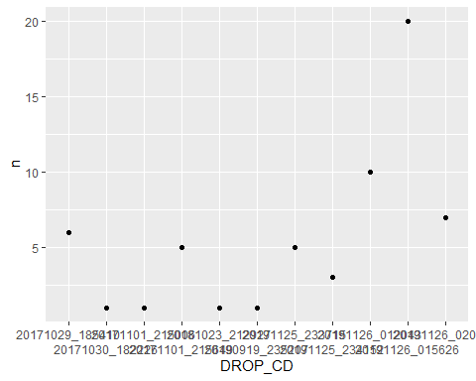

The number of Opaka between 10 and 15 cm that were caught at sites with at least one fish in that size bin.

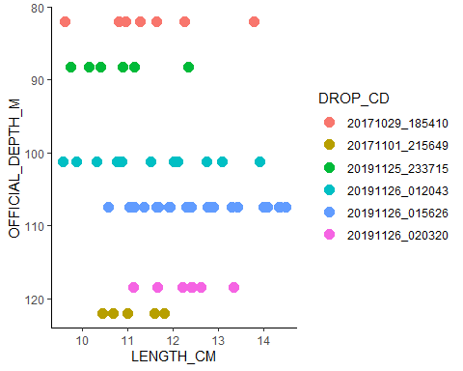

6 camera drops had 5 or more fish between 10 - 15 cm. The samples came from Oahu and all were caught between 100 - 110 m deep (which is the first quantile of depths sampled).

#### What is causing the mode in the larger size classes in the BFISH camera data?

* Which sites are most of these samples coming from?
* Which islands are these samples from?
* What depth are these samples from?

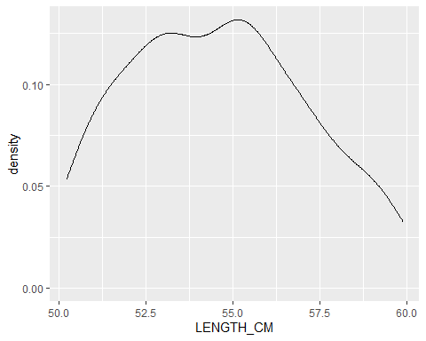

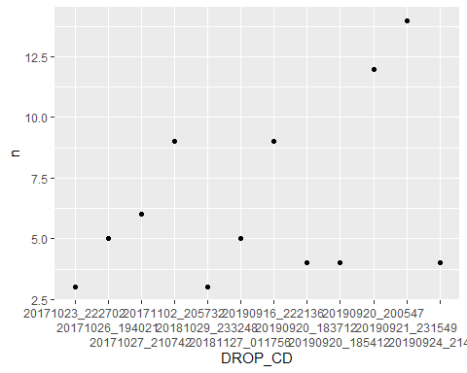

The number of Opaka between 50 and 60 cm caught at sites with more than n = 2 fish of that size.

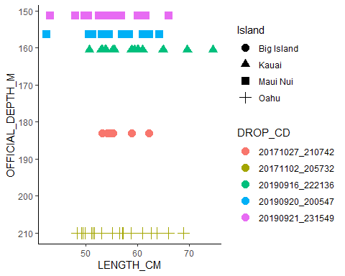

5 camera drops had more than 5 fish between 50 and 60 cm. The samples came from the Big Island (n = 1), Kauai (n = 1), Maui Nui (n = 2), and Oahu (n =1) were caught at depths of 150 to 210 m. The two highest catches occurred in 2019, and all occurred in 2019 or 2017.

## Fishing Lengths

## PSU SAMPLE_ID SPECIES_CD SCIENTIFIC_NAME   
## Min. : 271 Length:293 Length:293 Length:293   
## 1st Qu.:11839 Class :character Class :character Class :character   
## Median :16916 Mode :character Mode :character Mode :character   
## Mean :19741   
## 3rd Qu.:32422   
## Max. :43397   
##   
## COMMON_NAME LENGTH_CM WEIGHT_LB BFISH   
## Length:293 Min. :16.00 Min. :0.000 Length:293   
## Class :character 1st Qu.:35.50 1st Qu.:1.408 Class :character   
## Mode :character Median :41.50 Median :2.546 Mode :character   
## Mean :41.54 Mean :3.300   
## 3rd Qu.:48.00 3rd Qu.:4.877   
## Max. :77.00 Max. :9.900   
## NA's :1 NA's :253   
## SAMPLE_MEAN_DEPTH_M Island   
## Min. : 79.0 Length:293   
## 1st Qu.:116.0 Class :character   
## Median :137.0 Mode :character   
## Mean :139.3   
## 3rd Qu.:158.0   
## Max. :260.0   
##

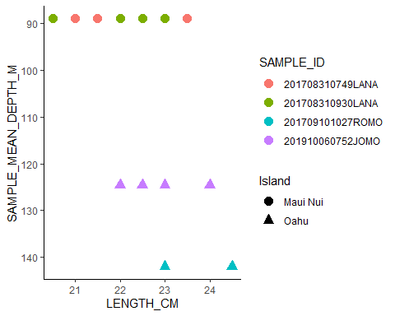

4 fishing events had more than 1 fish between 20 and 25 cm. The samples came from Oahu (n = 2) and Maui Nui (n = 2) and were caught at depths 89 to 142 m. The catches occurred in 2017 (n = 3) and 2019 (n = 1).

## Camera Lengths by Island and Year

* 5 Islands - Big Island, Maui Nui, Oahu, Ni’ihau, Kauai
* 4 Years - 2016, 2017, 2018, 2019

#### Density Plot by Year

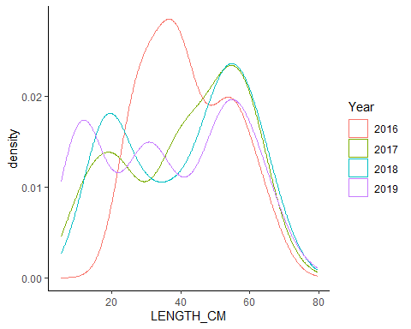

* All years have a bimodal (or tri) distribution, but small modes differ.
* 2019 has three modes, with middle one being the smallest.
* 2017 and 2018 are very similar to each other and 2016 is the most distinct from the other years.

#### Density Plot by Island

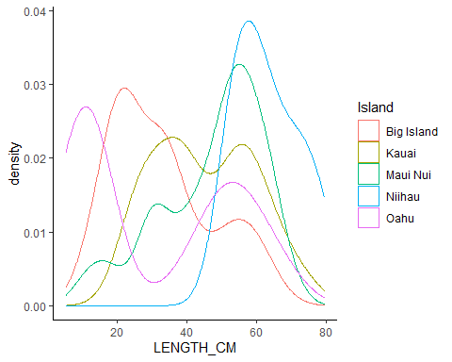

* Big Island and Oahu have more smaller fish and less bigger fish than the other islands.
* Niihau only had larger fish.
* Kauai had an almost even split between smaller and larger fish (with bigger small fish so less of a difference between modes).

#### Number of Fish per Island/Year

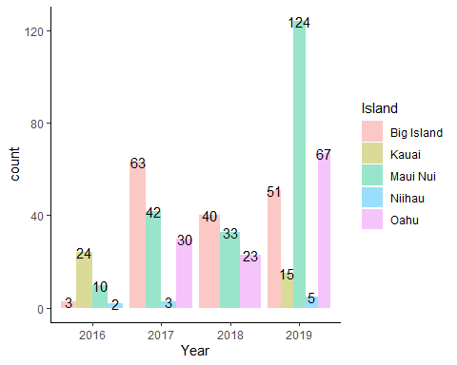

#### Density Plot by Island and Year

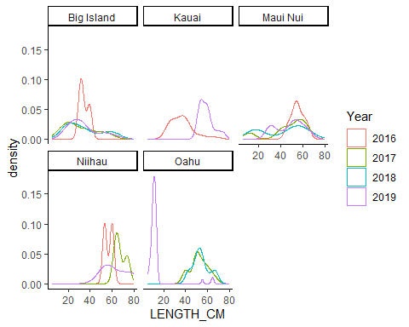

* In the Big Island, catches were pretty consistent between 2017-2019 but 2016 was very different, probably because n = 3. Also, depth was more in the mid-range of sampled depths. They did not sample in the shallower range, unlike other years.
* Kauai only had 2 years of data (2016 n = 24, and 2019 n = 15) and the distributions were different, 2016 had mostly smaller fish whereas 2019 had more larger fish.
* Maui Nui catches all had the same mode for larger sizes (between 40 - 70 cm) but the modes for the smaller sized fish fluctuated each year.
* Niihau had very small sample sizes (n = 2 - 5) for the 3 years sampling occurred there so distributions are not that reliable but size range is fairly consistent. Also, the distributions are consistent with the 2019 lengths in Kauai (support for combining those regions?).
* Oahu had consistent length distributions for 2017 and 2018 but 2019 was almost exclusively small fish (< 20 cm, n = 67)

#### Density Plot by Year and Island

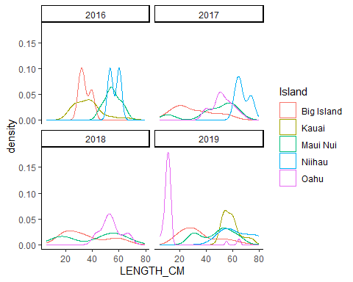

* In 2016, Big Island (n = 3) and Kauai (n = 24) were similar and Niiahu (n = 2) and Maui Nui (n = 10) were similar.
* In 2017, mostly smaller fish caught off Big Island compared to the other islands.
* In 2018, there is a bimodal distribution for Maui Nui and less pronouced for the Big Island. Oahu has only larger fish (> 40 cm).
* In 2019, the first mode is almost exclusively from Oahu samples, the second mode is from Big Island and Maui Nui samples, and the third mode is from all islands.

## Fishing Lengths by Island and Year

#### Density Plot by Year

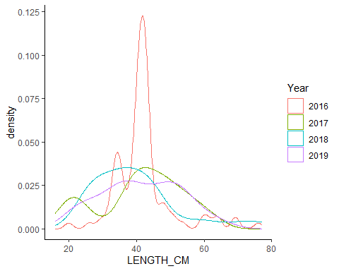

#### Density Plot by Island

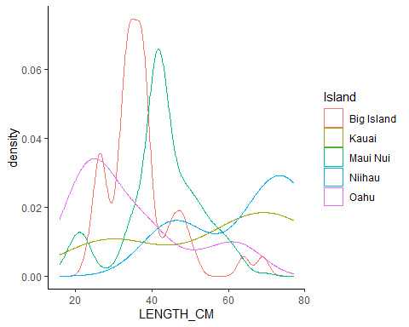

#### Number of Fish per Island/Year

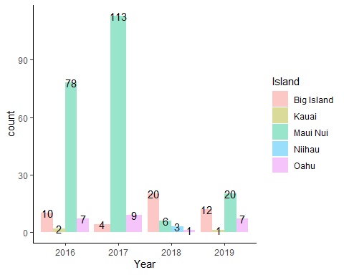

#### Density Plot by Island and Year

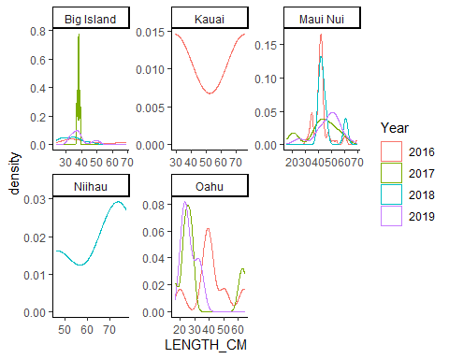

* Big Island only had 4 fish in 2017, that’s why there is a big spike. They were all about the same size.
* Kauai only had 2 fish in 2016 and 1 in 2019.
* 2019 looks pretty different from the other 3 in Maui Nui (the mode is larger than other years).
* Niihau only had 3 fish in 2018 (should we exclude since it doesn’t match up with the other samples?)
* Oahu has pretty low sample sizes but tends to be smaller fish than the other islands

## Camera vs Research Fishing

#### Areas sampled by camera and research fishing

## Reading layer `BFISH_PSU' from data source `C:\Users\Megumi.Oshima\Documents\FRMD-SAP-MOshima-SS3_Opakapaka_Assessment\Data\GIS\Shapefiles\BFISH_PSU.shp' using driver `ESRI Shapefile'  
## Simple feature collection with 25900 features and 35 fields  
## Geometry type: POLYGON  
## Dimension: XY  
## Bounding box: xmin: 368047.1 ymin: 2087107 xmax: 942047.1 ymax: 2466107  
## Projected CRS: WGS 84 / UTM zone 4N

## Reading layer `cb_2017_us_state_20m' from data source `C:\Users\Megumi.Oshima\Documents\FRMD-SAP-MOshima-SS3_Opakapaka_Assessment\Data\GIS\Shapefiles\cb_2017_us_state_20m.shp' using driver `ESRI Shapefile'  
## Simple feature collection with 52 features and 9 fields  
## Geometry type: MULTIPOLYGON  
## Dimension: XY  
## Bounding box: xmin: -179.1743 ymin: 17.91377 xmax: 179.7739 ymax: 71.35256  
## CRS: NA

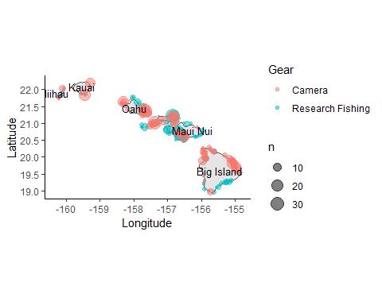

#### Depths Sampled by Gear

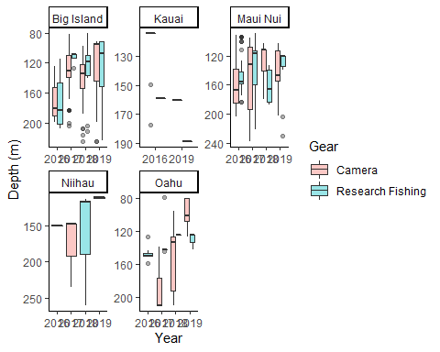

#### Length Composition Comparisons by Year

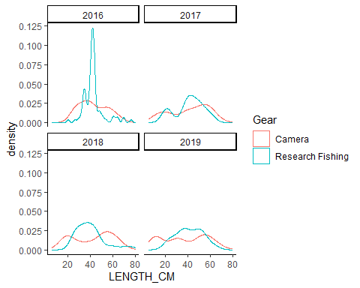

#### Length Composition Comparisons by Island

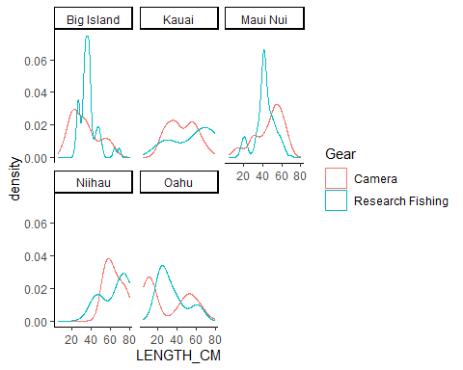

#### Sampling locations with small Opaka

Both camera and research fishing had a secondary mode of smaller fish 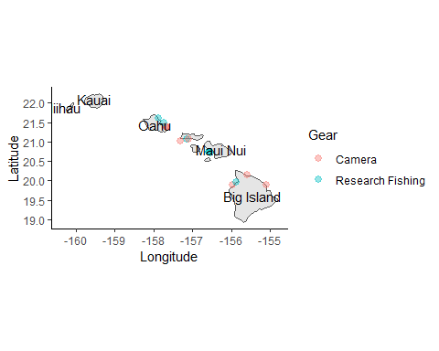

Remaining Questions:

* 2016 sampling? Why so low?
* 2019 What happened in Oahu? Why mostly really small fish?
* Differences in selectivity between methods?