MINISTRY OF EDUCATION AND SCIENCE OF UKRAINE
American University Kyiv
EPAM School of Digital Technologies

SDT 202 Object-Oriented Programming and Data Structures
Homework 1 Report

Instructor: Kolesnikov V. A.
Student: Maksym Ovcharenko
Group : BSEAI2024

Kyiv 2026

I acknowledge that this is my own work and that no unauthorized help was used.

Task: implement Ordered Symbol Table using given API. Bonus: create a visualization of the ‘put’ operation.
--
Source code (link to GitHub repository):
https://github.com/MOvcharenko/Ovcharenko-Algorithms-9
Note: Make sure the link to repository is clickable (!!!) and it leads to proper repository.
--
For online students only: Record Loom video and explain your code while sharing screen and your face. See example and explanations here. Add a loom link here. (Note: make sure the link is clickable (!!!) and it leads to proper video).
N/A
--

Program Output:
Part 1. Driver Output
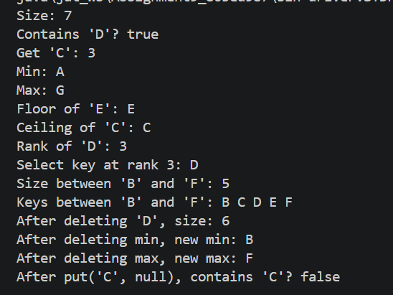

Part 2. Visualizer Output
