Introduction to Databases

PR203 Semester 1

Max Owens

Report on ER Diagram development and changes – Report 1

This document was originally created a week earlier than the upload date, however I began using GitHub on this day so therefore uploaded older documentation today.

To begin the construction of the ER Diagram and the process of normalization I put the text files into a collated Excel diagram to better see the data and determine how it can be organized. From there it became significantly easier to see common attributes and weed out the primary keys from the redundant data, which was a simple first step.

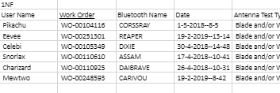

After adjusting the appearance of the data so it would become horizontal as opposed to vertical, spotting the unique identifiers became a bit simpler. I determined that the primary key for the data should be the Work Order. Further continuing the examination of the data, I decided that the pass/fail section of the data was redundant. I came to this conclusion because it was a simple calculation of other parts of the table, the data wasn’t unique or necessary, so it was removed.

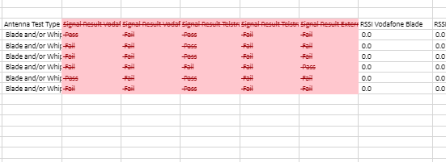

If needs be I can make a query which can re-create the pass/fail data with ease, but I believe it’s redundant.