Introduction to Databases

PR203 Semester 1

Max Owens

Report on ER Diagram development and changes – Report 2

After viewing the data on excel, it became clear to me that my next step would be to attempt to group the data.

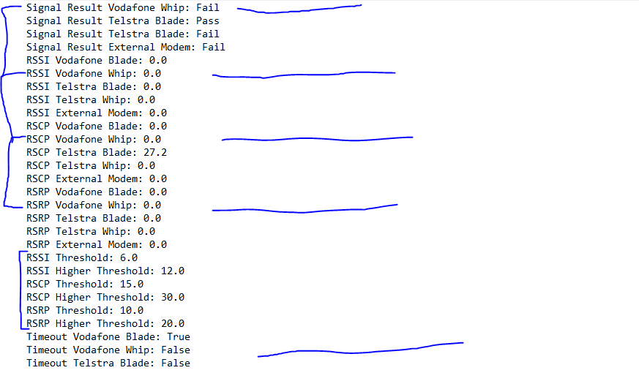

It was easy to see common nouns and that they each had similar attributes to them. For example, Each ISP and associated device each had its own signal result/type. I jumped on notepad and cut up the data and put it into appropriate groups.

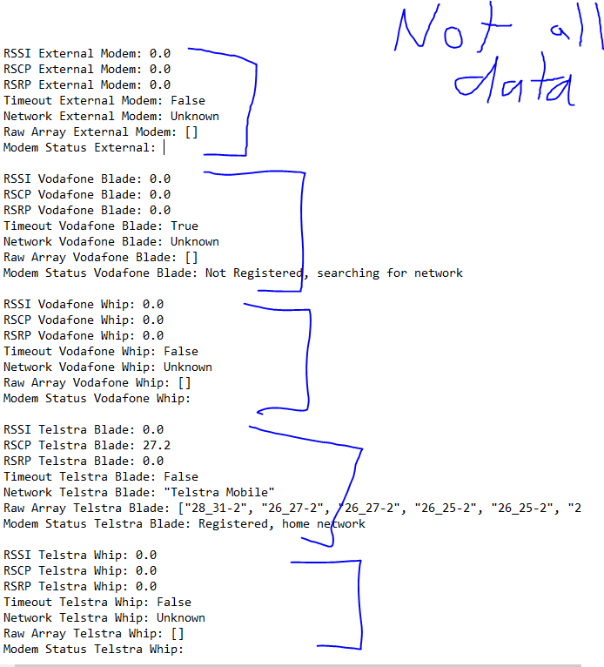

After cutting the data up, it ended up leaving me with a chunk of signal type (RSRP etc) threshold data. I will now translate the separated data into a LucidChart ER diagram. The rest of the data fit quite nicely into an employee table and a testing device table.

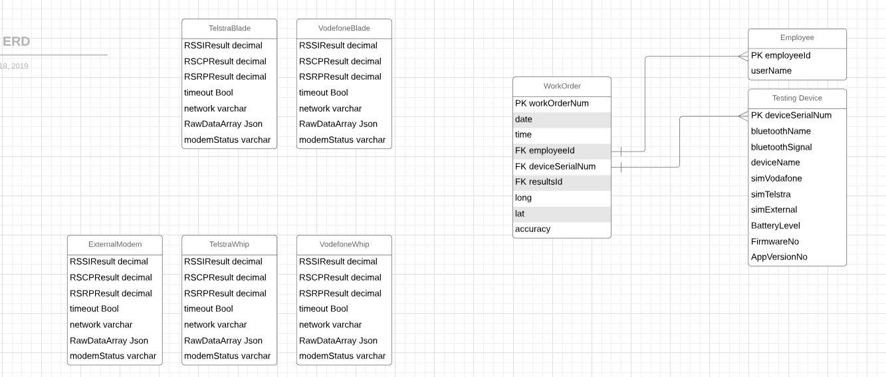

With those 5 tables made I still need to work out where to put the threshold data.

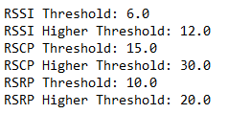

Since these are not assigned to any of the blade/whip/external, it’s entirely possible they can fit inside the work order table.

After some time I finished the following table on LucidChart.

