Introduction to Databases

PR203 Semester 1

Max Owens

Report on ER Diagram development and changes – Report 2

After seeing the database compiled in MySQL workbench and reverse engineering it, I could begin to see some faults. Firstly, the auto increment function was helpful, but it made it impossible to tie in the employees and the results from the test into the work order. In theory, the auto incrementation made unique keys very helpful, but in terms of this assignment and database it would make it impossible to complete the queries and search through the database efficiently and successfully. Several datatypes I had chosen were also inappropriate, which needed to change.

* Several integers and JSON became varchars
* I needed to make decimal more specific

I began to wonder whether I could use the work order number as a foreign key in order to attach all the associated equipment data.

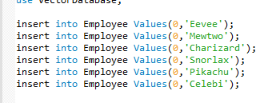

From looking at the data entry I also realized that auto incrementing a primary key on employee is completely useless. The usernames of the employees are all unique which makes this decision easy; all I needed to do was to make the username the primary key.

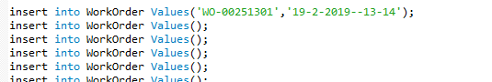

I noticed this while entering in the work order data. How am I going to bring in the employee tables? Following the same logic, how am I going to tie in the equipment data into the work order? Time to revisit my ERD and do some editing.

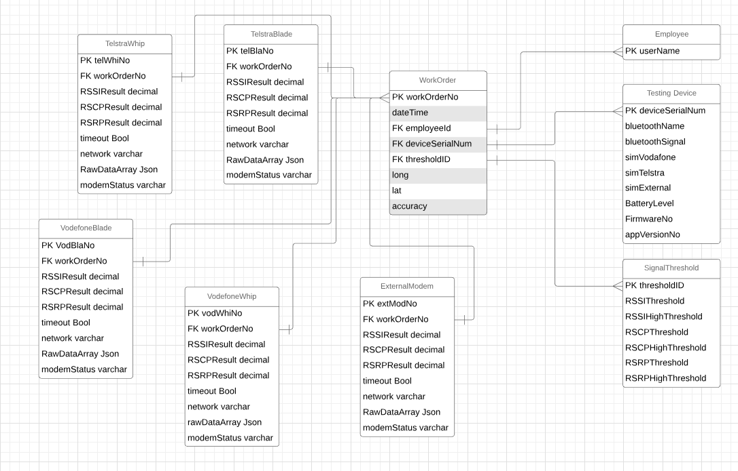

I have now significantly shrunk the work order and updated all keys to make more sense. Time to update the database.

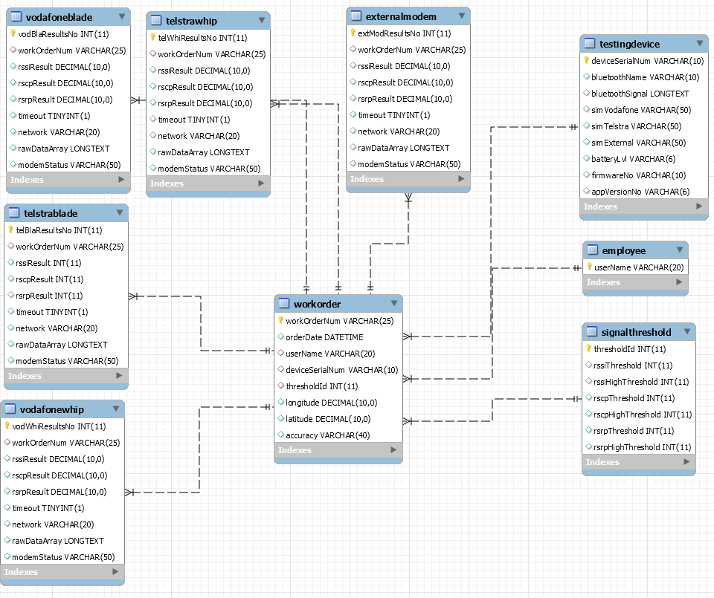

Nice. Came to realise the Threshold table needs workOrderNum too, so it was updated.