Introduction to Databases

PR203 Semester 1

Max Owens

Report on ER Diagram development and changes – Report 4

­Earlier today Amit posted some clarification to devices used in the data – turns out I had accidentally combined two tables that should be separate. Thankfully, it appears it will make the queries and the data much easier to look at. At the moment, my super-table of two devices looks like this:

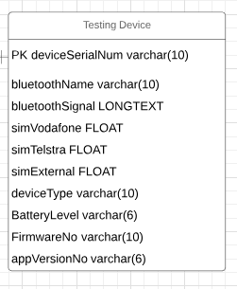

When it turns out that in reality there is a signal tester device AND a Bluetooth device.



Thank you, Amit.

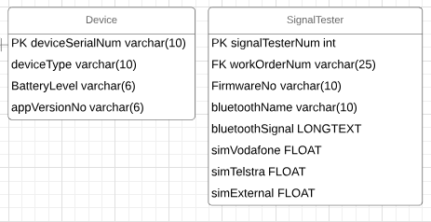

I put appVersionNo with Device, as apple devices aren’t known to use naming conventions exhibited in the firmware numbers. I will auto increment a unique ID for the signal testers.