What is Helm?

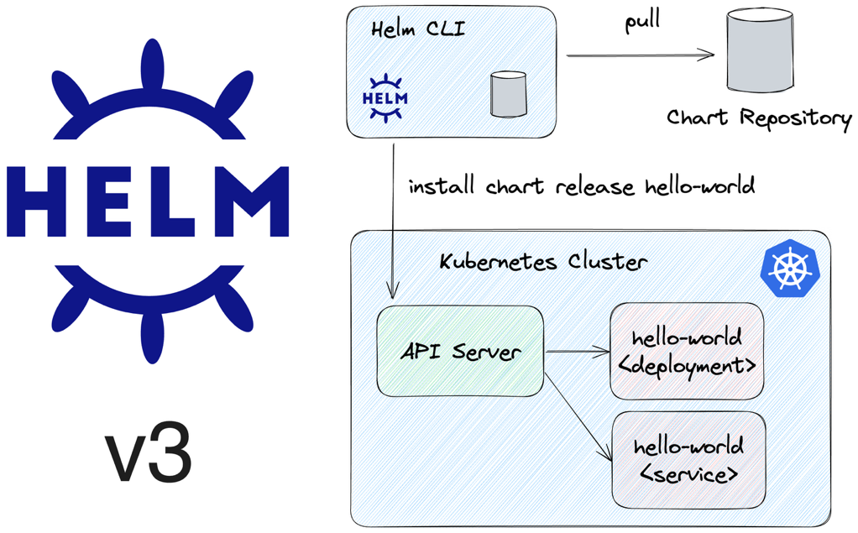
Think of Helm as the package manager for Kubernetes, just like:
- apt for Ubuntu
- yum for RHEL
- npm for Node.js
- pip for Python
Instead of installing software on a server, Helm installs applications on Kubernetes.

Problem Before Helm
Imagine Flipkart has these microservices:
Frontend
Product Service
Cart Service
Order Service
Payment Service
Notification Service
MySQL
Redis
Kafka
For just one service (Cart Service), you may need:
deployment.yaml
service.yaml
configmap.yaml
secret.yaml
hpa.yaml
ingress.yaml
networkpolicy.yaml
For 10 services:
70+ YAML files
Now suppose:
- Dev environment → 1 replica
- QA → 2 replicas
- Production → 10 replicas
Without Helm, you'll maintain separate YAMLs:
cart-dev.yaml
cart-qa.yaml
cart-prod.yaml
This becomes difficult to manage.

How Helm Solves This
Helm creates a template.
Instead of hardcoding:
replicas: 3
Helm uses:
replicas: {{ .Values.replicaCount }}
Values come from:
values.yaml
Example:
replicaCount: 10
For QA:
replicaCount: 2
For Dev:
replicaCount: 1
Same chart.
Different values.

Flipkart Real-Time Scenario
Suppose Flipkart wants to deploy Cart Service.
Without Helm:
Deployment YAML
Service YAML
ConfigMap YAML
Ingress YAML
HPA YAML
Every environment needs separate copies.
With Helm:
helm install cart-service cart-chart
Helm creates everything automatically.

Production Deployment
Suppose Cart Service v1 is running.
cart:v1
New release arrives:
cart:v2
Upgrade:
helm upgrade cart-service cart-chart \
--set image.tag=v2
Helm updates Kubernetes resources.

Production Rollback
After deployment:
Payment failures increasing
Cart Service crashing
Rollback:
helm rollback cart-service 1
Within seconds:
v2 → v1
This is one of Helm's biggest advantages.

Helm Components

1. Chart
A Chart is a package.
Example:
flipkart-cart-chart
Contains:
Deployment
Service
ConfigMap
Ingress
Structure:
cart-chart/
├── Chart.yaml
├── values.yaml
├── templates/

2. Chart.yaml
Metadata.
Example:
apiVersion: v2
name: cart-chart
version: 1.0.0
Like a package description.

3. values.yaml
Configuration values.
replicaCount: 3
image:
repository: flipkart/cart
tag: v1
Environment-specific settings live here.

4. Templates
Actual Kubernetes manifests.
Example:
spec:
replicas: {{ .Values.replicaCount }}
Helm replaces placeholders with values.

5. Release
Installed chart instance.
Example:
helm install cart-prod cart-chart
Here:
Release Name = cart-prod
Chart = cart-chart
You can install same chart multiple times:
helm install cart-dev cart-chart
helm install cart-qa cart-chart
helm install cart-prod cart-chart

6. Repository
Collection of Helm charts.
Examples:
- Bitnami
- Prometheus Community
- Grafana Labs
Add repository:
helm repo add bitnami https://charts.bitnami.com/bitnami

Helm Workflow in Flipkart
Developer
↓
GitHub
↓
Jenkins
↓
Docker Build
↓
Docker Hub
↓
Helm Upgrade
↓
Kubernetes
Example:
helm upgrade cart cart-chart \
--set image.tag=2.5.0
Jenkins automatically deploys the new version.

Why Large Companies Love Helm

Standardization
All teams follow same structure.

Reusability
One chart can be used for:
Dev
QA
UAT
Prod

Versioning
helm history cart
Shows deployment history.

Rollback
helm rollback cart 2
Instant rollback.

Automation
Perfect for:
- Jenkins
- GitHub Actions
- GitLab CI
- Argo CD

Interview Answer (2 Minutes)
What is Helm?
Helm is the package manager for Kubernetes. It packages Kubernetes manifests into reusable Charts. Using Helm, organizations such as Flipkart can deploy, upgrade, configure, version, and roll back applications consistently across environments. Helm reduces YAML duplication, supports parameterization through values.yaml, and simplifies application lifecycle management through commands like install, upgrade, rollback, and uninstall.

Key Terms
Term | Meaning
Chart | Package of Kubernetes resources
Release | Running instance of a chart
Repository | Storage for charts
values.yaml | Configuration file
Template | Dynamic Kubernetes YAML
Upgrade | Deploy new version
Rollback | Revert to previous version
This "Cart Service deployment at Flipkart" example is very close to how Helm is actually used in enterprise Kubernetes environments.

