Side car Class notes:
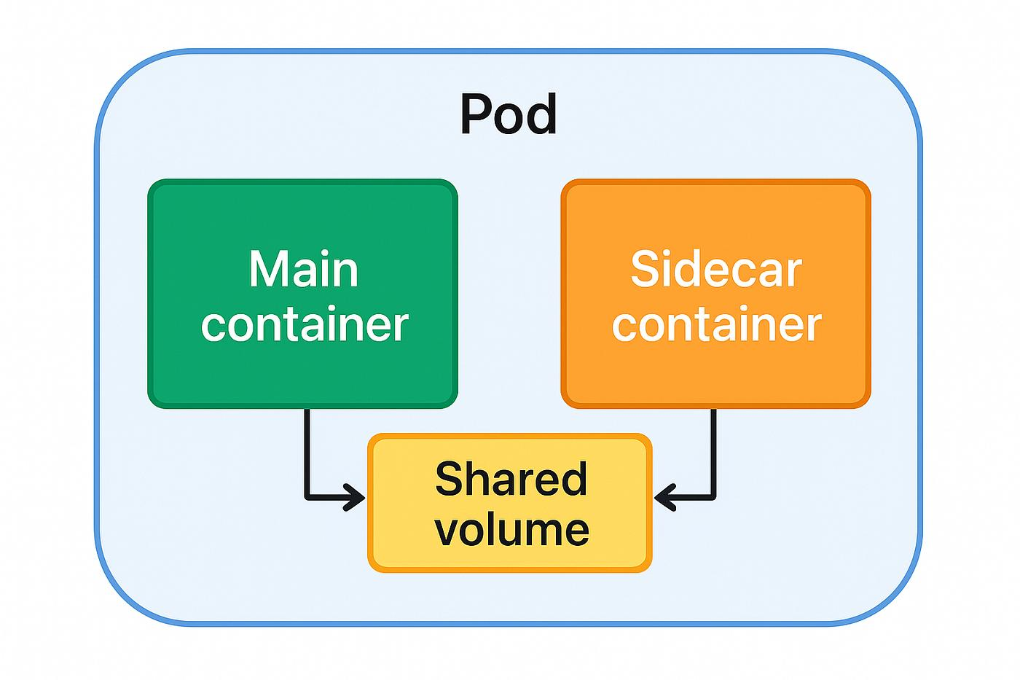

Lab Objective
We will:
- Create a Pod
- Run:
  - Main nginx container
  - Busybox sidecar container
- Share logs using a shared volume
- Sidecar continuously reads logs

apiVersion: v1
kind: Pod

metadata:
name: sidecar-pod

spec:
volumes:
- name: shared-logs
emptyDir: {}

containers:

- name: nginx-container
image: nginx
volumeMounts:
- name: shared-logs
mountPath: /var/log/nginx

- name: sidecar-container
image: busybox

command: ["/bin/sh","-c","while true; do cat /logs/access.log; sleep 5; done"]

volumeMounts:
- name: shared-logs
mountPath: /logs
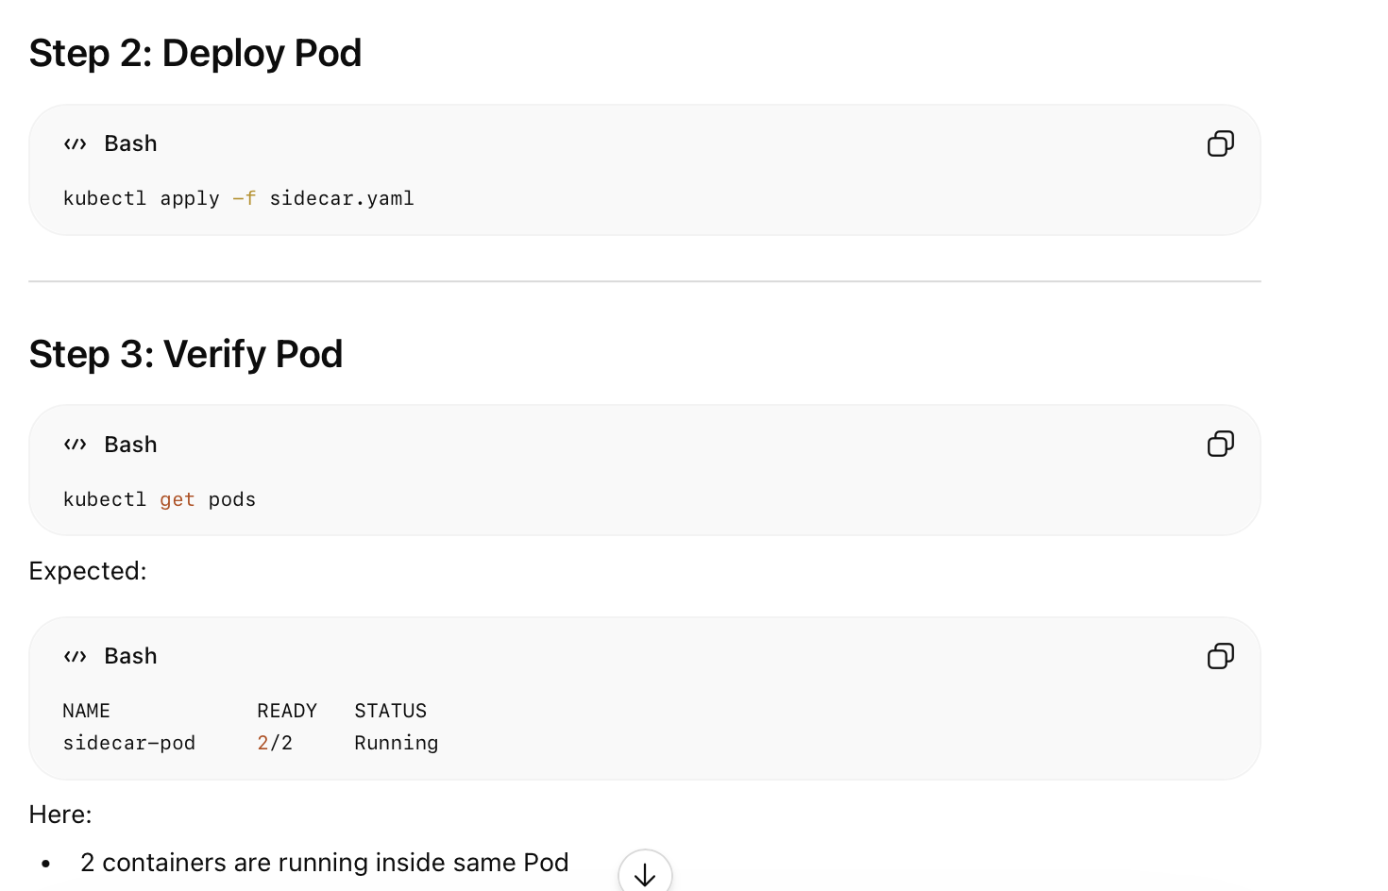

# Open Shell Inside Main Container (enter inside the nginx container)
kubectl exec -it sidecar-pod -c nginx-container -- /bin/bash
If bash is not available:
kubectl exec -it sidecar-pod -c nginx-container -- /bin/sh

# check the logs internally:
echo "Hello Sidecar" >> /var/log/nginx/access.log
Or
curl localhost
Since both containers share the same volume:
- nginx writes logs
- sidecar reads same logs

# Verify Sidecar Output
kubectl logs sidecar-pod -c sidecar-container

You will see Hello sidecar

