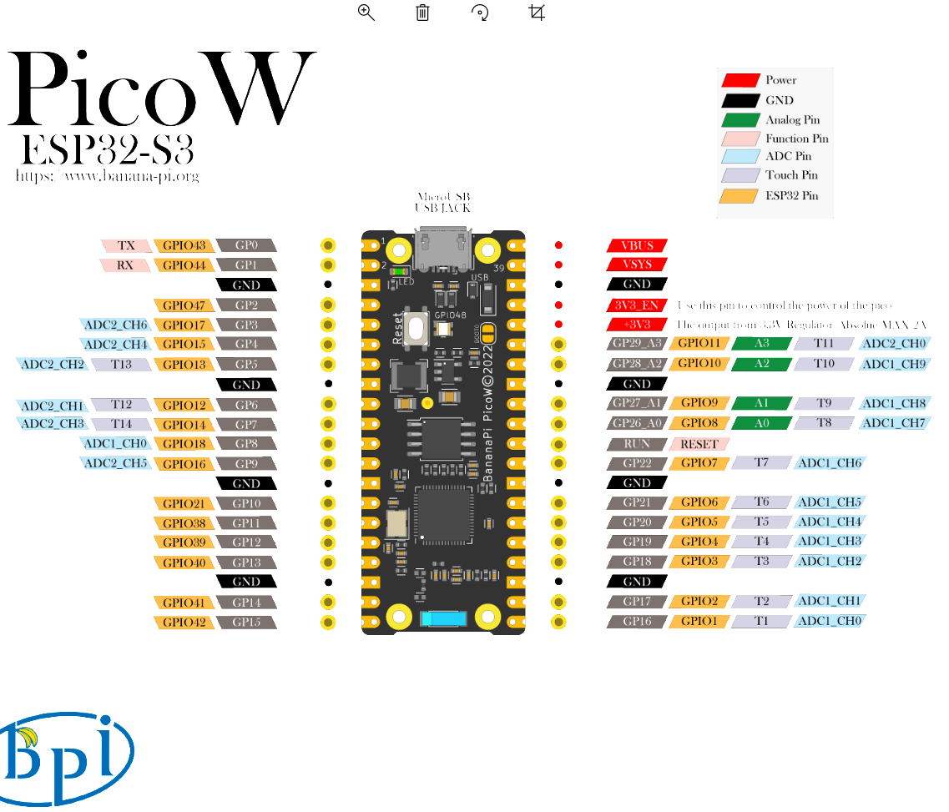

For installing and configuration go to following address:

**Installation and Use of the Visual Studio Code ESP-IDF Extension**

<https://www.youtube.com/watch?v=XDDcS7HQNlI>

After configuration select COM port and your board on bottom menu of VScode like bellow images:

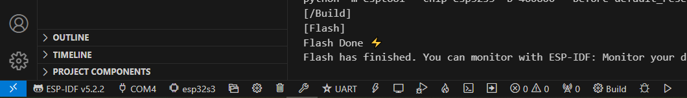



UART should be selected if you are using serial communication.

For creating **new project from scratch** first select a folder then select terminal and write:



idf.py create-project . TEST

But I don\t Know why I’m getting error

Solution:

<https://www.esp32.com/viewtopic.php?t=32794&start=10>

Hi Jorgen, I have the same problem, i.e. idf.py does not run in the powershell terminal which is opened by clicking Teminal and then New Terminal. However I get round this by opening an ESP-IDF terminal, this can be done by pressing ctrl E, releasing and then pressing t, or by pressing F1 to bring up the command pallet, type in ESP-IDF to filter out unwanted commands and then find Open ESD-IDF Terminal and click on it. Within the ESP-IDF terminal idf.py works perfectly. Note that I did install the environment variables by hand.

To include library watch:

**ESP32 - How to create your First ESP IDF project (From Scratch)**

<https://www.youtube.com/watch?v=oHHOCdmLiII&t=16s>

time 8:14/13:10

How use configmenu:

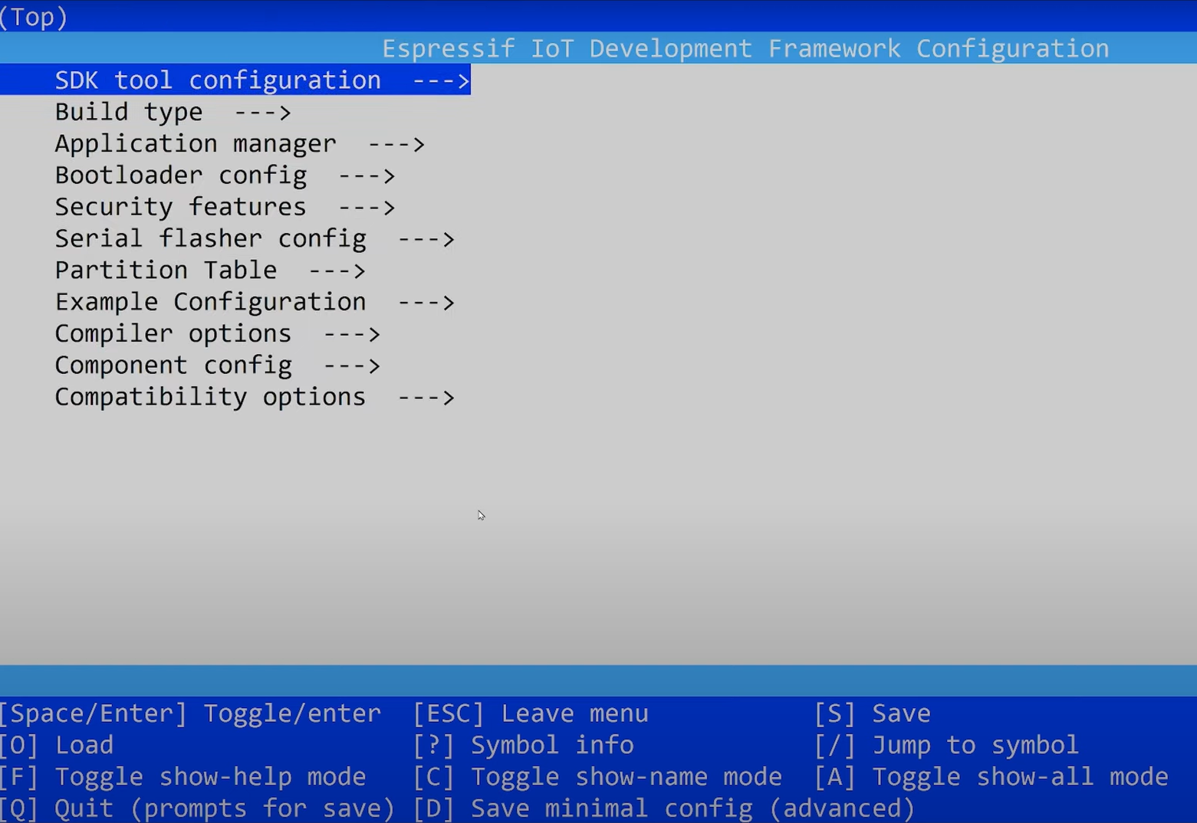

Press F1 and type Terminal:

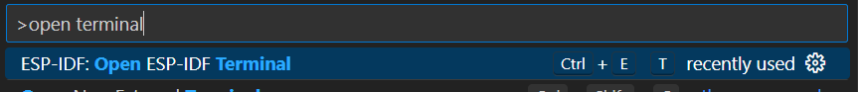

Select ESP-IDF Terminal

Now in Terminal write:

Start idf.py menuconfig

For example you can use it to change cpu frequency of ESP32

