Qt Creator — Issue & Solution Log
Android Deployment: Architecture Mismatch & Device Setup
Date: 30 May 2026

Issue 1: Architecture Mismatch Error

Error Messages
The deployment device "MazAndroidEmulator2" does not support the architectures used by the kit.
The kit supports 'arm64-v8a', but the device uses 'x86_64'.
CMake project configuration failed. No CMake configuration for build type 'Debug' found.

Root Cause
The project kit was configured for arm64-v8a (real Android devices) but the emulator MazAndroidEmulator2 was running x86_64 architecture. Qt Creator cannot deploy an arm64 build to an x86_64 device.

Issue 2: No System Image Found for arm64-v8a

Symptom
When creating a new AVD in Qt Creator (Devices > Devices > Add), selecting arm64-v8a showed a yellow warning triangle:
No system images found for arm64-v8a. Install a system image from the SDK Manager first.

Solution
The Android SDK was missing the arm64-v8a system image. Fix via SDK Manager:
- Go to Edit > Preferences > Devices > Android
- Click SDK Manager
- Under SDK Platforms, expand your target API level
- Check 'Google APIs ARM 64 v8a System Image'
- Click Apply and wait for the download to complete

Issue 3: Android SDK Settings Verification

How to Confirm Android Setup is Healthy
Navigate to Edit > Preferences > SDKs > Android tab. All items should show green checkmarks:
- JDK location: C:\Program Files\Java\jdk-23
- Android SDK location: C:\Users\Mazi\AppData\Local\Android\Sdk
- Android NDK list: 27.2.12479018
- Status: Android settings are OK. (SDK Version: 20.0)
- OpenSSL Settings are OK
Screenshot of healthy Android SDK configuration:
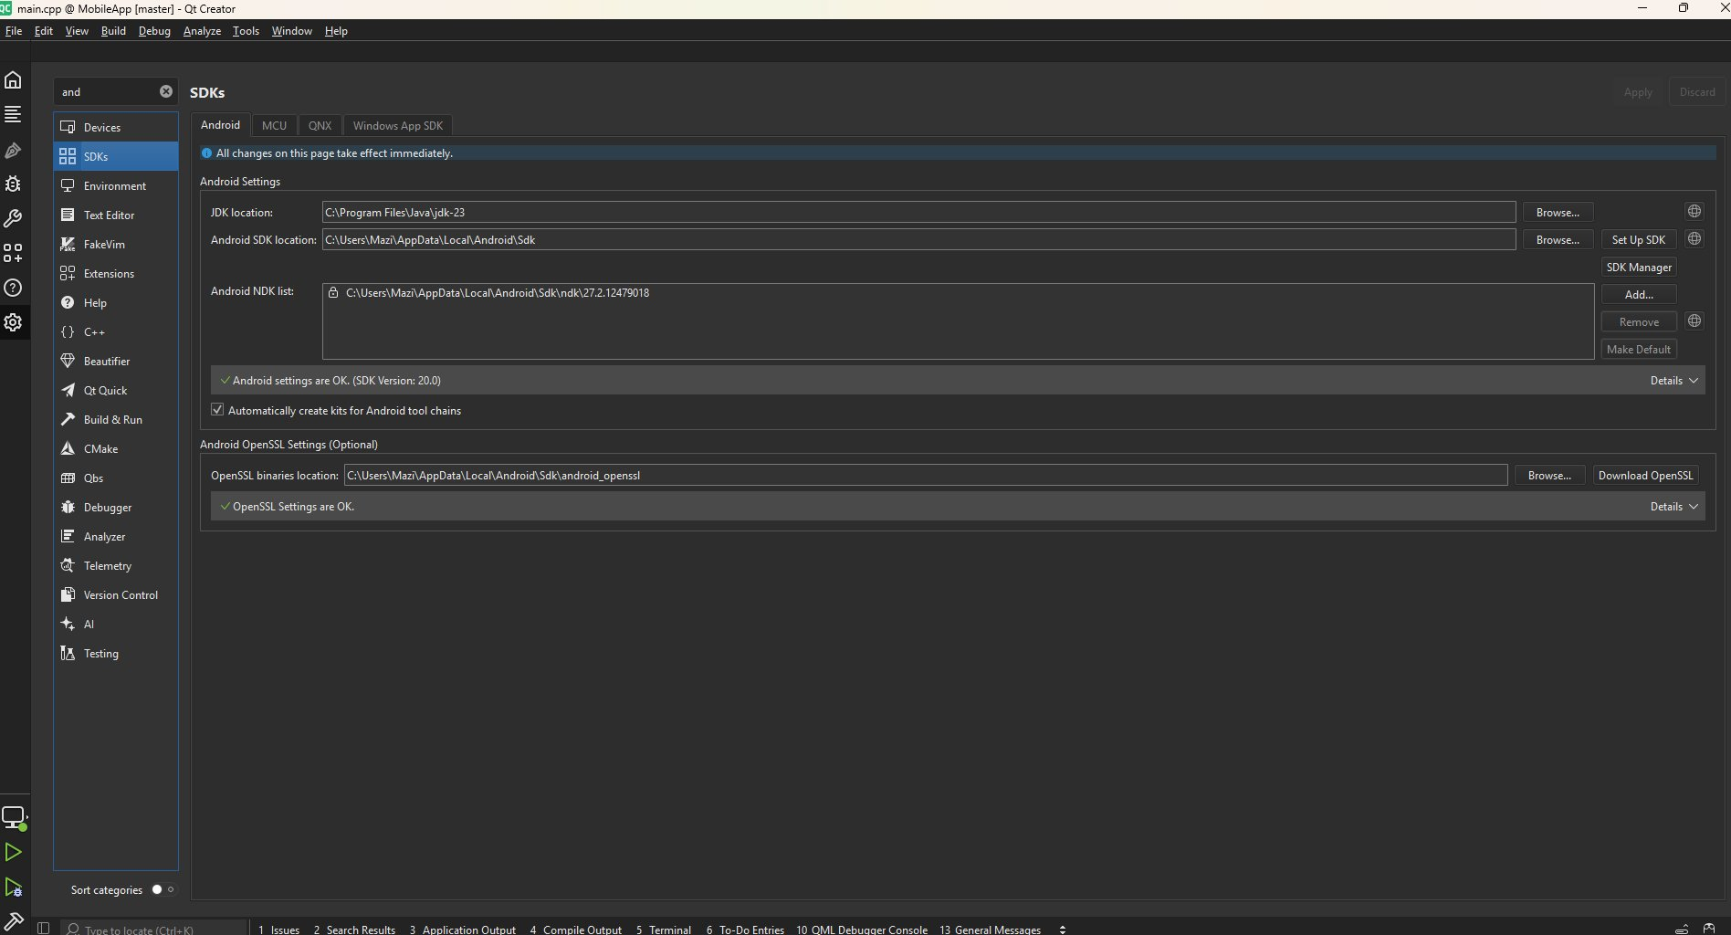
Fig 1. Qt Creator SDK settings showing all green — healthy configuration

Issue 4: Physical Device Not Appearing in Qt Creator

Device Used
- Device: Xiaomi Redmi Note 9 Pro
- CPU: Snapdragon 720G — ARM64 (arm64-v8a)
- Android Version: 12.0 (SDK 31)
- RAM: 6GB
Device specs (used to confirm arm64-v8a architecture):
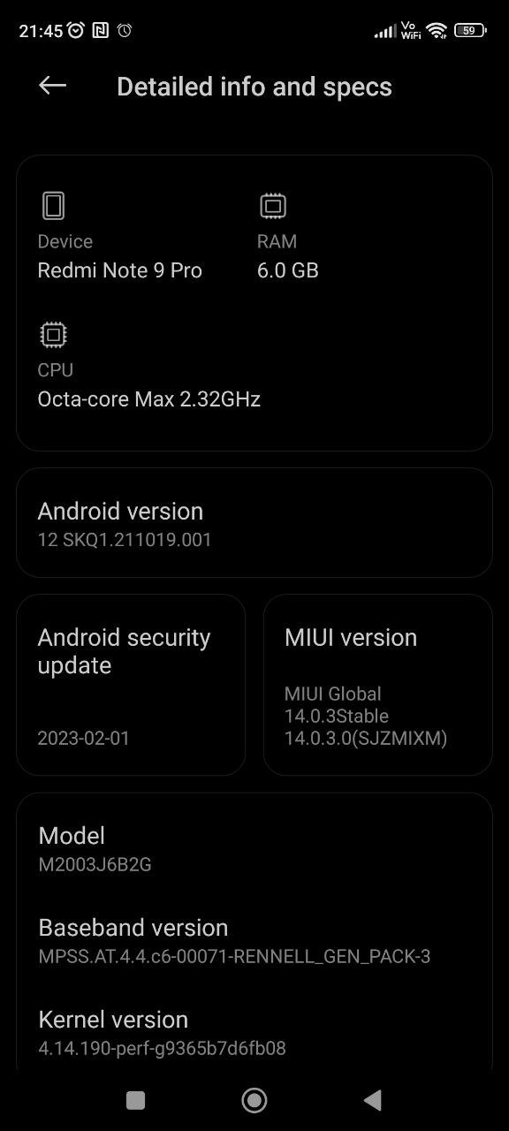
Fig 2. Redmi Note 9 Pro specs confirming arm64-v8a CPU architecture

Steps to Enable USB Debugging
- Go to Settings > About Phone
- Tap MIUI Version 7 times rapidly until 'You are now a developer' appears
- Go to Settings > Additional Settings > Developer Options
- Enable USB Debugging
- Enable Install via USB
- Connect phone via USB cable
- On the phone, tap Allow when the USB debugging authorization prompt appears
- Set USB mode to File Transfer (MTP)

Verify ADB Detects the Phone
Since adb is not in the system PATH, use the full path to adb.exe:
C:\Users\Mazi\AppData\Local\Android\Sdk\platform-tools\adb.exe devices
Expected output confirming the phone is connected and authorized:
List of devices attached
1e1467b3 device

Add ADB to System PATH (Optional but Recommended)
- Search 'Environment Variables' in Windows Start
- Edit > System Variables > Path > New
- Add: C:\Users\Mazi\AppData\Local\Android\Sdk\platform-tools
- Click OK and restart Command Prompt
- Now 'adb devices' works from anywhere

Result: Device Detected in Qt Creator
After USB debugging was enabled and the phone authorized, Qt Creator auto-detected the device:
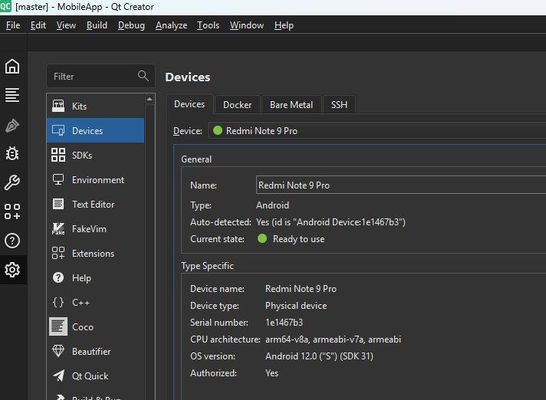
Fig 3. Redmi Note 9 Pro detected in Qt Creator Devices — status: Ready to use, arm64-v8a, Authorized: Yes

Issue 5: Android Kit Not Active for the Project

Symptom
Even though the Redmi Note 9 Pro was detected and the arm64-v8a kit was configured correctly in Preferences, the bottom-left device selector only showed 'Desktop'. The kit popup showed:
Kit: Desktop Clang 19 (MinGW)
Build: Debug

Kit Configuration Was Correct
The arm64-v8a kit in Preferences was fully valid with no warnings:
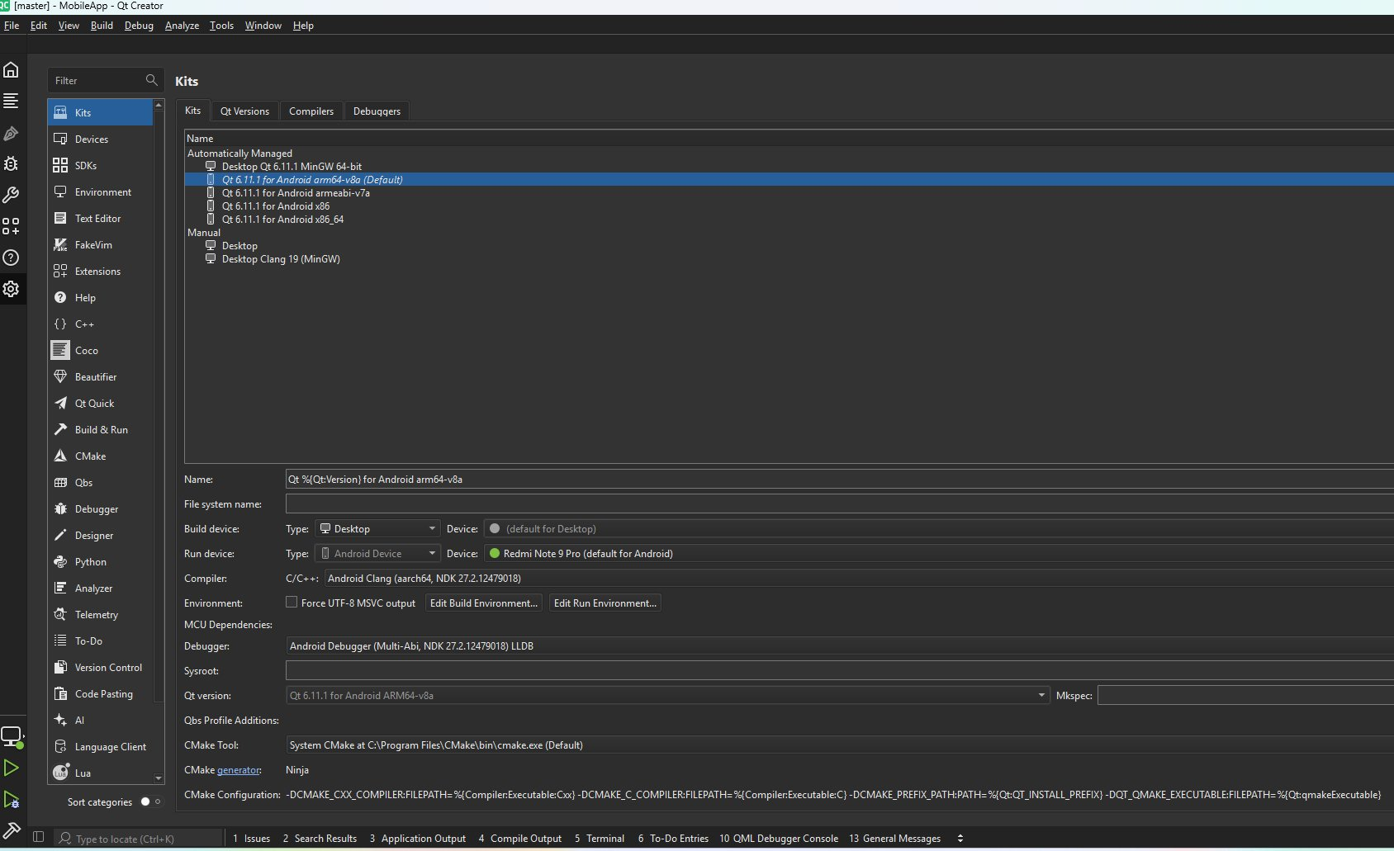
Fig 4. Qt 6.11.1 for Android arm64-v8a kit — Run device shows Redmi Note 9 Pro (green dot), all settings valid

Available Kits List
The Kits page showed all automatically managed kits were present:
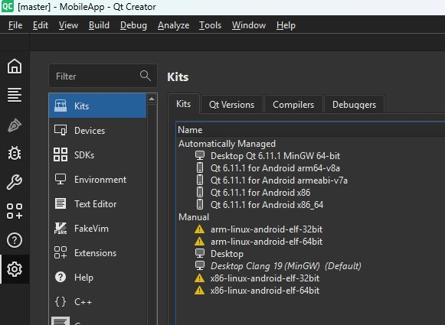
Fig 5. Kits list showing Qt 6.11.1 for Android arm64-v8a as default (no warning icons)

Root Cause
The project's .user file locked it to the Desktop kit. The Android kit existed globally but was not enabled for this specific project.

Solution: Delete the .user File and Reconfigure
- Go to Build > Clear CMake Configuration
- Navigate to the project folder:
D:\Projects\QT_Projects\QT_Fradars\TestQT_1\QT_Review\BLEApp\MobileApp
- Delete the file: CMakeLists.txt.user
- In Qt Creator: File > Close Project
- Reopen the project via File > Open Recent
- On the Configure Project screen, check ONLY: Qt 6.11.1 for Android arm64-v8a
- Click Configure Project

Alternative: Use Build Menu Kit Selector
If the Configure Project screen does not appear, use:
- Go to Build > Open Build and Run Kit Selector...
- Select the Android arm64-v8a kit from the list
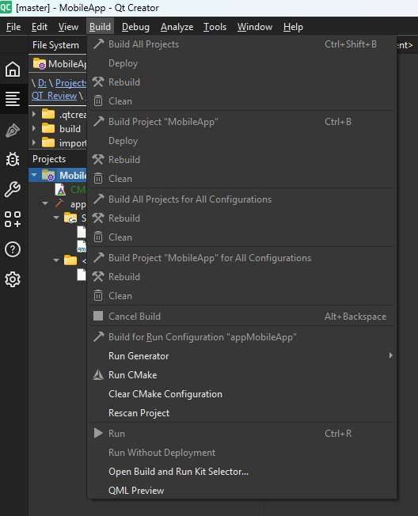
Fig 6. Build menu showing 'Open Build and Run Kit Selector' option

Final Result: Successful Configuration
After reconfiguring the project with the correct kit, the bottom-left device selector showed:
- Run device: Redmi Note 9 Pro (green dot)
- Kit: Qt 6.11.1 for Android arm64-v8a
- Deploy to Android Device
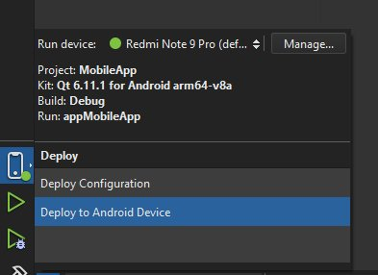
Fig 7. Final state — Redmi Note 9 Pro selected as run device with correct arm64-v8a kit
The app can now be built and deployed directly to the physical device by pressing the Run (▶) button.

Quick Reference Summary
Issue | Root Cause | Solution
Architecture mismatch error | Emulator x86_64 vs kit arm64-v8a | Use physical arm64 device or add x86_64 kit
No system image for arm64-v8a | System image not installed in SDK | Install via SDK Manager > ARM 64 v8a System Image
Phone not detected in Qt Creator | USB debugging not enabled / no driver | Enable Developer Mode, USB Debugging, authorize ADB
adb not recognized in CMD | platform-tools not in system PATH | Use full path or add platform-tools to PATH
Android kit not active for project | .user file locked project to Desktop kit | Delete CMakeLists.txt.user and reconfigure project

Document generated from Qt Creator troubleshooting session.

