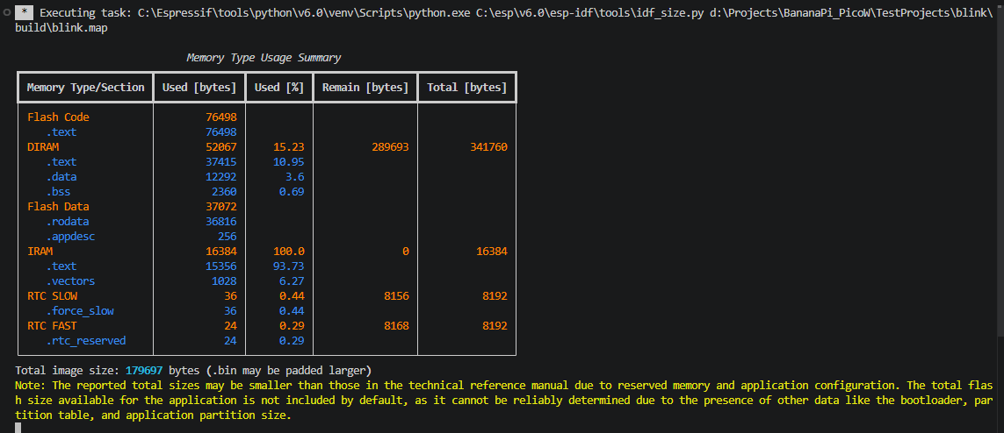
https://wiki.banana-pi.org/BPI-PicoW-S3

/////////////////
https://www.youtube.com/watch?v=5IuZ-E8Tmhg&t=185s
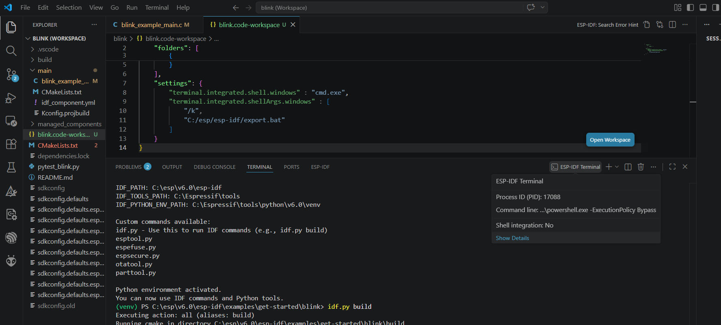
----
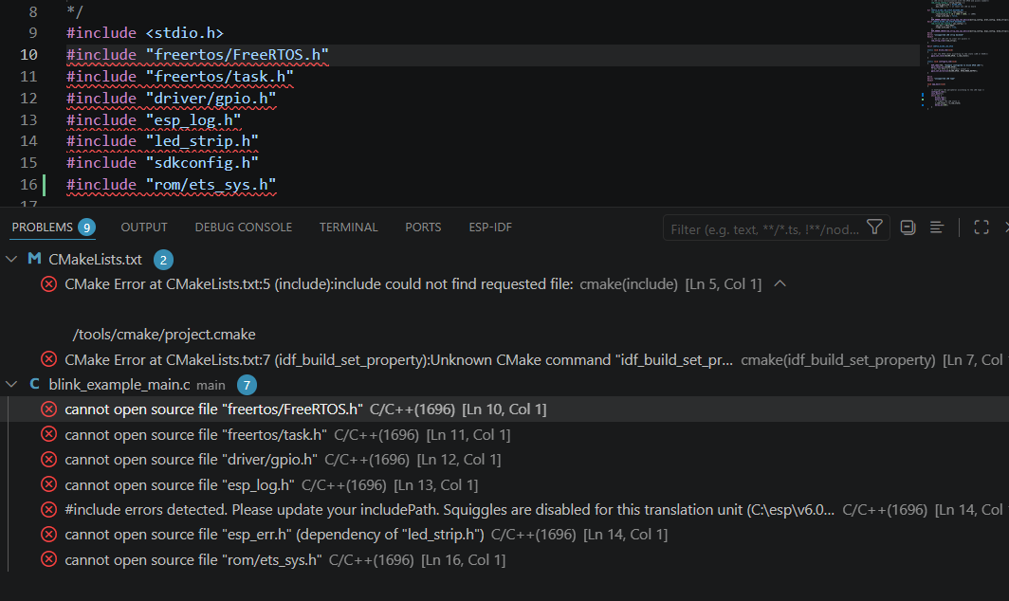
Solution:
add following lines to settings.jason to fix part of issues.
"C_Cpp.default.compileCommands": "${workspaceFolder}/build/compile_commands.json",
"C_Cpp.intelliSenseEngine": "default"
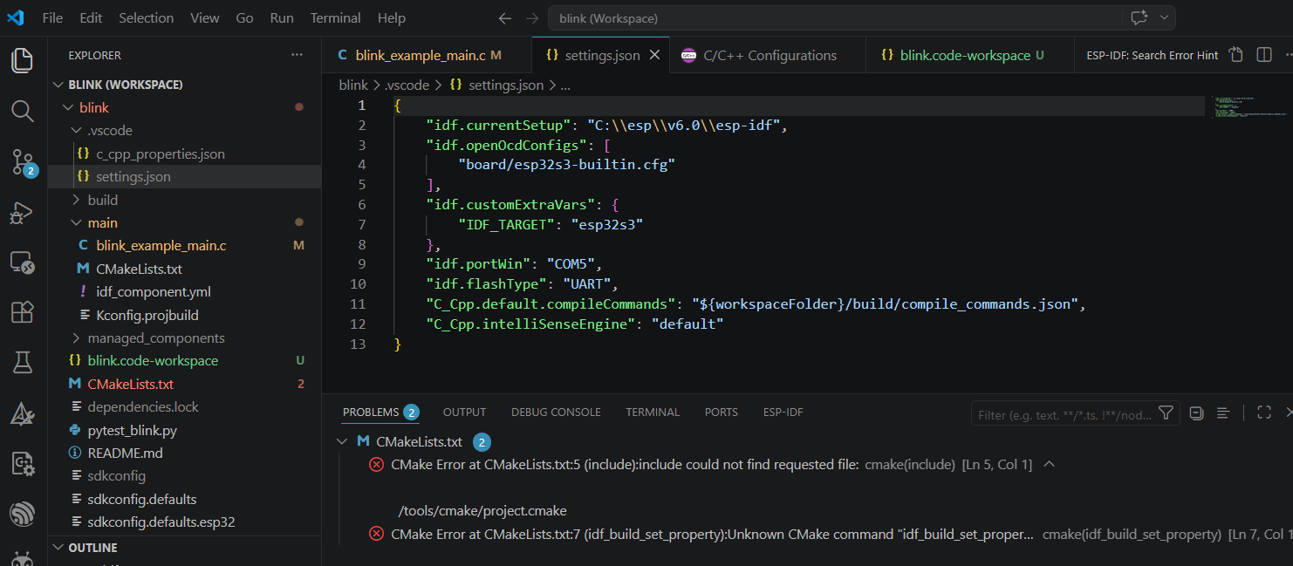
====
- Setup ESP-IDF extension:
Command Palette (Ctrl+Shift+P): ESP-IDF: Welcome
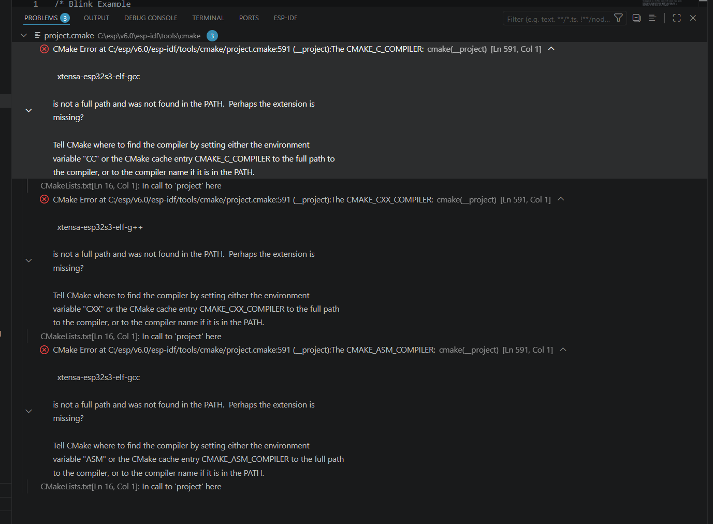
CMake Error at C:/esp/v6.0/esp-idf/tools/cmake/project.cmake:591 (__project):The CMAKE_C_COMPILER:

xtensa-esp32s3-elf-gcc

is not a full path and was not found in the PATH. Perhaps the extension is
missing?

Tell CMake where to find the compiler by setting either the environment
variable "CC" or the CMake cache entry CMAKE_C_COMPILER to the full path to
the compiler, or to the compiler name if it is in the PATH.
CMake Error at C:/esp/v6.0/esp-idf/tools/cmake/project.cmake:591 (__project):The CMAKE_C_COMPILER:

xtensa-esp32s3-elf-gcc

is not a full path and was not found in the PATH. Perhaps the extension is
missing?

Tell CMake where to find the compiler by setting either the environment
variable "CC" or the CMake cache entry CMAKE_C_COMPILER to the full path to
the compiler, or to the compiler name if it is in the PATH.
===
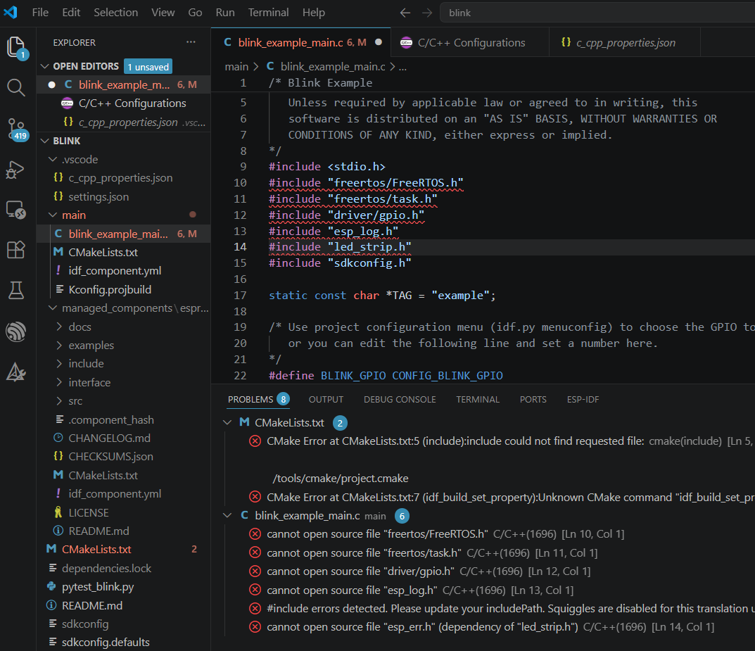
To create c_cpp_properties.json check image bellow:
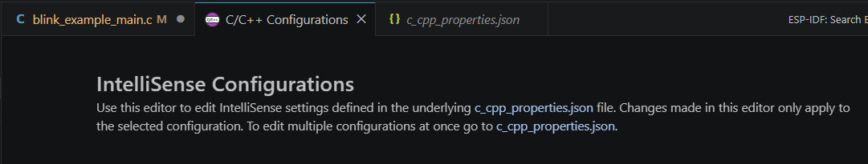
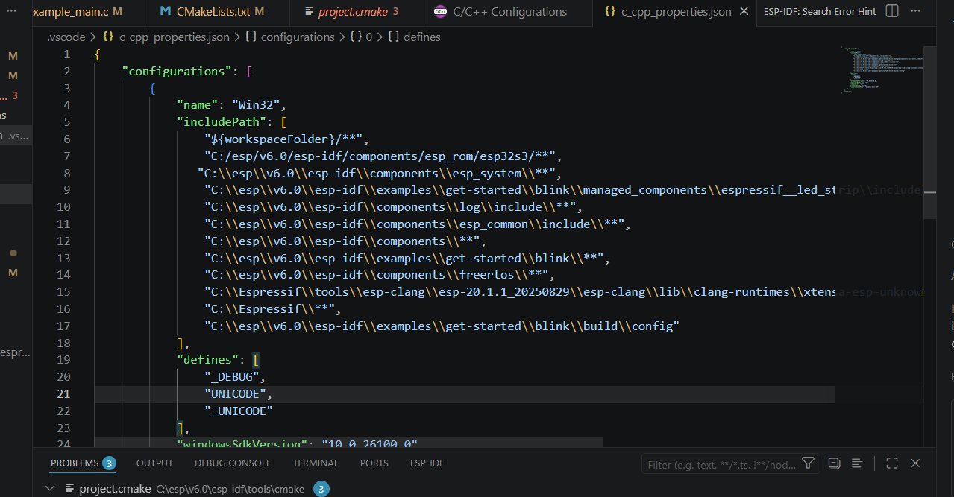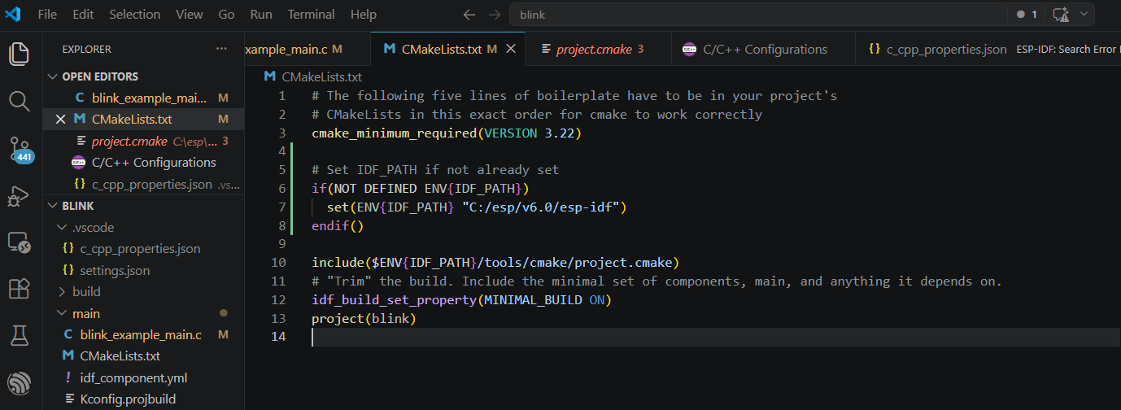

Error in *.hpp and #include <cstdint>
Try for me it didn’t worked:
If you want to use C++ specific features (like namespaces, classes, or <cstdint>), you should check your File Associations:
- Go to File > Preferences > Settings (or Cmd/Ctrl + ,).
- Search for "Associations".
- Under Files: Associations, add an entry:
  - Item: *.hpp
  - Value: cpp
- Restart VS Code.
