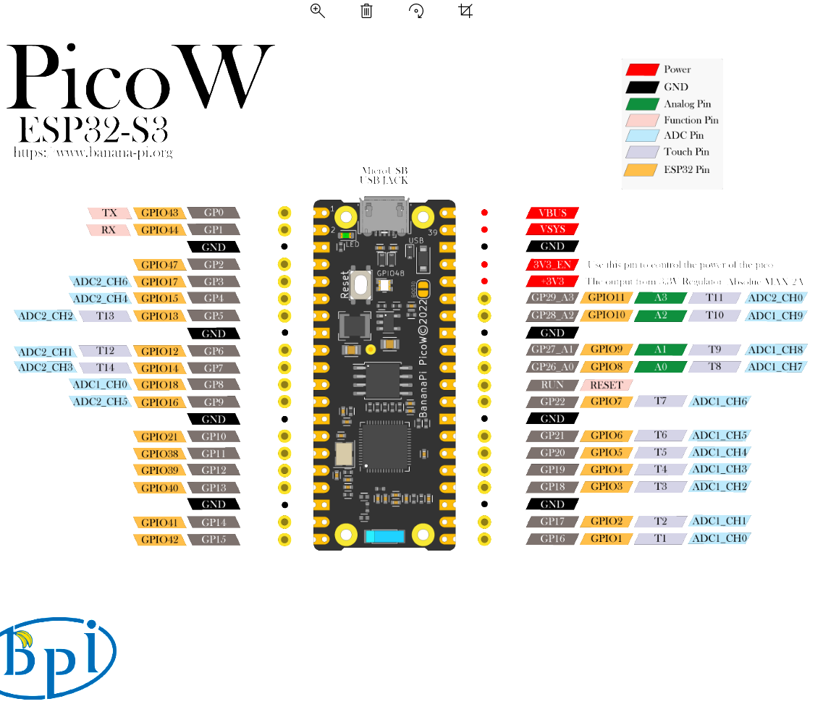
For installing and configuration go to following address:
Installation and Use of the Visual Studio Code ESP-IDF Extension
https://www.youtube.com/watch?v=XDDcS7HQNlI
After configuration select COM port and your board on bottom menu of VScode like bellow images:
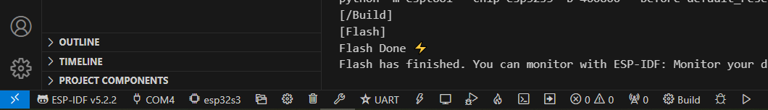
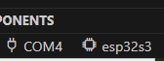
UART should be selected if you are using serial communication.

For creating new project from scratch first select a folder then select terminal and write:
idf.py create-project –p . TEST
idf.py create-project -p . app_main

But I don’t Know why I’m getting error
Solution:
https://www.esp32.com/viewtopic.php?t=32794&start=10
Hi Jorgen, I have the same problem, i.e. idf.py does not run in the PowerShell terminal which is opened by clicking Terminal and then New Terminal. However I get round this by opening an ESP-IDF terminal, this can be done by pressing ctrl E, releasing and then pressing t, or by pressing F1 to bring up the command pallet, type in ESP-IDF to filter out unwanted commands and then find Open ESD-IDF Terminal and click on it. Within the ESP-IDF terminal idf.py works perfectly. Note that I did install the environment variables by hand.

Important tip: All tasks should have while(1) loop with vtaskdelay inside:
vTaskDelay(led_delay2 / portTICK_PERIOD_MS);

Otherwise you will face repeating error in Terminal of Vscode. It is like board is resetting again and again

To include library watch:

ESP32 - How to create your First ESP IDF project (From Scratch)

https://www.youtube.com/watch?v=oHHOCdmLiII&t=16s
Time: 8:14/13:10
How use configmenu:
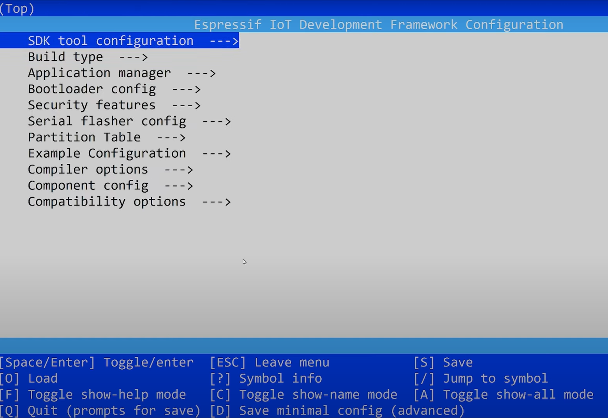

Press F1 and type Terminal:
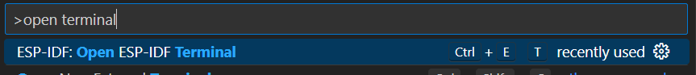
Select ESP-IDF Terminal
Now in Terminal write:
Start idf.py menuconfig
For example you can use it to change cpu frequency of ESP32
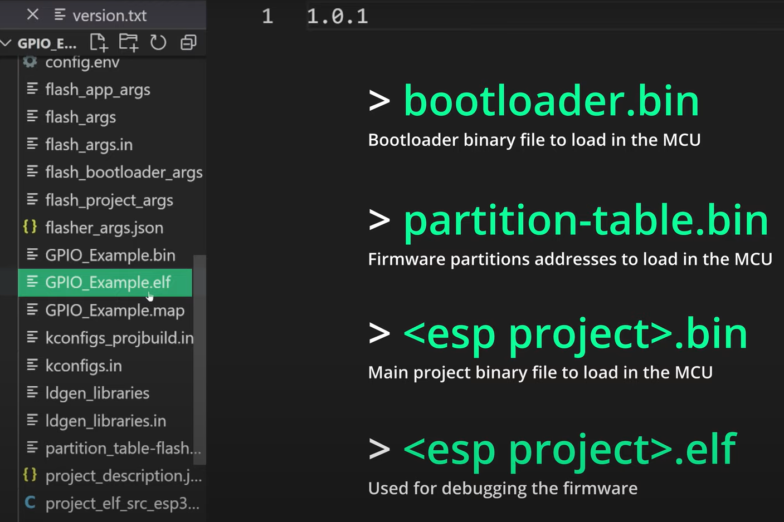

ESP-IDF Hint: esp_mac.h header file is not included by esp_system.h anymore. It shall then be manually included with #include "esp_mac.h"

Add :
"C:/Users/Iran/esp/**",
"C:/Espressif/**",
"C:/Users/Iran/esp/v5.2.2/esp-idf/components/log/include"
To Json file of your project
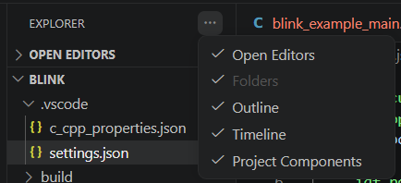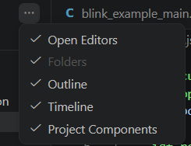
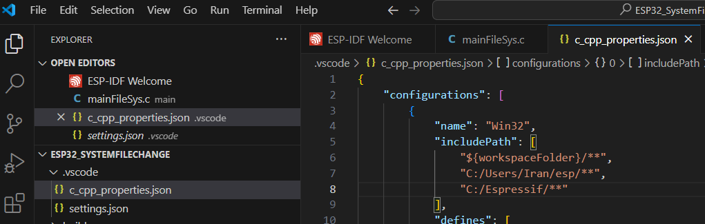

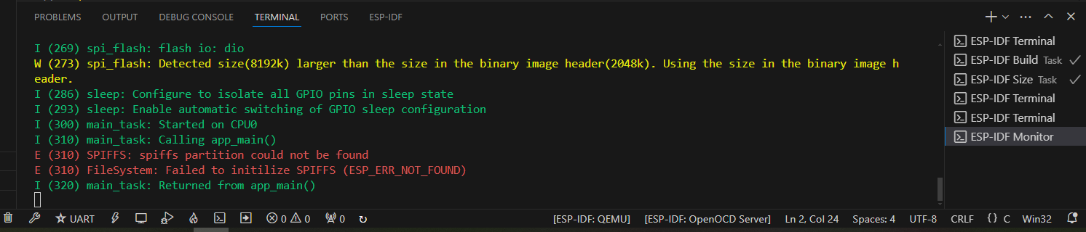
W (273) spi_flash: Detected size(8192k) larger than the size in the binary image header(2048k). Using the size in the binary image header.
Solution:

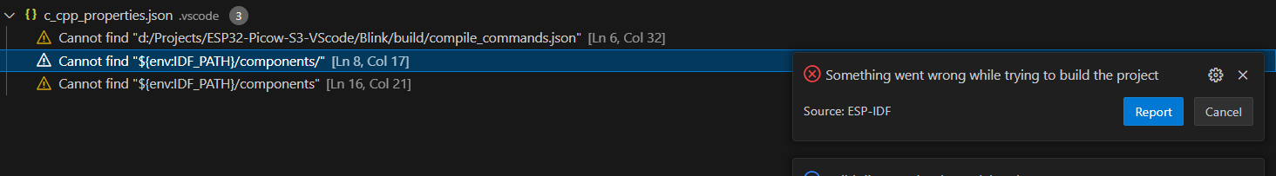
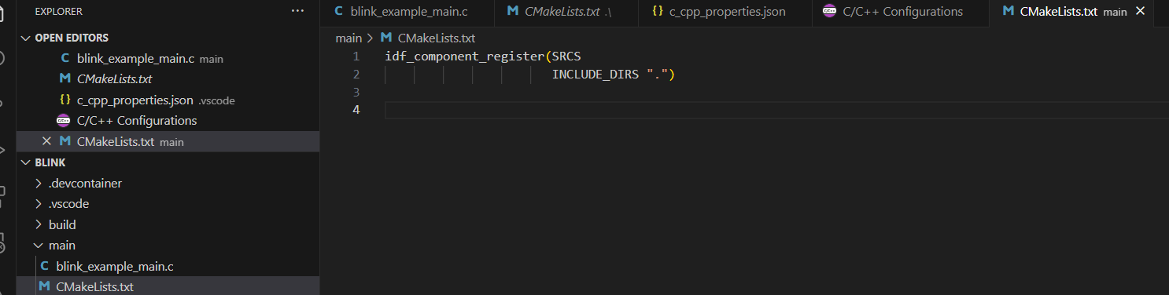
Solution: file CMkeList.txt should contains .c file name inside like image below
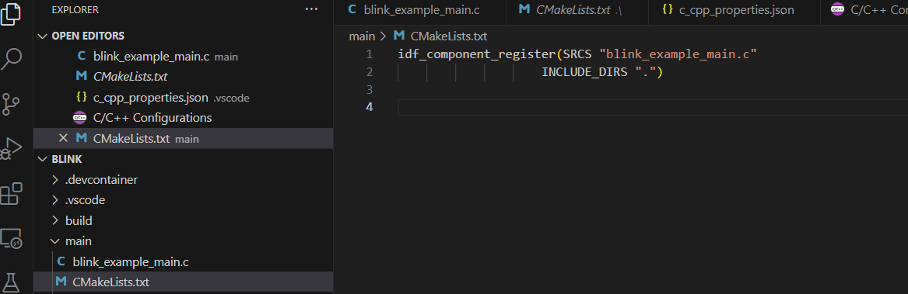

Bare Metal programing of ESP32

Bare metal GPIO driver for ESP32 | Toggling an LED

#include <stdio.h>
//#include <cstdint>
#include "FreeRTOS.h"
#include "task.h"

#define GPIO_OUT_W1TS_REG 0x60004008
#define GPIO_OUT_W1TC_REG 0x6000400c
#define GPIO_ENABLE_REG 0x60004020
#define GPIO5 5
#define DELAY_MS 500

void app_main(void)
{
volatile __UINT32_TYPE__* gpio_out_w1ts_reg = (volatile __UINT32_TYPE__*) GPIO_OUT_W1TS_REG;
volatile __UINT32_TYPE__* gpio_out_w1tc_reg = (volatile __UINT32_TYPE__*) GPIO_OUT_W1TC_REG;
volatile __UINT32_TYPE__* gpio_enable_reg = (volatile __UINT32_TYPE__*) GPIO_ENABLE_REG;

*gpio_enable_reg = (1 << 5);

*gpio_out_w1ts_reg = (1 << 5);
*gpio_out_w1tc_reg = (1 << 5);

}

https://www.youtube.com/watch?v=QrJf6CF_g_8
identifier "CONFIG_FREERTOS_HZ" is undefined
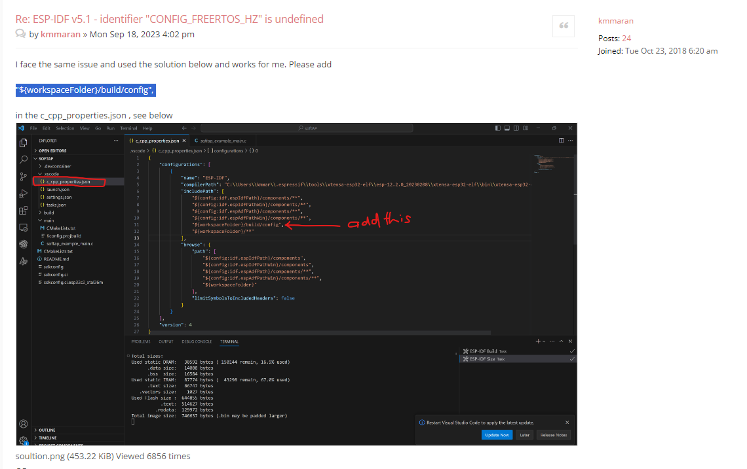

Sometimes you change something in code but when it is built a deferent project although you just opened your project folder.
Solution:
You should full clean 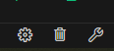

I couldn’t use GPIO43 and GPIO44 as normal input and output. It just like the freeRTOS or bootloader uses this pins as cannel for console output:
Solution:
Default is UART0 and I put that on none and add following codes to your code. And remember to use  to Full clean

//uart_driver_delete(UART_NUM_0);
gpio_reset_pin(GPIO_NUM_43);
gpio_reset_pin(GPIO_NUM_44);

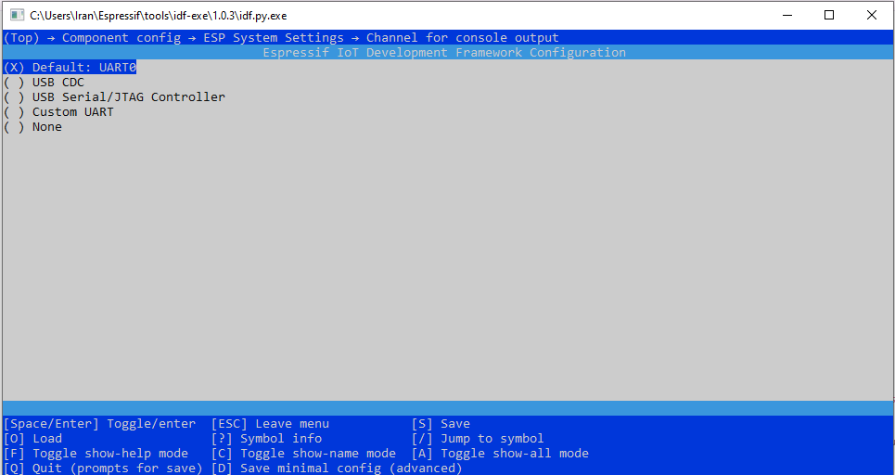
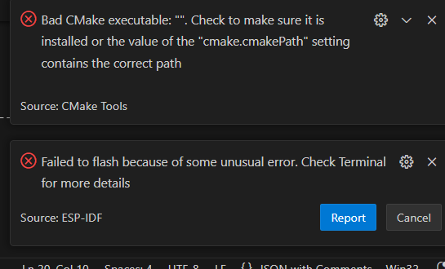

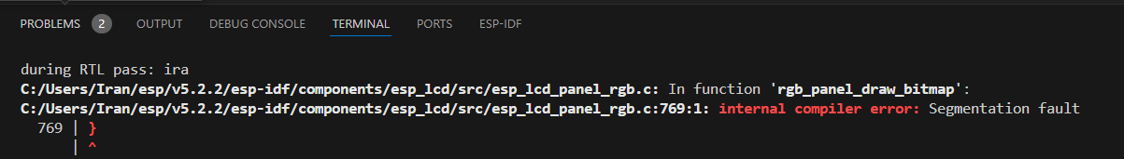

Reload bootloader:
I tried many ways to reset chip. The problem was after reset factory it was rebooting every few seconds after usb connection. And this is not the problem at all you just need to load your new program in VSCode. Following you can find different ways for resetting the flash of ESP32-S3.
Note: consider that esptool is for esp32 not for esp32-S3.
In order for your development board to download programs correctly, you need to set the BPI-PicoW-S3 to download mode, there are two methods:
Connect to the computer via USB, use tweezers to short the BOOT, then press the Reset button and release it, and finally disconnect the BOOT short.
Use this website to Erase and load bootloader:
https://adafruit.github.io/Adafruit_WebSerial_ESPTool/

How reset the board to use Mu Editor(CircuitPython)
https://bpi-steam.com/PicoW_S3_doc/en/CircuitPython/update_circuitpython.html

better way for reset ESP32 is to use esptool>
To perform an ESP32 factory reset, we’ll use esptool, which is “a Python-based, open-source, platform-independent utility to communicate with the ROM bootloader in Espressif chips.“

How to Factory Reset ESP32-S3-BOX-Lite

https://www.esp32.com/viewtopic.php?t=36018
or use link to
https://espressif.github.io/esp-launchpad/?flashConfigURL=https://espressif.github.io/esp-box/launchpad.toml
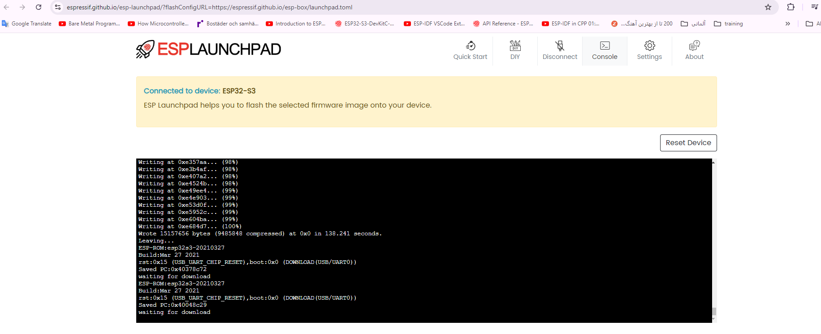
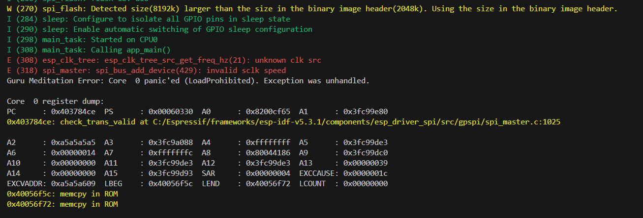

SPI Flash Physical Layout (ESP32-S3)
──────────────────────────────────────────
0x000000 ← Bootloader (first byte written)
0x008000 ← Partition table
0x010000 ← Your app binary (app_main lives here)

