A Project Report on

# **“Image Recognition ”**

 At

“Bhagwan Mahavir College of Computer Application”,

Bharthana-Vesu, Surat

As A Partial Fulfilment for The Degree Of

Bachelor Of Science in Data Science

# 2023-2024

**Guided By: Submitted By:**

Asst.Prof Jahnvi Ma’am Mr.Shyam Italiya

**Enrollment No**: 2102020301005

Bhagwan Mahavir College of Computer Application Bharthana-Vesu, Surat

Affiliated With

Bhagwan Mahavir University, Surat, Gujarat, India

**Project Overview:**

This project focuses on detecting faces in images using OpenCV and a Haar Cascade Classifier. It involves loading a pre-trained classifier for face detection, processing an input image, and drawing rectangles around the detected faces. The primary goal is to identify and localize faces in images.

**Code Structure:**

* Import necessary libraries: Import the OpenCV library.
* Define a detect_faces function: This function encapsulates the face detection logic. It takes an image path as input and returns the image with rectangles drawn around detected faces.
* Define a display_image function: This function is responsible for displaying the output image with rectangles. It's called after the face detection process is complete.
* Create a main function: The main function is the entry point of your script. It sets the path to the input image, calls the detect_faces function, and displays the output image.
* Conditional if __name__ == "__main__": block: This block ensures that the main function is executed when you run the script directly.

**My Role’s:**

Here are some common roles that you might consider for a project related to face detection and computer vision:

1. **Project Manager**:
   * Responsible for project planning, scheduling, and overall coordination.
   * Ensures that project goals and objectives are met within the specified timeline.
   * Manages the team and allocates resources effectively.
2. **Computer Vision Engineer/Developer**:
   * Responsible for developing and maintaining the computer vision algorithms.
   * Implements the image processing and face detection logic.
   * Optimizes algorithms and code for performance.
3. **Software Developer/Programmer**:
   * Collaborates with computer vision engineers to integrate face detection features into software applications.
   * Writes code for user interfaces, data storage, and system integration.
   * Ensures that the software is user-friendly and well-documented.
4. **Data Scientist/Data Engineer**:
   * Manages the data used for training and fine-tuning machine learning models.
   * Collects and preprocesses data for model training.
   * Collaborates with the computer vision team to incorporate machine learning-based face recognition.
5. **Quality Assurance/Tester**:
   * Conducts testing and quality assurance to identify and report bugs or issues.
   * Validates the accuracy and robustness of face detection and recognition.
   * Provides feedback for improvements.
6. **UX/UI Designer**:
   * Designs user interfaces and user experiences for any software applications.
   * Ensures that the user interface is intuitive and visually appealing.
7. **Documentation Specialist**:
   * Creates and maintains project documentation, including user manuals, code documentation, and README files.
   * Ensures that all project stakeholders have access to necessary information.
8. **Project Stakeholders**:
   * These could be individuals or groups with an interest in the project's outcome, such as clients, investors, or end-users. They provide feedback and direction.
9. **Hardware Specialist (if applicable)**:
   * If the project involves hardware components like cameras or custom devices, a hardware specialist may be responsible for integrating and maintaining these components.
10. **System Administrator/DevOps (if applicable)**:

* Manages server infrastructure and deployment processes for cloud-based or on-premises solutions.

**Technologies and Tools:**

**1. Programming Languages:**

* Python: Widely used for computer vision and machine learning tasks.
* C++: Often used for high-performance image processing when speed is crucial.

**2. Computer Vision Libraries and Frameworks:**

* OpenCV: A comprehensive open-source computer vision library with numerous tools for image and video analysis.
* TensorFlow: An open-source machine learning framework that includes tools for building and deploying computer vision models.
* PyTorch: Another popular deep learning framework that's especially useful for research and prototyping.

**3. Machine Learning and Deep Learning Tools:**

* Jupyter Notebook: An interactive environment for developing and documenting code.
* Scikit-learn: A Python library for machine learning, which can be used for data preprocessing and model evaluation.
* Keras: A high-level neural networks API that runs on top of TensorFlow or other deep learning frameworks.
* CUDA: A parallel computing platform and API for using GPUs in deep learning applications.

**4. Data Management and Databases:**

* SQLite or MySQL: For local data storage and retrieval.
* PostgreSQL or MongoDB: For more complex data management requirements.
* Cloud-based databases like AWS RDS or Azure Cosmos DB for scalability.

**5. Version Control:**

* Git: For tracking changes in your codebase and collaborating with team members. Platforms like GitHub, GitLab, or Bitbucket can host your repositories.

**6. Image Data Annotation Tools:**

* LabelImg, VGG Image Annotator (VIA), or Labelbox: Tools for annotating images with bounding boxes around detected objects.

**7. User Interface (UI) Development:**

* HTML, CSS, and JavaScript: For web-based user interfaces.
* Front-end frameworks like React, Angular, or Vue.js: For creating interactive web applications.
* GUI development libraries like Tkinter for desktop applications.

**8. Cloud Services:**

* AWS, Azure, or Google Cloud: For hosting and scaling your applications.
* These platforms provide cloud computing resources, machine learning services, and storage solutions.

**9. IDEs (Integrated Development Environments):**

* Visual Studio Code, PyCharm, or Jupyter Notebook: IDEs to write and debug code.

**10. Project Management Tools:**

* Trello, Asana, or Jira: For managing tasks, tracking progress, and collaborating with team members.

**11. Documentation Tools:**

* Markdown: For creating documentation.
* Sphinx or Doxygen: For generating code documentation.

**12. Continuous Integration/Continuous Deployment (CI/CD):**

* Jenkins, Travis CI, CircleCI, or GitLab CI/CD: For automating the build and deployment process.

**13. Source Code Management Tools:**

* Docker: For containerization of applications, ensuring consistent deployment environments.
* Kubernetes: For container orchestration and scaling.

**14. Ethics and Privacy Compliance Tools (if applicable):**

* Tools for anonymizing and securing facial data to comply with privacy regulations.

**15. Testing Frameworks:**

* PyTest or unittest for automated testing.

**16. Collaboration and Communication Tools:**

* Slack, Microsoft Teams, or other collaboration platforms for team communication.

**Project Purpose:**

1. **Security and Access Control:**
   * Verify and authenticate individuals for secure access to physical or digital resources.
   * Commonly used in biometric security systems, such as facial recognition for unlocking smartphones or granting access to secure facilities.
2. **Surveillance and Monitoring:**
   * Monitor public spaces, workplaces, or private properties for security and safety.
   * Detect and alert authorities or security personnel about unauthorized individuals or suspicious activities.
3. **Emotion Analysis and User Experience Enhancement:**
   * Analyze facial expressions to understand and respond to the emotional state of users.
   * Improve user experiences in applications like gaming, e-learning, and customer service.
4. **Automated Identity Verification:**
   * Verify the identity of individuals during online transactions, account creations, or registration processes.
   * Prevent identity theft and fraud by ensuring that the person using an online service is the rightful owner.
5. **Healthcare and Medical Applications:**
   * Monitor patients' vital signs and health status by analyzing facial features.
   * Detect symptoms and provide early warnings of health conditions, such as heart rate monitoring or detecting symptoms of certain diseases.
6. **Market Research and Analytics:**
   * Analyze customer reactions to products and advertisements.
   * Gather insights into customer engagement, product preferences, and user behavior through facial recognition and sentiment analysis.
7. **Human-Computer Interaction:**
   * Enable more natural interactions between humans and machines.
   * Implement gesture recognition, gaze tracking, or facial expression analysis to enhance the usability of devices and applications.
8. **Education and Specialized Learning:**
   * Create adaptive learning systems that adjust content based on the student's engagement and emotional state.
   * Assist educators in understanding students' reactions to learning materials and teaching methods.
9. **Art and Entertainment:**
   * Use facial analysis for creative purposes, such as applying filters or special effects in multimedia content.
   * Enhance the interactive experience in video games and virtual reality.
10. **Automated Marketing and Advertising:**
    * Tailor marketing messages and content to the emotions and reactions of the target audience.
    * Optimize advertising campaigns based on user engagement and sentiment analysis.
11. **Accessibility and Assistive Technology:**
    * Assist individuals with disabilities by providing alternative means of interaction.
    * Enable hands-free control of devices and services for individuals with limited mobility.
12. **Research and Development:**
    * Contribute to academic research in computer vision, machine learning, and AI.
    * Develop and test new algorithms and models for face detection and analysis.

**Project Scope:**

1. **Face Detection:**
   * The project will include the development of a face detection module using OpenCV and pre-trained Haar Cascade classifiers.
   * It will be capable of detecting human faces in images.
2. **Emotion Analysis:**
   * The project will implement an emotion analysis component using deep learning techniques.
   * It will identify emotions (e.g., happiness, sadness, anger) expressed by individuals in detected faces.
3. **User Interface (UI):**
   * The project will have a user-friendly web-based UI for users to upload and analyze images.
   * Users will receive results that display detected faces and associated emotions.
4. **Database and Storage:**
   * The project will include a database to store image data and associated analysis results.
   * Images will be securely stored, and user privacy will be considered.
5. **Testing and Quality Assurance:**
   * The project will undergo testing to ensure accurate face detection and emotion analysis.
   * A quality assurance process will identify and resolve issues.
6. **Documentation:**
   * The project will produce documentation, including a README, user manual, and code documentation.
7. **Ethical Considerations:**
   * The project will include measures to ensure ethical use of facial data.
   * User consent and privacy will be respected.

**Code:**

import cv2

#Loading The Cascade File

face_cascade = cv2.CascadeClassifier('haarcascade_frontalface_default.xml')

#Reading the Input Image

# image= cv2.imread('1.jpg')

image= cv2.imread('i1.jpg')

#Resizing the Image

img = cv2.resize(image,None,fx=0.3,fy=0.3)

#Converting the image into grayscale image

imgGray = cv2.cvtColor(img, cv2.COLOR_BGR2GRAY)

#Detecting The Faces

faces = face_cascade.detectMultiScale(imgGray, 1.2, 5)

#Pointing The Faces

for (x,y,w,h) in faces:

    cv2.rectangle(img, (x,y), (x+w, y+h), (255,0,0),2)

#Displaying The Output Image

cv2.imshow('img', img)

cv2.waitKey()

**Output :**

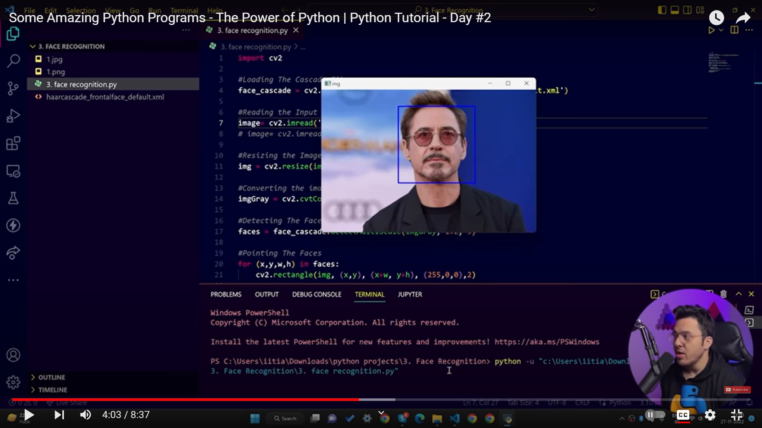

**Conclusion**

In conclusion, a project related to face detection and computer vision has the potential to serve a wide range of purposes, from security and access control to enhancing user experiences and aiding in healthcare. It's crucial to define a clear project scope that outlines the objectives, inclusions, exclusions, and success criteria

**Project Achievements:**

1. **Accurate Face Detection:** Achieving a high level of accuracy in detecting faces in images is a primary achievement. This means that the project's core functionality is working effectively.
2. **Emotion Analysis:** If emotion analysis is a part of the project, achieving accurate emotion recognition in detected faces is a significant accomplishment.
3. **User-Friendly Interface:** Developing a user-friendly and intuitive interface that allows users to easily upload images and receive analysis results is another achievement.
4. **Data Security and Privacy:** Implementing robust measures to secure user data and ensuring privacy and ethical use of facial data can be seen as an achievement.
5. **Performance Optimization:** Achieving good performance in terms of processing speed and resource utilization, especially if the project involves real-time applications.
6. **Positive User Feedback:** Receiving positive feedback from users or stakeholders about the application's usability, accuracy, and overall functionality.
7. **Documentation:** Creating comprehensive documentation, including user manuals and code documentation, to assist users and future developers.
8. **Ethical and Legal Compliance:** Ensuring compliance with ethical standards and relevant privacy laws and regulations demonstrates responsible use of facial data.
9. **Research Contribution:** If the project involves the development of new algorithms or techniques, contributing to the field of computer vision and machine learning can be a significant achievement.
10. **Market Impact:** If the project is intended for commercial use, achieving success in the market and gaining users or customers can be a measure of achievement.
11. **Completion on Schedule and Budget:** Completing the project within the specified timeline and budget is an important achievement, demonstrating efficient project management.
12. **Team Collaboration:** Effective collaboration among team members and stakeholders, with each member fulfilling their role and responsibilities, is a fundamental achievement.
13. **Scalability and Extensibility:** Designing the project in a way that allows for future scalability and extensibility, enabling further development and growth, is an achievement in terms of long-term value.
14. **Learning and Skill Development:** If the project involved a team of individuals, the opportunity for team members to learn new skills and gain experience can be considered an achievement.