The most important concepts in Machine Learning

- How would you define Machine Learning?
Machine Learning is the field of study that gives computer the ability to learn without being explicitly programmed.
There are lots of definitions about Machine Learning but I think that’s is the most beautiful.
- Can you name four types of problems where it shines?
Machine Learning is great for :
>Problems for which existing solutions require a lot of hand-tuning or long list of rules.
>Complex problems for which there is no good solution al all using traditional approach.
>Fluctuation environments ( ML system can adapt to new data).
>Getting insights about complex problems and large amounts of data.
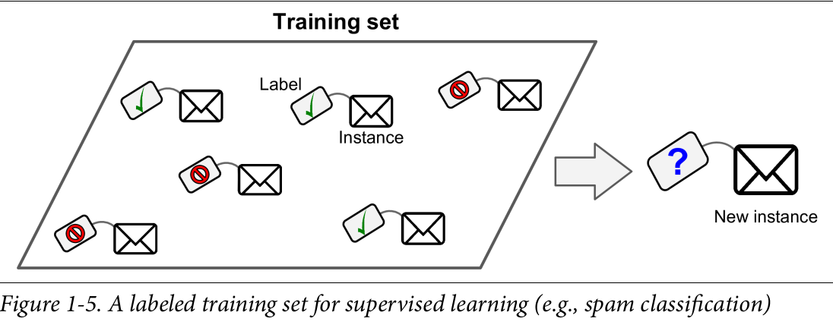
- What is a labeled training set?
The data you feed to the algorithm includes the desired solutions.
- What are the two most common supervised tasks?
Classification like KNN, Decision Trees, etc. And Linear Regression like Simple Linear Regression or Multi Linear Regression.
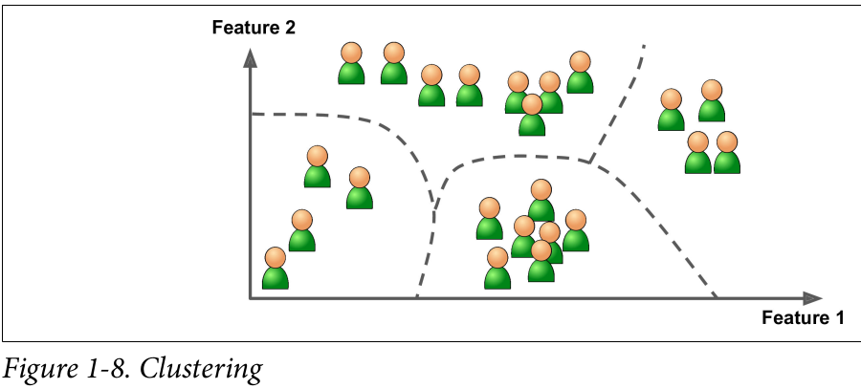
- Can you name four common unsupervised task?
>You have a lot of data about your blog’s visitors and you may want to run a clustering algorithms to try to detect groups of similar visitors.
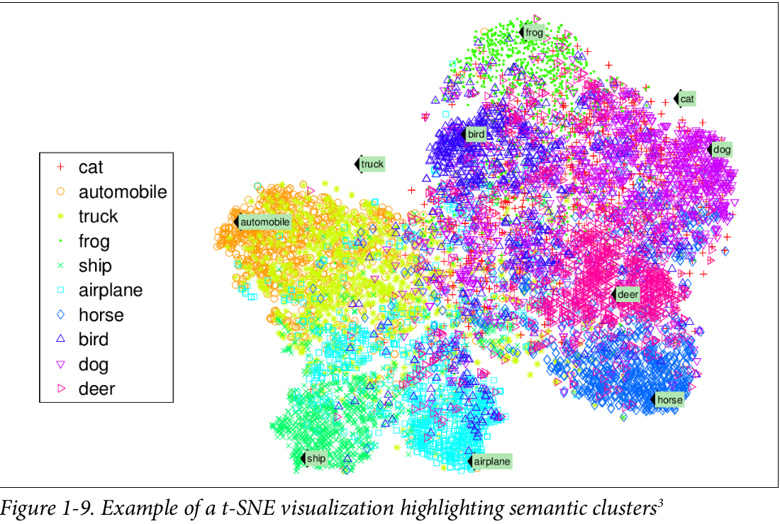
>Visualization algorithms are good examples. You feed them a lot of complex and unlabeled data and the output a 2D or 3D representation of your data that can easily plotted. So you can understand how the data is organized and perhaps identify unsuspected patterns.
> Dimensionality reduction, in which the goal is to simplify the data without losing too much information. One way to do this is to merge several correlated features into one. For example, a car’s mileage may be very correlated with its age, so the dimensionality reduction algorithm will merge then into one feature that represents the car’s wear and tear. This is called feature extraction.
It is often a good idea to try to reduce the dimension of your training data using a dimensionality reduction algorithm before you feed in to another Machine Learning algorithm. It will run much faster, the data will take up less disk and memory space, and some cases it may also perform better.
> Anomaly detection, for example detecting unusual credit card transactions to prevent fraud, catching manufacturing defects, or automatically removing outliers from a dataset before feeding it to another learning algorithm.
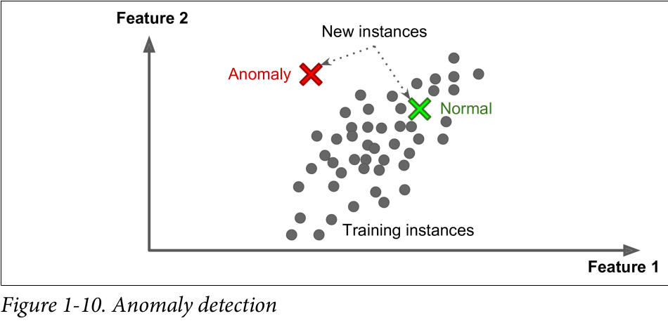

- What type of Machine Learning algorithm would you use to allow a robot to walk in various unknown terrains?
I would use Reinforcement Learning but for that moment we are not going to learn more about that topic.
- What type of algorithm would you use to segment your customers into multiple groups?
I would use the unsupervised Machine Learning algorithm Clustering.
- Would you frame the problem of spam detection as a supervised learning problem or an unsupervised learning problem?
I frame the problem of spam detection as supervised learning because we feed the algorithm with labeled data and we want to classifier an email as spam or ham. For that reason we use the classification method to do this task.
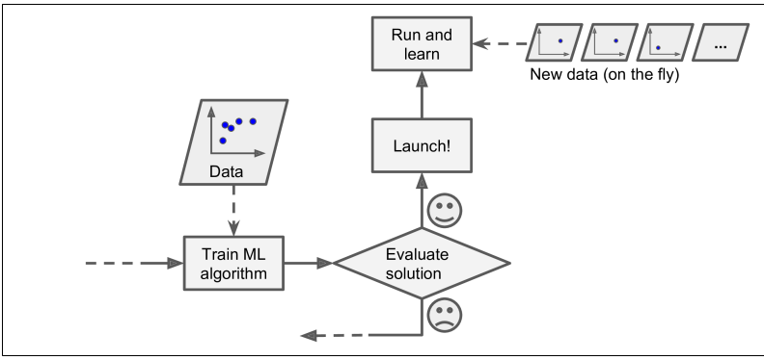
- What is an online learning system?
It’s a system you train incrementally by feeding it data instances sequentially, either individually or by small groups called mini-batches. Each learning step is cheap and fast, so the system can learn about new data on the fly.
You do not confuse the meaning of online learning with the word online reefering to the internet, think of it as incremental learning.
- What is out-of-core learning?
Online learning algorithms can also be used to train systems on huge dataset that cannot fit in one machine’s main memory. The algorithm loads part of the data, runs a training step on that data, and repeats the process until it has run on all of the data.
- What type of learning algorithm relies on a similarity measure to make predictions?
The Instance-based learning.
- What is the difference between a model parameter and a learning algorithm’s hyperparameter?
The model parameters are those that we could use to perform our model and that make the model fit best to the data.
The hyperparameter are those that we use to create the model. It is a parameter of a learning algorithm.
- What do model-based learning algorithms search for? What is the most common strategy they use to succeed? How do they make predictions?
The model-based learning algorithms search for generalize from a set of example.
The most common strategy is to build a model of these examples and then used it to make predictions.
We just input a new feature and the the model uses its parameters to predict the output.
- Can you name at least four of the main challenges in Machine Learning.
>Insufficient Quantity of Training Data.
>Non representative Training Data.
>Poor-Quality Data.
>Irrelevant Features.
>Over-fitting the Training Data.
>Under-fitting the Training Data.
- If your model performs great on the training data but generalizes poorly to new instances, what is happening? Can you name three possible solutions?
The problem could be the training data is over-fitting or you just adapted the model and hyperparameters to produce the best model for that particular training set. This means that the model is unlikely to perform as well on new data.
- What is a test set and why would you want to use it?
The test set is reasonable part of the entire data set and we use it to test our model perform and measure its accuracy.

