Bayesian analysis of the species-specific lengthening of the growing season in two European countries and the influence of an insect pest

Annette Menzel^{1*}, Nicole Estrella¹, Werner Heitland², Andreja Susnik³, Christoph Schleip¹, Volker Dose⁴

¹ Chair of Ecoclimatology, Technical University Munich, Am Hochanger 13, D-85354 Freising, Germany
² Chair of Animal Ecology, Technical University Munich, Am Hochanger 13, D-85354 Freising, Germany
³ Environmental Agency of the Republic of Slovenia, Agrometeorological Department, Vojkova 1b, 1001 Ljubljana, Slovenia
⁴ Max-Planck-Institut für Plasmaphysik, Boltzmannstrasse 2, D-85748 Garching, Germany

* Corresponding author PD Dr. Annette Menzel
Department of Ecology
Technical University Munich
Am Hochanger 13
85 354 Freising, Germany

Phone: (+49) 8161 714743
Fax: (+49) 8161 714753
Email: menzel@forst.tu-muenchen.de
Date of receipt: September 26, 2006
Key words: growing season; global warming; phenology; deciduous broad-leaved species; Cameraria ohridella; Bayes; temperature
Abstract
A recent lengthening of the growing season in mid and higher latitudes of the northern hemisphere is reported as a clear indicator for climate change impacts. We study for Germany (1951-2003) and Slovenia (1961-2004) whether changes in the start, end, and length of the growing season differ among four deciduous broad-leaved tree species and countries, how they are related to temperature changes and which might be the confounding effects of an insect attack. The functional behaviours of the phenological and climatological time series and their trends are not analysed by linear regressions, but by a new Bayesian approach taking into account different models for the functional description (one change-point, linear, constant).
We find advanced leaf unfolding in both countries with equal species order (oak > horse chestnut, beech, and birch). However, this advance is non linear over time and more expressed in Germany with clear change-points in the late 1970s, followed by marked advances after these dates (on average 3.6 days decade⁻¹ in the 2000s). In Slovenia, we find a more gradual advance of onset dates (on average 0.8 days decade⁻¹ in the 2000s). Leaf colouring of birch, beech, and oak is slightly delayed in the last 3 decades, especially in Germany, however with no clear functional behaviour. Abrupt changes in leaf colouring dates of horse chestnut with nowadays advancing onset dates can be linked across countries to damages by a newly emerging pest (C. ohridella). The lengthening of the growing season, more distinct in Germany than in Slovenia (on average 4.2 and 1.0 days decade⁻¹ in the 2000s, respectively), exhibits the same species order in both countries (oak > birch > beech). Damage by horse chestnut leaf-miner leads to lesser lengthening (Germany) and drastic shortening (Slovenia) of the horse chestnut growing season (-12 days decade⁻¹ in the 2000s). Advancing spring leaf unfolding and lengthening of the growing season of oak, beech and birch are highly related to increasing March temperatures in both countries. Only advancing beech and oak leaf unfolding in Germany, which are generally observed later in the year than the other two species, are better correlated with April temperatures, which comparably exhibit marked change-points end of the 1970s.
Introduction

Since the Third Assessment Report of the Intergovernmental Panel on Climate Change (IPCC 2001), there is increasing evidence of a coherent signal of climate change across systems and sectors, especially in terrestrial ecosystems (see reviews by Sparks & Menzel 2002, Walther et al. 2002, Parmesan & Yohe 2003, Root et al. 2003). A quite frequently reported phenomenon is the lengthening of the growing season in mid and higher latitudes of the northern hemisphere, revealed by analyses of time series of remote sensed data, e.g. AVHRR NDVI data (Myneni et al. 1997, Zhou et al. 2001), of atmospheric CO₂-concentrations (Keeling et al. 1996), of the Bowen ratio (e.g. Fitzjarrald et al. 2001) and of phenological observations (e.g. Defila & Clot 2005, Menzel & Fabian 1999). However, even the simple question whether this lengthening is mostly due to spring advance, autumn delay or both is difficult to answer.
For example, in Japan, the lengthening of the growing season of Gingko biloba by 2.6 days decade⁻¹ is predominantly caused by a later leaf fall (Matsumoto et al. 2003). In Germany, the observed expansion of broad-leaved tree species’ growing season is more due to advancing leaf unfolding, less due to later leaf colouring, whereas in other European countries these effects may be alike (Menzel et al. 2006). Variations in the lengthening of the growing season across countries may be due to differences in regional warming, due to varying time periods analysed or due to different definitions of start and end of the growing season.

Satellite data and CO₂-measures provide species and regional averaged information; by contrast, phenological observations are species- and site-specific. So far, there is some evidence that the lengthening of the growing season differs across species. For example, in Central Europe, European Beech (Fagus sylvatica L.) experiences smaller advances in leaf unfolding (Menzel et al. 2001, Kramer 1995) and exhibits a lower temperature response (e.g. Menzel et al. 2006). Another likely disturbance, which has to be taken into account, is a species-specific insect pest, the horse chestnut leaf-miner Cameraria ohridella (Lep., Gracillariidae), causing premature defoliation on white flowering horse chestnut (Aesculus hippocastanum L.) (Salleo et al. 2003). As the damage to leaves can be mixed up with leaf colouring, observed leaf colouring dates may be disturbed by horse chestnut leaf-miner damage (Menzel 2003). After the first detection of the horse chestnut leaf-miner near Lake Ohrid in Macedonia in 1984 (Simova-Tosic & Filev 1985) and its description as new species in 1985 (Deschka & Dimic 1986), this species has expanded its area by about 50-100 km / year. Totally unexpected, C. ohridella appeared in Austria in 1989 in the region of Linz and rapidly spread east, north, and west so that, by 2000, it had colonised major parts of Central and Eastern Europe (Heitland & Freise 2001). It can now be observed as far north as in England (2002), Denmark, and Sweden (Heitland et al. 2005). Therefore, Germany and Slovenia are suitable countries to study to above mentioned questions, as their phenological networks both offer long-term records of four deciduous tree species, both being affected by the insect pest and allowing a comparison of phenological impacts under more Central European and Mediterranean climate.

In this paper, we study by Bayesian non-parametric function estimation for the two European countries, Germany and Slovenia, (1) whether changes in the length of the growing season are related to trends in leaf unfolding and / or leaf colouring dates, (2) which is the variation among different broad-leaved species, (3) which might be the confounding effects of an insect attack and (4) how these changes are related to recent temperature changes.
In contrast to traditional analyses of phenological changes by linear regression technique, we apply here the method of Bayesian non-parametric function estimation, which allows a comparison of models to describe the time series (e.g. change point, linear and constant model). Annual estimates of functional behaviour as well as rates of change (trends) with their respective variance can be given either for all model choices separately or averaged by the respective model probabilities.
Material and Methods

Phenological Data
Out of the phenological network data of the German (1951-2003) and the Slovenian meteorological service (1961-2004), we selected four deciduous tree species: horse chestnut (Aesculus hippocastanum L.), silver birch (Betula pendula L.), common oak (Quercus robur L.) and European beech (Fagus sylvatica L.). The length of the growing season was determined by (1) onset of leaf unfolding, defined as the stage when first leaf stalks are visible, and by (2) leaf colouring, defined as the date when 50% of all leaves (still at the tree or already fallen to the ground) show autumnal colouring. In both national networks, these phases have been recorded by volunteers interested in nature and few employees of the respective weather services, following similar observation rules and standards (DWD 1991, ARSO 2003), however the number of stations included in this study was higher for Germany (c. 1550 in 2003) than for Slovenia (12). The data have been collected and quality checked by the respective national weather services. For both countries, national mean annual onset dates were calculated. In Germany the data were restricted to altitudes below 700 m in order to exclude too late events; in Slovenia, only one station was situated above 700 m. Although station densities differ in both countries, the calculated national means may be representative for each country due to an enormous sample size in Germany and due to careful and spatially representative site selection in the Slovenian network. In order to study the spread of C. ohridella across the country, Germany was divided up into 3 latitudinal bands (south <50°N, middle 50-52.5°N, north >52.5°N).

Temperature Data
The temperature data set TYN CY 1.1, created by Mitchell et al. (2002) for Germany and Slovenia, was downloaded from the Tyndall Centre for Climate Change Research (www.cru.uae.ac.uk/~timm/climate/index.html). The data set comprises monthly mean temperatures from 1951 to 2000. For the Slovenian analysis, the temperature records were restricted to the 1961-2000 time period, comparable to the phenological data.

Methods
The Bayesian approach to analyse the functional behaviour of the phenological time series and their trends followed exactly the methodology introduced by Dose & Menzel (2004). Three different models were employed to describe the time series. The constant model represents the hypothesis of no change at all with a functional behaviour constant in time and associated zero rate of change. The linear model assumes a time-linear change of the observed phenomenon with associated constant rate of change. The change-point model allows for a time-varying trend. Its development starts from triangular functions, hence two linear segments, which match at particular change-point choices. The result of the Bayesian marginalization rule is a superposition of all possible triangular functions for the present data weighted by their respective change-point probability. An analogous procedure is applied to the trend estimation. The probabilities of the three models given time series data are calculated with Bayesian model theory as well. If none of the three models exhibits an overwhelming probability, then we eliminate the variable ‘model’ from the calculation by a further marginalization step, superposing the three answers for functional behaviour and trend weighted with the respective model probabilities. The latter averaging process does not modify the shape of the trend derived from the change-point model, but adds an offset due to the constant contribution from the linear model and a reduction of the amplitude by the amount of model probability obtained for the change-point model. These latter model averaged information for functional behaviour and trend is further used in our paper. Instead of significance levels, which are not provided by Bayesian statistics, we talk about a trend clearly different from zero, when the range of the annual trend ± variance does not include zero.
Results

Model probabilities and trends of leaf unfolding, leaf colouring and growing season

Table 1 summarises the model probabilities for each of the three models (one change-point model, linear, and constant model) and the trends with confidence ranges (variance) at the end of the time series. The respective model-averaged functional behaviours and the trends against year are displayed in Fig. 1. These results confirm that leaf unfolding in spring is generally advancing in the last 4 (Slovenia) to 5 (Germany) decades (Fig. 1, upper line). However, the Bayesian approach brings into light differences across species and countries.

In Germany, we find a strong preference for the change-point model to describe phenological spring (between 61% for birch and 98 % for oak) with maximum change-point probabilities in 1970 and 1979 (horse chestnut) and 1978/9 (birch, beech, oak). This means, a linear interpretation of the time series is by far not the best choice. The respective rates of change (trends) of the model-averaged functional behaviours underline that from the mid 1960s (horse chestnut, birch) and end of 1970s (beech, oak) onwards, the trends are negative and range between –0.30 (birch) and –0.46 (oak) days year⁻¹ in 2003. The confidence ranges are given by the variance and indicate that the trends are clearly different from zero.

In Slovenia, three of four leaf unfolding estimates seem to advance as well, however the negative trends reached in 2004 are not different from zero (Tab. 1). Similarly to Germany, oak displays the strongest trends and the highest preference for the change-point model among all species. For horse chestnut and birch, the linear model is almost as good or even better than the one change-point model. Beech leaf unfolding in Slovenia is delayed for 3 decades (1961-1990), although the rate of change declined; the negative advancing trend in the 2000s is not different from zero. A previous separate analysis of Slovenian data with linear regression method revealed that half of the stations had negative and half of them had positive trends; the development towards earlier onset dates was mainly observed in urban areas.

Leaf colouring trends in autumn (Fig. 1, middle row) are slightly positive for birch, beech and oak over the last three decades, indicating delayed leaf colouring over time. The trends reached in 2003/04 in Germany are different from zero (between 0.06 and 0.11 days year⁻¹), whereas the confidence ranges of the respective leaf colouring trends in Slovenia include zero (Tab. 1). For these three species, there is no clear preference for the change-point or linear model. The observations on the forth species seem to be affected by the horse chestnut leaf-miner, as in both countries, horse chestnut leaf colouring is advancing, in Slovenia very sharply from 1993 onwards (maximum change-point probability 0.17 in 1993, 99% probability of the change-point model) and in Germany more gradually (43% probability of the change-point model). Both advancing trends are clearly different from zero.

In Germany and Slovenia, the growing seasons for all but one species (horse chestnut in Slovenia) have been lengthened over the last 4 to 5 decades (Figure 1, bottom row). We observe for all four species stronger trends in Germany than in Slovenia, clearly positive in 2003 (between 0.20 and 0.50 days year⁻¹). It is quite obvious that the main effect for this lengthening is due to an earlier start, less to a later end of the growing season (Tab. 1). In Slovenia, the growing season for birch, beech and oak is lengthening, however only for oak, the trend achieved in 2004 is clearly different from zero (0.22 days year⁻¹). In both countries, the advancing observed leaf colouring dates of horse chestnut in autumn lead to species-specific differences in both countries. Whereas in Germany the growing season of horse chestnut is now the shortest one out of the four with smallest positive trends in 2003, we find in Slovenia an extreme shortening from the 1990s onwards, resulting in high trends (-1.20 days year⁻¹ in 2004).

The horse chestnut leaf-miner and observed leaf colouring dates

The leaf-miner Cameraria ohridella causes premature defoliation of Aesculus hippocastanum trees and heavily infested trees can be completely defoliated in September (Salleo et al. 2003). Thus, since the 1990s depending on the spread, observed leaf colouring dates of horse chestnut in the phenological networks may be disturbed by visible damages caused by this pest species, although this should not be the case. In Germany, leaf colouring is clearly defined as autumnal leaf colouring. Infested plant specimens, regardless by pathogens or diseases, should be discarded (DWD 1991). In this spirit, since 2000 the manager of the phenological network of the German Meteorological Service has continuously given the observers warnings against the horse chestnut leaf-miner (Ekko Bruns, DWD, personal communication). Similarly, in Slovenia observers were informed about the infection since 1996.
As the observed mean leaf colouring dates of horse chestnut in Slovenia seem to be decisive for the length of the growing season, we display the respective time series in Figure 2. In the upper panel, time series of observed leaf colouring dates and estimated functional behaviour both display a sharp alteration from 1990 onwards; the widening confidence margins originate from higher variability of the observed dates at the end of the time series. The advancing trends (Fig. 2, lower panel) are almost stable for the last 8 years with relative small uncertainty.
We tested whether the observed diverging results for horse chestnut, advancing leaf colouring dates in both countries, and in Slovenia even a shortening of the growing season, can be related to leaf damages by the horse chestnut leaf-miner. Therefore, we determined, by station and year, the differences between leaf colouring dates of oak and horst chestnut. These time spans were equally treated by Bayesian non-parametric function estimation (Fig. 3). We know that the horse chestnut leaf-miner entered Bavaria (Germany) in 1992 from Austria; spreading out west and north, it colonised major parts of Germany in only 7 years. In 1998, C. ohridella could be detected in two thirds of Germany (Heitland & Freise 2001). In Slovenia, C. ohridella was first mentioned in 1995 (Milevoj & Maček 1997), however the moths were probably introduced into Slovenia around one year earlier. In 1996, it was observed in Maribor, Ormož and Ljubljana; in 1997, it was already present almost all over Slovenia, and by the following year it spread throughout the country (Milevoj 2004). At the phenological stations, the pest was identified later from 1997 to 2002. Fig. 3 (middle row) mirrors this spread with rapidly increasing time spans between oak and horse chestnut leaf colouring from the end 1990s onwards. The maximum change-point probability for Slovenia is reached in 1998, equivalent to the reported observations of the moths. In Germany, the spread from south to north is not reflected in the change-point probabilities as their maxima occur earlier in the north and middle parts.
Temperature triggers of leaf unfolding, leaf colouring and growing season

Spring phenological changes and alteration of the length of the growing season are clear indicators of recent temperature changes (see Sparks and Menzel 2002, Menzel 2002). Table 2 provides the necessary information how spring / autumn phases and the length of the growing season are related to mean national monthly temperatures. March is the most decisive month for leaf unfolding in both countries with correlation coefficients up to –0.83. This means that for spring leaf unfolding between 49 and 69% of the common variance are explained by March temperatures. Solely beech and oak in Germany, with much later bud burst than birch and horse chestnut, exhibit higher correlations with April temperatures. The same pattern is true for the length of the growing season. Here, for the growing season of birch and horse chestnut, 38% of the common variance are explained by March temperatures, for beech and oak, between 35 and 46% are explained by April temperatures.
Leaf colouring in autumn of birch, beech and oak is mostly influenced by September temperatures with warmer late summer leading to later leaf colouring. In this case, only the results for Germany are highly significant ranging between r=0.54 and 0.63 (R²= 29% to 40%). For horse chestnut in both countries, however, we reveal a different triggering factor: Warm May (Germany) and June (Slovenia) leads to earlier leaf colouring. This finding might be related to stages in the annual development of the horse chestnut leaf-miner, finding better conditions in those years.

We examined whether the mean temperature records of the months identified above (Tab. 2) exhibited similar model probabilities (constant temperature, linear change or change-point model) in the Bayesian analysis (Tab. 3). Except for September temperature in both countries, the constant model is the by far least likely one. Linear and change-point model reveal similar probabilities for March (Germany, Slovenia) and May (Germany) temperature. In contrast, April temperature in Germany and April and June temperature in Slovenia can be better described by the change-point model indicating discontinuous changes over the last decades. All trends in 2000 indicate warming, the values for April and September (Germany) and June and September (Slovenia) temperature are clearly different from zero.
Discussion

Different mean dates of leaf unfolding, leaf colouring and length of the growing season across countries mirror the main climatic differences between Slovenia and Germany. Slovenia’s climate can be characterised as Mediterranean on the coast and continental with warm dry to hot summers and cold winters in the plateaus and valleys to the east. In Germany, we find moderately cool or cold, also wet winters and fairly mild wet summers, only occasionally dry. Leaf unfolding of the four species is on average c.8 days earlier, leaf colouring c.10 days later and the growing season c.18 days longer in Slovenia than in Germany (see Fig. 1). We know that leaf unfolding is clearly related to spring temperatures, e.g. for Germany a temperature response of c.–4.5 days °C⁻¹ for horse chestnut leaf unfolding is reported (Menzel et al. 2005, Menzel et al. 2006).

However, these differences in phenological means across countries are not stable in time. For birch, beech and oak, we find a stronger advance of leaf unfolding in Germany than in Slovenia in the last decades: The average trend 2003 of the four deciduous tree species in Germany amounts to –0.36 days / year in contrast to –0.08 days /year in Slovenia . As leaf colouring is only slightly delayed in both countries, this change in spring tends to converge the length of the growing season in both countries. These findings confirm previous results by the traditional linear regression method. Menzel et al. (2006) have found a stronger general spring advance and a stronger advance of leaf unfolding of beech in Germany than in Slovenia, related to a higher spring warming.

A similar ranking across species of the trends achieved in 2003/04 is found in both countries: In spring, oak reacts strongest, followed by horse chestnut, beech and birch. Changes in leaf colouring are most similar for all countries and species, except horse chestnut. Subsequently, the lengthening of the growing season is most expressed for oak, followed by birch, beech and finally horse chestnut, and this ranking is again equal in both countries. We conclude that there is some preliminary evidence that the rank order of responses and trends of different species might be similar across countries. However, more studies have to verify this.

Our study clearly detects an influence of the damage caused by the horse chestnut leaf-miner on leaf colouring dates in Slovenia and Germany. Our results demonstrate that first reported occurrence dates of the pest are generally associated with years of maximum change-point probability of the Bayesian analysis. However, we cannot relate these change-points in the Bayesian analysis of recorded leaf colouring dates to the known spatial spread of the pest. Probably this analysis in latitudinal bands is disturbed by a none-exclusively directional spread, as Gilbert et al. (2004) reported that C. ohridella is generally observed first in highly populated locations, due to anthropogenous transfer by cars, trucks or trains, before colonizing the countryside.Other known effects of horse chestnut leaf-miner include reduced seed size and weight of heavily damaged trees (Thalmann et al. 2003) and sometimes a second flowering in early autumn. Second flowering was reported e.g. in September 2000 in Munich and Frankfurt, probably as a reaction to a warm and dry summer 2000 (Heitland & Freise 2001). The phenomenon of second flowering of horse chestnut has been observed in recent years in Slovenia, too. Second flowering can equally be induced by climatic drought stress in hot and dry years or damage caused by the pathogen Guignardia aesculi. However, phenological observations in these national networks are not able to resolve the amount of second flowering in autumn, because only regular spring flowering is observed and kept in the data bases. Our study demonstrates that in special cases, phenological onset dates may be affected by biological factors, such as pest and diseases, and a careful interpretation of the reported results is necessary.

Our Bayesian analysis also allows to interpret major difference between leaf unfolding of birch / horse chestnut and beech / oak in Germany. The change-point model is highly preferred in the case of beech and oak (96% and 98% model probability, Tab.1). The highest change-point probabilities are always identified in 1978/9, however the values are higher for beech and oak (maximum of 8.1 and 10.1 %, respectively) than for birch and horse chestnut (3.8 and 3.5 %). The feature can be explained by Tab. 2, 3 and Fig. 3: Birch and horse chestnut leaf unfolding are mainly triggered by March temperatures, which are more gradually increasing in the last decades, leading to a more smoothly advancing leaf unfolding of those species. Beech and oak leaf unfolding, occurring on average not in April but beginning of May, are predominantly triggered by April temperatures. And this monthly mean temperature exhibits cooling from 1951 till end of the 1970s and a sharp warming from then onwards (see Fig. 3). This trait is mirrored in the respective phenological data series, underlining that phenology is an integrating bio-indicator of climate change. However, species-specific differences have to be taken into account. Depending on the mean onset dates, time series of these observations reflect temperature changes of different periods in spring.
References
ARSO (2003) Navodila za fenološka opazovanja. 51 pp
Defila C, Clot B (2005) Phytophenological trends in the Swiss Alps, 1951–2002. Meteorologische Zeitschrift 14 (2):191-196
Deschka G, Dimic N (1986) Cameraria ohridella n. sp. aus Mazedonien, Jugoslawien (Lepidoptera, Lithocelletidae). Acta Ent. Jugosl. 22/1:11-23
Dose V, Menzel A (2004) Bayesian analysis of climate change impacts in phenology. Global Change Biology 10:259-272
DWD (1991) Anleitung für die phänologischen Beobachter des Deutschen Wetterdienstes. Vorschriften und Betriebsunterlagen Nr. 17. Deutscher Wetterdienst, Offenbach am Main.
Fitzjarrald DR, Acevedo OC, Moore KE (2001) Climatic consequences of leaf presence in the eastern United States. Journal of Climate 14:598–613
Gilbert M, Grégoire JC, Freise JF, Heitland W (2004) Long-distance dispersal and human population density allow the prediction of invasive patterns in the horse chestnut leafminer Cameraria ohridella. Journal of Animal Ecology 73:459-468
Heitland W, Freise J (2001) Verbreitung der Roßkastanien-Miniermotte, Cameraria ohridella (Lep., Gracillariidae) in Deutschland. [Distribution of the horse-chestnut leaf miner, Cameraria ohridella (Lep., Gracillariidae) in Germany]. Mitt. Dtsch. Ges. Allg. Angew. Ent. 13:131-134
Heitland W, Freise JF, Sturm A, Lenz N (2005) Die Rosskastanien-Miniermotte Cameraria ohridella DESCHKA & DIMIC, 1986 (Lepidoptera, Gracillariidae): Gründe ihres Erfolgs als Blattschädling an der weiß blühenden Gewöhnlichen Rosskastanie Aesculus hippocastanum (Hippocastanaceae) und Möglichkeiten zur Bekämpfung. Entomologie heute 17:157-172
IPCC (2001) McCarthy JJ, Canziani OF, Leary NA, Dokken DJ, White KS (Eds) Climate Change 2001: Impacts, Adaptation & Vulnerability. Contribution of Working Group II to the Third Assessment Report of the Intergovernmental Panel on Climate Change, Cambridge, Cambridge University Press, 1000 pp
Keeling CD, Chin JFS, Whorf TP (1996) Increased activity of northern vegetation inferred from atmospheric CO2 measurements. Nature 382:146–149
Kramer K (1995) Phenotypic plasticity of the phenology of seven European tree species in relation to climatic warming. Plant, Cell and Environment 18:93-104
Matsumoto K, Ohta T, Irasawa M, Nakamura T (2003) Climate change and extension of the Ginkgo biloba L. growing season in Japan. Global Change Biology 9:1634-1642
Menzel A (2003) Plant phenological anomalies in Germany and their relation to air temperature and NAO. Climatic Change 57 (3):243-263
Menzel A, Fabian P (1999) Growing season extended in Europe. Nature 397:659
Menzel A, Estrella N, Fabian P (2001) Spatial and temporal variability of the phenological seasons in Germany from 1951-1996. Global Change Biology 7:657-666
Menzel A, Estrella N, Testka A (2005) Temperature response rates from long-term phenological records. Climate Research 30:21-28
Menzel A, Sparks TH, Estrella N, Koch E et al (2006) European phenological response to climate change matches the warming pattern. Global Change Biology 12:1969-1976
Milevoj L (2004) The occurrence of some pests and diseases on horse chestnut, plane tree and Indian bean tree in urban areas of Slovenia. Acta agriculturae slovenica 83(2):297–300
Milevoj L, Maček J (1997) Rosskastanien-Miniermotte (Cameraria ohridella) in Slowenien. Nachrichtenblatt Deutscher Pflanzenschutzdienst 49 (1):14-15
Mitchell TD, Hulme M, New M (2002) Climate data for political areas. Area 34:109-112
Myneni RB, Keeling CD, Tucker CJ, Asrar G, Nemani RR (1997) Increased plant growth in the northern high latitudes from 1981-1991. Nature 386:698-702
Parmesan C, Yohe G (2003) A globally coherent fingerprint of climate change impacts across natural systems. Nature 421:37-42
Root TL, Price JT, Hall KR, Schneider SH, Rosenzweig C, Pounds JA (2003) Fingerprints of global warming on wild animals and plants. Nature 421:57-60
Salleo S, Nardini A, Raimondo F, Assunta Lo Gullo M, Pace F, Giacomich P (2003) Effects of defoliation caused by the leaf miner Cameraria ohridella on wood production and efficiency in Aesculus hippocastanum growing in north-eastern Italy. Trees 17:367-375
Simova-Tosic D, Filov S (1985) Contribution to the horse chestnut miner. Zastita bilja 36:235-239 (in Serbocroat)
Sparks TH, Menzel A (2002) Observed changes in seasons: an overview. International Journal of Climatology 22:1715-1725
Thalmann S, Freise J, Heitland W, Bacher S (2003) Effects of defoliation by horse chestnut leafminer (Cameraria ohridella) on reproduction in Aesculus hippocastanum. Trees 17: 383-388
Walther GR, Post E, Convey P, Menzel A, Parmesan C, Beebee TCJ, Fromentin JM, Hoegh-Guldberg O, Bairlein F (2002) Ecological responses to recent climate change. Nature 416:389-395
Zhou LM, Tucker CJ, Kaufmann RK, Slayback D, Shabanov NV, Myneni RB (2001) Variations in northern vegetation activity inferred from satellite data of vegetation index during 1981 to 1999. J. Geophy. Res. 106 (D17):20069-20083

Acknowledgements
Phenological data were collected during the COST725 initiative ‘Establishing a European Phenological Data Platform for Climatological Applications’ (www.cost725.org).

Table 1
Results of Bayesian non-parametric function estimation for four deciduous broad-leaved tree species (Aesculus hippocastanum L., Betula pendula L., Quercus robur L., Fagus sylvatica L.) and 3 indicators of the growing season (national means of leaf unfolding, leaf colouring, length) in Germany (1951-2003) and Slovenia (1961-2004). °4 years missing, *9 years missing. The trend is given with the respective variance.
 |  |  | Model probabilities |  |  | Trend
 |  |  | change-point | linear | constant | [days / year in 2003 / 04]
Germany (1951-2003) | Leaf unfolding | H. Chestnut | 0.74 | 0.25 | 0.01 | -0.35 ± 0.11
Germany (1951-2003) | Leaf unfolding | Birch | 0.61 | 0.36 | 0.03 | -0.30 ± 0.12
Germany (1951-2003) | Leaf unfolding | Beech | 0.96 | 0.03 | 0.01 | -0.33 ± 0.03
Germany (1951-2003) | Leaf unfolding | Oak | 0.98 | 0.02 | 0.00 | -0.46 ± 0.03
Germany (1951-2003) | Leaf colouring | H. Chestnut | 0.43 | 0.36 | 0.21 | -0.13 ± 0.07
Germany (1951-2003) | Leaf colouring | Birch | 0.43 | 0.39 | 0.18 | 0.11 ± 0.06
Germany (1951-2003) | Leaf colouring | Beech | 0.42 | 0.43 | 0.15 | 0.06 ± 0.04
Germany (1951-2003) | Leaf colouring | Oak | 0.44 | 0.55 | 0.01 | 0.09 ± 0.03
Germany (1951-2003) | Growing season | H. Chestnut | 0.58 | 0.34 | 0.08 | 0.20 ± 0.09
Germany (1951-2003) | Growing season | Birch | 0.73 | 0.27 | 0.00 | 0.42 ± 0.15
Germany (1951-2003) | Growing season | Beech | 0.78 | 0.21 | 0.01 | 0.36 ± 0.12
Germany (1951-2003) | Growing season | Oak | 0.91 | 0.09 | 0.00 | 0.50 ± 0.07
Slovenia (1961-2004) | Leaf unfolding | H. Chestnut | 0.40 | 0.37 | 0.23 | -0.06 ± 0.12
Slovenia (1961-2004) | Leaf unfolding | Birch | 0.38 | 0.46 | 0.16 | -0.03 ± 0.37
Slovenia (1961-2004) | Leaf unfolding | Beech* | 0.47 | 0.28 | 0.25 | -0.02 ± 0.06
Slovenia (1961-2004) | Leaf unfolding | Oak | 0.68 | 0.28 | 0.04 | -0.19 ± 0.09
Slovenia (1961-2004) | Leaf colouring | H. Chestnut | 0.99 | 0.01 | 0.00 | -1.39 ± 0.24
Slovenia (1961-2004) | Leaf colouring | Birch | 0.52 | 0.23 | 0.25 | -0.01 ± 0.03
Slovenia (1961-2004) | Leaf colouring | Beech* | 0.46 | 0.34 | 0.20 | 0.01 ± 0.06
Slovenia (1961-2004) | Leaf colouring | Oak° | 0.43 | 0.45 | 0.12 | 0.05 ± 0.07
Slovenia (1961-2004) | Growing season | H. Chestnut | 0.88 | 0.12 | 0.00 | -1.20 ± 0.58
Slovenia (1961-2004) | Growing season | Birch | 0.44 | 0.48 | 0.08 | 0.05 ± 0.32
Slovenia (1961-2004) | Growing season | Beech* | 0.27 | 0.31 | 0.42 | 0.02 ± 0.09
Slovenia (1961-2004) | Growing season | Oak° | 0.55 | 0.44 | 0.01 | 0.22 ± 0.15
 | Leaf colouring Oak-Horse Chestnut | Slovenia° | 0.96 | 0.04 | 0.00 | 2.67 ± 1.72
 | Leaf colouring Oak-Horse Chestnut | Germany-south | 0.93 | 0.07 | 0.00 | 0.55 ± 0.06
 | Leaf colouring Oak-Horse Chestnut | Germany-middle | 0.93 | 0.07 | 0.00 | 0.52 ± 0.06
 | Leaf colouring Oak-Horse Chestnut | Germany-north | 0.84 | 0.16 | 0.00 | 0.43 ± 0.07

Table 2
Pearsons correlation coefficients (r) of four deciduous broad-leaved tree species (Aesculus hippocastanum L., Betula pendula L., Quercus robur L., Fagus sylvatica L.) and monthly mean temperatures in Germany (G, 1951-2000) and Slovenia (S, 1961-2000) (only values of the best month are given). Bold significant <0.0001, normal <0.001, italics <0.08. °4 years missing autumnal observations, *9 years missing
 |  |  | Horse chestnut |  | Birch |  | Beech* |  | Oak°
 | C | n | month | r | month | r | month | r | month | r
Spring | G | 50 | March | -0.71 | March | -0.70 | April | -0.79 | April | -0.83
Spring | S | 40 | March | -0.79 | March | -0.78 | March | -0.33 | March | -0.50
Autumn | G | 50 | May | -0.61 | Sep. | 0.54 | Sep. | 0.63 | Sep. | 0.59
Autumn | S | 40 | June | -0.42 | no month sign. |  | Sep. | 0.53 | Sep. | 0.39
Growing  Season | G | 50 | March | 0.62 | March | 0.62 | April | 0.59 | April | 0.68
Growing  Season | S | 40 | March | 0.44 | March | 0.70 | March | 0.59 | March | 0.50

Table 3

Results of Bayesian non-parametric function estimation for selected mean monthly temperatures (see Table 2) in Germany (1951-2000) and Slovenia (1961-2000). The trend is given with the respective variance.

 |  | Model probabilities |  |  | Trend
 |  | change-point | linear | constant | [°C / year in 2000]
Germany (1951-2000) | March | 0.41 | 0.49 | 0.10 | 0.063 ± 0.094
Germany (1951-2000) | April | 0.94 | 0.03 | 0.03 | 0.144 ± 0.062
Germany (1951-2000) | May | 0.55 | 0.40 | 0.05 | 0.156 ± 0.180
Germany (1951-2000) | September | 0.34 | 0.26 | 0.40 | 0.077 ± 0.066
Slovenia (1961-2000) | March | 0.39 | 0.50 | 0.11 | 0.074 ± 0.130
Slovenia (1961-2000) | April | 0.81 | 0.11 | 0.08 | 0.487 ± 0.601
Slovenia (1961-2000) | June | 0.97 | 0.02 | 0.01 | 0.207 ± 0.039
Slovenia (1961-2000) | September | 0.41 | 0.33 | 0.26 | 0.033 ± 0.033

Figure captions

Figure 1
Bayesian non-parametric function estimates for four deciduous tree species in Germany (1951-2003) (black) and Slovenia (1961-2004) (red). Left column: onset dates [day of the year], right column: trends [day year⁻¹], upper line: spring leaf unfolding [day of the year], middle: autumnal leaf colouring [day of the year], bottom: length of the vegetation period [day]

Figure 2
Bayesian non-parametric function estimates for horse chestnut leaf colouring dates in Slovenia (1961-2004). Upper line: onset dates [day of the year], red: observations, black: average functional behaviour, grey: confidence range (±variance), bottom line: trends [day year⁻¹], grey: confidence range (±variance)

Figure 3
Bayesian non-parametric function estimates for the time span between horse chestnut and oak leaf colouring dates in Germany (1951-2003) (black: south <50°N, grey: middle 50°-52.5°N, light grey: north >52.5°N) and Slovenia (1961-2004) (red). Upper line: time span [days], middle: trends [days year⁻¹], bottom: probability of the change-point

Figure 4
Bayesian non-parametric function estimates for spring leaf unfolding of four deciduous tree species in Germany (1951-2003) [day of the year] (black, left y-axis) and relevant mean national monthly temperatures (1951-2000) [°C] (right y-axis).
Figure 1
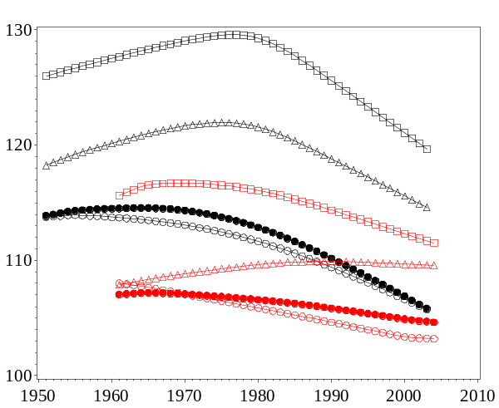 | 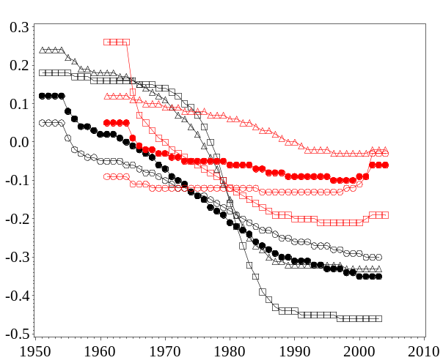
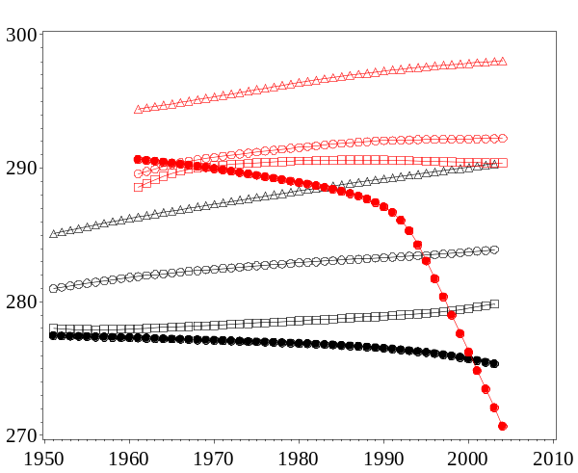 | 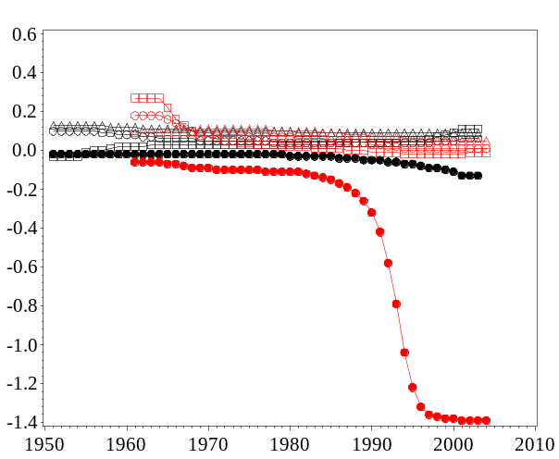
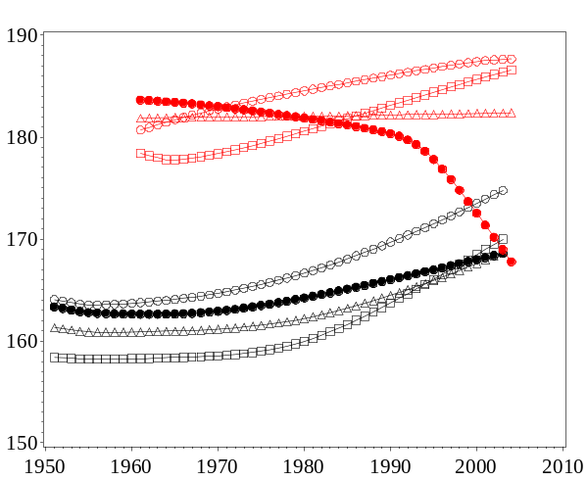 | 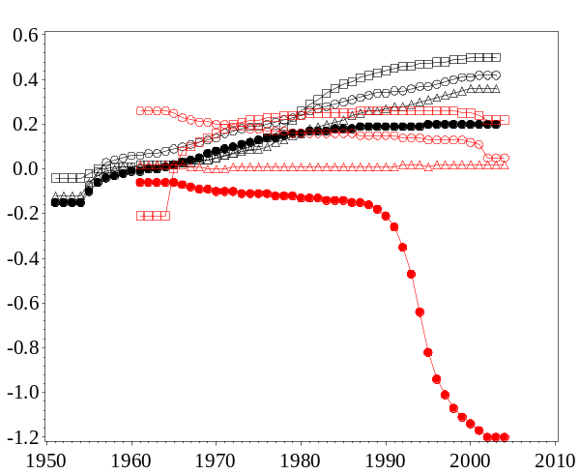

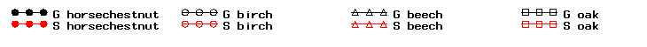

Figure 2
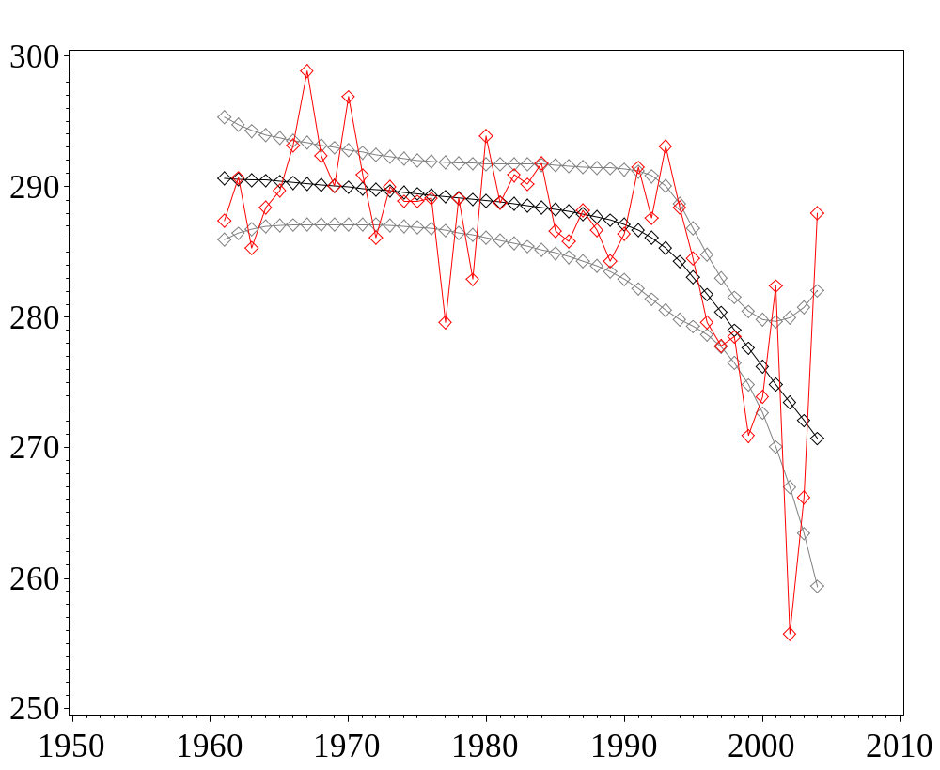

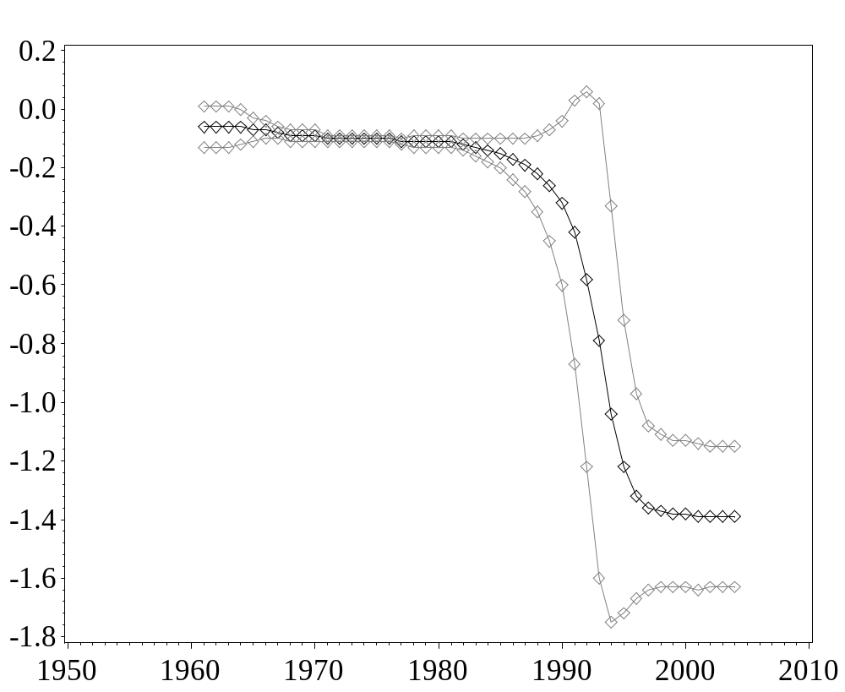
Figure 3
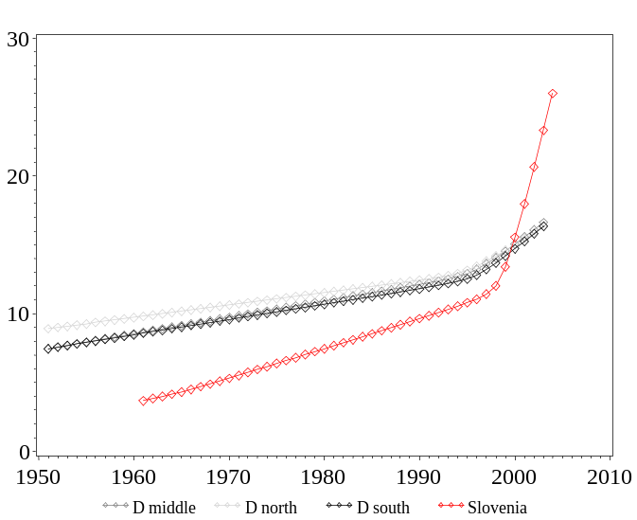
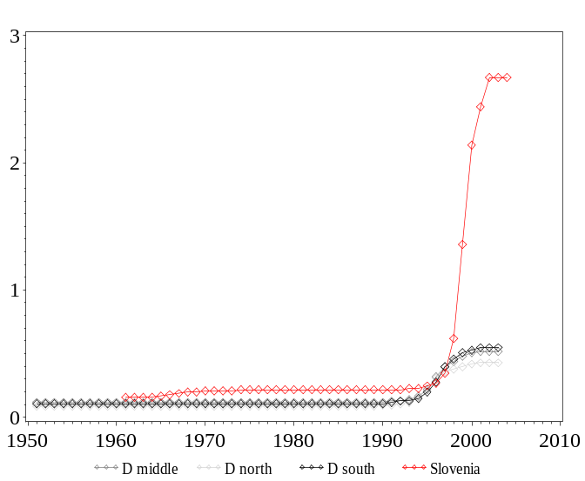
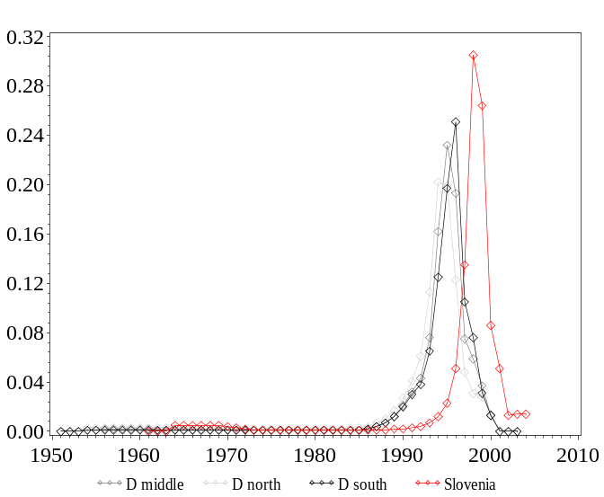

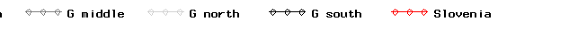
Figure 4

