Audio Dynamic Range Control (DRC) track support
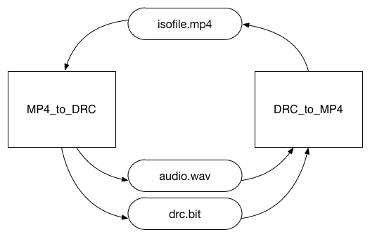
Figure 1 - DRC file format tools

Description
The following atoms have been added to the file format reference software in order to support the new separate tools for drc tracks: LoudnessAtom ‘ludt’, LoudnessBaseAtom ‘tlou’ or ‘alou’, ChannelLayoutAtom ‘chnl’ and DownMixInstructionsAtom ‘dmix’. The tools provided by this contribution allow adding and reading DRC data from an ISO media based file. The first tool “DRC_to_MP4” takes a WAV file with 16bit signed PCM audio and a DRC bitstream as an input. The output is a .mp4 file, containing an audio track, which contains the raw audio samples and the static DRC data atoms. The .mp4 file also contains a ‘unid’ metadata track, which contains the dynamic DRC data. The second tool “MP4_to_DRC” takes a .mp4 file as an input. It generates two output files: a WAV audio file and a DRC bit stream file.

Supported Functionality
There are two command line tools available. Both use command line parameters to control their behavior. Both can provide detailed logging output, which can be controlled by a debugging level parameter.

DRC_to_MP4
This tool allows putting DRC data inside an ISO based media file. There are two input files needed for this tool. The first input is a WAV audio file. The audio must be 16 bit signed PCM little endian. The second input file is a DRC bitstream. The DRC bitstream can be created with the drcToolEncoder from the MPEG-D reference software (http://wg11.sc29.org/svn/repos/MPEG-D/Part04-Dynamic_Range_Control). The output is a ISO based media file, containing two tracks. The first track is an audio track, containing the static DRC data. The second one is a metadata track of the type ‘unid’, containing the dynamic DRC data, drcGains.
Parameter | Description
-h | Prints a description of the parameters
-a AudioInputFile | WAV Audio Inputfile (mandatory)
-b DrcInputFile | DRC Bitstream Inputfile (mandatory)
-o OutputFile | Output path of the .mp4 file (mandatory)
-d DebugLevel | 0 = No Logging, 1 = Error, 2 = Warning, 3 = Info (Default), 4 = Debug, 5 = Trace
Table 1 - Parameters for DRC_to_MP4
Example:
DRC_to_MP4 -a audioInput.wav -b drcInputBitStream.bit -o output.mp4 -d 3

MP4_to_DRC
This tool reverts the function of DRC_to_MP4. It takes an ISO media based file as input and extracts the audio and DRC data. There must be two tracks inside the input file: the audio track with 16 bit signed PCM little endian (‘sowt’) and the DRC metadata track (‘unid’). The output of the MP4_to_DRC tool consists of two files. These files have the same characteristics and information as the input files of DRC_to_MP4. Although it is possible that there are multiple DRC metadata tracks, this tool only supports a single DRC metadata track and therefore needs a parameter to determine the location of the DRC metadata track.
Parameter | Description
-h | Prints a description of the parameters
-i InputFile | ISO media based input file (mandatory)
-a AudioOutputFile | WAV Audio Outputfile (mandatory)
-b DrcOutputFile | DRC Bitstream Outputfile (mandatory)
-t AudioTrackNumber | Used for selecting audio track in .mp4 file (default = 1)
-t DrcTrackNumber | Used for selecting drc track in .mp4 file (default = 2)
-d DebugLevel | 0 = No Logging, 1 = Error, 2 = Warning, 3 = Info (Default), 4 = Debug, 5 = Trace
Table 2 - Parameters for MP4_to_DRC
Example:
MP4_to_DRC -i inputFile.mp4 -a wavOutputFile.wav -b drcOutputBitStream.bit -d 3

Building and using the tool
The two tools are strongly coupled with the MPEG-D reference software (http://wg11.sc29.org/svn/repos/MPEG-D/Part04-Dynamic_Range_Control). To build MP4_to_DRC and DRC_to_MP4 download the MPEG-D reference software and build the drcToolDecoder and the drcToolEncoder.
The DRC file format tools can be found at http://wg11.sc29.org/svn/repos/MPEG-04/Part12-ISO_Base_Media_File_Format/trunk/IsoLib/drc_in_isom. In order to build to software, link or copy the built MPEG-D reference software in the same folder as the drc_in_isom folder.
The libisomediafile also needs to be built and in the same folder as the drc_in_isom folder. You can find it here: http://wg11.sc29.org/svn/repos/MPEG-04/Part12-ISO_Base_Media_File_Format/trunk/IsoLib/libisomediafile.
Basically copy or link the following svn directories in the same folder. Build the MPEG-D reference software’s drcToolDecoder and drcToolEncoder. Build the libisomediafile. The last step is to build DRC_to_MP4 and MP4_to_DRC.
- http://wg11.sc29.org/svn/repos/MPEG-D/Part04-Dynamic_Range_Control
- http://wg11.sc29.org/svn/repos/MPEG-04/Part12-ISO_Base_Media_File_Format/trunk/IsoLib/drc_in_isom
- http://wg11.sc29.org/svn/repos/MPEG-04/Part12-ISO_Base_Media_File_Format/trunk/IsoLib/libisomediafile

