Still Image File Format
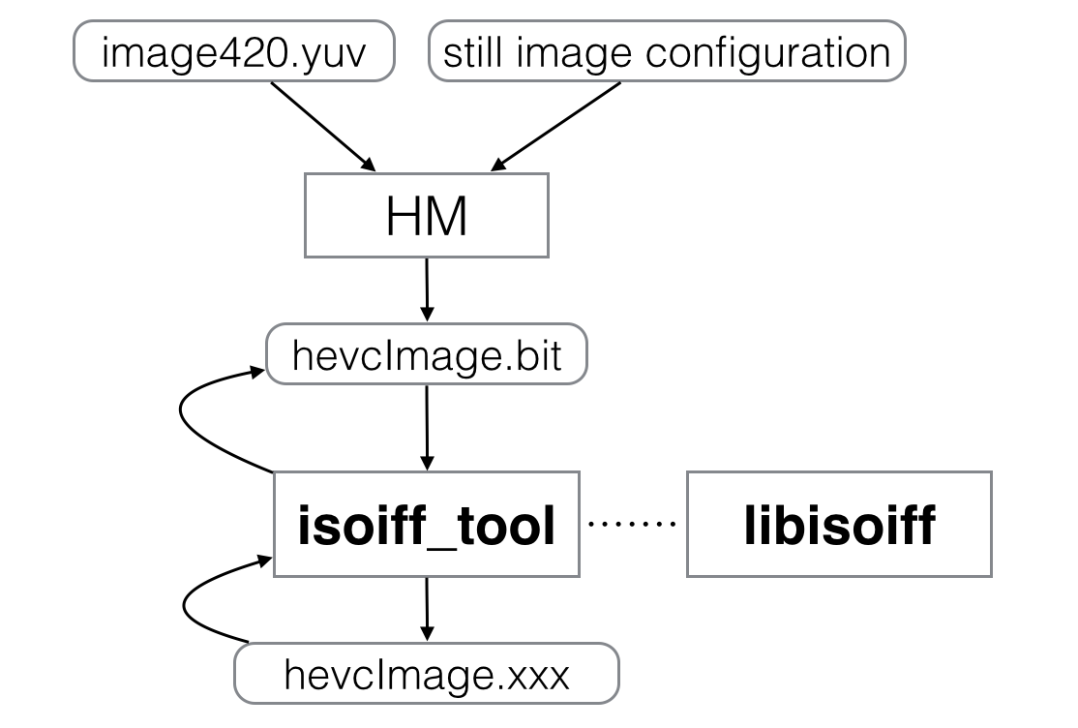
Figure 1 – Still Image File Format Tools

Description
The isoiff_tool is the reference software for the Still Image File Format. It is able to use bitstreams created by HM (HEVC reference software) with the main-still-image profile. Isoiff_tool uses libisoiff, which has been implemented to create general image collections, conforming to the Still Image File format. Libisoiff uses libisomediafile to read and write ISO Base Media files. Isoiff_tool and libisoiff are only able to create image collections, which means that most of the output files consist of the Meta atom. Image sequences are similar to movies and consist of track atoms and are not supported by libisoiff and isoiff_tool.

Supported Functionality
The contribution consists of the library libisoiff and the command line tool isoiff_tool. The library provides functions to create and manipulate image collections. It abstracts from the ISO Base Media’s Meta box structure. It is designed to support any image format and supports functionality to add any image Meta data.
The tool isoiff_tool uses the libisoiff and the HEVC’s reference software HM to create an image collection with a single HEVC image.

libisoiff
This library is written in C and uses libisomediafile. The following functions will create and update boxes related to the meta box to create an Still Image Format conforming file.
Function | Description
ISOIFF_CreateImageCollection | Creates an image collection conforming to ISO Base Media Image File Format
ISOIFF_NewImage | Creates and adds an image with a given type and data to an image collection
ISOIFF_NewMeta | Creates and adds a meta item with a given type and data to an image collection
ISOIFF_WriteCollectionToFile | Writes an image collection to a file
ISOIFF_ReadCollectionFromFile | Reads an image collection from a file
ISOIFF_GetAllImagesWithType | Collects all images of a given type from an image collections and presents the result as an array
ISOIFF_GetAllMetasWithType | Collects all meta items of a given type from an image collections and presents the result as an array
ISOIFF_GetImageType | Gets the 4cc type of an image
ISOIFF_GetMetaType | Gets the 4cc type of an meta item
ISOIFF_GetImageData | Gets the data of an image in form of an MP4Handle
ISOIFF_GetMetaData | Gets the data of an meta item in form of an MP4Handle
ISOIFF_SetImageAsCover | Sets an image as the cover image of its collection
ISOIFF_AddImageRelation | Adds a relation between two images to their collection
ISOIFF_AddMetaToImage | Adds a meta item to an image
ISOIFF_AddImageToMeta | Adds a image to an meta item
ISOIFF_GetImagesOfImageWithType | Collects all images that an image points to, with a certain relation type
ISOIFF_GetMetasOfImageWithType | Collects all meta itmes that an image points to, with a certain relation type
ISOIFF_GetImagesOfMetaWithType | Collects all images that an meta item points to, with a certain relation type
Table 1 – Image collection functions of libisoiff
The library also provides functions to create image and meta data for HEVC images. This functions are in a separate header file isoiff_hevc.h. It is designed to support applications to create HEVC images and is an extension to the general libisoiff functions. It is possible to implement other extensions like that for other image formats, such JPEG and AVC. These HEVC functions are used in the isoiff_tool command line tool.

Isoiff_tool
This tool uses libisoiff to create HEVC images within the Still Image File format. It requires the HEVC reference software to parse NAL units to gather information for the decoder configuration record required by HEVC images. The input of this tool is a HEVC bitstream created by HM (HEVC reference software) with the main-still-image profile. There must only be a single frame inside the bitstream. The output is an ISO Base Media file with a Meta box on file level, which represents an image collection. Inside the meta box are two items, the image item and the decoder configuration record.
To extract an HEVC image from an ISO Base Media file there is a reading mode implemented. The mode must be set as a parameter to indicate whether to write or read ISO Base Media files. The output of the reading mode is a HEVC bitstream, which can be used as an input for HM’s decoder.
Parameter | Description
-h | Prints a description of the parameters
-m Mode | 0 = read bitstream, write file format; 1 = read file format, write bitstream (mandatory)
-i InputFile | Inputfile, depends on the mode (mandatory)
-o OutputFile | Outputfile (mandatory)
-d DebugLevel | 0 = No Logging, 1 = Error, 2 = Warning, 3 = Info (Default), 4 = Debug, 5 = Trace
Table 2 - Parameters for isoiff_tool
Example:
Reading HEVC Bitstream and creating ISO Media Based Image File Format:
isoiff_tool -m 0 -i inputFile.bit -o outputFile.mp4 -d 3
Reading ISO Media Based Image File Format and creating HEVC Bitstream:
isoiff_tool -m 1 -i inputFile.mp4 -o outputFile.bit -d 3

Building and using the library and tool
Create a folder, where every required library and libisoiff and isoiff_tool will be build. This is necessary for includes with relative paths in the projects. For further references this folder is called build folder.
Libisoiff requires libisomediafile, which can be found here: http://wg11.sc29.org/svn/repos/MPEG-04/Part12-ISO_Base_Media_File_Format/trunk/IsoLib/libisomediafile. Download the folder structure to the build folder and build the library according to the target operating system.
The isoiff_tool requires HEVC’s refrence software HM, which can be found here https://hevc.hhi.fraunhofer.de/svn/svn_HEVCSoftware/trunk. Download the trunk folder to the build folder and rename it to “HM”. Build HM according to the target operating system.
Libisoiff and isoiff_tool can be found at this location: http://wg11.sc29.org/svn/repos/MPEG-04/Part12-ISO_Base_Media_File_Format/trunk/IsoLib/isoiff_tool/. Download the folder into the build folder. If libisomediafile and HM have been built correctly, all dependencies should be in place. If not, adjust the dependencies to the correct locations of the libraries. Build libisoiff before isoiff_tool.

