Inclusion, reporting and analysis of demographic variables in chronobiology and sleep research

Selma Tir1,2, Rhiannon White1,3, & Manuel Spitschan1,4,5

1 Department of Experimental Psychology, University of Oxford

2 Sleep and Circadian Neuroscience Institute, Nuffield Department of Clinical Neurosciences, University of Oxford

3 Warwick Medical School, University of Warwick, United Kingdom

4 Centre for Chronobiology, Psychiatric Hospital of the University of Basel, Switzerland

5 Transfaculty Research Platform Molecular and Cognitive Neurosciences, University of Basel, Switzerland

Author note

This work was funded by the Wellcome Trust (Sir Henry Wellcome Fellowship to MS 204686/Z/16/Z; Research Enrichment – Diversity & Inclusion WT 204686/Z/16/A) and Linacre College (Biomedical Sciences Junior Research Fellowship to MS).

The authors made the following contributions. Selma Tir: Data curation, Investigation, Software, Visualization, Writing – original draft, Writing – review & editing; Rhiannon White: Investigation, Writing – original draft, Writing – review & editing; Manuel Spitschan: Conceptualization, Data curation, Funding acquisition, Investigation, Methodology, Project administration, Software, Writing – original draft, Writing – review & editing.

Correspondence concerning this article should be addressed to Manuel Spitschan, Department of Experimental Psychology, University of Oxford, Anna Watts Building, Radcliffe Observatory Quarter, Woodstock Rd, Oxford, OX2 6GG, United Kingdom. E-mail: [manuel.spitschan@psy.ox.ac.uk](mailto:manuel.spitschan@psy.ox.ac.uk)

Abstract

Many aspects of sleep and circadian physiology appear to be sensitive to participant-level characteristics. While recent research robustly highlights the importance of considering participant-level demographic information, it is not clear to what extent this information is available in the large body of already published literature. Here, we investigated study sample characteristics in the published sleep and chronobiology research over the past 40 years. 6,777 articles were identified and a random sample of 20% was included. The reporting of sample size, age, sex, gender, ethnicity, level of education, socio-economic status, and profession of the study population was scored, and any reported aggregate summary statistics for these variables were recorded. We found that while >90% of studies reported age or sex, all other variables were reported in <10% of cases. Sex balance greatly changed over the years, from a ~3:1 male to female ratio in the 1990s to a near-equal representation in the 2010s. We found that the majority of studies report at least sex or age, while other variables are typically not reported. Reporting quality is highly variable, indicating an opportunity to standardize reporting guidelines for participant-level characteristics to facilitate meta analyses.

*Keywords:* demographics, ethnicity, sex, research participants, reporting, publishing, meta-science

*Word count:* 3200

Inclusion, reporting and analysis of demographic variables in chronobiology and sleep research

# 1 Summary

In this article, we addressed the question how representiative, diverse and inclusive published research articles in sleep and chronobiology are. We analysed a sample of >1,300 articles published in sleep research and chronobiology journals between 1979 and 2019 for its inclusion, reporting analysis of demographic variables of study participants, including age, sex, gender, ethnicity, level of education, socio-economic status, and professio. We found that while >90% of studies reported age or sex, all other variables were reported in <10% of cases, with the frequency of reporting changing over time. We identify opportunities for improving the reporting of demographic variables.

# 2 Research Agenda

Future research needs to identify: 1. Schemas for reporting demographic variables in a harmonised way across geographical and culutral contexts; 2. Gaps in the sleep and chronobiology literature with respect to understudied populations; 3. Understand the extent to which research practices run counter the inclusion of diverse populations in research in all stages of the research cycle, and how this can exacerbate health inequities.

# 3 Practice Points

1. Published studies on circadian and sleep physiology should be carefully examined.
2. Reporting of demographic variables should be done carefully and systematically.
3. Inclusion and diversity of different populations across the field needs to be ensured.

# 4 Introduction

There are large individual differences in and circadian physiology (1–8), demonstrating the need to consider sleep and circadian physiology at participant-level. Some of these characteristics are systematically related to demographic variables, most notably sex (9–13), age (9,14–20) and ethnicity (21–24). Zooming out from the level of individual studies, there are significant inequities in sleep health depending on ethnicity and socio-economic status (25–30). As compromised sleep has many knock-on effects, including negative effects on cardiovascular, metabolic, neurobehavioural and cognitive function, it is a key imperative to understand how demographic variables influence sleep and circadian rhythms.

The extent to which a scientific field’s findings are generalisable are a function of the representativeness of a given study sample, and the extent to which findings differ between, e.g., different sexes and ethnicity In the domain of sex, a recent study reviewed the reporting and analysis of sex in biological sciences research (31). The authors found that while sex inclusion has significantly increased over the past 10 years (32), sex-based analysis has not improved, despite recent policies and funder mandates (33). The term “gender data gap” has recently been introduced, demonstrating that women have historically been excluded from biomedical research (34). Similarly, the lack of diversity in biomedical and clinical research, and understudy of minorities in the presence of existing health inequities exacerbates these inequities (35).

While research findings converge on participant-level demographic characteristics affecting outcomes, it is not clear to what extent this information is available in the large body of already published literature, nor to what extent it is even reported. Here, we address the question of participant-level demographic characteristics (age, sex, gender, ethnicity, level of education, socio-economic status, and profession of the study population) and reporting thereof in chronobiology and sleep research. We extracted the study sample characteristics in a total of 1355 randomly sampled publications across the 8 top (ranked by the Journal Impact Factor) chronobiology and sleep research and subjected them to a comprehensive analysis in terms of the inclusion, reporting and analysis of demographic variables.

# 5 Methods

## 5.1 Procedure

Journal articles published between 1979 and 2019 (odd years) in the top eight sleep and chronobiology journals were considered. The list of possible target journals was based on a previously established list of journals implementing a hybrid strategy by consulting the Web of Science Master Journal List, domain-relevant expertise in sleep and chronobiology and consulting with a senior researcher with >25 years of experience in the field (36). From this previously derived list, we selected eight journals based on their five-year Impact Factor, and included *Journal of Pineal Research* (ISSN: 0742-3098 / 1600-079X; 2018 5-year IF: 12.197), *Sleep* (0161-8105 / 1550-9109; 5.588), *Journal of Sleep Research* (0962-1105 / 1365-2869; 3.951), *Sleep Medicine* (1389-9457 / 1878-5506; 3.934), *Journal of Clinical Sleep Medicine* (1550-9389 / 1550-9397; 3.855), *Journal of Biological Rhythms* (0748-7304 / 1552-4531; 3.349), Behavioral Sleep Medicine (1540-2002 / 1540-2010; 3.162), and *Chronobiology International* (0742-0528 / 1525-6073; 2.998). While *Sleep Medicine Reviews* also features in the list of journals, we did not include it as it primarily publishes reviews.

## 5.2 Article inclusion

6,777 articles were identified through a MEDLINE search by the journal and including odd years. A random sample of 20% was initially selected for screening. Inclusion requirements included conducting original research in the English language, reporting human data, and recruiting volunteers. As such, animal studies, bibliographies, case reports, comments, conference proceedings, editorials, guidelines, letters, retracted publications, reviews, errata and corrigenda were excluded.

## 5.3 Review and article extraction

All included articles were reviewed for eligibility and coded by RW. The reporting of sample size, age, sex, gender, ethnicity, level of education, socio-economic status, and profession of the study population was scored binarily (0 = not reported, 1 = reported), and any reported aggregate summary statistics for these variables were recorded. Funding source, geographical location and clinical focus of the article were examined, as well as whether data were analyzed by including any of the demographic variables as covariates. Data were coded in an Excel Spreadsheet and analyzed in R Studio (version 4.0.5). Reporting of funding, geographical location, and number of sub-studies for each article were investigated for the sample of articles that passed all eligibility criteria.

## 5.4 Pre-registration

We pre-registered our protocol (specified using the PRISMA-P template (37,38)) on the Open Science Framework (<https://osf.io/cu3we/>).

## 5.5 Materials, data and code availability

All data underlying this manuscript are available on a public GitHub repository (<https://github.com/hcvnl/sleep_circadian_demographics_data>). The article was written in R (39) using RMarkdown and papaja (40), employing a series of additional R packages (41–64) and is fully reproducible.

# 6 Results

## 6.1 Number of analysed articles

Out of 1355 identified and pre-screened articles, we included and extracted data from 1152 (85%). The distribution of years in which the articles were published is non-uniform and we included and extracted data from more recent articles (Fig. 1). In addition, the representation of journals in the final list of articles is non-uniform, not least as the included journals will have not have been available from the entire data collection period (1979 and onwards).

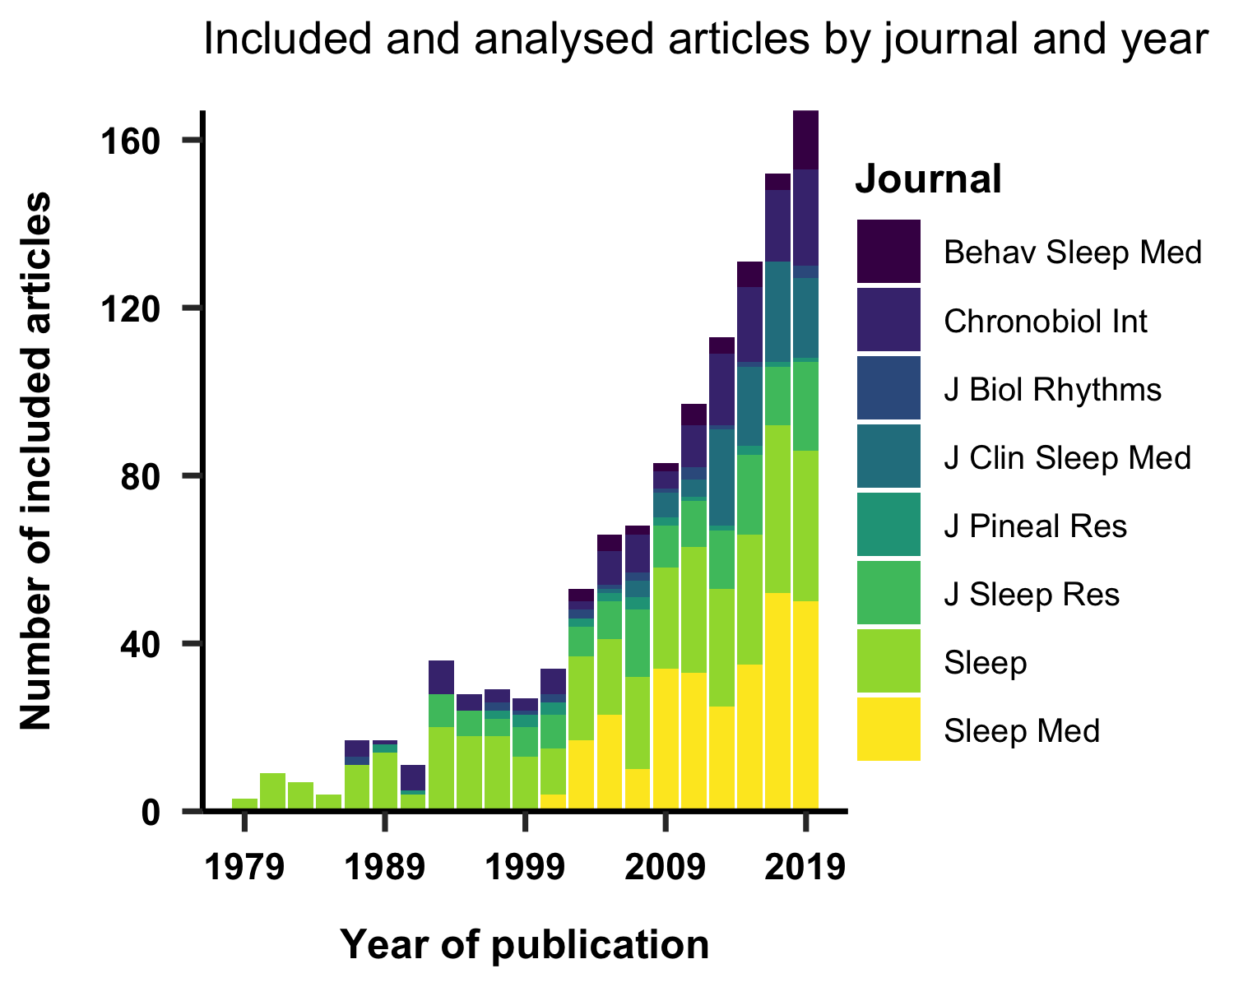

*Figure* *1.*  Included and analysed articles by year and journal. More recent articles are more represented, reflecting an overall increase in scientific output.

We also examined reasons for exclusion amongst the articles that we did not include and extract data from. These are given in Figure 2. Reasons for exclusion vary somewhat between different years, with articles not reporting original research being excluded at the highest rate on average.

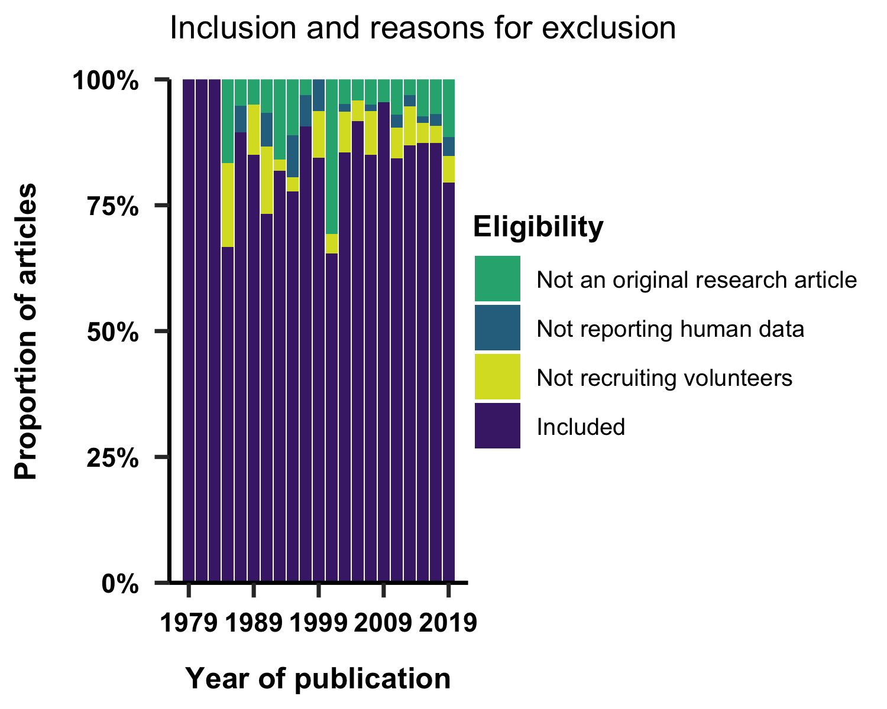

*Figure* *2.*  Normalised distributions of included and excluded articles.

## 6.2 Funding

We examined the reporting of funding sources in included articles. Funding sources were reported by 62% of studies, while funding number was also reported in 69% of these cases (Fig. 3). Overall, funding by the United States’ National Institutes of Health (NIH) represented 19% of the reported funding agencies. 92% of the studies funded by the NIH also reported funding number. The second most represented funding agencies were the Australian National Health and Medical Research Council (NHMRC) and the Canadian Institutes of Health Research (CIHR).

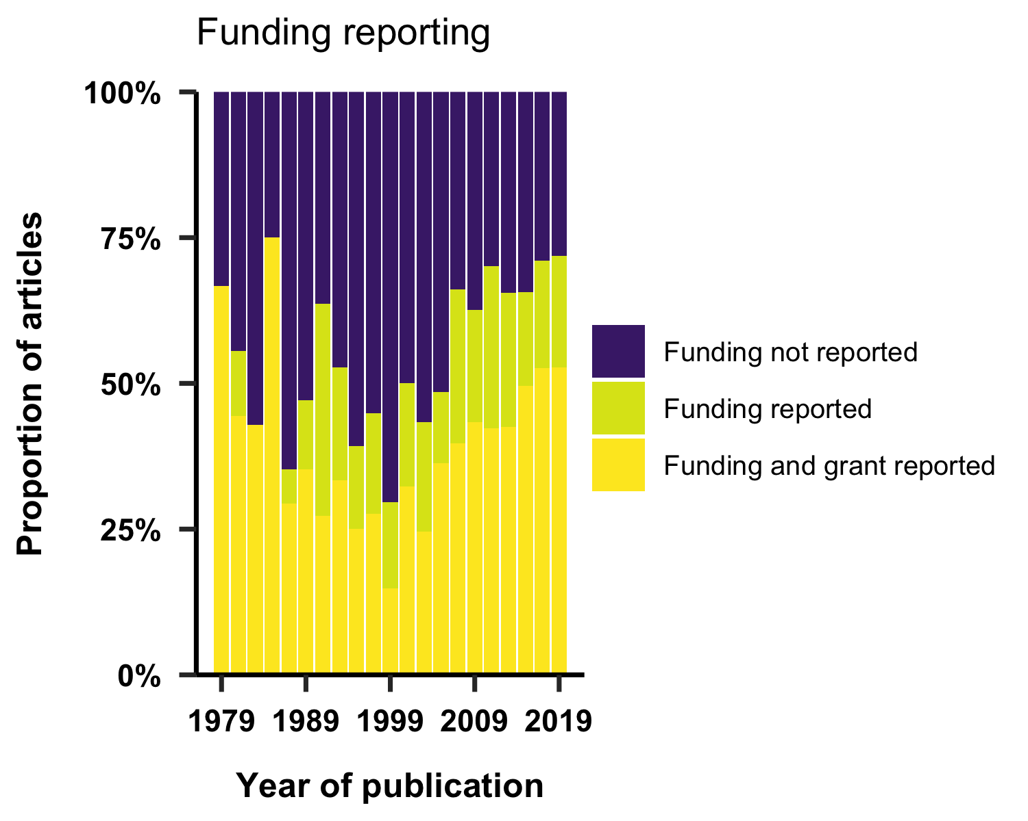

*Figure* *3.*  Reporting of funding across years.

## 6.3 Geographical location

93% of articles were conducted in a single country. The geographical location of the study was explicitly reported in 57% of studies. The country of study was inferred for the rest of the sampled articles. Inference was primarily based on the first author’s affiliation. Overall, 53 countries were represented. 7% of articles reported multiple countries of study. Figure 4 shows the distribution of study location across time with the eight most represented countries. Across all years, the US is the most represented country.

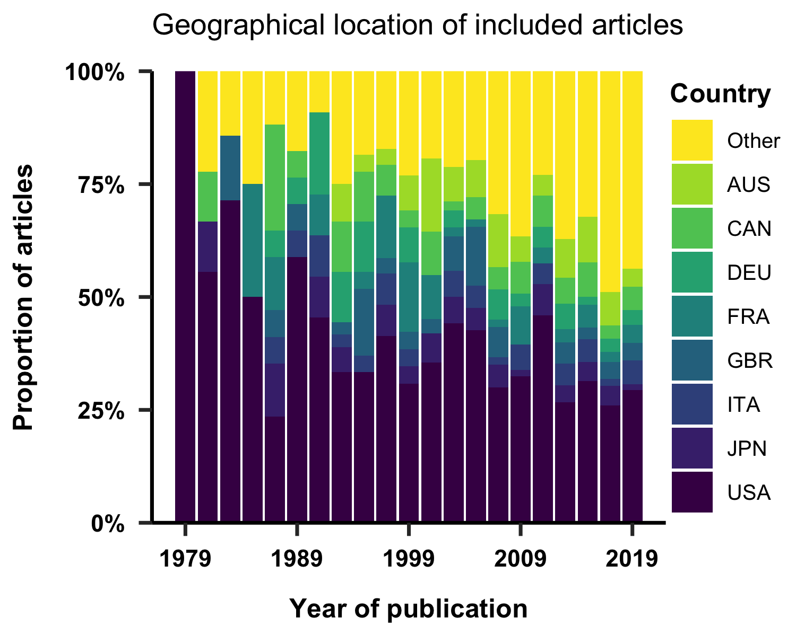

*Figure* *4.*  Gegraphical location of the studies. The eight most represented countries across the entire dataset are individually shown.

## 6.4 Sample size

We examined whether sample size reported in studies, and the sample sizes reported. Overall, sample size was reported in 92% of studies. We furthermore examined the distribution of samples sizes as a function of the publication year of the article (Fig. 5), showing a wider distribution of sample sizes in more recent articles.

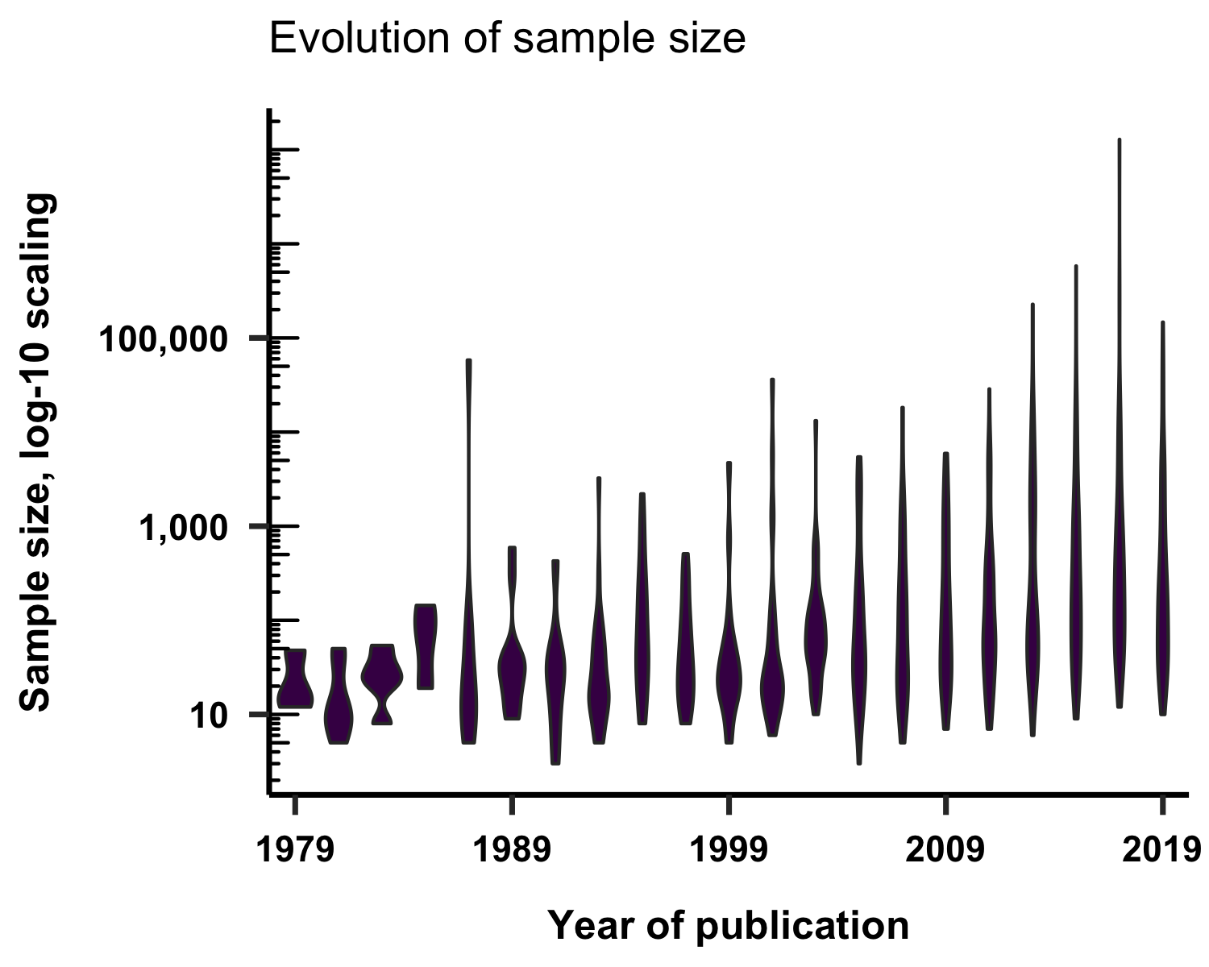

*Figure* *5.*  Sample size of the recruited volunteers as a function of publication year. Numbers are computed on a log-10 scale.

## 6.5 Age

93% of articles reported a variable describing age. Overall, the average mean age of the study populations was 39 years old. We examined the extent to which the mean age across studies differed widely as a function of publication year (Fig. 6), and found that the mean age is much more widely varied in later years, likely reflecting the extent of considering study samples that are more varied in age.

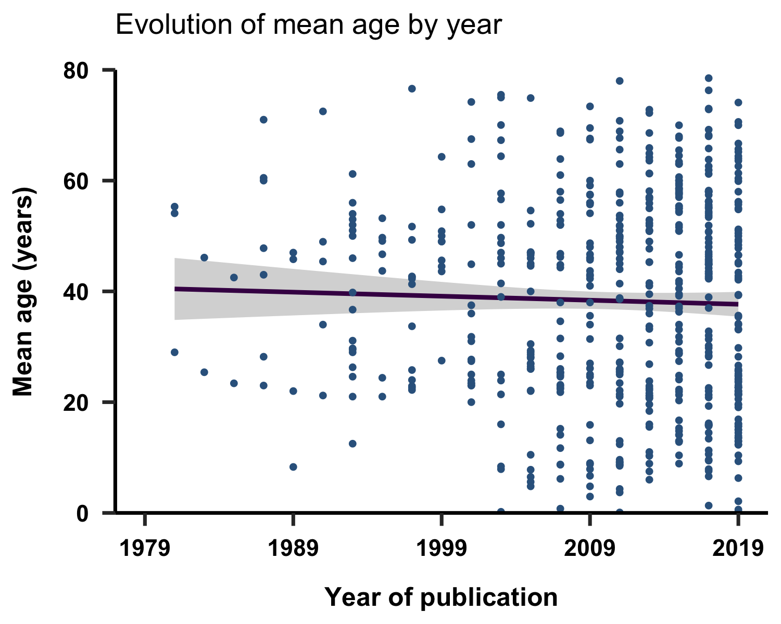

*Figure* *6.*  Evolution of mean age in included studies as a function of publication year. Fit shown is a linear fit (±95%CI).

## 6.6 Sex

Sex was reported in 89% of the studies. In Figure 7, we show the proportion of studies that recruited male subjects, female subjects, both sexes or did not specify the sex of the participants. 13% of the studies reporting sex only recruited male participants, while 10% only employed females. Out of the studies focusing on a single gender, 1% of the male studies focused on a sex dependent feature, while 2% of the female studies did. 4% of studies reported age by sex.

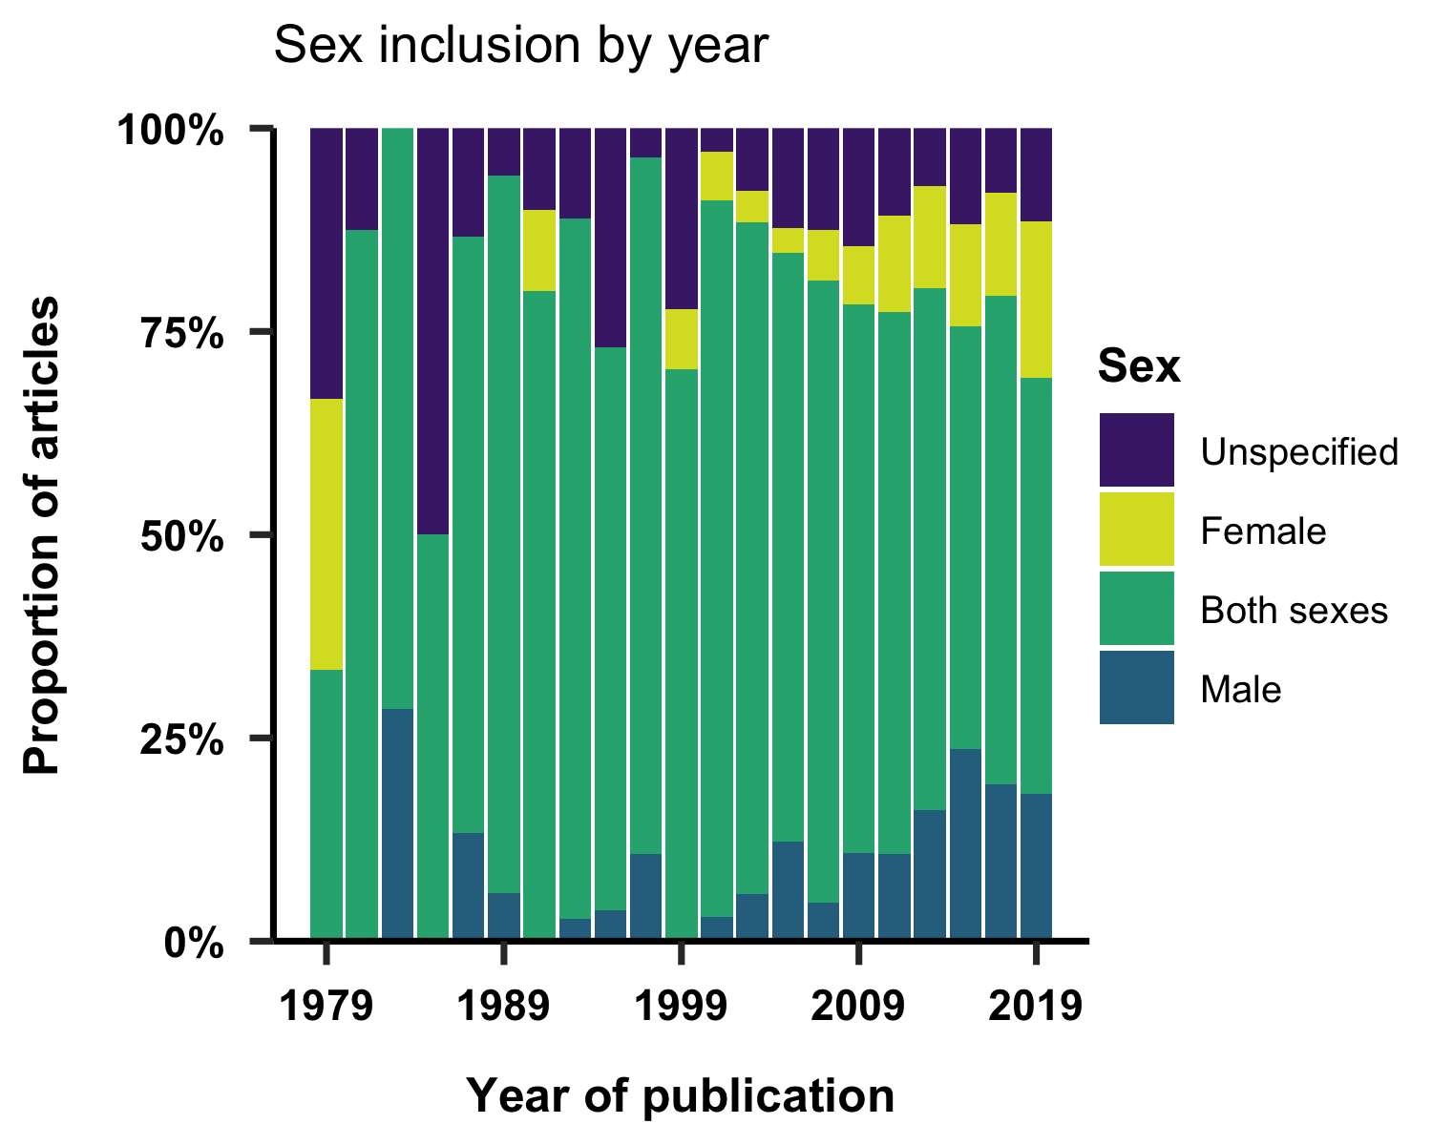

*Figure* *7.*  Sex inclusion by year. Proportion of studies that recruited male subjects, female subjects, both sexes, or did not specify the sex of the participants.

## 6.7 Ethnicity, education, profession and socio-economic status

We examined the reporting of the demographic variables ethnicity, education, profession and socio-economic status. These demographics variables were reported in 12% of studies for education, 15% for ethnicity, 2% for profession, and 4% for socio-economic status. Figure 8 shows the distribution of this reporting across the years. Qualitatively, there is a clear increase of reporting additional demographic variables over time, with ethnicity being the most reported demographic variables across articles in more recent years.

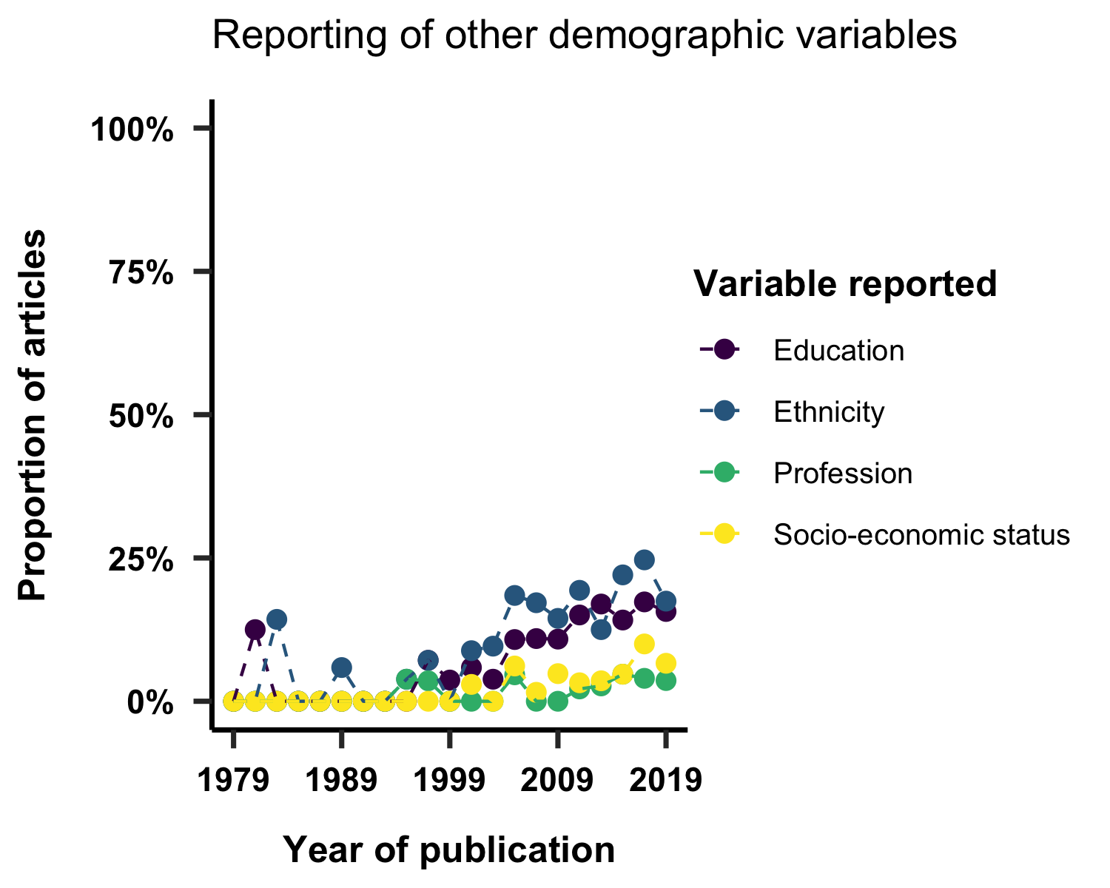 We furthermore examined the number of categories included for each of these demographic variables. In Figure 9, we show the number of categories reported for each variable among those articles that included it in a histogram. On overage, we find that the coding scheme for each of these variables in the included articles comprised between 3 and 4 variables.

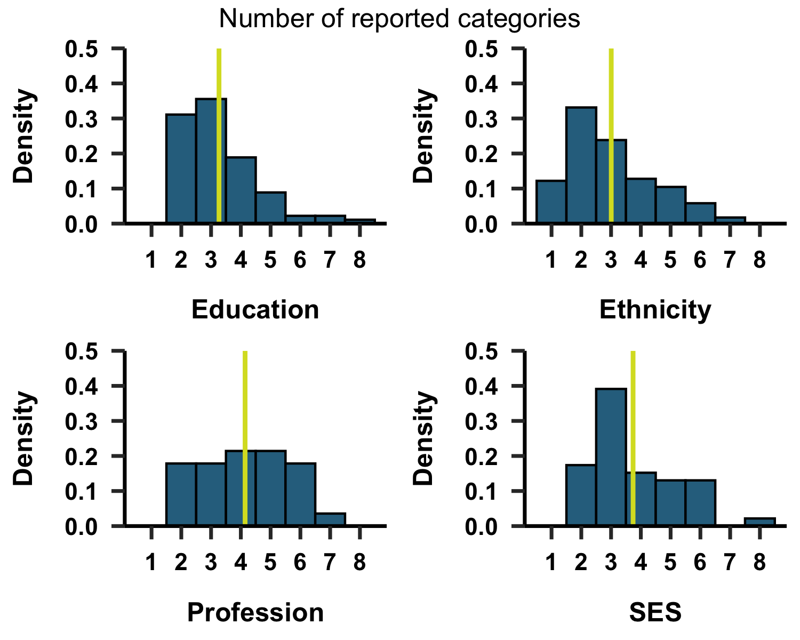

*Figure* *9.*  Number of categories reported for education, ethnicity, profession and socio-economic status (SES). Yellow vertical line corresponds to the median.

## 6.8 Study focus

We considered whether a given article reported on a specific, pre-defined group of people. We find 3% of articles focused on a sex dependent feature, while 50% investigated a clinical feature. 1% of studies focused on twins, 1% on pregnant women, 2% on shift workers and 4% on university students.

## 6.9 Analysis disaggregation

We examined the extent to which articles reported subgroup analyses of the data based on one or more of the reported demographic variables. Over time (Fig. 9), we see a distinct evolution of the extent to which subgroup analyses of the study sample were performed. The most common subgroup analyses involve disaggregting by sex and age, or both.

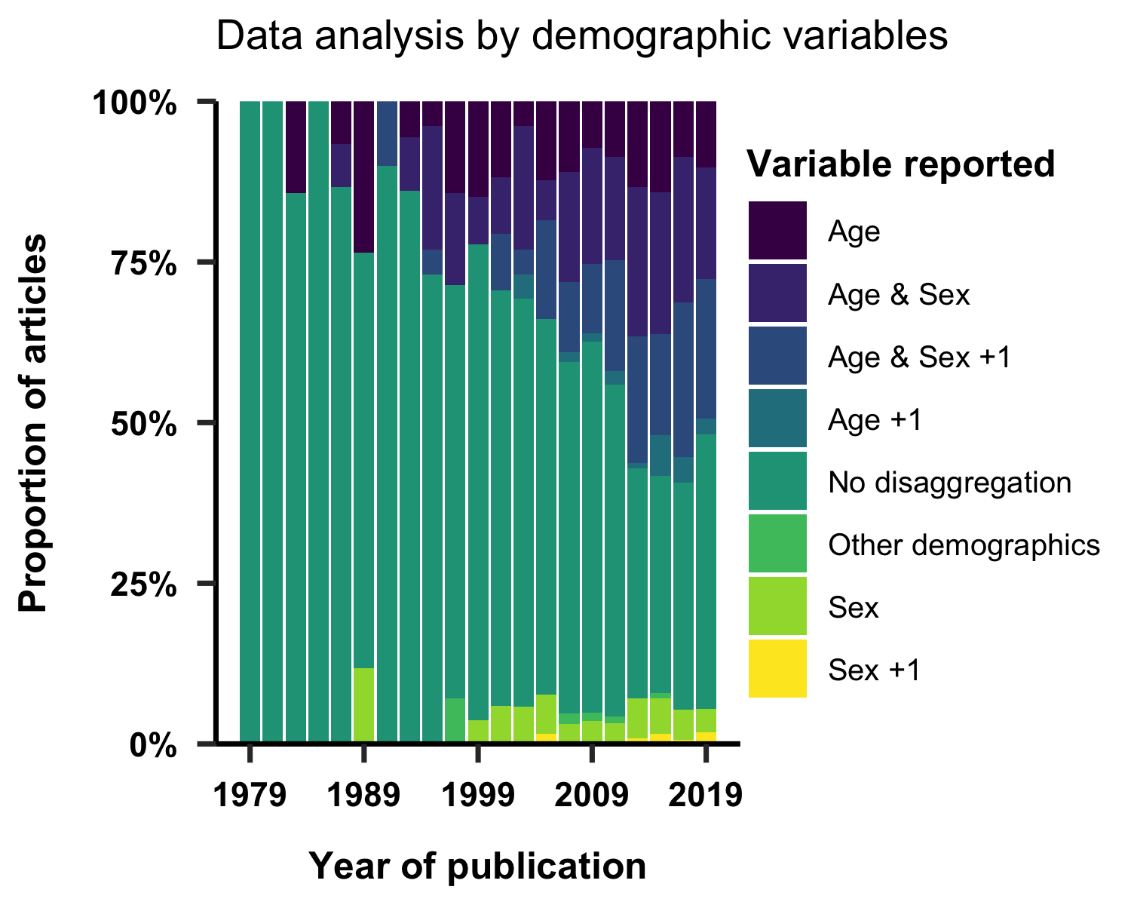

*Figure* *10.*  Use of study population characteristics as variables in the analysis.

# 7 Discussion

## 7.1 Summary of main findings

Here, we considered the inclusion, reporting of 1152 articles in chronobiology and sleep research, sampled from eight journals. More articles from more recent years are included, with articles originating in the US representing the large group. Over time, we found an increase in the range of sample sizes. We furthermore find a wider spread of average ages included in articles. Across the included articles, we observe an increase in reporting of demographic variables (ethnicity, education, professional and socioeconomic status) over time, with ethnicity being the most-reported variable in recent years. Of studies included these demographic variables, the number of categories varies widely between studies.

## 7.2 Taking an inventory of represented study samples reveals the representativeness of our collective knowledge

The ability to generalise findings from the scientific literature to wide and diverse populations of people hinges upon the representativeness of the study sample with respect to demographic categories. The question to what extent the composition of a given study sample can make the generalisability of findings difficult or impossible has received attention in the field of psychology, where many articles published in prominent journals reflected participants from WEIRD (Western, Educated, Industrialized, Rich, and Democratic) contexts (65,66). In other fields, analyses similar to the one in the present review have been published (67–69), but to our knowledge, this review represents a first look at the inclusion, reporting and analysis participant demographics in chronobiology and sleep research.

## 7.3 The need to consider individual differences

There is convergent knowledge that sleep and circadian physiology and health are subject to large individual differences. Demographic variables provide on lens through which to understand individual differences, and importantly can provide insights into systemic disadvantages and inequities. In the clinical domain, the need to time therapy based on a patient’s individual circadian rhythm has more recently become the focus of the emerging field of chronotherapy or chronotherapeutics (70–73). Understanding interindividual variability needs to become a key research area to understand the circadian and sleep physiology in the face of human diversity.

## 7.4 Limitations of the current review

We turn to possible limitations of this review and the included analyses and discuss how they might introduce bias in our findings. First, we consider the possibility that the article selection procedure may have introduced biases. Our review only concerned articles from a subset of eight specialized journals. As a consequence, the included articles were necessarily published in these journals, ignoring relevant articles published in other specialised journals (such as those included in the list of candidate journals), and articles published in other, including interdisciplinary journals. This raises the question to what extent we may have missed a section of the literature that would have been relevant to include here. As an alternative strategy, we considered randomly sampling a subset of chronobiology and sleep research articles produced by a general search (e.g. on search from “sleep OR chronobiology” on MEDLINE), but considered this to be too permissive. Our strategy of selecting a subset of candidate journals provided a reasonable trade-off, as well as sampling from a range of field-specific outlets.

Due to the non-uniform distribution of publication years of the included articles (Fig. 1), variables derived from published papers and visualized and/or analyzed by year will have varying uncertainty, with reported percentages from publications of the earlier years being most uncertain. The fact that early years are represented with fewer articles, however, is a not a function of our data set, but of the exponential growth of scientific output (74–76).

## 7.5 Towards standardised reporting of demographic variables: From checklists to schemas?

There are guidelines and/or checklists for standardizing reporting of participant characteristics, such as CONSORT (77) or STROBE (78) (an extensive data base for health research reporting guidelines is provided by the Equator Network, <https://www.equator-network.org/>). Some biomedical journals (e.g. 79) specifically state demographic reporting requirements in the author instructions. Similarly, some organisations may make recommendations of specific reporting items for specific types of study questions (80).

These guidelines and/or checklists are largely focused on *what* is reported and not *how* it is reported. There is, *a priori*, however, no reason to not develop and use a standardized and machine-readable schema for reporting participant characteristics. The FAIR principles state that data should be findable, accessible, interoperable and reusable (81), and one way of realising these criteria is the use of data schemas which could prescribe categories of data and common naming schemes for reporting participant characteristics. Importantly, however, “what gets counted counts” (82), and it will be imperative to understand to what extend such any data schema may be exclusionary, e.g., by enforcing gender binaries (83), and whether any specific demographic variable is truly important (following the principle of data minimization). A further central point to consider is the extent to which disaggregation by demographic variables could be used to do harm in some way (82).

# 8 Conclusion

This review provided a first look at the inclusion, reporting and analysis of demographic variables in the chronobiology and sleep research literature, considering >1000 articles across eight journals. We addressed the need to consider individual differences, as well as the dependence of sleep and circadian rhythms ond demographic variables. Additionally, we we outline an opportunity to improve reporting of participant-level characteristics using formalised data schemas.

# 9 References

1. Dongen HPA van, Vitellaro KM, Dinges DF. Individual Differences in Adult Human Sleep and Wakefulness: Leitmotif for a Research Agenda. Sleep [Internet]. 2005 Apr [cited 2021 May 8];28(4):479–98. Available from: <https://academic.oup.com/sleep/article-lookup/doi/10.1093/sleep/28.4.479>

2. Kerkhof GA. Inter-individual differences in the human circadian system: A review. Biological Psychology [Internet]. 1985 Mar [cited 2021 May 8];20(2):83–112. Available from: <https://linkinghub.elsevier.com/retrieve/pii/0301051185900195>

3. Tankova I, Adan A, Buela-Casal G. Circadian typology and individual differences. A review. Personality and Individual Differences [Internet]. 1994 May [cited 2021 May 8];16(5):671–84. Available from: <https://linkinghub.elsevier.com/retrieve/pii/0191886994902097>

4. Horne JA, Östberg O. Individual differences in human circadian rhythms. Biological Psychology [Internet]. 1977 Sep [cited 2021 May 8];5(3):179–90. Available from: <https://linkinghub.elsevier.com/retrieve/pii/0301051177900011>

5. Baehr EK, Revelle W, Eastman CI. Individual differences in the phase and amplitude of the human circadian temperature rhythm: With an emphasis on morningness-eveningness: Phase and amplitude of the temperature rhythm. Journal of Sleep Research [Internet]. 2000 Jun [cited 2021 May 8];9(2):117–27. Available from: <http://doi.wiley.com/10.1046/j.1365-2869.2000.00196.x>

6. Burgess HJ, Fogg LF. Individual Differences in the Amount and Timing of Salivary Melatonin Secretion. Yamazaki S, editor. PLoS ONE [Internet]. 2008 Aug [cited 2021 May 8];3(8):e3055. Available from: <https://dx.plos.org/10.1371/journal.pone.0003055>

7. Santhi N, Thorne HC, Veen DR van der, Johnsen S, Mills SL, Hommes V, et al. The spectral composition of evening light and individual differences in the suppression of melatonin and delay of sleep in humans: Artificial evening light suppresses melatonin and delays sleep. Journal of Pineal Research [Internet]. 2012 Aug [cited 2021 May 8];53(1):47–59. Available from: <http://doi.wiley.com/10.1111/j.1600-079X.2011.00970.x>

8. Chellappa SL. Individual differences in light sensitivity affect sleep and circadian rhythms. Sleep [Internet]. 2021 Feb [cited 2021 May 8];44(2):zsaa214. Available from: <https://academic.oup.com/sleep/article/doi/10.1093/sleep/zsaa214/5922657>

9. Redline S, Kirchner HL, Quan SF, Gottlieb DJ, Kapur V, Newman A. The effects of age, sex, ethnicity, and sleep-disordered breathing on sleep architecture. Archives of Internal Medicine. 2004 Feb;164(4):406–18.

10. Santhi N, Lazar AS, McCabe PJ, Lo JC, Groeger JA, Dijk D-J. Sex differences in the circadian regulation of sleep and waking cognition in humans. Proceedings of the National Academy of Sciences of the United States of America. 2016 May;113(19):E2730–2739.

11. Cain SW, Dennison CF, Zeitzer JM, Guzik AM, Khalsa SBS, Santhi N, et al. Sex differences in phase angle of entrainment and melatonin amplitude in humans. Journal of Biological Rhythms. 2010 Aug;25(4):288–96.

12. Anderson ST, FitzGerald GA. Sexual dimorphism in body clocks. Science (New York, NY). 2020 Sep;369(6508):1164–5.

13. Mong JA, Baker FC, Mahoney MM, Paul KN, Schwartz MD, Semba K, et al. Sleep, rhythms, and the endocrine brain: Influence of sex and gonadal hormones. The Journal of Neuroscience: The Official Journal of the Society for Neuroscience. 2011 Nov;31(45):16107–16.

14. Espiritu JRD. Aging-Related Sleep Changes. Clinics in Geriatric Medicine [Internet]. 2008 Feb [cited 2021 May 8];24(1):1–4. Available from: <https://linkinghub.elsevier.com/retrieve/pii/S0749069007000729>

15. Mander BA, Winer JR, Walker MP. Sleep and Human Aging. Neuron [Internet]. 2017 Apr [cited 2021 May 8];94(1):19–36. Available from: <https://linkinghub.elsevier.com/retrieve/pii/S0896627317300880>

16. Desforges JF, Prinz PN, Vitiello MV, Raskind MA, Thorpy MJ. Sleep Disorders and Aging. New England Journal of Medicine [Internet]. 1990 Aug [cited 2021 May 8];323(8):520–6. Available from: <http://www.nejm.org/doi/abs/10.1056/NEJM199008233230805>

17. Li J, Vitiello MV, Gooneratne NS. Sleep in Normal Aging. Sleep Medicine Clinics [Internet]. 2018 Mar [cited 2021 May 8];13(1):1–1. Available from: <https://linkinghub.elsevier.com/retrieve/pii/S1556407X17301029>

18. Bliwise DL. Sleep in Normal Aging and Dementia. Sleep [Internet]. 1993 Jan [cited 2021 May 8];16(1):40–81. Available from: <https://academic.oup.com/sleep/article-lookup/doi/10.1093/sleep/16.1.40>

19. Benloucif S, Green K, L’Hermite-Balériaux M, Weintraub S, Wolfe LF, Zee PC. Responsiveness of the aging circadian clock to light. Neurobiology of Aging [Internet]. 2006 Dec [cited 2021 May 8];27(12):1870–9. Available from: <https://linkinghub.elsevier.com/retrieve/pii/S0197458005003428>

20. Duffy JF, Zitting K-M, Chinoy ED. Aging and Circadian Rhythms. Sleep Medicine Clinics [Internet]. 2015 Dec [cited 2021 May 8];10(4):423–34. Available from: <https://linkinghub.elsevier.com/retrieve/pii/S1556407X15000995>

21. Ahn S, Lobo JM, Logan JG, Kang H, Kwon Y, Sohn M-W. A scoping review of racial/ethnic disparities in sleep. Sleep Medicine. 2021 Feb;81:169–79.

22. Goldstein SJ, Gaston SA, McGrath JA, Jackson CL. Sleep Health and Serious Psychological Distress: A Nationally Representative Study of the United States among White, Black, and Hispanic/Latinx Adults. Nature and Science of Sleep. 2020;12:1091–104.

23. Eastman CI, Molina TA, Dziepak ME, Smith MR. Blacks (African Americans) have shorter free-running circadian periods than whites (Caucasian Americans). Chronobiology International. 2012 Oct;29(8):1072–7.

24. Eastman CI, Tomaka VA, Crowley SJ. Circadian rhythms of European and African-Americans after a large delay of sleep as in jet lag and night work. Scientific Reports [Internet]. 2016 Dec [cited 2021 Apr 30];6(1):36716. Available from: <http://www.nature.com/articles/srep36716>

25. Jackson CL, Johnson DA. Sleep disparities in the era of the COVID-19 pandemic highlight the urgent need to address social determinants of health like the virus of racism. Journal of Clinical Sleep Medicine [Internet]. 2020 Aug [cited 2021 May 13];16(8):1401–2. Available from: <http://jcsm.aasm.org/doi/10.5664/jcsm.8570>

26. Jackson CL, Powell-Wiley TM, Gaston SA, Andrews MR, Tamura K, Ramos A. Racial/Ethnic Disparities in Sleep Health and Potential Interventions Among Women in the United States. Journal of Women’s Health [Internet]. 2020 Mar [cited 2021 May 13];29(3):435–42. Available from: <https://www.liebertpub.com/doi/10.1089/jwh.2020.8329>

27. Williams NJ, Grandner MA, Snipes SA, Rogers A, Williams O, Airhihenbuwa C, et al. Racial/ethnic disparities in sleep health and health care: Importance of the sociocultural context. Sleep Health [Internet]. 2015 Mar [cited 2021 May 13];1(1):28–35. Available from: <https://linkinghub.elsevier.com/retrieve/pii/S2352721814000096>

28. Jackson CL, Walker JR, Brown MK, Das R, Jones NL. A workshop report on the causes and consequences of sleep health disparities. Sleep [Internet]. 2020 Aug [cited 2021 May 13];43(8):zsaa037. Available from: <https://academic.oup.com/sleep/article/doi/10.1093/sleep/zsaa037/5802387>

29. Jean-Louis G, Grandner M. Importance of recognizing sleep health disparities and implementing innovative interventions to reduce these disparities. Sleep Medicine. 2016 Feb;18:1–2.

30. Laposky AD, Van Cauter E, Diez-Roux AV. Reducing health disparities: The role of sleep deficiency and sleep disorders. Sleep Medicine [Internet]. 2016 Feb [cited 2021 May 13];18:3–6. Available from: <https://linkinghub.elsevier.com/retrieve/pii/S1389945715000519>

31. Woitowich NC, Beery A, Woodruff T. A 10-year follow-up study of sex inclusion in the biological sciences. eLife [Internet]. 2020 Jun [cited 2021 May 8];9:e56344. Available from: <https://elifesciences.org/articles/56344>

32. Beery AK, Zucker I. Sex bias in neuroscience and biomedical research. Neuroscience and Biobehavioral Reviews. 2011 Jan;35(3):565–72.

33. Clayton JA, Collins FS. Policy: NIH to balance sex in cell and animal studies. Nature [Internet]. 2014 May [cited 2021 May 8];509(7500):282–3. Available from: <http://www.nature.com/articles/509282a>

34. Criado-Perez C. Invisible women: Exposing data bias in a world designed for men. 2020.

35. Oh SS, Galanter J, Thakur N, Pino-Yanes M, Barcelo NE, White MJ, et al. Diversity in Clinical and Biomedical Research: A Promise Yet to Be Fulfilled. PLOS Medicine [Internet]. 2015 Dec [cited 2021 May 8];12(12):e1001918. Available from: <https://dx.plos.org/10.1371/journal.pmed.1001918>

36. Spitschan M, Schmidt MH, Blume C. Transparency and open science principles in reporting guidelines in sleep research and chronobiology journals. Wellcome Open Research [Internet]. 2020 Jul [cited 2021 May 8];5:172. Available from: <https://wellcomeopenresearch.org/articles/5-172/v1>

37. Shamseer L, Moher D, Clarke M, Ghersi D, Liberati A, Petticrew M, et al. Preferred reporting items for systematic review and meta-analysis protocols (PRISMA-P) 2015: Elaboration and explanation. BMJ [Internet]. 2015 Jan [cited 2021 May 8];349(jan02 1):g7647–7. Available from: <https://www.bmj.com/lookup/doi/10.1136/bmj.g7647>

38. PRISMA-P Group, Moher D, Shamseer L, Clarke M, Ghersi D, Liberati A, et al. Preferred reporting items for systematic review and meta-analysis protocols (PRISMA-P) 2015 statement. Systematic Reviews [Internet]. 2015 Dec [cited 2021 May 8];4(1):1. Available from: <https://systematicreviewsjournal.biomedcentral.com/articles/10.1186/2046-4053-4-1>

39. R Core Team. R: A language and environment for statistical computing [Internet]. Vienna, Austria: R Foundation for Statistical Computing; 2020. Available from: <https://www.R-project.org/>

40. Aust F, Barth M. papaja: Create APA manuscripts with R Markdown [Internet]. 2020. Available from: <https://github.com/crsh/papaja>

41. Wei T, Simko V. R package "corrplot": Visualization of a correlation matrix [Internet]. 2017. Available from: <https://github.com/taiyun/corrplot>

42. Wickham H, François R, Henry L, Müller K. Dplyr: A grammar of data manipulation [Internet]. 2021. Available from: <https://CRAN.R-project.org/package=dplyr>

43. Attali D, Baker C. ggExtra: Add marginal histograms to ’ggplot2’, and more ’ggplot2’ enhancements [Internet]. 2019. Available from: <https://CRAN.R-project.org/package=ggExtra>

44. Kaplan D, Pruim R. Ggformula: Formula interface to the grammar of graphics [Internet]. 2021. Available from: <https://CRAN.R-project.org/package=ggformula>

45. Wickham H. ggplot2: Elegant graphics for data analysis [Internet]. Springer-Verlag New York; 2016. Available from: <https://ggplot2.tidyverse.org>

46. Wilke CO. Ggridges: Ridgeline plots in ’ggplot2’ [Internet]. 2021. Available from: <https://CRAN.R-project.org/package=ggridges>

47. Xiao N. Ggsci: Scientific journal and sci-fi themed color palettes for ’ggplot2’ [Internet]. 2018. Available from: <https://CRAN.R-project.org/package=ggsci>

48. Henry L, Wickham H, Chang W. Ggstance: Horizontal ’ggplot2’ components [Internet]. 2020. Available from: <https://CRAN.R-project.org/package=ggstance>

49. Arnold JB. Ggthemes: Extra themes, scales and geoms for ’ggplot2’ [Internet]. 2021. Available from: <https://CRAN.R-project.org/package=ggthemes>

50. Auguie B. gridExtra: Miscellaneous functions for "grid" graphics [Internet]. 2017. Available from: <https://CRAN.R-project.org/package=gridExtra>

51. Xie Y. Dynamic documents with R and knitr [Internet]. 2nd ed. Boca Raton, Florida: Chapman; Hall/CRC; 2015. Available from: <https://yihui.org/knitr/>

52. Sarkar D. Lattice: Multivariate data visualization with r [Internet]. New York: Springer; 2008. Available from: <http://lmdvr.r-forge.r-project.org>

53. Sarkar D, Andrews F. latticeExtra: Extra graphical utilities based on lattice [Internet]. 2019. Available from: <https://CRAN.R-project.org/package=latticeExtra>

54. Edwards SM. Lemon: Freshing up your ’ggplot2’ plots [Internet]. 2020. Available from: <https://CRAN.R-project.org/package=lemon>

55. Bates D, Maechler M. Matrix: Sparse and dense matrix classes and methods [Internet]. 2021. Available from: <https://CRAN.R-project.org/package=Matrix>

56. Pruim R, Kaplan DT, Horton NJ. The mosaic package: Helping students to ’think with data’ using r. The R Journal [Internet]. 2017;9(1):77–102. Available from: <https://journal.r-project.org/archive/2017/RJ-2017-024/index.html>

57. Pruim R, Kaplan D, Horton N. mosaicData: Project MOSAIC data sets [Internet]. 2021. Available from: <https://CRAN.R-project.org/package=mosaicData>

58. Borchers HW. Pracma: Practical numerical math functions [Internet]. 2021. Available from: <https://CRAN.R-project.org/package=pracma>

59. Wickham H, Hester J. Readr: Read rectangular text data [Internet]. 2020. Available from: <https://CRAN.R-project.org/package=readr>

60. Wickham H, Bryan J. Readxl: Read excel files [Internet]. 2019. Available from: <https://CRAN.R-project.org/package=readxl>

61. Wickham H. Reshaping data with the reshape package. Journal of Statistical Software [Internet]. 2007;21(12):1–20. Available from: <http://www.jstatsoft.org/v21/i12/>

62. Wickham H. Stringr: Simple, consistent wrappers for common string operations [Internet]. 2019. Available from: <https://CRAN.R-project.org/package=stringr>

63. Müller K, Wickham H. Tibble: Simple data frames [Internet]. 2021. Available from: <https://CRAN.R-project.org/package=tibble>

64. Wickham H. Tidyr: Tidy messy data [Internet]. 2021. Available from: <https://CRAN.R-project.org/package=tidyr>

65. Henrich J, Heine SJ, Norenzayan A. The weirdest people in the world? Behavioral and Brain Sciences [Internet]. 2010 Jun [cited 2021 May 8];33(2-3):61–83. Available from: <https://www.cambridge.org/core/product/identifier/S0140525X0999152X/type/journal_article>

66. Muthukrishna M, Bell AV, Henrich J, Curtin CM, Gedranovich A, McInerney J, et al. Beyond Western, Educated, Industrial, Rich, and Democratic (WEIRD) Psychology: Measuring and Mapping Scales of Cultural and Psychological Distance. Psychological Science [Internet]. 2020 Jun [cited 2021 May 8];31(6):678–701. Available from: <http://journals.sagepub.com/doi/10.1177/0956797620916782>

67. O’Bryant S, O’Jile J, McCaffrey R. Reporting of Demographic Variables in Neuropsychological Research: Trends in the Current Literature. The Clinical Neuropsychologist [Internet]. 2004 Jan [cited 2021 May 8];18(2):229–33. Available from: <http://www.tandfonline.com/doi/abs/10.1080/13854040490501439>

68. Sifers SK. Reporting of Demographics, Methodology, and Ethical Procedures in Journals in Pediatric and Child Psychology. Journal of Pediatric Psychology [Internet]. 2002 Jan [cited 2021 May 8];27(1):19–25. Available from: <https://academic.oup.com/jpepsy/article-lookup/doi/10.1093/jpepsy/27.1.19>

69. Jones SH, St. Peter CC, Ruckle MM. Reporting of demographic variables in the *Journal of Applied Behavior Analysis*: Demographic Variables. Journal of Applied Behavior Analysis [Internet]. 2020 Jul [cited 2021 May 8];53(3):1304–15. Available from: <http://doi.wiley.com/10.1002/jaba.722>

70. Adam D. Core Concept: Emerging science of chronotherapy offers big opportunities to optimize drug delivery. Proceedings of the National Academy of Sciences [Internet]. 2019 Oct [cited 2021 May 8];116(44):21957–9. Available from: <http://www.pnas.org/lookup/doi/10.1073/pnas.1916118116>

71. Greco CM, Sassone-Corsi P. Personalized medicine and circadian rhythms: Opportunities for modern society. Journal of Experimental Medicine [Internet]. 2020 Jun [cited 2021 May 8];217(6):e20200702. Available from: <https://rupress.org/jem/article/doi/10.1084/jem.20200702/151791/Personalized-medicine-and-circadian-rhythms>

72. Dijk D-J, Duffy JF. Novel Approaches for Assessing Circadian Rhythmicity in Humans: A Review. Journal of Biological Rhythms [Internet]. 2020 Oct [cited 2021 May 8];35(5):421–38. Available from: <http://journals.sagepub.com/doi/10.1177/0748730420940483>

73. Hill RJW, Innominato PF, Lévi F, Ballesta A. Optimizing circadian drug infusion schedules towards personalized cancer chronotherapy. Gallo J, editor. PLOS Computational Biology [Internet]. 2020 Jan [cited 2021 May 8];16(1):e1007218. Available from: <https://dx.plos.org/10.1371/journal.pcbi.1007218>

74. Powell JJW, Fernandez F, Crist JT, Dusdal J, Zhang L, Baker DP. Introduction: The Worldwide Triumph of the Research University and Globalizing Science. In: Powell JJW, Baker DP, Fernandez F, editors. International Perspectives on Education and Society [Internet]. Emerald Publishing Limited; 2017 [cited 2021 May 8]. p. 1–36. Available from: <https://www.emerald.com/insight/content/doi/10.1108/S1479-367920170000033003/full/html>

75. Bornmann L, Mutz R. Growth rates of modern science: A bibliometric analysis based on the number of publications and cited references: Growth Rates of Modern Science: A Bibliometric Analysis Based on the Number of Publications and Cited References. Journal of the Association for Information Science and Technology [Internet]. 2015 Nov [cited 2021 May 8];66(11):2215–22. Available from: <http://doi.wiley.com/10.1002/asi.23329>

76. Parolo PDB, Pan RK, Ghosh R, Huberman BA, Kaski K, Fortunato S. Attention decay in science. Journal of Informetrics [Internet]. 2015 Oct [cited 2021 May 8];9(4):734–45. Available from: <https://linkinghub.elsevier.com/retrieve/pii/S1751157715200442>

77. Schulz KF, Altman DG, Moher D, CONSORT Group. CONSORT 2010 statement: Updated guidelines for reporting parallel group randomised trials. BMJ (Clinical research ed). 2010 Mar;340:c332.

78. Elm E von, Altman DG, Egger M, Pocock SJ, Gøtzsche PC, Vandenbroucke JP, et al. Strengthening the Reporting of Observational Studies in Epidemiology (STROBE) statement: Guidelines for reporting observational studies. BMJ (Clinical research ed). 2007 Oct;335(7624):806–8.

79. Robinson JK, McMichael AJ, Hernandez C. Transparent Reporting of Demographic Characteristics of Study Participants. JAMA Dermatology [Internet]. 2017 Mar [cited 2021 May 8];153(3):263. Available from: <http://archderm.jamanetwork.com/article.aspx?doi=10.1001/jamadermatol.2016.5978>

80. Veitch JA, Knoop M. CIE TN 011:2020 What to document and report in studies of ipRGC-influenced responses to light [Internet]. International Commission on Illumination (CIE); 2020 Nov [cited 2021 May 8]. Available from: <http://cie.co.at/publications/what-document-and-report-studies-iprgc-influenced-responses-light>

81. Wilkinson MD, Dumontier M, Aalbersberg IjJ, Appleton G, Axton M, Baak A, et al. The FAIR Guiding Principles for scientific data management and stewardship. Scientific Data [Internet]. 2016 Dec [cited 2021 May 8];3(1):160018. Available from: <http://www.nature.com/articles/sdata201618>

82. D’Ignazio C, Klein LF. Data feminism. Cambridge, Massachusetts: The MIT Press; 2020. (Strong ideas series).

83. Hyde JS, Bigler RS, Joel D, Tate CC, Anders SM van. The future of sex and gender in psychology: Five challenges to the gender binary. American Psychologist [Internet]. 2019 Feb [cited 2021 May 8];74(2):171–93. Available from: <http://doi.apa.org/getdoi.cfm?doi=10.1037/amp0000307>