|  |  |
| --- | --- |
| Editor  New Phytologist | **David Herrera**  Postbox 10 01 64  07701 Jena  Germany  Phone +49 (0)3641 57-6152    E-Mail: dherrera @bgc-jena.mpg.de  Web [www.bgc-jena.mpg.de](http://www.bgc-jena.mpg.de) |

1st November 2019

Dear Editor

We are resubmitting the manuscript entitled “*Non-structural carbon* *ages and transit times provide insights on carbon allocation dynamics of mature trees*”, for consideration for publication in “*New Phytologist*”. We would like to thank you for the comments and recommendations from a previously submitted version, and for encouraging resubmission.

In this manuscript, we compare models of nonstructural carbon (NSC) dynamics in trees and address three main questions: **i)** How different are the predictions of NSC dynamics between tree tissues and trees of species representing different functional types? **ii)** What is the predicted age composition of the NSC reserves for trees under carbon limitation and how long can trees use these reserves? And **iii)** what are the main carbon fluxes that influence the mean age and mean transit time for NSC in trees?

We are glad that from the revisions you and the reviewers found the paper important and useful. We conducted the uncertainty analysis that was lacking in the manuscript to solve the concerns that you and the referees had. We also improve the text as suggested by the referees and we made the discussion clearer. We hope our new changes improve the understanding of the manuscript and address adequately the issues raised in the previous revision process.

On behalf of all the coauthors,

Thanks for your consideration

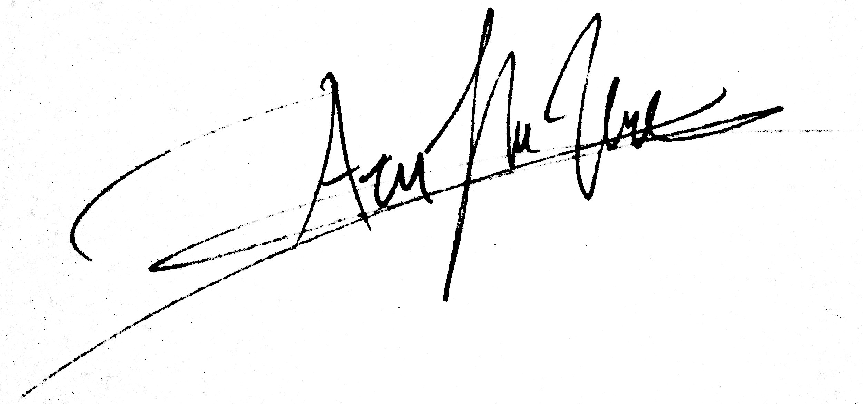

David Andres Herrera Ramirez