## *New Phytologist* Supporting Information

Article title: **Non-structural carbon ages and transit times provide insights in carbon allocation dynamics of mature trees.**

Authors: David Herrera-Ramirez1 Jan Muhr1,2 Henrik Hartman1 Christine Römermann3,4 Susan Trumbore1 Carlos A. Sierra1

Article acceptance date: Click here to enter a date.

The following Supporting Information is available for this article:

**Fig. S1** Uncertainties associated with the model parameters with the largest influence in the NSC mean age and mean transit time per species **A**) *Pinus halepensis*, **B**) *Acer rubrum*, and **C**) *Pinus taeda*. It is shown the uncertainty as a density distribution of the mean age and the transit time of the NSC of the tree. The uncertainties associated with the mean ages of the individual tree pools are also shown per tree species. This density distributions are the results of 1000 Monte Carlo simulations, where each simulation was calculated with different combinations of the model parameter values. The parameter values were chosen randomly from the parameter space.

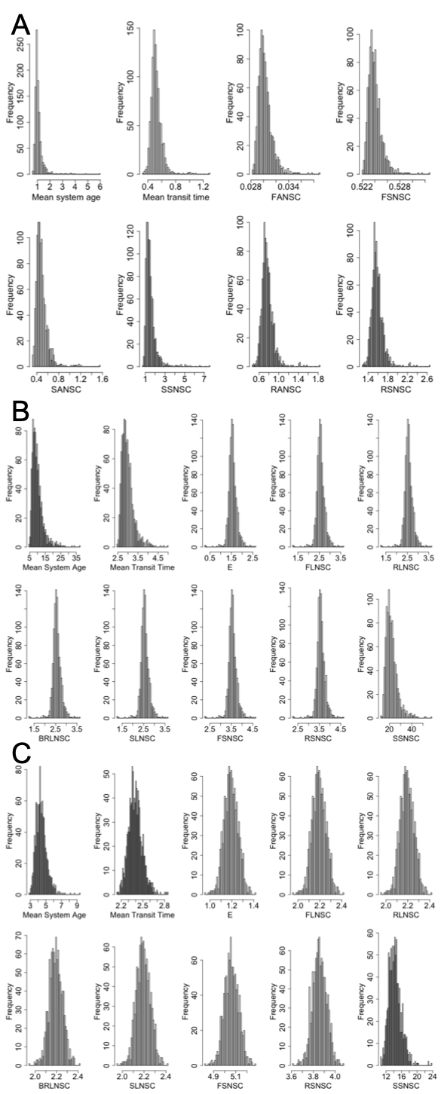

**Figure S2:** Mean sensitivity value μ and its correspondent variance σ for each flux of each species *Pinus halepensis*, *Acer rubrum* and *Pinus taeda* calculated by the Elementary Effects method. The larger the mean sensitivity value the more sensitive is the mean age or the mean transit time to changes in that flux. The bigger the variance of indexes the higher the nonlinear response of the mean age and mean transit time to changes in the fluxes. The fluxes are labeled as they are defined in Table 2.

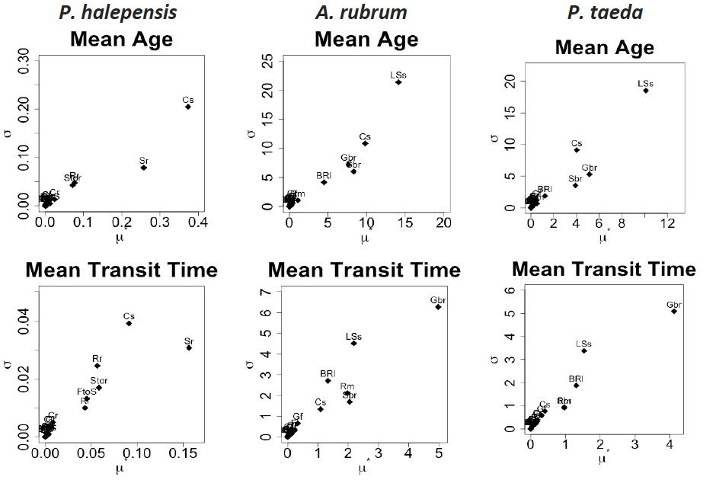

**Figure S3:** Association between the most sensitive NSC fluxes (Figure S2) and the mean age and mean transit time for each species: *Pinus halepensis*, *Acer rubrum* and *Pinus taeda*.

