**Determine the maximum water holding capacity (WHCmax)**

**of soil samples**

**Content:**

1. Basic principles of the analytical procedure

2. Devices and consumables

3. Procedure to

4. Preparations

5. Calculation of WHCmax

6. Remarks

7. Attachment

**1. Basic principles of the analytical procedure**

Water holding capacity is defined as the water amount that remains in the soil after draining by a force greater than gravity. It`s controlled primarily by the soil texture and the soil organic matter content.

To determine the maximum water holding capacity (WHCmax) fresh soil samples will be saturated with water (ratio 1:2) in a filter funnel overnight. The funnel is placed on an absorbent membrane until the excess water is drawn away by gravity. Once equilibrium is reached, the water holding capacity is calculated based on the weight of the water held in the sample vs. the sample dry weight.

Soil biochemical tests are routinely carried out at target soil water content equivalent to a certain percentage (usually 60%) of the sample’s WHC, as results can be affected by very wet or dry conditions.

**2. Devices and consumables**

* 2 mm sieve
* 50 ml glasses for determination of soil dry weight
* 50 ml Falcon-Tubes with an open bottom
* mesh material (polyester, mesh size ... µm)
* rubber band
* crystallizing dish (2 pieces, Ø 230 mm)
* towel
* sand

**3. Procedure to**

* preparations:
  + soil sieving
  + determination of water content
  + determination of water absorption
* calculation WHCmax
* additional: adjust a certain water content to soil samples

**4. Preparations**

**4.1 soil sieving**

* carefully sieve fresh (or rather - 20 °C stocked) soil samples to < 2 mm; remove roots and stones ( > 2 mm)

**4.2 determine the soil water content**

* label small glasses (50 ml); note the net weight of the glass
* weigh in 10 g of sieved soil sample in the glass; note the weight
* dry it over night (min. 24 h) at 105°C till constant weight is adjusted
* take the glasses out of the oven (put on an ovenmitt) and put them immediately in the in [desiccator](https://www.google.de/search?q=Exsikkator&spell=1&sa=X&ei=mpOfVea9LqXiywPxyaeIBw&ved=0CBsQvwUoAA) cupboard for cool down (otherwise they can absorb water from the air)
* weigh the dried samples; note the weight

|  |  |  |  |  |
| --- | --- | --- | --- | --- |
| sample | empty glass [g] | fresh weight [g] | dry weight with glass [g] | dry weight [g] (calculated) |
|  |  |  |  |  |

$water weight [g]={fresh weight}^{*}-dry weight$

*\**

|  |
| --- |
| $$gravimetric water content [\%]=\frac{water weight}{{dry weight}^{*}}$$ |
| $$dry matter content [\%]=\frac{{dry weight}^{*}}{{fresh weight}^{*}}$$ |

*\* weight without glass weight*

**4.3 determine the soil water absorption**

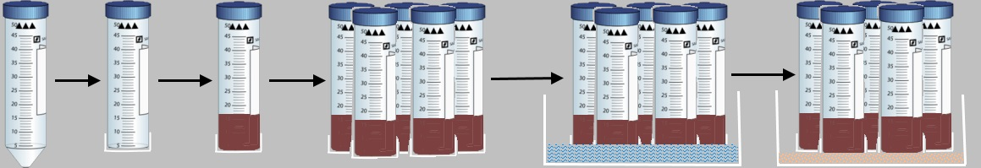

* close the open bottom of the Falcon-Tubes with mesh material (sealed with rubber band)
* label the Falcon-Tubes or number them consecutively
* weigh the Falcon-Tubes; note the weight
* weigh in 15 g sieved soil in the Falcon-Tubes; note the weight
* bind at a time 5 Falcon-Tubes together
* put a towel in the first crystallizing dish and place the Falcon-Tubes in (mesh downwards)
* fill dist. water (ratio 1:2) in the crystallizing dish
* cover it with a paper towel over night

next day:

* fill a second crystallizing dish with sand (at least 1cm high) and put in the tubes for 30 min for draining
* weigh the tubes; note the weight

|  |  |  |  |
| --- | --- | --- | --- |
|  | | | |
| sample | empty Falcon-Tube [g] | weight [g] | weight with Falcon-Tube [g] |
|  |  |  |  |

**5. Calculation of WHCmax**

To calculate the maximum water holding capacity (WHCmax) you need the value for water absorption and the value for the water content of your samples. 100% WHC equates the water volume which can be absorbed by 100 g dried soil.

$$dry weight=dry matter content× {fresh weight}^{*}$$

$$weight 100\% WHC ={output weight WHC}^{*}$$

$${WHC}_{max }[\%]=\frac{({fresh weight}^{*} –{dry weight}^{*})}{(weight 100\% WHC – {dry weight}^{*})}$$

* *weight without Falcon Tube weight*

**additional:** adjust a certain water content (e.g. 60% WHC for incubation experiments)

$$factor 60\% WHC=\frac{((weight 100\% WHC-{dry weight}^{*}×0,6)+{dry weight}^{*}) }{{fresh weight}^{*}}$$

$$water addition for 60\% WHC \left[ml\right]=\left(factor 60\% WHC-1\right)×soil sample weight x$$

**6. Remarks**

**…**

**7. Attachment**

…

Summarized by Jessica Heublein (Feb. 2016)