**Measuring soil respiration**

**(and collect gas samples for 14C analysis)**

**Content:**

1. Basic principles of the analytical procedure

2. Devices and consumables

3. Procedure to

4. Preparations

5. Incubation and CO2-measurement

6. Gas sampling for 14C analysis

7. Literature

8. Shopping list

1. **Basic principles of the analytical procedure**

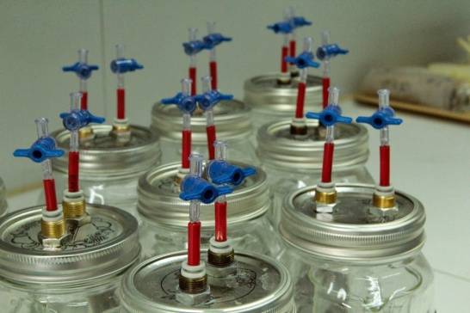Soils are an important reservoir for organic carbon and for atmospheric CO2. Carbon is released from soil to atmosphere by soil organisms via decomposition and mineralization. The potential release of CO2 from soils by microbial respiration can be determined in lab incubations under standardized conditions (constant temperature and soil moisture). The duration of the incubation depends on the objective of the study.

If samples have been stored at low temperature prior to incubation, a pre-incubation is recommended to allow soil microbes to adapt to incubation temperature.

Previous experiments showed that respiration of soil microbes in many soils is highest at a water holding capacity of 60% (e.g., REY et al. 2005; CARTER & GREGORICH 2007). To avoid a change in the adjusted soil moisture a certain amount of dist. water should be added to the bottom of the incubation jars.

Preserving jars are modified into incubation jars by adding two One-Way-Stopcock connections to the lid that enable the sampling of CO2 efflux as well as the flushing with synthetic air (if following 14C measurement of the developed CO2 is scheduled).

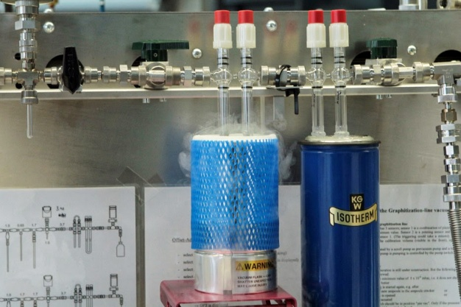An examination of the radiocarbon signature of the carbon dioxide evolving from the soil through microbial respiration gives an estimate of soil organic carbon turnover times. For the 14C measurement a minimum amount of 1 mg carbon per sample is required (2% CO2 = 1850 ppm/bar per liter).

**2. Devices and consumables** (shopping list attached)

* preparations:
  + 2 mm sieve
  + See instructions: "*how to determine the maximum water holding capacity (WHCmax) of soil samples"*
  + Dispensette for distilled water
  + plastic sample bags
  + spraying nozzle
  + calibration jar (with identified volume [ml])
* respiration measurement in general:
  + CO2-analyzer (*Li-Cor® 6262*)
  + CS-silicone septa for Li-Cor®
  + incubation/preserving jars (1 liter) with vacuum seal and two One-Way-Stopcocks
  + 250 ml beaker (tall shape)
  + vacuum pump
* calibration:
  + flushing gas (CO2 free) from *Westfalen*
  + calibrating gas (3000 ppm CO2 + N) from *Westfalen*
  + 5 ml syringe with Stopcock
  + needle
* 14C gas sampling:
  + injection flasks (100 ml)
  + plugs and aluminum crimp cap + manual crimping tools (crimper and decapper)

|  |  |
| --- | --- |
| Additional devices: stopwatch |  |

**3. Procedure to**

* Preparations:
  + soil sieving
  + determine the maximum water holding capacityof your samples and adjust a certain soil moisture
  + weigh in soil samples
  + determine the volume of the pump and the sample jars
  + leakage test for incubation jars
* incubation:
  + preincubation of soil samples
  + „flush“ the samples with synthetic (CO2 free) air
  + CO2-time series measurement
  + gas sampling for 14C-analysis

**4. Preparations**

**4.1 soil sieving**

* carefully sieve fresh (or rather - 20 °C stocked) soil samples to < 2 mm; remove roots and stones ( > 2 mm)

**4.2 adjust soil moisture to 60% WHCmax**

* estimate the required water amount for adjusting the soil moisture to 60% water holding capacity (to determine the water holding capacity see instructions: "*determine the maximum water holding capacity (WHCmax) of soil samples"*
* weigh in ~100 g sieved soil in plastic sample bag and add estimated water amount via a spraying nozzle equally to the soil sample

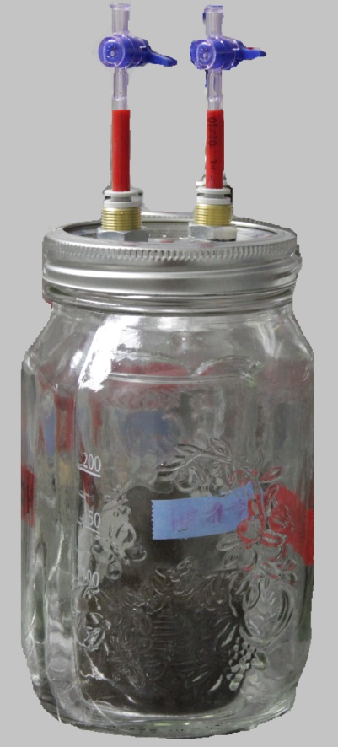**4.3 weigh in soil samples**

* label beaker (250 ml) and incubation jars; note the net weight of the beaker
* weigh in 70 g (± 0,5g) of moistened soil sample in the beaker; note the weight
* add 5 ml dist. water in the empty incubation jar and put in the beaker with the soil sample
* close the lid of the incubation jars; leave the stopcocks open

**4.4 determine the volume of the pump and the incubation jars**

**Always wear safety glasses during evacuation of incubation jars!**

* + 1. determine the volume of the pump using a calibration jar

VP

**2**

**1**

Pl = … mbar

4 mbar

VR

* switch on the vacuum pump, note the indicated value of the atmospheric pressure (Patm)
* close the stopcocks of the calibration jar and connect one outlet to the vacuum pump
* **1:** develop the air of the vacuum pump (press “Start”)
* If the pressure decreased near zero (± 4 mbar): stop the pump (press “Stop”)
* **2**: open the cock between the pump and the calibration jar and note the stabilized value (Pl)
* to calculate the volume of the pump (VP):

|  |  |
| --- | --- |
|  | * VP – volume of the pump * VR – volume of the calibration jar * Patm - atmospheric pressure * PI – pressure in the calibration jar |

* + 1. determine the volume of the incubation jars (with soil sample)

**2**

**1**

Ps = … mbar

4 mbar

* It’s the same procedure with the incubation jars – connect the incubation jars with the vacuum pump, evacuate the volume of the pump while the stop-cocks are closed [**1**], stop the pump (press „Stop“),open the cock between the pump and the calibration jar and note the stabilized value (PS) [**2**]; after 30 seconds check the pressure again and note the value 🡪 difference to PS is the leakage rate
* to calculate the volume of the incubation jars VS:

|  |  |
| --- | --- |
|  | * VS - volume of the incubation jar * Patm -atmospheric pressure * VP – volume of the pump * PS - pressure in the incubation jar |

* + 1. leakage test for incubation jars
* if the value of the leakage rate is smaller than 15 mbar, the jar is air tight; if the leakage rate is higher than 15 mbar you have to change the lid and repeat the test
* eventually close all the stop cocks and disconnect the incubation jar from the vacuum pump. Open slightly the cocks of the incubation jars to remove underpressure.

**5. Incubation and CO2-measurement**

**5.1 pre-incubation**

* if the leakage test was successful the samples have to be pre-incubated for 4 days under laboratory conditions (20°C) to allow soil microbes to adapt to incubation temperature

**5.2 flush with synthetic (CO2 free) air**

* before the incubation can start the samples have to be flushed for 2 minutes with synthetic (of particular importance if you want to measure 14C)

|  |  |  |
| --- | --- | --- |
| **Open** | **Flush** | **Close** |
| synth. air  Inkubationsgläser.jpg  2  1 | 2 min  Inkubationsgläser.jpg  open  open | Inkubationsgläser.jpg  1  2 |

* close both cocks (note date and time!) 🡪 starting point of incubation
* if the samples should be incubated under constant conditions (e.g. 20°C), put them into a climate chamber.

**5.3 CO2-time series measurement**

5.3.1 Preparations:

* Start the system: switch on the Li-Cor **one hour** before you want to measure (switch to I, start the pump (Elite 800), switch on the nitrogen supply (0,2 – 0,4 bar)
* adjust the CO2 baseline to zero (use the knob „CO2 zero“)
* check if: the pressure is at 600 mbar, the water trap is not saturated (indicator color should be blue not purple) and the Soda Lime in the CO2 trap is not older than 3 months (check the label at the tube)

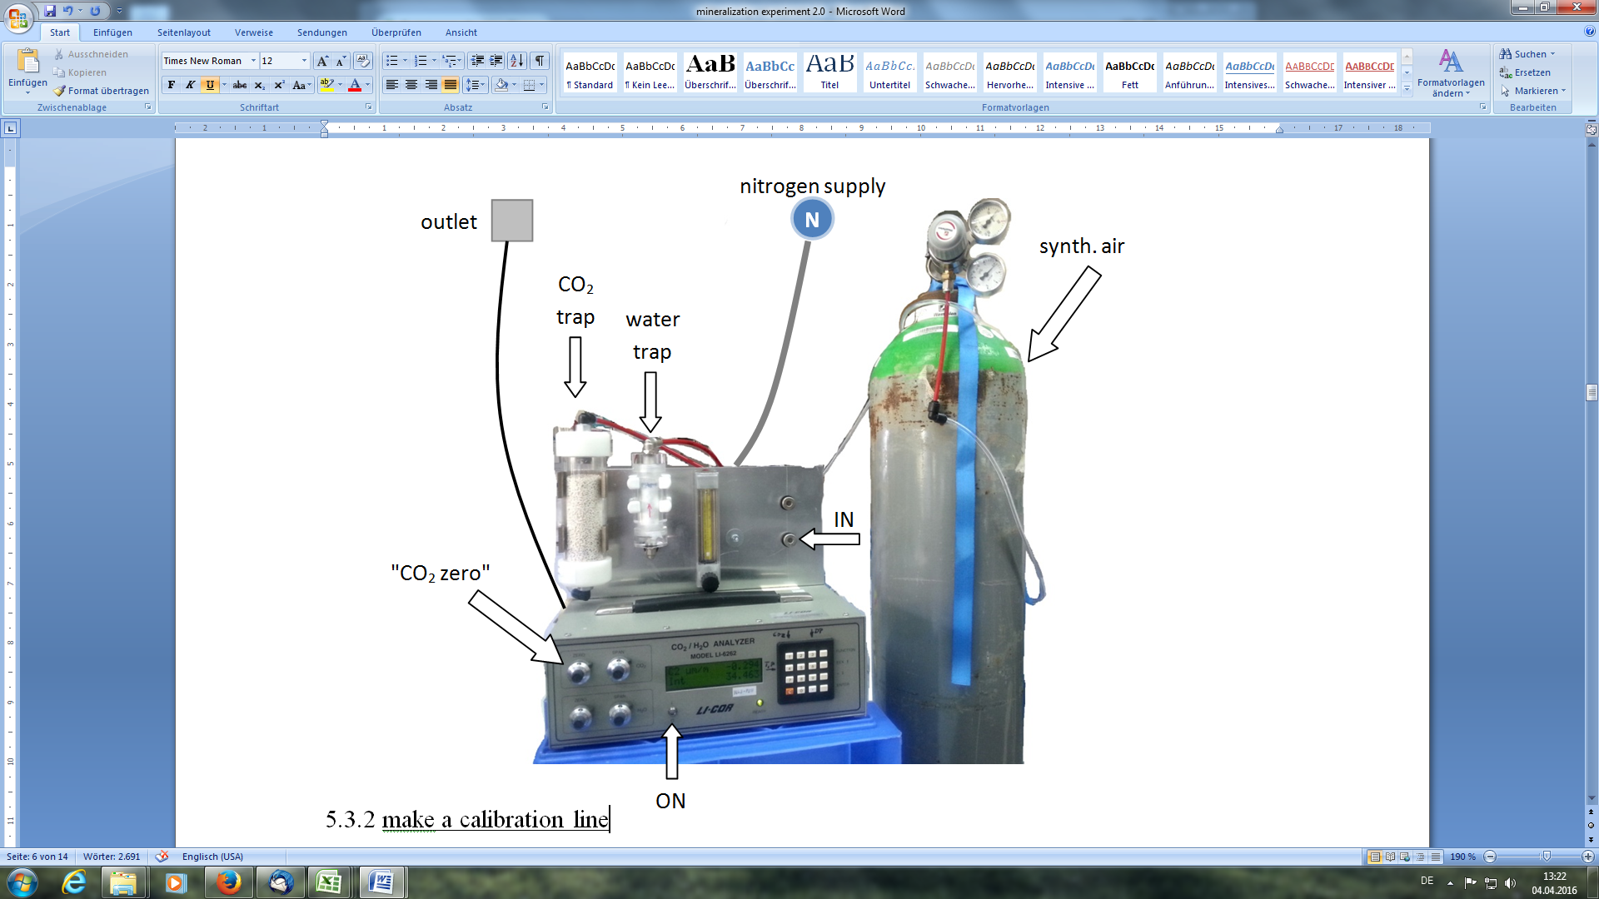

ON

5.3.2 make a calibration line:

* in the beginning of each series of measurement you have to make a calibration line with a CO2 reference gas (CO2-value = 3000 ppm).

|  |  |  |  |
| --- | --- | --- | --- |
| Date | Volume | Peak area (Int) | Peak height (Int Max) |
|  | 5,0 |  |  |
|  | 4,4 |  |  |
|  | 4,0 |  |  |
|  | 3,4 |  |  |
|  | 3,0 |  |  |
|  | 2,4 |  |  |
|  | 2,0 |  |  |
|  | 1,4 |  |  |
|  | 1,0 |  |  |
|  | 0,4 |  |  |

* calibration gas:

To open the CO2 gas bottle: make sure that valve [2] is closed while slightly open valve [1].

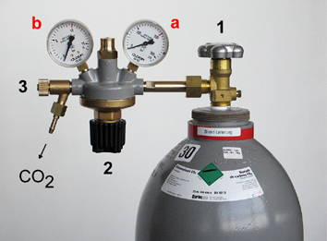

* + connect a 5ml syringe with stopcock
  + open the stopcocks of the syringe and the gas supply
  + let the CO2 stream in by turning the blue knob [**2**], close it afterwards
  + close the stopcock of the syringe
  + disconnect the syringe from the gas supply
  + to adjust the needed amount of CO2 the stopcock has to reopened slightly, set the desired volume (see calibration table above); close the stopcock afterwards
* add a needle to the syringe and pierce the septum of the CO2-analyzer in the middle (stopcock still closed, don`t press the plunger!)
* adjust the setup settings:
  + select the integrate-function: „*Function*“ 🡪 „*9*“ 🡪 *Enter*
  + select the channel code for CO2 in µmol/mol abs.: „*22*“ 🡪 *Enter*
  + select the starting point of your measurement : „On Exit“ (integration will start immediately) or „Thrsh“ (integration starts when selected channel rises above the threshold value) 🡪 select „*Thrsh*“ 🡪 *Enter*
  + select the starting threshold value: „0.25“ 🡪 *Enter*
  + select the ending point of your measurement : „Manuel“, „elaps tm“ or „Thrsh“ 🡪 select „*Thrsh*“ (integration stops at threshold value of 0.25µm/m) 🡪 don`t press Enter yet!

|  |  |  |  |  |  |  |  |  |  |  |  |  |  |  |  |  |  |  |
| --- | --- | --- | --- | --- | --- | --- | --- | --- | --- | --- | --- | --- | --- | --- | --- | --- | --- | --- |
| * open the stopcock of the syringe 🡪 press *Enter* 🡪 press the plunger evenly down 🡪 measurement starts * for further measurements: select integrate function: „*Function*“ 🡪 „*9*“ 🡪 *Enter* , press *Enter* 3 times more, open the stopcock, press *Enter* and press the plunger down 🡪 measurement starts * to switch between the two displays press 1 and 2 respectively   + 1. measure your samples: * swirl the incubation jar slightly, so that the developed CO2 is uniformly distributed * connect the syringe (with the stopcock) to one outlet of the incubation jar * 1. Open valve A, 2. Open the stopcock of the syringe, push and pull the plunger 10 times for flushing * take a 1 ml or 0,6 ml gas sample (by using the 5ml or 1ml syringe) * **close valve A of the incubation jar! Close the stopcock of the syringe!** * the procedure for measurement is the same like for the calibration (press „function“ 🡪 „9“ 🡪 *Enter*, press *Enter* 3 times more, open the stopcock, press *Enter* and press the plunger down 🡪 measurement starts) * protocol for sample measurement:  |  |  |  |  |  |  | | --- | --- | --- | --- | --- | --- | | Sample | Time | Date | Volume | Peak area (Int) | Peak height (Int Max) | | ***…*** |  |  |  |  |  | |  |  |  |  |  |  |   5.3.4 post-processing:  **Notice:** you have to remove the air pressure in the hoses of the gas bottle by opening the valve [2] (stopcock open) after closing the valve [1] (see picture)! If there is no more pressure, you can unscrew the manometer and secure the gas bottle by its lid.   * you have to close the CO2 gas bottle after usage:   http://www.seilnacht.com/news/tngas05.JPG |

**6. Gas sampling for 14C analysis**

***For the 14C measurement a minimum amount of 1 mg carbon per sample is required***

***(2% CO2 = 1850 ppm/bar per liter).***

**6.1 preparations:**

* close each injection flasks with a plug and secure the plug with an aluminum crimp cap (press lightly!)
* label the flasks with sample names etc.
* evacuate the injection flasks at minimum 4 mbar (the flask should be on its side!) by piercing the plug with a needle connected to the vacuum pump
* exchange the needle after 2-3 time use (otherwise needles can break off)

**6.2 gas sample transfer in injection flasks:**

* use a 60 ml-syringe to take the gas sample (120-135ml in total) from the incubation jar and inject the sample in the evacuated injection flask
* before: swirl the jar, connect the syringe with a stopcock, flush the syringe (push & pull)
* take the sample, close the stopcocks, disconnect the syringe
* add a syringe needle and pierce the plug and inject the gas sample

**7. Literature**

* M.R. CARTER & E.G. GREGORICH (2007): “Soil Sampling and Methods of Analysis”, Second Edition, S. 590, CRC Press
* REY et al. (2005): “Effect of temperature and moisture on rates of carbon mineralization in a Mediterranean oak forest soil under controlled and field conditions”, European Journal of Soil Science, [Volume 56, Issue 5,](http://onlinelibrary.wiley.com/doi/10.1111/ejs.2005.56.issue-5/issuetoc) pages 589–599

**8. Shopping list**

|  |  |  |  |
| --- | --- | --- | --- |
|  | **Name** | **Company** | **Purchase order name & item number** |
| **Incubation** |  | | |
|  | preserving jar 1L , without lids | P. Krieger Hotel- und Gaststättenbedarf Schäferstraße 94 31224 Peine | „Einmachglas Quattro“ Stagioni 100cl  365160MQ2321991 |
|  | One Way Stopcock | Mednet GmbH Borkstraße 10 48163 Münster | VPB1000055N |
|  | connecter | SERTO GmbH Falderbaumstraße 41 34123 Kassel | „Gerade Schottverbindung“  FP 31550-6 |
|  | glue | Bindulin-Werk H.L.Schönleber GmbH Wehlauer Strasse 49-59 90766 Fürth | Dichtfix (Tolouol) 47,5g Tube  D 10 TR |
|  | Exchange slices for 1L preserving jars | Gläser und Flaschen GmbH  Altonaer Str. 84-90  13581 Berlin | „Leifheit Ersatzscheiben“ 12 package  V1056400-12 |
| https://de.vwr.com/stibo/low_res/std.lang.all/95/26/4549526.jpg | beaker | VWR International GmbH Hilpertstraße 20a 64295 Darmstadt | „Bechergläser, hohe Form“  213-1172 |
| **CO2 measurement** |  | | |
| Calibrating gas  (3000 ppm CO2 + N) | Westfalen  Industrieweg 43 48155 Münster |  |
|  | Flushing gas (CO2 free) (UN 1956; 20,5 Vol % O2, Rest N2, KW-free) | Westfalen  Industrieweg 43 48155 Münster |  |
|  | CS-Siliconsepta for  Li-Cor (transparent, 3 mm thick, Ø 11 mm) | CS-Chromatographie Service GmbH | 366003 |
|  |  |  |  |
| https://dccdn.de/doccheckshop.com/out/pictures/generated/product/1/665_665_75/115102_bbraun-injekt-einmalspritzen_5ml_2465.jpg | 5 ml syringe Injekt® | B. Braun Melsungen AG Carl-Braun-Straße 1 34212 Melsungen | Injekt, 5 mL, Eccentric  9202650 |
| http://ghs-obermeier.de/shop/images/product_images/thumbnail_images/pet_9658.jpg | Cannulas (0,8 x 40 mm) | Henke-Sass Wolf GmbH  Keltenstraße 1  78532 Tuttlingen | 4710018040 |
|  | | | |
| **14C measurement** | Injection flasks 100ml, without lid | VWR International GmbH Hilpertstraße 20a 64295 Darmstadt | „100ml Injektionsflasche“, PEWA  612-0464 |
|  | plug | Bellco Glass 340 Edrudo Road Vineland  NJ 08360 | „Septum Stopper“, 20mm  2048-11800 |
|  | aluminium crimp cap | Macherey-Nagel GmbH & Co.KG Neumann Neander Str. 6-8 52355 Düren | BK N20-L, si  702804 |

**Flush with synthetic air (CO2 free) for soil samples with big tank**

1. Big cylinder must be closed. Connect the flasks in a line of flushing, two needles, inlet from tank, outlet to the atmosphere.
2. Open the valves of all the pipes that are connected to the inlet needles of the flasks.
3. Open the valves of the cylinder. **black valve slowly and then the gray.**
4. Let the flow in and out for 2 minutes.
5. When finished, close the inlet valve, take the needle out and after 15 seconds, take the outlet needle out as well, to avoid overpressure.
6. Close the cylinder valves. First close the valve of the cylinder and then the one of the manometer.
7. Note down the time, that is the incubation starting point.