**Protocol for sampling C14 from soil respiration**

1. **Traps preparation. See protocols**

**Objective**

* 6 rings X 2 samples (one every 12 hours) X 2 days = 24 MS. That is already 6 replicates per sample per day.
* 3 rings X 2 samples (one every 12 hours) X 4 days = 24 MS. That is already 3 replicates per sample per day.
* 4 rings X 5 times (6, 10, 14, 18, 22) X 5 days = 25 MS. There is no replicate for sample

**Leakage test**

1. An instrument that measures CO2 concentration is useful in a molecular sieve (MS) sampling kit for leak testing. Leak testing can be performed by removing all the CO2 in a sampling system (e.g., Mini kit and chambers) when set in a closed loop configuration (by pass). An instrument that measures the CO2 in the system once it has been removed (or at least reduced significantly below that of the surrounding air), by pumping continuously the air inside the system, but not through soda lime or molecular sieve, any leaks should be detectable from the ingress of atmospheric CO2. Clearly detection of leaks will depend on the rate of atmospheric ingress and the sensitivity of the instrument performing the CO2 measurements, with the higher sensitivity of an IRGA being an advantage. To compensate for the lower sensitivity of the Mini kit CO2 sensor, leak testing can be performed over a longer period. We also periodically perform leak tests by coupling the Mini kit to an IRGA (Garnett 2021).
2. In the case of the Mini kit, submerge the chamber in water to ensure no incoming CO2 from below (2 cm), then adjust all the fittings and scrub the remaining CO2 until steady state. Then close all valves and circulate the air through the bypass, the CO2 ppm should remain constant. If it increases, it means that there is incoming CO2 from outside.
3. To find a **leakage rate**, write the ppm every 15 seconds during 10 or 15 minutes and then plot. A common leakage rate is around 3 to 5 ppm. The **diffusion rate** (atmospheric CO2 entering the chamber system) when sampling, might decrease as respiration CO2 builds up and the gradient goes from inside to outside due to high concentrations.

**Installation**

1. Install the PVC collar 3 weeks before the measurement to avoid influence from biomass damage/disturbance. The higher the porosity, the deeper the insertion of the collar. In ecosystems with permanent rooting of plants (e.g. forest ecosystems), the collars should be placed on top of the humus layer and only pressed firm but gently into the humus to avoid cutting the roots. Chamber height should be at least 10 cm and depth into the soil at least 3 cm to 20 cm. Install the chambers considering to represent the heterogeneity of soil conditions. Remove vegetation if you want only heterotrophic CO2.
2. When inserting the PVC ring. Measure the inner height (effective chamber volume).
3. When placing the top, open one of the openings to avoid overpressure and be able to close the top properly.
4. If the soil is too hard, you will need a knife to open the path for the PVC ring. A hammer could work. The damage of the biomass while inserting the ring could alter the isotope signature. To prevent this, do not insert the chamber deeply and instead try to reduce the diffusion inwards around the ring by placing some clay or an O-ring.
5. Close the chamber. Connect one tube (deeper than the second one) to the inlet of the water trap (MgCl). Connect the tube coming out of the pump to the right side of the pipes box (use a wider silicon hose to connect them). The left pipe coming out of the circuit box goes to the chamber (shallower).

**Scrubbing**

1. Turn the Minikit ON. Close all the valves except scrubbing. Allow the air to pass through the soda lime (atmospheric CO2 capture).
2. Turn the pump ON. In this sense, the respiration from the chamber is sucked by the pump and goes first to the water trap, flows to the CO2 sensor and register concentration (also without water is protected). Pump until it gets down to 0 or to a steady state. As CO2 from soil is still building up, the sensor would never reach 0 ppm. As a rule (Kwon 2019), based on pump speed you can scrub a volume equivalent to at least 5 times the chamber volume. Pumping rate is 1.2 L/min. VOLUME OF CHAMBER IS 1983 CM3, If I insert the collar 4 cm. To pump 5 times the chamber, it needs to be at least 8.3 min.
3. Once the sensor is showing a ppm in steady state. Set the cal to 400 (this is going to be the initial CO2 concentration without atmospheric contamination) by holding the stick ON. Record that number since it’s the minimal suction background value. There is a small dead volume between Sampling valves and the sieves (as well as inside the flask pipe). This can be flushed by closing V2 (with the pump ON) for some seconds until the flow stops and then opening it. This will draw low pressure to the dead volume and then flush it. This step is repeated 3 times (Palonen 2016).
4. Now the value is in 400 ppm. When you are going to scrub the flask, close the scrubber and open the flask valves. The ppm will increase till 580. Then open the scrubber and wait until is 400 again. Do it several times since the flow circuit is not going through the flask directly.
5. Close scrubbing valves. Turn OFF the pump.
6. How to scrub sampling pipping section? How to scrub sampling pipping section? There is a small dead volume between V2 and the sieves. This can be flushed by closing V2 (with the pump ON) for some seconds until the flow stops and then opening it. This will draw low pressure to the dead volume and then flush it. This step is repeated 3 times (Palonen 2016).

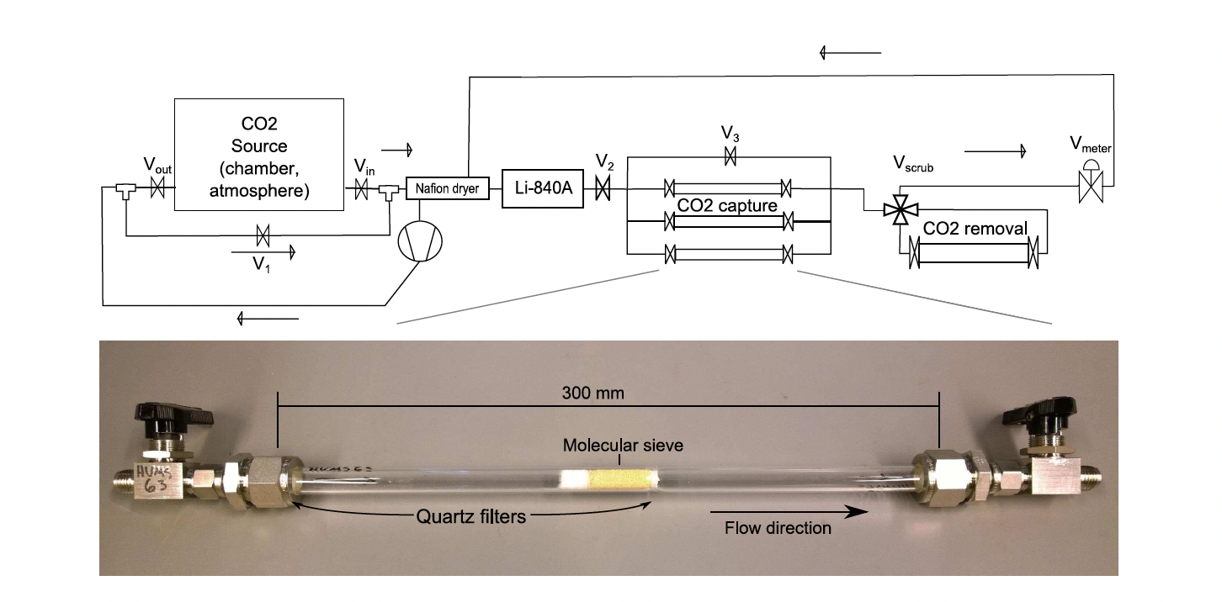

**Monitoring of threshold**

1. After some time, measure the CO2 concentration by turning ON the pump and opening the bypass valves. Close them after finishing measurement? What is the threshold? Make calculations with volume of chamber.

**Sampling**

1. When reached the threshold (after 40 min, it reached 1100 ppm), open sample valves and MS valves and turn ON pump until CO2 concentration reaches initial background. Turn OFF pump. However, as the soil is still respiring, the concentration might not go to initial value.
2. Write initial concentration immediately before starting pumping for sampling and then final concentration to calculate MS CO2 capture with the next equation. Use the ideal gas equation to know the mass of CO2. **VOLUME OF CHAMBER IS 1983 CM3 IF I bury the collar 4 cm.**

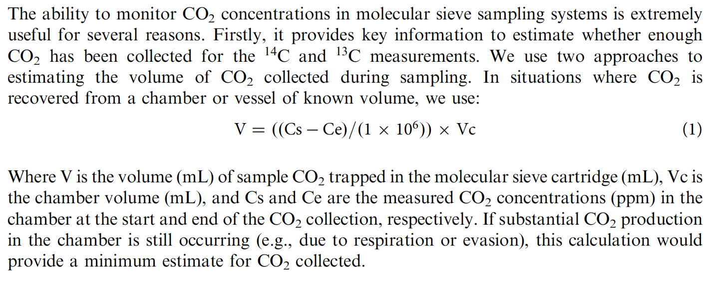

1. After finishing MS CO2 collection, close sample valves and uninstall the MS trap.

**Test**

1. Test the leakage rate with a known gas concentration circulating through the system. Leakage should be < 3% of the measured flux.
2. Check the diffusion and air movement around the chamber with the smoke of a cigarette.

**This is a test**