Integrating Multi-Omics Data for Deep Learning-Based Prediction of Production and Feed Efficiency Traits in Pigs
Ioanna-Theoni Vourlaki¹, Maria Gracia Luigi-Sierra², Levi Ayres³, Yuliaxis Ramayo-Caldas¹, Mario P.L. Calus³, Peter Karlskov-Mortensen², Miriam Piles¹
¹ Animal Breeding and Genetics Program, IRTA, Caldes de Montbui, Spain; ² Department of Veterinary and Animal Sciences, University of Copenhagen, Copenhagen, Denmark; ³ Animal Breeding and Genomics, Wageningen University & Research, the Netherlands;
Abstract
Background
Integrating multi-omics data through deep learning offers a promising approach to enhance the prediction of complex production traits in livestock. In pigs, genomic, transcriptomic, and epigenomic layers provide complementary information that can improve the prediction of traits such as average daily gain (ADG), backfat thickness (BFT), and residual feed intake (RFI). However, the optimal strategies for omics integration and feature selection to maximize predictive performance remain unclear. Here we evaluated deep learning models using two multi-omics integration strategies, early and intermediate fusion, across 443 pigs from Duroc (DD), Landrace (LL) and Yorkshire (YY) breeds. Dimensionality reduction and feature selection were applied via principal component analysis, partial least squares (PLS), and multi-omics factor analysis. Model performance was evaluated using Leave-One-Breed-Out (LOBO) validation for across-breed transferability and stratified 5-fold cross-validation for multi-population generalisation.
Results
Across all traits and validation schemes, intermediate integration combined with PLS-based feature selection consistently outperformed alternative approaches. Models using PLS-selected features (100-200 per omics layer) achieved higher predictive correlations than models using full omics datasets, while substantially reducing model complexity. Under the LOBO strategy, median prediction correlations reached for RFI: 0.71 in DD, 0.70 in LL, 0.67 in YY; for ADG: 0.38 in DD, 0.46 in LL and 0.38 in YY; for BFT: 0.40 in DD, 0.51 in LL, and 0.50 in YY. In stratified 5-fold cross-validation, the highest median correlations were 0.48 for ADG, 0.51 for BFT, and 0.72 for RFI. These results demonstrate that targeted feature selection effectively captures the most informative omics signals for trait prediction.
Conclusions
Structured intermediate integration of multi-omics data with PLS-based feature selection provided robust and accurate deep learning predictions of key pig production traits, achieved using only a small, strategically selected subset of informative features from each omics layer. This approach was generalizable across breeds and traits, offering a practical framework for multi-omics assisted breeding programs to enhance productivity and feed efficiency.

Background
Genomic selection, as introduced by Meuwissen et al. [1], has transformed animal breeding over the past two decades by enabling the use of dense genome-wide markers to improve estimation of breeding values and accelerate genetic gain. Traditional genomic prediction models rely primarily on single-nucleotide polymorphism (SNP) data and linear statistical approaches such as genomic best linear unbiased prediction (GBLUP; [2]) or Bayesian methods [3]. While these models have proven effective, they may fail to capture the complex, nonlinear biological interactions that contribute to phenotypic variability [4].
Deep learning (DL), a family of machine learning algorithms designed to model complex and nonlinear patterns in high-dimensional data, offers a promising alternative for capturing higher-order interactions [5-7]. Originating from Rosenblatt’s perceptron in the 1950s [8], DL methods have evolved to automatically extract informative representations from raw data without requiring strong parametric assumptions.
Recent advances in high-throughput technologies have enabled the simultaneous collection of multiple omics datasets, including transcriptomics, epigenomics, proteomics, and metabolomics, which capture complementary layers of biological regulation underlying phenotypic variation. Integrating these omics layers can substantially improve trait prediction by modelling regulatory interactions, tissue-specific gene activity, and epigenetic modifications that are not captured by genomic data alone. Empirical studies in pigs, mice, Drosophila melanogaster, quail, and cattle have shown that incorporating transcriptomic, metabolomic, or microbiome information can enhance predictive accuracy [9-16]. Nevertheless, effective multi-omics integration remains challenging due to high dimensionality, noise, and heterogeneity across data types.
In plant breeding, multi-omics integration has shown considerable potential, although gains have been inconsistent across datasets and traits, highlighting both the opportunities and challenges of holistic, data-driven strategies in modern breeding [17]. Omics technologies have already advanced livestock breeding by uncovering molecular mechanisms underlying growth, fertility, feed efficiency, and disease resistance. Extending these efforts to multi-omics frameworks that combine complementary data layers could further enhance genomic prediction and accelerate genetic gain [18-19].
Several multi-omics integration strategies have been extensively reviewed [20-23]. These include early integration, where omics layers are concatenated prior to modelling; intermediate integration, in which each dataset is first processed or modelled independently, and the resulting representations are then merged; and transformation-based integration, where each omics dataset is transformed typically into graphs, similarity matrices, or kernel representations before these transformed structures are combined into a unified model input. Additionally, factorization methods such as Multi-Omics Factor Analysis (MOFA; [24,25]) offer an unsupervised framework to identify both shared and modality-specific sources of variation across omics layers, effectively learning a joint representation of multi-omics data that can be used for downstream tasks.
Deep learning provides a powerful framework for multi-omics integration because it can effectively merge heterogeneous datasets and capture nonlinear relationships more efficiently than conventional genomic prediction models, although its superior performance is not guaranteed [5]. Several studies have reported improved prediction of complex traits in livestock using deep learning [26-28], yet significant computational demands and limited sample sizes remain key challenges [29].
Feature selection (FS) and dimensionality reduction also play a crucial role in reducing data complexity and enhancing deep learning performance, particularly in moderate sample sizes common in animal studies [7]. Machine learning-based FS methods including, filter, wrapper, and embedded techniques have been successfully applied to SNP and other molecular markers in livestock [7,30,31], yet their application to multi-omics deep learning remains limited.
Empirical studies indicate that integrating multiple omics datasets can enhance trait prediction; however, the lack of standardized and effective data fusion strategies remains a major limitation. Challenges such as data heterogeneity, high dimensionality, and model optimization hinder the full exploitation of multi-omics information. These issues are particularly pronounced in deep learning applications, where high-dimensional datasets increase computational complexity and complicate model training, making it more difficult to fully leverage the predictive advantages of deep learning.
To address these gaps, this study explores deep learning-based strategies for integrating SNP genotypes, gene expression profiles, and DNA methylation data to predict three key production traits in pigs: daily weight gain (ADG), backfat thickness (BFT), and residual feed intake (RFI). We systematically compared early and intermediate integration approaches, in which each omics layer was either concatenated directly or processed through a dedicated subnetwork whose latent representations were subsequently merged for prediction. To assess the effect of dimensionality reduction and FS, models were benchmarked using (i) all available features, (ii) reduced representations obtained via principal component analysis (PCA), and (iii) subsets of statistically informative features identified through partial least squares (PLS) and MOFA. Predictive ability was first evaluated for across-breed transferability, followed by a stratified 5-fold cross-validation framework to assess performance under breed-stratified sampling. Together, these analyses allow us to identify the most robust deep learning strategies for multi-omics prediction in pigs. By establishing which integration and feature-reduction approaches maximize predictive accuracy, this work provides practical guidelines for incorporating heterogeneous omics data into genomic prediction pipelines and contributes to the development of more biologically informed and efficient breeding strategies.

Methods

Experimental Animals and Sampling
The study initially included 483 male, non-castrated pigs representing three commercial pure breeds: Duroc (DD), Landrace (LL), and Yorkshire (YY). After quality control and filtering (see below), 443 animals were retained for the final analyses (DD, n = 300; LL, n = 295; YY, n = 152). Animals were chosen according to their genomic breeding values to capture the upper and lower ranges of key selection traits, i.e., growth and feed efficiency in DD, and growth, feed efficiency, and litter size in LL and YY. All pigs were managed identically and received the same standard diet. When the animals reached approximately 100 kg, longissimus dorsi muscle biopsies were collected, rapidly frozen in liquid nitrogen within five minutes, and stored at -80 °C until further use. These samples were subsequently processed for molecular analyses, including RNA-seq and RRBS.

Phenotypes
Three phenotypic traits corresponding to the 443 animals were included in this study due to their importance in animal breeding: ADG, BFT, and RFI. Phenotypic records were pre-corrected within breed for systematic environmental effects based on the breeding company’s standard genetic evaluation protocols. Average daily gain (g/d) was computed in the growth window from 30 to 100kg of live weight. Trial measurements were taken from electronic feeding stations. The traits was defined as:
$$\text{ADG}=\frac{{\text{Body weight}}_{\text{end of trial}}-{\text{Body weight}}_{\text{start of trial}}}{\text{Days of trial}}×1000$$
and subsequently adjusted for the stable where the pig was housed (section), sex, parity of the dam, and start weight using a linear regression model.
Backfat thickness (BFT, mm) was calculated as the mean of four backfat measurements taken at approximately 100 kg live weight and was adjusted for the stable where the pig was housed, sex, parity of the dam, and weight at scanning.
Residual feed intake (RFI, g/d) was defined as the residuals from a linear regression of average feed intake during the trial on section, parity of the dam, ADG, and metabolic body weight (kg). Metabolic body weight was computed as:
$$\text{MBW}=\frac{{\text{Body weight}}_{\text{end of trial}}^{1.75}-{\text{Body weight}}_{\text{start of trial}}^{1.75}}{1.75×\left({\text{Body weight}}_{\text{end of trial}} − {\text{Body weight}}_{\text{start of trial}}\right)}$$
The phenotypic distributions of all traits are presented in Supplementary Figures 1-3.

SNPs-Genotypes
Animals were genotyped using the 50K GGP-Porcine Illumina Bead SNP array (NEOGEN). The genotypic data for 443 pigs from the Duroc, Landrace, and Yorkshire breeds contained approximately 41,000 SNPs with no missing data within breed, as missing genotypes had been imputed by the breeding company. Quality control was conducted using Plink v1.90b6.21 [32-33] and custom R scripts [34]. Raw genotype files were converted to text and screened for problematic markers. This process led to the removal of 358 duplicated SNP IDs, keeping a single copy for biallelic variants, and the exclusion of indels and triallelic SNPs, resulting in a dataset of 40,535 biallelic SNPs. Each breed was genotyped separately, and monomorphic positions were removed during imputation; therefore, merging the breeds introduced missing genotypes for some SNPs across breeds. To generate a dataset suitable for across-breed analyses, we retained only SNPs that were biallelic and present in all three breeds, resulting in a common panel of 11,900 SNPs.

Gene expression data
RNA raw data processing
Transcriptomic data were derived from the longissimus dorsi muscle. Total RNA was extracted using the RNeasy Fibrous Tissue Mini Kit (Qiagen), libraries were prepared using the NEBNext Ultra II polyA + mRNA kit and were subsequently sequenced on the Illumina NovaSeq 6000 platform (2×150 bp paired-end reads). Quality control of raw sequencing reads was performed using FastQC, followed by removal of ribosomal RNA sequences with BBduk. Adapter trimming and filtering of low-quality reads were carried out with TrimGalore, discarding reads containing more than five ambiguous bases (Ns), reads shorter than 35 bp, and bases with Phred quality scores below 20. Filtered reads were aligned to the Sscrofa 11.1 reference genome (Ensembl release v109) using the STAR aligner in a 2-pass mode [35], in which splice junctions detected during the first pass were incorporated into the genome index to improve second-pass alignment accuracy. Alignment quality metrics were assessed using Qualimap [36]. Gene-level quantification was performed with featureCounts [37] to obtain a sample-by-gene count matrix. Lowly expressed genes were removed by retaining only those with counts-per-million (CPM) > 0.5 in at least 20% of individuals, resulting in an expression matrix containing 14,293 genes across 443 animals. To correct for compositional differences between libraries, Trimmed Mean of M-values (TMM) normalization was applied, followed by log2-CPM transformation of the normalized counts. All normalization and transformation steps were performed using the edgeR package in R [38].

Methylation data
DNA Methylation Data Processing
Genomic DNA was isolated from the longissimus dorsi muscle of 443 pigs. Reduced Representation Bisulfite Sequencing (RRBS) libraries were prepared using the Diagenode Premium RRBS v2 kit [39]. Libraries were sequenced on a Novaseq 6000 platform. Raw reads were processed using UMI-tools to attach unique molecular identifiers for deduplication, followed by quality control with FastQC and trimming with TrimGalore (≥15 bp, MspI site removal). Reads were aligned to the Sus scrofa 11.1 reference genome using Bismark [40] option (--pbat), with deduplication using UMIs. Methylation calls from complementary strands were merged, and CpG sites were retained if covered by ≥10 reads in ≥20% of pigs per breed. Contiguous cytosines within ±1 bp on opposite strands were merged as single CpGs to increase coverage. DNA methylation levels were expressed as the proportion of methylated reads relative to the total number of reads at each CpG site. Samples were retained if they contained data for at least 80% of the retained CpG sites within each breed. After filtering, any remaining missing values were replaced with the median methylation rate of the corresponding CpG site within the same breed. Methylation rates estimated from low-coverage observations (between 1 and 4 reads) were imputed using a Bayesian beta-binomial approach. Specifically, the observed number of methylated reads was modeled as a realization of a binomial distribution with parameters n (coverage; 1-4 reads) and p (the true methylation rate). A beta distribution was used as the prior for p, with parameters defined based on the breed-specific median methylation level for that CpG site. The imputed value corresponded to the median of the resulting posterior beta distribution. If the posterior median was extremely small (<10⁻¹⁰), it was rounded to zero. After filtering and imputation, the final dataset contained 1,095,304 CpG sites across the 443 pigs.

Deep Learning-based Prediction
Several deep learning-based prediction approaches were implemented to predict the three phenotypes following different strategies in terms of network architecture and input information. Regarding network architecture, two strategies for integrating multi-omics information were assessed, each resulting in a distinct Multilayer Perceptron configuration: ‘early integration’ and ‘intermediate integration’.
The Multilayer Perceptron (MLP) is one of the most widely used deep learning architectures. A MLP is a fully connected feedforward neural network that transforms inputs of any dimension into outputs of the desired dimension. Each neuron in a given layer is connected to every neuron in the previous layer and to every neuron in the next layer. Each neuron receives input values multiplied by their corresponding weights. The sum of all weighted inputs plus a bias term is then passed through a nonlinear activation function, which introduces nonlinearity and enables the network to model complex relationships. The output of each hidden layer can be represented as:
$$H^{(l)}=f(XW^{(l)}+b^{(l)})$$
where $H^{(l)}$ is the output of layer $l$, $X$ is the input matrix of all training examples, $W^{(l)}$ is the weight matrix, $b^{(l)}$ is the bias vector, and $f(⋅)$ is a nonlinear activation function. The output of neurons from one layer serves as input to the next layer. Supplementary Figure 4 illustrates the basic workflow of an MLP network.
In the early integration approach (Supplementary Figure 5, Panel A), the three omics datasets are concatenated before being fed into the MLP model, allowing the network to process all features jointly. Because this combined input is high-dimensional, a bottleneck layer, a hidden layer with a reduced number of neurons, is introduced to compress the input space. This dimensionality reduction prevents the model from having millions of learnable parameters, lowering computational cost and helping the network extract meaningful representations rather than overfitting. Following the bottleneck layer, a series of hidden layers, whose number was selected during hyperparameter optimization, process the compressed features and ultimately produce the final output layer that yields the predicted phenotypic traits.
In the intermediate integration approach (Supplementary Figure 5, Panel B), the three omics datasets are fed into separate subnetworks. Each omics subnetwork starts with its input layer, followed by a bottleneck layer to reduce dimensionality. The outputs of these subnetworks are then concatenated into a single hidden layer, which is followed by an additional hidden layer that halves the number of nodes from the previous layer. Finally, the output layer generates predictions of the phenotype. This strategy allows the network to learn omic-specific representations before integrating information across omics datasets.
Regarding the information in the input datasets, different FS strategies were implemented to evaluate whether reducing redundancy and eliminating non-informative features could enhance predictive performance, with the absence of variable selection used as a benchmark. Thus, in this case, the complete data matrices for each omic layer were used after standardization. For each dataset (SNPs, gene expression, and CpG methylation) and for the target traits, we used the StandardScaler implementation from scikit-learn version 1.7.1 [41]. For every omics layer, the scaler was fitted exclusively on the corresponding training subset to estimate the mean and standard deviation, and these parameters were subsequently applied to the test subset. This procedure ensured a leakage-free z-score transformation in all modelling approaches.
The DNA methylation dataset comprised over one million CpG sites, which imposed substantial computational demands and hindered the model’s ability to generalise and capture meaningful patterns. Dimensionality was reduced by selecting features based on the following criteria:
Variance across samples
For each CpG site, the variance across all 443 samples was calculated. The distribution of variances was examined across multiple quantiles (0.01, 0.05, 0.1, 0.25, 0.5, 0.75, 0.9, 0.95, 0.99; Supplementary Figure 6). Two variance cutoffs were applied to define subsets of CpGs:
- A lenient cutoff of 0.01, which retained CpG sites above the 76.9th percentile of variance. This resulted in approximately 255,933 CpG sites, corresponding to 24.1% of the total CpGs.
- A stricter cutoff of 0.05, which retained CpG sites above the 95th percentile, resulting in roughly 14,492 CpGs, corresponding to only 1.95% of the total sites.
This variance-based selection strategy, hereafter referred to as variance filtering, ensures that low-variance or invariant CpG sites, which contribute little to phenotypic prediction, are excluded from the model (Supplementary Figure 7). The lenient and strict cutoffs are designated VF0.01 and VF0.05, respectively, throughout this study.
Variable Importance in Projection (VIP) scores in a Partial least Squares (PLS) analysis
Unlike unsupervised methods such as PCA or MOFA, PLS is a supervised learning method, as it uses the training set phenotypes (Y) to guide the extraction of latent components from the predictor matrix (X). Specifically, PLS identifies latent components that maximize the covariance between X and Y, thereby capturing variation in the omics data that is most predictive of the trait. Features that contribute strongly to the most influential components receive higher importance scores. PLS was performed using the caret package in R (Kuhn, 2008), and FS was applied exclusively to the training set defined based on each prediction scenario (see “Sampling process and validation” section below).
PLS models were fitted separately for each trait by omics dataset (SNPs, gene expression, and CpGs). For the SNP-based models, the full dataset of 11,900 markers was included. Gene expression models used the complete set of 14,293 genes, whereas CpG-based models were fitted using the variance-filtered CpG matrix (variance threshold = 0.05), comprising 14,493 CpG sites. For each combination of trait and omics layer within each training dataset, feature importance scores were computed using the varImp function from the caret package [42]. This function calculates scores based on the weighted sum of absolute regression coefficients, adjusted according to each component’s contribution to the reduction in the sum of squares. From these importance scores, the top k features were selected independently for each omics layer, where k = 10, 100, 200, 500, 1,000, 3000 or 5,000. For example, when k = 10, the 10 most important SNPs, 10 most important genes, and 10 most important CpG sites were retained, each based on separate PLS models for that omics layer. These selected subsets were subsequently used as inputs for the deep learning model, ensuring that the most predictive features from each omics dataset were preserved.

Threshold of variance explained by the first k principal components
To further address the high dimensionality of the omics datasets, we applied dimensionality reduction using Principal Component Analysis (PCA). PCA identifies orthogonal components that capture the maximum variance within each omics layer and provides a compressed representation that reduces noise and redundancy. This can benefit deep learning models, as a relatively small number of components may retain most of the relevant biological signal, improving model efficiency and predictive performance. To avoid data leakage, all preprocessing steps were performed using training-only information. PCA was applied separately to each omics dataset. The number of components retained was determined using a variance-explained threshold, keeping all components that together explained 90% of the total variance within each omics layer. For the CpG data, the variance-filtered matrix (threshold = 0.01) comprising 255,933 sites was used, as applying PCA to the full set of ~1 million CpG sites was computationally infeasible. The resulting PCA-derived features were used as inputs for the deep learning models. PC components were used as separate inputs to the integration-based model, whereas for early integration, they were concatenated prior to model input. This design allowed us to isolate the effect of the integration strategy itself, minimizing differences due to feature dimensionality.
MOFA+ latent factor contributions
MOFA+ [24] is a probabilistic factor analysis framework designed for multi-omics integration. It identifies latent factors that capture sources of variability across heterogeneous omics layers. MOFA is an unsupervised learning method, as it does not require any information about the target trait or labels. Conceptually similar to PCA, MOFA+ reduces dimensionality across multiple omics datasets simultaneously, capturing coordinated or layer-specific patterns of variation. Each latent factor can represent variability that is shared across several omics layers or specific to a single layer, providing a flexible and interpretable representation of multi-omics structure. Because MOFA aims to model meaningful covariance patterns, it is generally advisable to remove low-variance features prior to analysis; such features typically contribute noise and do not meaningfully inform the factor structure. Overall, MOFA captures covariance both within each omics layer and between layers, enabling a data-driven dimensionality reduction that preserves cross-omics relationships.
In this study, MOFA was used as a FS method prior to prediction and was applied independently within each training set to prevent information leakage into the test data. The full SNP dataset and the full set of gene expression features were used. Because MOFA requires sufficient variability to identify meaningful latent factors, the CpG variance-filtered matrix (VF0.05), of 14,493 sites was used as MOFA input. MOFA+ was used to extract latent factors for FS prior to prediction. Model options were defined as follows: all omics datasets (SNPs, gene expression, and CpGs) were modelled using a Gaussian likelihood, and the number of latent factors was set to 20. Training options were defined to ensure robust factor estimation: a random seed was used and stored for reproducibility, latent factors explaining less than 3% of variance across all omics were automatically dropped to remove uninformative factors, ensuring that only factors capturing meaningful variation were retained.A maximum of 1,000 iterations were allowed. Feature selection using MOFA was performed as follows. After the model identified the optimal number of latent factors, we focused on factors that captured variation shared across all modelled omics layers. From the MOFA output matrices, we extracted the contribution of each feature to the identified latent factor. Features were ranked by the absolute value of their contributions, and subsets of varying sizes (10, 100, 200, 500, 1,000, 3,000, and 5,000 features) were retained independently for each omics layer. For example, the top 100 SNPs, top 100 genes, and top 100 CpG sites were selected based on their respective contributions to the latent factor . These subsets were then used as inputs for the deep learning model, ensuring that the most informative features from each omics dataset were preserved. All the above-mentioned input strategies were applied for the intermediate integration method. A summary of all methods and FS strategies is provided in Table 1.

Table 1: Model setup including the two integration strategies and the different input strategies. Each model variant (combination of integration and input strategy) run separately for each trait and each training dataset.
 | Intermediate Integration |  |  |  |  |  |  |  |  |  | Intermediate and Early Integration
 | All features (AF) | Variance-filtering (VF) features | PLS |  |  |  | MOFA |  |  |  | PCA > 90%
 |  |  | Subset size of selected features
 |  |  | 10 | 100 | 200 | 500 |  | 1000 | 30000 | 5000
SNPs | ALL | ALL | Selected |  |  |  |  |  |  |  | Selected
Transcripts | ALL | ALL | Selected |  |  |  |  |  |  |  | Selected
CpGs | ALL | threshold > 0.01 (VF.001) | Selected |  |  |  |  |  |  |  | Selected
 |  | threshold > 0.05 (VF.005)

Sampling process and validation
Prediction performance was evaluated under two distinct scenarios: 1) Across breeds, and 2) Within a single mixed population comprising all three breeds. The first scenario assessed model transferability, that is, whether the omics layers capture trait-feature relationships that are consistent across breeds. To explore this, a Leave-One-Breed-Out (LOBO) validation approach was implemented. In this strategy, each of the three breeds was used in turn as the test dataset, while the remaining two breeds were combined to form the training dataset. This resulted in three distinct training-test splits for each model. Table 2 shows the number of animals in each combination.

Table 2: Leave-One-Breed-Out (LOBO) validation approach where one breed was used as the test set and the remaining two were combined as the training set.
Prediction | Training Set (n) | Test Set (n)
Train on DD + LL → Test on YY | 143 + 148 = 291 | 152
Train on DD + YY → Test on LL | 143 + 152= 295 | 148
Train on LL + YY → Test on DD | 148 + 152= 300 | 143

The second scenario evaluated predictive performance in a pooled dataset containing all three breeds. In this stratified cross-validation approach, we assumed that the relationships between omics features and the phenotype were largely shared across breeds, allowing the three populations to be merged into a single dataset. Thus, we implemented a stratified 5-fold cross-validation, ensuring that each fold contained animals from all three breeds (YY, LL, and DD) in roughly equal proportions. This approach allowed us to evaluate prediction performance while maintaining balanced breed representation in both training and test sets (Supplementary Figure 8).Unlike LOBO validation, stratified cross-validation evaluates the model’s ability to generalise across individuals from multiple breeds simultaneously. For LOBO, each test set contained a single breed, and Pearson correlations between predicted and observed traits were computed within each fold. This setup reflects the model’s transferability to an unseen breed that was not included in the training dataset. In contrast, each fold in stratified cross-validation included individuals from all breeds. To avoid inflated correlations driven by breed differences, we computed Pearson correlations using phenotype-adjusted traits, where breed effects were removed. This approach captures the model’s ability to predict individual variation within breeds rather than differences between breeds. The raw traits (ADG, BFT, and RFI) were adjusted by extracting the residuals from a linear model in which breed was included as a covariate, using the lm function in R. Pearson correlations were computed on the test set of each cross-validation fold, containing individuals from multiple breeds, by comparing predicted and observed values. .
Hyperparameter Optimization
MLP models were implemented for various model setups resulting from the combination of integration strategy and input configuration. Each model was trained separately for the three phenotypes and for each of the eight training datasets (three from the LOBO strategy and five from the 5-fold cross-validation strategy). Additionally, each network combination (trait x dataset x strategy) was trained from scratch three times, using different initialization seeds and performing independent hyperparameter tuning in each run. These three independent runs per model setup capture variability due to both random initialization and hyperparameter selection, providing robust estimates of model performance.
Hyperparameter tuning was performed separately for each model variant using the Keras Tuner [43] library to identify the optimal set of hyperparameters. To ensure robustness, tuning was conducted using stratified 5-fold cross-validation, with each fold maintaining an equal representation of the three breeds. Within each fold, 20% of the training data was held out as a validation set, used exclusively to evaluate model fit during hyperparameter selection; the model does not learn from the validation set.
Deep learning performance is influenced by multiple hyperparameters, and thus hyperparameter optimization is a critical step. The Bayesian Optimization tuner in Keras tuner, was used to efficiently explore the hyperparameter space and identify configurations that minimize validation loss, allowing for faster and more effective hyperparameter selection compared to random or grid search. For each configuration, five models (one per fold) were trained. For each fold, the model’s performance was monitored on the validation set using the same loss function as for training (mean squared error, MSE). The validation loss refers to the value of this loss function computed on the validation set. The best validation loss is (the lowest value observed during training), and the epoch at which it occurred were recorded for hyperparameter selection. . After training all five folds for a given configuration, the tuner computed the median validation loss and median epoch across the folds. The Bayesian tuner then compared the median validation losses across all tested hyperparameter trials, and the configuration with the lowest median validation loss was selected as optimal. The median epoch from this best trial was also stored. Once the best hyperparameters were identified, the network was retrained on the entire training dataset using this optimal configuration and the best epoch. Predictions were then made on the test dataset, which served as a gold standard for an unbiased evaluation of model performance. Model performance on the test set was quantified using the Pearson correlation coefficient between observed and predicted trait values. A schematic diagram of the model training and validation process for each input strategy based on LOBO prediction scenario is shown in Figure 1 and for 5-fold cross validation in Supplementary Figure 9.
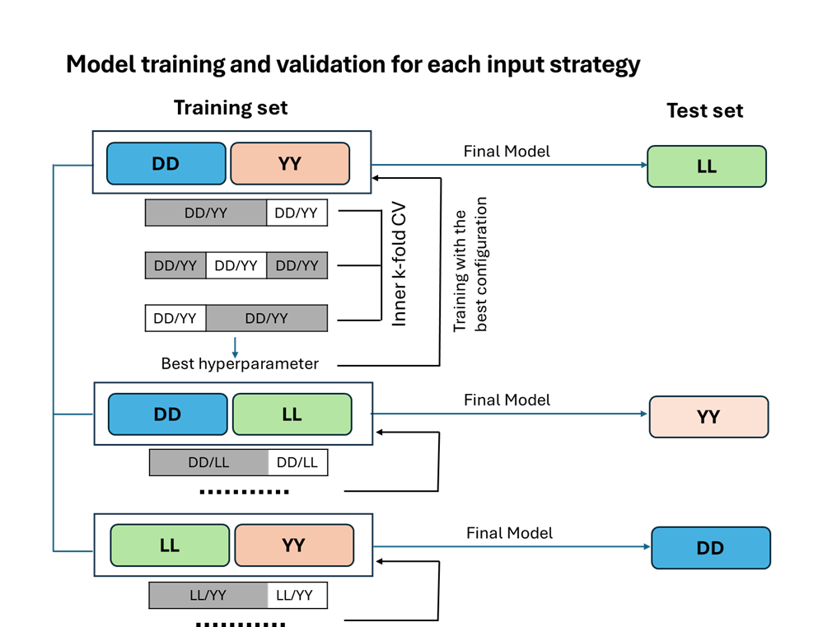
Figure 1: A schematic diagram of the model training and validation process for each input strategy under the LOBO prediction scenario.
Hyperparameters for early and intermediate integration models were optimized using Bayesian optimization. The complete search space is reported in Table S1. To prevent overfitting and improve model generalization, we applied L2 regularization with a weight decay parameter. L2 regularization penalizes large weight values by adding the squared magnitude of each coefficient to the loss function, encouraging weights to remain small and reducing model complexity. L2 regularizers were applied to all hidden layers. In addition to L2, we implemented dropout, batch normalization, and early stopping to further mitigate overfitting and underfitting. Dropout and L2 regularization were applied to each hidden layer (Supplementary Figure 4). All analyses were implemented in R version 4.2.2 and Python 3.11.5 [44] using TensorFlow 2.19.0 [45] with the Keras 3.9.2 [46] interface and Keras Tuner 1.4.7 [43].

Results
Comparison of Multi-Omics Integration Strategies
We first compared early and intermediate integration strategies under the LOBO validation scheme using PCA-transformed inputs to ensure a direct comparison between approaches (Figure 2). Across all traits and breeds, intermediate integration consistently outperformed early integration, yielding higher median correlations and more stable predictive performance.
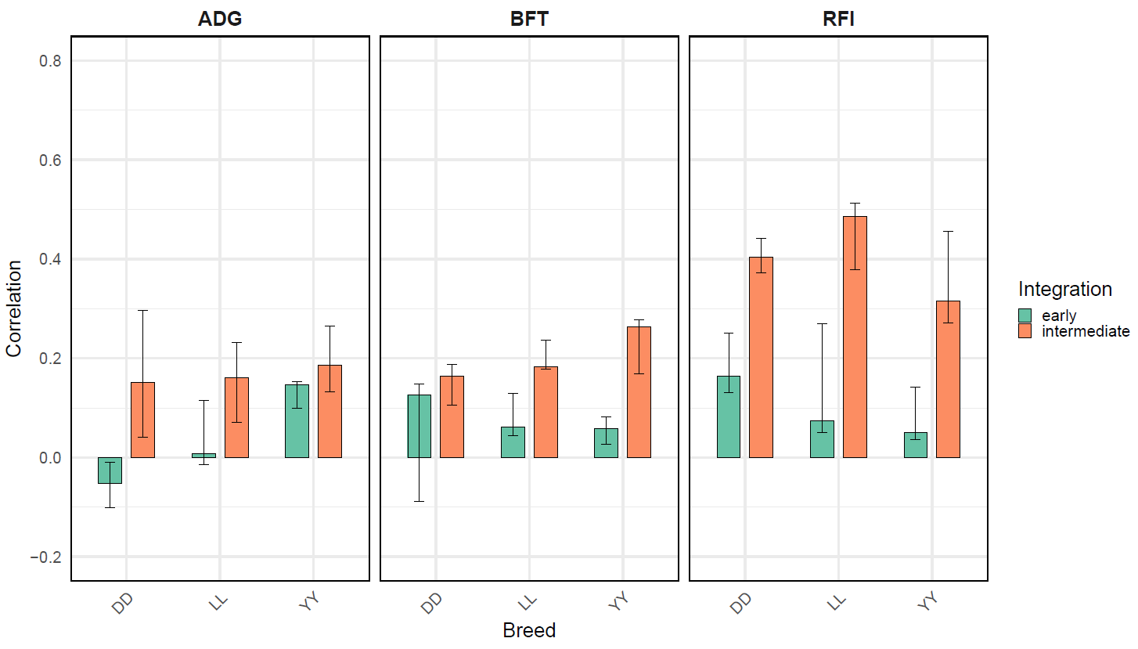
Figure 2: Comparison of early versus intermediate integration strategies for prediction of three phenotypic traits across the three breeds. Bars represent the median correlation values from three independent runs with different initializations, and the vertical lines indicate the minimum and maximum correlation values. Results were obtained using PCA-transformed inputs. The breed shown on the horizontal axis corresponds to the breed being predicted in each case. Results were generated using a LOBO strategy.
RFI was the best predicted traits with correlation values ranging from 0.3 to 0.5. Backfat and DGL showed comparable predictive performance, with correlation coefficients not exceeding 0.3. Based on the clear and consistent superiority of intermediate integration, all subsequent analyses were conducted using this framework.

Effect of Feature Dimensionality on Prediction Performance
We next evaluated whether reducing the number of CpG sites through variance-based filtering affected prediction performance (Figure 3). Across traits and breeds, models trained on substantially reduced CpG sets (VF0.01 and VF0.05) achieved prediction accuracies comparable to those obtained using the full dataset. For RFI, the highest median correlation was observed in the LL breed (0.55) using VF0.05. Prediction performance for ADG and BFT was lower than for RFI, with the highest median correlations of 0.26 for ADG (VF0.05, YY) and 0.29 for BFT (AF, LL). Although the AF strategy exceeded the VF strategy in some cases for ADG and BFT, these differences were not statistically significant, as indicated by overlapping vertical lines. Notably, reducing the CpG feature space to as little as 1.95% of the original set did not result in a loss of predictive ability, indicating that much of the predictive signal is captured by a relatively small subset of CpG sites.
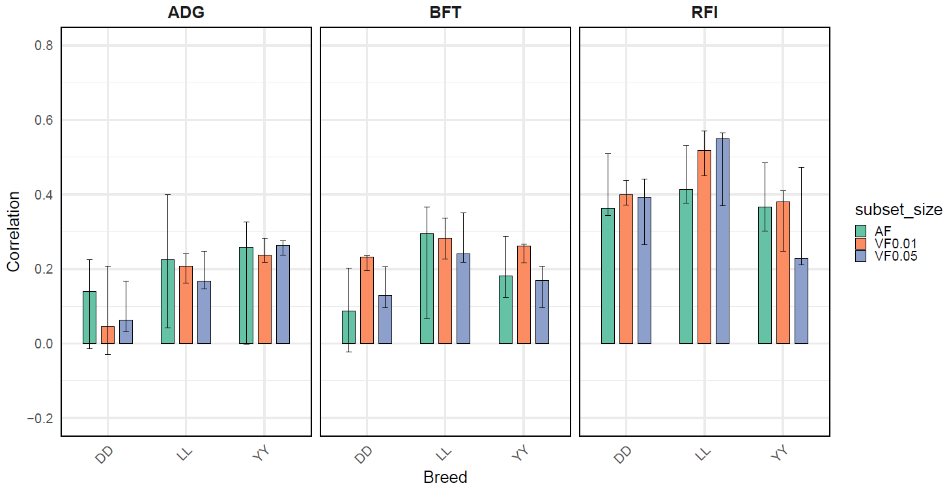
Figure 3: Comparison of prediction performance across three model input variants: (i) All features used (AF) 11k SNPs, 14k genes, 1M CpGs; (ii) Variance-filtered CpGs with threshold 0.01 (VF0.01) 11k SNPs, 14k genes, 255k CpGs; and (iii) Variance-filtered CpGs with threshold 0.05 (VF0.05) 11k SNPs, 14k genes, 14k CpGs.. Results were generated using a LOBO strategy. Bars represent the median correlation values from three independent runs with different initializations, and the vertical lines indicate the minimum and maximum correlation values.

Unsupervised Multi-Omics Integration Using MOFA
Latent Structure of Multi-Omics Data Identified by MOFA
MOFA was applied to variance-filtered CpG data (VF0.05), together with SNPs (11k) and transcriptomic features (14k), to explore the latent structure of the multi-omics data in an unsupervised manner (Figure 4). Figure 4 (top panel) shows the percentage of variance explained by the MOFA model for each omic layer when the training set included breeds LL and DD. In this example, the model explained approximately 29.2% of the variance in SNPs, 45.9% in transcripts, and 42.9% in CpGs. These values reflect the fraction of total variance in each omics layer that is captured by the latent factors inferred by MOFA. A similar pattern was observed when LL and YY were included in the training dataset. In this case, when the model was trained using only the DD and YY breeds, CpGs accounted for the largest proportion of the total explained variance (47.4%), slightly exceeding that of transcripts (45.6%). (Supplementary Figure 10).

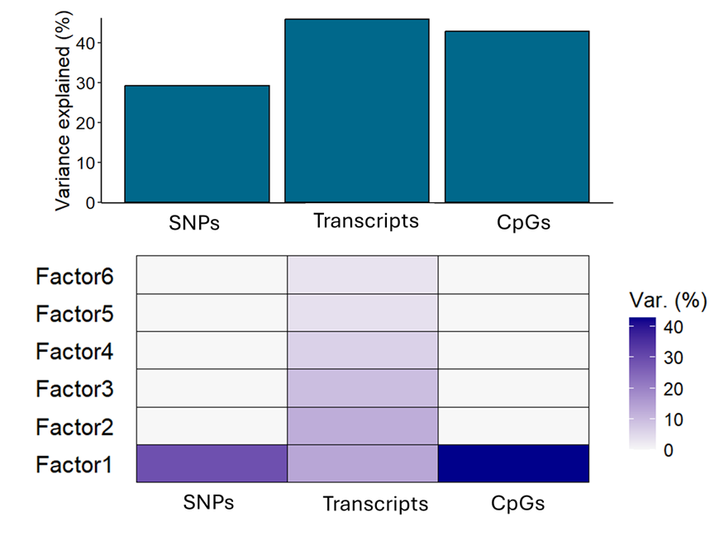
Figure 4: Total variance explained across all factors (top panel) and variance decomposition analysis showing the percentage of variance explained by each factor for each data modality (bottom panel). The results correspond to LOBO strategy and training dataset including the DD and LL breeds.
Figure 4 (bottom panel) presents the variance decomposition across the six inferred factors, illustrating the amount of variability each factor captures within each omic modality. Notably, MOFA identified six latent factors that jointly account for a substantial proportion of the total variance, consistent with the PVE observed in top panel. The variance decomposition reveals that Factor 1 represents a major source of variability shared across all omic layers, with particularly strong contributions from CpGs but also evident signals in SNPs and transcripts. This pattern was consistently observed across all LOBO training sets (Supplementary Figure 10). In contrast, the remaining factors primarily capture transcript-specific sources of variation, highlighting the modality-specific structure learned by the model. Next, we examined the latent factor values using MOFA’s built-in visualization functions (Figure 5). Visualization of factor values revealed a clear separation of samples by breed along Factor 1, indicating that this factor captures a strong breed-associated source of variation. The effect was most pronounced for CpGs, while still detectable, though less dominant, for gene expression and SNPs. In contrast, most remaining factors captured variability that was largely independent of breed.
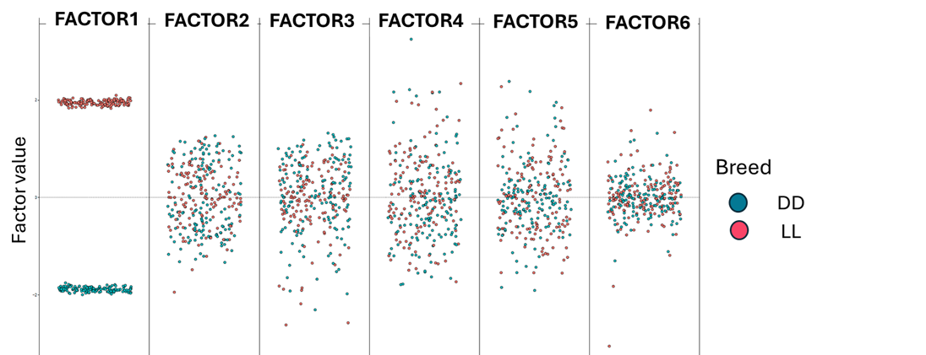
Figure 5: Factor values for each sample, colored by breed. As the data were centered prior to running MOFA, each factor places samples along a one-dimensional axis centered at zero. Samples with different signs reflect opposite phenotypes along the inferred axis of variation, with higher absolute values indicating a stronger effect. Results correspond to the LOBO strategy and the training dataset, including LL and DD breeds.

Prediction Performance Using MOFA-Selected Features
MOFA was applied separately to each of the three training sets corresponding to the LOBO strategy. For each run, a distinct feature subset derived from MOFA Factor 1 was used for prediction. As shown in Figure 6, RFI is the best predicted trait, reaching a median correlation of 0.63 for the LL breed when 5,000 features per omic were used. BFT also showed its highest predictability for LL, with a median correlation of 0.36 at the same subset size, although the performance using 3,000 features is very similar for both traits. For ADG, the best prediction was observed using 1,000 features for LL, with a median correlation of 0.33. Prediction accuracy increased with larger feature subsets, with diminishing gains beyond 3,000-5,000 features. Overall, MOFA-based feature selection improved prediction compared with PCA-based inputs (Figure 2, orange bars), variance-filtered and all-feature inputs (Figure 3).
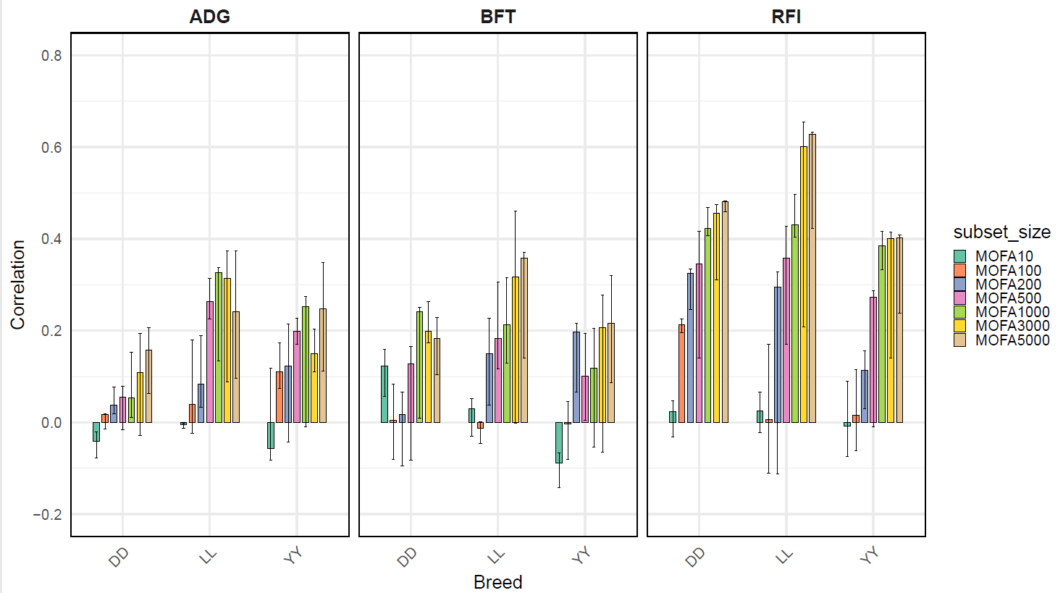
Figure 6: Comparison of prediction performance using different MOFA-selected features for each omic. The color-coded bars represent the selected subset sizes (10, 100, 200, 500, 1000, 3000, 5000). For MOFA input, 11,900 SNPs, 14,293 transcripts, and 14,492 CpG sites were used. Results correspond to LOBO strategy. Bars represent the median correlation values from three independent runs with different initializations, and the vertical lines indicate the minimum and maximum correlation values.

Supervised Feature Selection Using PLS

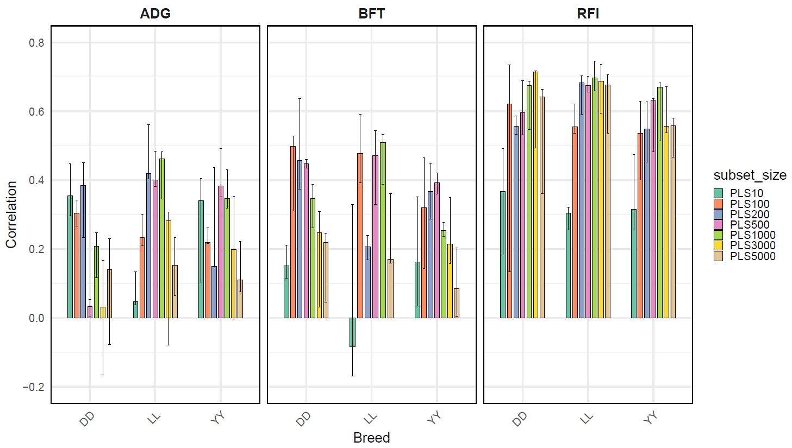
Figure 7: Comparison of prediction performance using different PLS-selected features for each omic. The color-coded bars represent the selected subset sizes (10, 100, 200, 500, 1000, 3000, and 5000). For the PLS input, 11,900 SNPs, 14,293 transcripts, and 14,492 CpG sites were used. Results correspond to LOBO strategy. Bars represent the median correlation values from three independent runs with different initializations, and the vertical lines indicate the minimum and maximum correlation values.

PLS-based feature selection consistently yielded the highest prediction accuracies across all traits and breeds (Figure 7). Among all traits, RFI remained the most predictable trait. The highest median correlation (0.71) was observed for the DD breed when 3,000 features were selected, although the value obtained using 1,000 features was very similar (0.68). For the LL and YY breeds, median correlations of 0.70 and 0.67, respectively, were achieved using 1,000 features. In the LL breed, performance with 200 and 500 features was not substantially different, with correlations of 0.68 and 0.67, respectively. Likewise, in the YY breed, 500 features yielded a correlation of 0.63, very close to the value obtained with 1,000 features.
For BFT, the highest median correlation (0.51) was obtained for the LL breed using 1,000 features, followed by 0.50 with 200 features, and 0.40 with 100 features for DD and YY respectively. Notably, LL showed very similar performance with 100 (0.48) and 500 (0.49) features, indicating stable predictability across these subset sizes. For DD 100 features yielded the highest median correlation (0.49). For ADG, the LL breed again showed the highest median correlation (0.46) using 1,000 features, but this value was very close to the performance obtained with 200 features (0.42). For DD and YY, the median prediction ability was similar around 0.38 for 200 and 500 features, respectively. Interestingly, using only 10 features already yielded a relatively strong prediction for this trait, with correlations of 0.35 for DD and 0.34 for YY. Notably, prediction accuracy using PLS-selected features was more homogeneous across breeds, with substantial overlap in performance distributions.

Generalization Across Breeds
The LOBO results indicated consistent trait-omics relationships across breeds, supporting the use of a mixed-breed dataset. Model generalizability was therefore evaluated using stratified 5-fold cross-validation, ensuring that breed proportions were preserved in both training and test sets.. As shown in Figure 8, the median prediction correlations were 0.34 for ADG, 0.29 for backfat, and 0.51 for RFI.

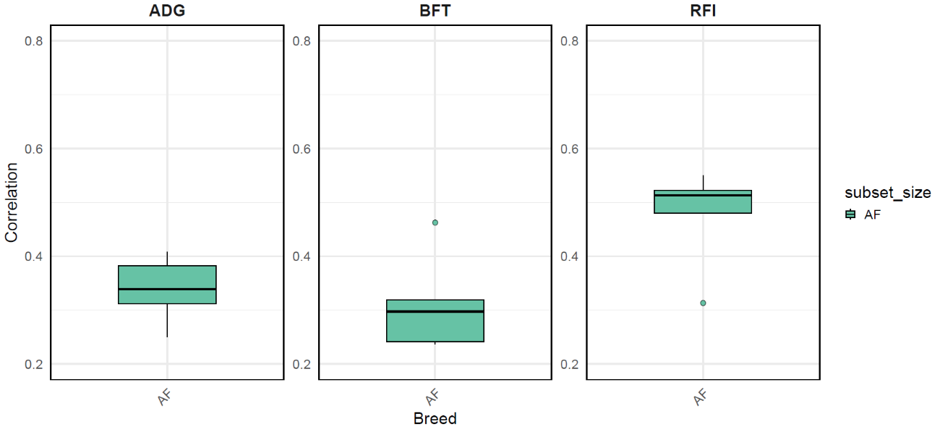
Figure 8: Box plots showing the distribution of correlation values for the all features (AF) strategy across 5-fold cross-validation. Each box spans the interquartile range (IQR, 25th-75th percentile) of the correlation values, the black line represents the median, and whiskers indicate the minimum and maximum values within 1.5×IQR. Outliers beyond this range are shown as individual points.
Next, the PLS strategy was implemented, as it emerged as the best-performing approach based on the LOBO results. Each model, implemented with a different configuration of trait-subset sizes, was trained three times from scratch using three initialization seeds (913, 1024, 1105) to ensure robustness across the small subset of selected features. As Figure 9 shows, RFI remained the trait with the highest predictive accuracy. Specifically, when comparing the five subset sizes, the median correlation values were 0.51 for PLS10, 0.71 for PLS100, 0.72 for PLS200, and 0.66 for both PLS500 and 0.70 PLS1000. The best predictive performance was achieved using 200 features. However, increasing the number of features from 100 to 200 did not lead to a substantial improvement, and the IQR was smaller with 100 features, indicating more consistent predictions. For BFT the median values for the different subset of features were 0.44, 0.41, 0.51, 0.49, 0.51 for PLS10, PLS100, PLS200, PLS500 and PLS1000. BFT was best predicted using 200 features where the corresponding model exhibited a relatively small IQR in the boxplot, indicating a low variability across folds. For ADG the different subset sizes of features selected using PLS resulted in median correlation values of 0.37, 0.48, 0.47, 0.41 and 0.44 for PLS10, PLS100, PLS200, PLS500 and PLS1000, respectively. Overall, selecting 100 features yielded the highest median performance. For all traits, intermediate subset sizes (100-200 features) achieved the highest or near-highest median correlations, with no gains observed when increasing the number of features beyond this range.

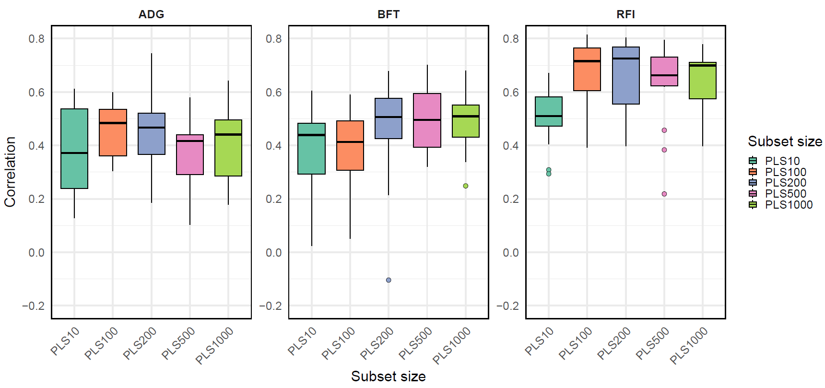
Figure 9: Box plots show the distribution of correlation values for the PLS strategy across 5-fold cross-validation, with three independent runs per fold using different initialization seeds (913, 1024, 1105). Each box spans the interquartile range (IQR, 25th-75th percentile) of the correlation values, the black line represents the median, and whiskers indicate the minimum and maximum values within 1.5×IQR. Outliers beyond this range are shown as individual points. The color-coded box plots represent the selected subset sizes (10, 100, 200, 500, 1000).

Hyperparameter Stability Across Cross-Validation
To assess the stability of model tuning, we summarized the frequency of hyperparameter values selected across the 5-fold cross-validation for each PLS-subset strategy (10, 100, 200, 500, 1000), where every model was trained three times per fold to account for variation due to random initialization. In total, 75 configurations per trait were retained and used to compute the frequency.
Table 3: Frequency of hyperparameter values selected during Bayesian hyperparameter tuning across 5-fold cross-validation. Each model was trained three times per fold using different initialization seeds (913, 1024, 1105), for a total of 75 runs per trait. Numbers in parentheses indicate the number of runs (out of 75) in which a given hyperparameter value was selected.
 | ADG | BFT | RFI
Activation_fused | tanh (31/75) | tanh (32/75) | tanh (30/75)
Activation_snp | ELU(48/75) | ELU (48/75) | ELU (46/75)
Activation_transcript | tanh(41/75) | tanh(43/75) | tanh (44/75)
Activation_cpg | tanh(42/75) | tanh(42/75) | tanh(44/75)
L | 0.001(55/75) | 0.001(57/75) | 0.001(55/75)
Units_snp | 8(25/75) | 8(25/75) | 8(24/75)
Units_ transcript | 38(24/75) | 38(26/75) | 38(26/75)
Units_cpg | 8(35/75) | 8(41/75) | 8(33/75)
Dropout_snp | 0.1(40/75) | 0.1(42/75) | 0.1(43/75)
Dropout_ transcript | 0.2(43/75) | 0.2(41/75) | 0.2(44/75)
Dropout_cpg | 0.4(37/75) | 0.5(35/75) | 0.4(39/75)
Units_fused | 8(28/75) | 64(25/75) | 8(26/75)
Dropout_fused | 0.1(44/75) | 0.1(42/75) | 0.1(45/75)
Learning rate | 0.001(54/75) | 0.001(59/75) | 0.001(53/75)
Activation_snp / transcript / cpg / fused : Activation functions for each omics-specific subnetwork and the concatenated layer after integration of the omics subnetworks.
Units_snp / transcript / cpg / fused: Number of hidden units in each subnetwork and in the fused layer
Dropout_snp / transcript / cpg / fused: Dropout rates applied to each subnetwork and the fused layer
L: L2 regularization coefficient
Learning rate: Learning rate used during model training

Across traits, hyperparameter selection was highly consistent (Table 3). Similar activation functions, regularization strengths, and learning rates were repeatedly selected across folds and initialization seeds. In particular, the same learning rate (0.001) and L2 regularization coefficient (0.001) were most frequently selected for all traits. Subnetwork and fused-layer sizes also showed limited variability, indicating stable architectural choices across ADG, BFT, and RFI.

Discussion
In this study, we systematically evaluated how multi-omics integration strategies and feature-selection approaches influence phenotype prediction within a deep learning framework. Across all traits, breeds, and validation schemes, the strongest and most consistent predictive performance was achieved by combining intermediate multi-omics integration with supervised feature selection based on PLS. Importantly, this high predictive performance was obtained using relatively small, carefully selected subsets of features (approximately 100-200 variables per omic layer), which outperformed models using the full omics datasets or other representations. These results indicate that prediction accuracy was primarily driven by the quality of feature selection and integration rather than by model complexity or input dimensionality, highlighting the power of data-driven feature selection in multi-omics prediction.
Although deep learning provides a flexible framework capable of capturing nonlinear relationships, our results indicate that it does not guarantee improved prediction in high-dimensional multi-omics settings. Instead, gains arise from structured integration that preserved modality-specific representations and from supervised FS that aligned inputs with the target phenotype. In this context, intermediate integration consistently outperformed early integration, highlighting the importance of learning omics-specific latent representations prior to fusion, particularly when data are heterogeneous across breeds. Given that the data originated from three breeds (DD, LL, and YY), we assessed across-breed consistency of omics-trait relationships using LOBO validation. Similar predictive performance across all breed combinations supports indicating that models trained on two breeds could reliably predict the third. This consistent transferability supports pooling data for stratified 5-fold cross-validation and implementing a single unified model across breeds. By preserving omics-specific representations before combining them, intermediate integration produced robust predictions across breeds, whereas early integration concatenating features prior to modelling was more sensitive to noise, scale differences, and breed-specific distributions. The consistent across-breed performance underscores the suitability of intermediate integration for generalization and transfer learning in genetically heterogeneous populations, in line with previous studies [47-49].
Feature selection is crucial in high-dimensional predictive modelling as it reduces computational demands and mitigates overfitting [50]. In this study, FS played a central role in achieving robust predictions. Supervised approaches, particularly multivariate filter methods such as PLS [51], outperformed unsupervised dimensionality-reduction methods such as PCA and MOFA, highlighting the importance of phenotype-guided prioritization in predictive modelling [9,52]. PLS explicitly maximizes covariance between predictors and the response variable, allowing the selection of features directly informative for the trait of interest. In contrast, unsupervised methods primarily capture dominant sources of variance, which in multi-breed populations often reflect population structure rather than variation directly associated with the trait of interest.
This pattern was evident in the MOFA analysis, where the dominant latent factor (Factor 1) consistently captured a source of variation shared across SNPs, transcripts, and CpGs, reflecting breed differences, with the same structure observed across all three training datasets. The relatively strong contribution of CpGs to Factor 1 suggests that epigenetic variation may act as a downstream integrator of genetic and regulatory differences, capturing coordinated, breed-associated regulatory patterns rather than purely short-term environmental effects. This observation is consistent with the tendency of unsupervised models to prioritize population-level variation over trait-specific signals. By selecting features with the highest contributions to Factor 1, the resulting subsets were enriched for biologically coherent variation, capturing stable, breed-associated molecular patterns that were reproducible across training sets.
Despite its lower predictive performance compared with PLS, MOFA remains valuable as an exploratory and interpretative tool. It decomposes multi-omics variation into shared and modality-specific factors, revealing major sources of variation and providing insight into the structure of complex datasets. However, because MOFA is unsupervised, the resulting feature rankings are not optimized for phenotype prediction. Consequently, MOFA-selected features may underrepresent trait-relevant variation when dominant sources of variance are not aligned with the prediction target, as observed for ADG and BFT, whereas RFI was predicted more accurately. MOFA has been successfully applied in diverse biological contexts, including disease biology, immunological signatures, and multi-omics vaccine response profiling [53-55], demonstrating its utility. In livestock research, its application remains limited, but our study demonstrates that MOFA can uncover latent structure, reveal biologically meaningful variation such as breed differences, and guide FS for predictive modelling, highlighting its potential as a versatile tool for multi-omics integration and interpretation. Future work could explore selecting features from multiple factors or combining MOFA with supervised refinement to better capture trait-specific signals.
For CpG sites, multivariate feature-selection approaches outperformed univariate variance filtering. By accounting for correlations and joint effects among CpGs, methods such as MOFA and PLS capture distributed epigenetic signals more effectively. Overall, multivariate approaches yielded stable, compact feature subsets that achieved predictive performance comparable or superior to much larger unfiltered sets across both LOBO and 5-fold cross-validation. Using fixed-size subsets of 100-200 features per omics layer (SNPs, CpGs, and genes) was sufficient to match or exceed performance of full datasets. The high predictive power of a small feature subset likely reflects the capture of the most informative biological signals: SNPs tagging key additive genetic effects, CpGs representing regulatory regions influencing gene expression, and selected genes corresponding to trait-relevant pathways. By focusing on these features, models reduce noise from redundant or uninformative variables while retaining maximal predictive information. Even with the optimal PLS strategy in the MLP network, some variability across cross-validation folds was observed, as expected from the nonlinear nature of MLPs, stochastic initialization, and high-dimensional data. Occasional low-performing outliers, particularly for RFI, illustrate the trade-off between maximum performance and stability, emphasizing the importance of considering both median performance and variability when applying PLS in multi-omics prediction.
Prediction accuracy differed across traits, with RFI showing the highest performance. This likely reflects its integrative nature as a feed efficiency trait, combining genetic, transcriptomic, and epigenomic signals related to metabolism and energy regulation. Variance decomposition using the GTMBLUP model (Ayres et al.) indicated that RFI had the highest total variance and lowest residual variance, whereas the transcriptomic component explained a large part of the BFT variance and a moderate part of the ADG variance, with methylation contributing variably across traits. These patterns suggest that combining SNPs, CpGs, and gene expression captures substantial biologically relevant variation, particularly for RFI, providing a higher signal-to-noise ratio for predictive modelling. Trait-specific differences also align with heritability: BFT is highly heritable but may show lower predictive accuracy due to lower phenotypic variability, ADG exhibits moderate heritability and environmental influence, and RFI shows low to moderate heritability but benefits from integrated multi-omics signals [56, 57]. Previous studies using SNP-only approaches reported prediction accuracies of ~0.30-0.52 for BFT and ADG, and ~0.27-0.53 for RFI depending on population and model [30, 58-51]. In the present multi-omics framework, correlations of ~0.52 for BFT, ~0.52 for ADG, and ~0.73 for RFI were achieved using a small subset of features per omics layer, highlighting the potential of multi-omics integration to improve phenotype-level prediction. At the same time, direct comparisons should be interpreted cautiously due to differences in trait definitions (e.g., ultrasound- versus carcass-based backfat, daily gain versus average daily gain), prediction targets (predicted phenotype versus genomic estimated breeding value), populations (purebred versus mixed-breed), and environmental conditions.
A critical aspect of deep learning models is the careful tuning and selection of hyperparameters. In this study, hyperparameter choices were guided by prior work (e.g., [5, 62]) and constrained to avoid overly complex configurations that could compromise generalization. The high dimensionality of the multi-omics data motivated specific architectural choices, such as the use of bottleneck layers to compress information and emphasize the most informative features. The high consistency of selected hyperparameters across traits and seeds demonstrates that the framework is robust to random initialization and sampling variation, supporting reproducibility. While similar hyperparameters across traits partly reflect the controlled feature selection and deterministic tuning, this stability suggests that the model can consistently learn similar representations of the multi-omics space. From a biological perspective, this convergence may indicate common organizational patterns in how SNPs, transcripts, and CpGs jointly encode information, while allowing trait-specific differences to emerge in downstream predictions. Overall, these results highlight the framework’s ability to balance generalizable structure with trait-specific variability, supporting its use for multi-omics prediction.
Omics-assisted approaches are particularly valuable for traits that are difficult or costly to measure, such as RFI, whereas traits like BFT and ADG can often be effectively improved using traditional selection. Our results show that integrating genomic, transcriptomic, and epigenomic data, combined with PLS-based FS, captures the most informative signals for RFI, enhancing phenotype-level prediction within the deep learning framework used in this study. These findings highlight the potential of multi-omics frameworks to support phenotyping strategies, pre-selection, or decision-making in breeding programs, while their effect on breeding value accuracy warrants further investigation using appropriate genetic evaluation models.
While multi-omics deep learning models offer accurate prediction, they are computationally demanding, requiring careful hyperparameter optimization and substantial memory. Incorporating PLS-based FS reduces input dimensionality, accelerates model training, and improves practicality, making large-scale applications increasingly feasible with high-performance computing resources. Although our study included 443 pigs across three commercial breeds, this represents a moderate dataset for multi-omics deep learning, and high-dimensional omics data can exacerbate the risk of overfitting. To mitigate these challenges, PLS-based FS was applied in this study, reducing each omic layer to a small subset of informative variables, and employed stratified 5-fold cross-validation and LOBO validation to ensure robust evaluation. The use of intermediate integration, which extracts latent omics-specific representations before fusion, further improved generalization. Future work should evaluate this framework on larger datasets to confirm its scalability and robustness and to explore potential gains from this framework or additional omics layers.
Importantly, the objective of this study was not to contrast deep learning with linear genomic prediction frameworks. In the companion study (Ayres et al.), the same multi-omics dataset was analyzed using a linear mixed-model framework based on the GTMBLUP approach, where SNPs, gene expression, and CpG methylation were incorporated through omics-specific relationship matrices. It should be noted, however, that direct comparison of our results with GTMBLUP should be done with caution, as the GTMBLUP analyses always used all features and a priori assumes that within each category each feature explains the same amount of variance, whereas deep learning can operate on transformed or raw features, capturing nonlinear relationships without assuming equal contributions to the explained variance. In this study, some models use feature selection or transformed representations, while others use the full raw feature matrices. Thee matrices in GTMBLUP summarize pairwise similarities among individuals for each omic layer and therefore represent a form of information aggregation prior to model fitting. In that framework, predictions were generally more accurate than those obtained with our deep learning models when no feature selection was applied. This highlights an important point: deep learning does not automatically guarantee superior performance, particularly in high-dimensional multi-omics settings. Linear mixed models operating on relationship matrices can efficiently capture additive effects while controlling overfitting, especially when the number of predictors greatly exceeds the number of observations.
When we applied supervised feature selection, particularly through PLS, predictive performance of the deep learning framework improved substantially and, in several cases, exceeded that of the GTMBLUP model. This suggests that the main limitation of deep learning in this context is not the modelling framework itself but the high dimensionality and noise present in raw omics features. By selecting compact sets of informative variables, the deep learning models may have been better able to exploit nonlinear relationships among SNPs, transcripts, and CpGs. It should be noted that the benefits of PLS-based feature selection are not exclusive to deep learning models. In a previous study, we demonstrated that PLS-based selection can also improve prediction accuracy in linear models by reducing noise and focusing on the most informative predictors [9].
The present results demonstrate that combining supervised feature selection with an intermediate multi-omics integration strategy provides an effective deep learning framework for multi-omics prediction. This approach captures both modality-specific information and cross-omics interactions, allowing the model to leverage nonlinear relationships among SNPs, transcripts, and CpGs. These findings also highlight that feature selection and data representation often matter more than model complexity, and that aligning integration and feature-selection strategies with the prediction objective is essential for robust prediction. By combining intermediate integration with supervised PLS-based feature selection, our framework generalizes across breeds and enables efficient, reproducible multi-omics prediction.
Conclusions
Integrating multiple omics layers through a deep learning framework, using intermediate integration combined with PLS-based feature selection, enables accurate prediction of complex traits in pigs using a small, carefully selected subset of features from SNPs, gene expression, and CpG methylation data. This demonstrates that high predictive performance can be achieved without relying on the full set of omics data, highlighting the value of structured integration and data-driven feature selection in multi-omics prediction. The proposed framework showed robust and generalizable performance across breeds and traits, capturing stable multi-omics representations despite variation in model initialization. These results suggest that the approach captures shared multi-omics patterns, with trait-specific differences reflected primarily in prediction performance rather than in the optimal modelling strategy. The shared architecture likely captures common structure across RFI, ADG, and BFT, while still accommodating trait-specific variation. By identifying which integration and feature-selection approaches maximize predictive accuracy, this work provides practical guidance for incorporating heterogeneous omics data into genomic prediction pipelines. Efficiently capturing informative signals, the framework shows strong potential for use in breeding programs to support phenotype-level predictions, guide phenotyping strategies, and optimize resource allocation. Future work could expand the framework by incorporating additional omics layers and evaluating its performance in larger, more diverse populations, while exploring complementary methods to further enhance interpretability, robustness, and applicability across traits.

Availability of data and materials
The datasets analyzed in this study are not publicly available due to confidentiality agreements with the commercial partners.

Funding
This study was funded by the European Union’s Horizon 2020 research and innovation programme under grant agreement No. 101000236 (GEroNIMO).

Acknowledgements
We gratefully acknowledge LF, Breeding & Genetics, Danish Agriculture & Food Council F.m.b.A., for providing the data used in this study.

References

- Meuwissen THE, Hayes BJ, Goddard ME. Prediction of total genetic value using genome-wide dense marker maps. Genetics. 2001;157:1819–1829.

- VanRaden PM. Efficient methods to compute genomic predictions. J Dairy Sci. 2008;91:4414–4423.

- Habier D, Fernando RL, Kizilkaya K, Garrick DJ. Extension of the Bayesian alphabet for genomic selection. BMC Bioinform. 2011;12:186.

- Green RM, Fish JL, Young NM, Smith FJ, Roberts B, Dolan K, et al. Developmental nonlinearity drives phenotypic robustness. Nat Commun. 2017;8:1–12.

- Montesinos-López OA, Montesinos-López A, Pérez-Rodríguez P, Barrón-López JA, Martini JWR, Fajardo-Flores SB, et al. A review of deep learning applications for genomic selection. BMC Genomics. 2021;22:19.

- Vieira S, Pinaya WHL, Garcia-Dias R, Mechelli A. Deep neural networks. In: Machine learning. Academic Press; 2020. p. 157–172.

- Ehret A, Hochstuhl D, Gianola D, Thaller G. Application of neural networks with back-propagation to genome-enabled prediction of complex traits in Holstein-Friesian and German Fleckvieh cattle. Genet Sel Evol. 2015;47:22.

- Rosenblatt F. The perceptron-a perceiving and recognizing automaton. Ithaca, NY: Project PARA, Cornell Aeronautical Laboratory; 1957. Report 85–460.

- Vourlaki IT, Piles M, Jové-Juncà T, Ramayo-Caldas Y, Quintanilla R, Ballester M. Incorporating genomic and transcriptomic effects in joint linear and non-linear structural models for predicting complex traits in pigs. Animal. 2026;20:101765.

- Jové-Juncà T, Haas VP, Calus MPL, Ballester M, Quintanilla R. Using transcriptomic data to improve the prediction of immunity traits in pigs. Animal. 2025;20:101742.

- Guo X, Sarup P, Bay Nord A, Henryon M, Ostersen T, Christensen OF. Metabolomic-genomic prediction realizes small increases in accuracy of estimated breeding values for daily gain in pigs. Genet Sel Evol. 2025;57:24.

- Haas VP, Wellmann R, Duenk P, Oster M, Ponsuksili S, Bennewitz J, et al. Incorporating transcriptomic data into genomic prediction models to improve the prediction accuracy of phenotypes of efficiency traits. Genet Sel Evol. 2025;57:59.

- Xu F, Che Z, Qiao J, Han P, Miao N, Dai X, et al. Integrating gene expression data into single-step method (ssBLUP) improves genomic prediction accuracy for complex traits of Duroc × Erhualian F2 pig population. Curr Issues Mol Biol. 2024;46:13713–13724.

- Calle-García J, Ramayo-Caldas Y, Zingaretti LM, Quintanilla R, Ballester M, Pérez-Enciso M. On the holobiont ‘predictome’ of immunocompetence in pigs. Genet Sel Evol. 2023;55:29.

- Perez BC, Bink MCAM, Svenson KL, Churchill GA, Calus MPL. Adding gene transcripts into genomic prediction improves accuracy and reveals sampling time dependence. G3 (Bethesda). 2022;12:jkac258.

- Li Z, Gao N, Martini JWR, Simianer H. Integrating gene expression data into genomic prediction. Front Genet. 2019;10:126.

- Montesinos-López OA, Montesinos-López A, Mosqueda-González BA, Delgado-Enciso I, Chavira-Flores M, Crossa J, et al. Genomic prediction powered by multi-omics data. Front Genet. 2025;16:1636438.

- Chafai N, Hayah I, Houaga I, Badaoui B. A review of machine learning models applied to genomic prediction in animal breeding. Front Genet. 2023;14:1150596.

- Wadood AA, Bordbar F, Zhang X. Integrating omics approaches in livestock biotechnology: Innovations in production and reproductive efficiency. Front Anim Sci. 2025;6:1551244.

- Athieniti E, Spyrou GM. A guide to multi-omics data collection and integration for translational medicine. Comput Struct Biotechnol J. 2022;21:134–149.

- Reel PS, Reel S, Pearson E, Trucco E, Jefferson E. Using machine learning approaches for multi-omics data analysis: A review. Biotechnol Adv. 2021;49:107739.

- Ritchie MD, Holzinger ER, Li R, Pendergrass SA, Kim D. Methods of integrating data to uncover genotype–phenotype interactions. Nat Rev Genet. 2015;16:85–97.

- Zitnik M, Nguyen F, Wang B, Leskovec J, Goldenberg A, Hoffman MM. Machine learning for integrating data in biology and medicine: Principles, practice, and opportunities. Inf Fusion. 2019;50:71–91.

- Argelaguet R, Arnol D, Bredikhin D, Deloro Y, Velten B, Marioni JC, et al. MOFA+: A statistical framework for comprehensive integration of multi-modal single-cell data. Genome Biol. 2020;21:111.

- Argelaguet R, Velten B, Arnol D, Dietrich S, Zenz T, Marioni JC, et al. Multi-Omics Factor Analysis—a framework for unsupervised integration of multi-omics data sets. Mol Syst Biol. 2018;14:e8124.

- Wu Z, Xu K, Chen Y, Liu Y, Song W. A new prediction model based on deep learning for pig house environment. Sci Rep. 2024;14:31141.

- Xu B, Mao Y, Wang W, Chen G. Intelligent weight prediction of cows based on semantic segmentation and back propagation neural network. Front Artif Intell. 2024;7:1299169.

- Lee HJ, Lee JH, Gondro C, Koh YJ, Lee SH. deepGBLUP: Joint deep learning networks and GBLUP framework for accurate genomic prediction of complex traits in Korean native cattle. Genet Sel Evol. 2023;55:56.

- Pedrosa VB, Chen SY, Gloria LS, Doucette JS, Boerman JP, Rosa GJM, et al. Machine learning methods for genomic prediction of cow behavioral traits measured by automatic milking systems in North American Holstein cattle. J Dairy Sci. 2024;107:4758–4771.

- Piles M, Bergsma R, Gianola D, Gilbert H, Tusell L. Feature selection stability and accuracy of prediction models for genomic prediction of residual feed intake in pigs using machine learning. Front Genet. 2021;12:611506.

- Tadist K, Najah S, Nikolov NS, Mrabti F, Zahi A. Feature selection methods and genomic big data: A systematic review. J Big Data. 2019;6:79.

- Purcell S, Neale B, Todd-Brown K, et al. PLINK: A tool set for whole-genome association and population-based linkage analyses. Am J Hum Genet. 2007;81:559–575.

- Chang CC, Chow CC, Tellier LCAM, et al. Second-generation PLINK: Rising to the challenge of larger and richer datasets. Gigascience. 2015.

- R Core Team. R: A language and environment for statistical computing. Vienna, Austria: R Foundation for Statistical Computing; 2022.

- Dobin A, Davis CA, Schlesinger F, Drenkow J, Zaleski C, Jha S, et al. STAR: Ultrafast universal RNA-seq aligner. Bioinformatics. 2013;29:15–21.

- Garcia-Alcalde F, Okonechnikov K, Carbonell J, Cruz LM, Gotz S, Tarazona S, et al. Qualimap: Evaluating next-generation sequencing alignment data. Bioinformatics. 2012;28:2678–2679.

- Liao Y, Smyth GK, Shi W. featureCounts: An efficient general purpose program for assigning sequence reads to genomic features. Bioinformatics. 2014;30:923–930.

- Robinson MD, McCarthy DJ, Smyth GK. edgeR: a Bioconductor package for differential expression analysis of digital gene expression data. Bioinformatics. 2010;26:139–140.

- Veillard AC, Datlinger P, Laczik M, Squazzo S, Bock C. Diagenode® Premium RRBS technology: cost-effective DNA methylation mapping with superior coverage. Nat Methods. 2016;13:i–ii.

- Krueger F, Andrews SR. Bismark: A flexible aligner and methylation caller for Bisulfite-Seq applications. Bioinformatics. 2011;27:1571–1572.

- Pedregosa F, Varoquaux G, Gramfort A, Michel V, Thirion B, Grisel O, et al. Scikit-learn: Machine learning in Python. J Mach Learn Res. 2011;12:2825–2830.

- Kuhn M. Building predictive models in R using the caret package. J Stat Softw. 2008;28:1–26.

- O’Malley T, Bursztein E, Long J, et al. KerasTuner: Hyperparameter tuning for humans. GitHub repository; 2019.

- Python Software Foundation. Python Language Reference (version 3.11.5). Python Software Foundation; 2023.

- Abadi M, Barham P, Chen J, et al. TensorFlow: A system for large-scale machine learning. In: Proc 12th USENIX Symp Oper Syst Des Implement. USENIX Association; 2016. p. 265–283.

- Chollet F, et al. Keras. 2015.

- Picard M, Scott-Boyer MP, Bodein A, Périn O, Droit A. Integration strategies of multi-omics data for machine learning analysis. Comput Struct Biotechnol J. 2021;19:3735–3746.

- Hauptmann T, Kramer S. A fair experimental comparison of neural network architectures for latent representations of multi omics for drug response prediction. BMC Bioinform. 2023;24:xxx.

- Jiang Z, Zhang H, Gao Y, Sun Y. Multi-omics strategies for biomarker discovery and application in personalized oncology. Mol Biomed. 2025;6:115.

- Chandrashekar G, Sahin F. A survey on feature selection methods. Comput Electr Eng. 2014;40:16–28.

- Guyon I, Elissee A. An introduction to variable and feature selection. J Mach Learn Res. 2003;3:1157–1182.

- Mehmood T, Liland KH, Snipen L, Sæbø S. A review of variable selection methods in Partial Least Squares Regression. Chemom Intell Lab Syst. 2012;118:62–69.

- Gupta A, Abe K, Maecker HT. Comprehensive analysis of multi-omics vaccine response data using MOFA and Stabl algorithms. Front Bioinform. 2025;5:1636240.

- Hama S, Seymen N, Gerlevik S, Kaya DE, Napolitani G, Ogawa S, et al. Multi Omics Factor Analysis (MOFA) identifies transposable element expression as a risk factor and inflammaging as a protective factor in myelodysplastic syndromes. Blood. 2023;142(Suppl 1):6450.

- Pekayvaz K, Losert C, Knottenberg V, Gold C, van Blokland IV, Oelen R, et al. Multiomic analyses uncover immunological signatures in acute and chronic coronary syndromes. Nat Med. 2024;30:1696–1710.

- Santiago KG, Lopez BI, Kim SH, Lee DH, Cho YG, Song YN, et al. Genetic parameters for different measures of feed efficiency and their relationship to production traits in three purebred pigs. Life (Basel). 2021;11:830.

- Hoque MA, Suzuki K. Genetic parameters for production traits and measures of residual feed intake in Duroc and Landrace pigs. Anim Sci J. 2008;79:543–549.

- Liu Y, Zhang Y, Zhou F, Yao Z, Zhan Y, Fan Z, et al. Increased accuracy of genomic prediction using preselected SNPs from GWAS with imputed whole-genome sequence data in pigs. Animals (Basel). 2023;13:3871.

- Salek Ardestani S, Jafarikia M, Sargolzaei M, Sullivan B, Miar Y. Genomic prediction of average daily gain, back-fat thickness, and loin muscle depth using different genomic tools in Canadian swine populations. Front Genet. 2021;12:665344.

- Zhang C, Kemp RA, Stothard P, Wang Z, Boddicker N, Krivushin K, Dekkers J, Plastow G. Genomic evaluation of feed efficiency component traits in Duroc pigs using 80K, 650K and whole-genome sequence variants. Genet Sel Evol. 2018;50:14.

- Do DN, Janss LL, Jensen J, Kadarmideen HN. SNP annotation-based whole genomic prediction and selection: An application to feed efficiency and its component traits in pigs. J Anim Sci. 2015;93:2056–2063.

- Vourlaki IT, Ramos-Onsins SE, Pérez-Enciso M, Castanera R. Evaluation of deep learning for predicting rice traits using structural and single-nucleotide genomic variants. Plant Methods. 2024;20:121.

