**{Database Name} Data Management Plan**

UAB {Department Name}

|  |  |
| --- | --- |
| Prepared by: | Morgan McAllister |
| **Project Advisor:** | {censored}, MSHI, MEng | |
| **Faculty Advisor:** | {censored}, RN, MEd, PhD | |
| **Version:** | 4 | |
| **Date:** | March 1, 2021 | |

**­Document Control**

This Data Management Plan is a living document and should be revisited to reflect any changes or on a quarterly basis(1).

**Version History**

After the final draft has been revised, ownership of this document will be turned over to {name}.

|  |  |  |  |
| --- | --- | --- | --- |
| Version | Issue Date | Author(s) | Comment |
| 1 | 25 Jun 2020 | Morgan McAllister | First draft |
| 2 | 10 Jul 2020 | Morgan McAllister | Second Draft: Revision of first draft following feedback from the reviewers, {name} and {name} |
| 3 | 16 Jul 2020 | Morgan McAllister | Third Draft: Revision of the second draft, following feedback from all {department} staff |
| 4 | 23 Jul 2020 | Morgan McAllister | Final: Revision following feedback from Faculty advisor and {department} surveys |
| 5 | 1 Mar 2021 | Morgan McAllister | Names and details {censored} for portfolio publication |
|  |  |  |  |

**TABLE OF CONTENTS**

Introduction 5

Background 5

Purpose 5

Scope 5

{department} Mission Statement 5

UAB Policies 6

Known Issues 7

Roles and Responsibilities 8

Database Manager 8

Clinical Data Specialist 8

Documentation Manager 8

Data Analyst 8

Principal Investigator 8

Team Members 8

Database Architecture 9

Major Data Sources 9

Active Collaborations 10

Standards 11

Naming Conventions 11

Table Prefixes 11

General Naming Guidelines 12

Guidelines for Table Names 12

Guidelines for Column Names 12

Creating New Tables 13

Removing Tables 13

Change Management 14

Change Request 14

Schema Changes History Report 14

Documentation 16

Entity Relationship Diagram 16

Data Dictionary 17

Metadata 17

Viewing Object Descriptions 17

Viewing Metadata in Object Explorer Details 18

Expansion Guide 19

Master Tables 19

Entity Relationship Diagram 19

Data Dictionary 19

Metadata 19

Known Issues 19

Appendix 20

# Introduction

## Background

The {department} is a prospective cohort of HIV positive patients who receive care from the University of Alabama at Birmingham (UAB) {censored}. The cohort began with a Microsoft Access database in 1995, which has seen many upgrades over the past 25 years. The database is now managed with Microsoft’s SQL Server Management Studio (SSMS). Because of the growth of the {database}, there has been an increasing demand on its database and users. The creation of this Data Management Plan (DMP) will help provide standardization, contain problem areas, and allow for more growth of the database.

## Purpose

This document intends to:

* Establish the information needs of the {department}
* Standardize some user interactions with the Database
* Bring attention to observations, areas of concern, and known issues with the database
* Delineate the process of expanding improvement and standardization efforts for the database
* Provide a comprehensive source of database information for new and existing {department} employees to reference
* Facilitate database documentation (ERDs, data dictionary, metadata, schema change history)
* Provide informational resources for employees to supply to investigators

## Scope

This document is meant to serve as a tool and starting point to address observed database issues, rather than a complete solution. Though a portion of the database has been documented to provide an example, the

Expansion Guide section details how to continue to expand improvements and create documentation for the entire database.

## {department} Mission Statement

“To enhance well-being and promote health equity for individuals and communities through the identification, development, implementation and dissemination of approaches that build upon the strengths of an interdisciplinary team with integrated informatics and research expertise.”(2)

# UAB Policies

This document contains additional guidelines for the {department} department, meant to be supplemental to existing policies provided by UAB. These policies can be found by the links in the table below:

|  |  |
| --- | --- |
| Title | Link |
| Data Access Policy | {removed} |
| Data Protection and Security | {removed} |
| HIPAA: HIPAA Administration | {removed} |
| HIPAA: Use & Disclosure of Identifiable Health Information for Research | {removed} |
| HIPAA: Patient Health Information Rights | {removed} |
| Minimum Security for Computing Devices Rule | {removed} |
| Data Classification Rule | {removed} |
| Data Custodian Responsibilities | {removed} |
| Acceptable Use of Computer and Network Resources | {removed} |
| Data Protection Rule | {removed} |

Table 1 UAB Policy Links

# Known Issues

|  |  |  |
| --- | --- | --- |
| Problem | Description | Proposed Solution(s) |
| Lack of Written Standards | Outside of organization-wide UAB Policies, there are currently no documented standards or processes to guide {department} employees when interacting with the database. | Roles and Responsibilities  Standards |
| Cluttered Database | Tables are often created in the database for reporting or analysis and not removed after. This has resulted in an unnecessarily large and complicated database. | Master Tables  Creating New Tables  Removing Tables |
| Ambiguous, Unstandardized Table Names | There are several tables with similar names and unofficial naming conventions, making it difficult to determine which tables are primary. | Naming Convention |
| Lack of Database Documentation | 1. This database lacks documentation of source information, change history, workflow standards, and basic database information.  2. There are no standardized tools or visuals to inform investigators of what information is available to be used in their research.  3. There are also no tools to help new employees visualize and learn the database. | Roles and Responsibilities  Standards  Schema Changes History Report  Entity Relationship Diagram  Data Dictionary  Metadata |
| Expansion Limitations | The {database} is large. The process of expanding recommendations for creating the necessary documentation to the entire database will take significant time. | The remainder of the database documentation can be done gradually, when the department has the time to spare. Guidelines for this process are outlined in Expansion Guide. |

Table 2 Known Issues

# Roles and Responsibilities

## Database Manager

The Database Manager (DBM) is an individual with the authority to make, approve, or deny any changes to the database. Additionally, the DBM is responsible for oversight of database use, new user training, as well as directing the team’s activities. It is the sole responsibility of the DBM to approve requests for changes to the master tables, as referenced in the Change Request section. The DBM will assign an individual or individuals to take ownership of this document and its maintenance and Expansion Guide through the role of Documentation Manager.

**Current Database Manager: {name}**

## Clinical Data Specialist

The Clinical Data Specialist (CDS) is the individual responsible for providing clinical expertise, receiving data request forms (*Appendix B*), overseeing the data mapping process, and ensuring data distribution for research initiatives complies with IRB requirements and UAB Policies.

## Documentation Manager

The Documentation Manager (DM) is an individual responsible for the governance of all elements mentioned in this document. The DM ensures consistency of data models by overseeing the use, accuracy, and expansion of the

Data Dictionary, Naming Conventions, Entity Relationship Diagram, and Metadata(3, 4). The DM revisits this document quarterly or when changes occur.

**Current Documentation Manager: {name}**

## Data Analyst

The Data Analyst (DA) is an individual who performs duties related to the collection and interpretation of data(4). Once a research project has been cleared by the CDS and DBM, data analysts may work with the PI to retrieve and analyze data. A DA can alter the database’s schema, following guidelines in the Standards section. A DA has a responsibility to ensure proper use and privacy of data accessed, in accordance with UAB Policies.

## Principal Investigator

The Principal Investigator (PI) refers to the lead investigator for a research initiative. It is the responsibility of the PI to comply with UAB Policies and IRB requirements for their research regarding use, retention, and disposal of data provided to them by the {department} department.

## Team Members

|  |  |  |
| --- | --- | --- |
| Name | Position Title | Contact |
| {removed} | Director of Information Technology Operations | {removed} |
| {removed} | Co-Director Database & IS UAB CFAR | {removed} |
| {removed} | Data Analyst | {removed} |
| {removed} | Data Analyst | {removed} |
| {removed} | Data Analyst | {removed} |
| {removed} | Data Analyst | {removed} |
| {removed} | Clinical Data Specialist | {removed} |

# **Database Architecture**

Most data for the database originate at the {censored}, where employees enter data into UAB’s EHR system, powered by Cerner. These data are stored in the UAB Health System Data Warehouse. {department} employees transfer this data into the {database} through PowerInsight, UAB’s business objects tool.

Figure 1 Flow of Data

## Major Data Sources

Data may also be transferred into the database from other sources:

|  |  |
| --- | --- |
| Source | Contains |
| PowerInsight | Provides access to UABHS data warehouse. Organization-wide, detailed patient information and EHR data. (2013-current) |
| Legacy {censored} CPR | Historical patient data from the {censored}’s past Computerized Patient Record system (2004-2012) |
| Access Database | {censored} Patient Data Prior to the {censored} CPR (1998-2004) |
| IDX | Appointment data, insurance, some demographics |
| Patient Reported Outcomes (PRO) | Signs & symptoms, mental health, medication adherence, substance abuse, risk factors, etc. See Appendix Afor further detail. |
| Monogram | Resistance Data |
| LDMS | Specimen Data |
| REDCap | Survey data for multiple research studies |
| Social Work Dashboard | {censored} Social Services data |
| Greenform | Patient register |

Table 3 Major Data Sources

## Active Collaborations

Reports from the database are generated both on a recurring schedule through standing local, state, national, and international collaborations, and as needed for individual research initiatives.

The {database} routinely exchanges data with the programs in the table below:

|  |  |
| --- | --- |
| Name | Description |
| {removed} | {removed} |
| {removed} | {removed} |
| {removed} | {removed} |
| {removed} | {removed} |
| {removed} | {removed} |
| {removed} | {removed} |
| {removed} | {removed} |
| {removed} | {removed} |
| {removed} | {removed} |
| {removed} | {removed} |
| {removed} | {removed} |

Table 4 Active Collaborations

# Standards

## Naming Conventions

Naming conventions are important for standardizing and simplifying database use in group settings(5). The following conventions were developed for the {database}, based on the needs of the department.

### Table Prefixes

When creating new tables or renaming old tables, the name should follow this pattern(5):

TYPE_SOURCE_ DA_PI_BKP_TABLENAME

1. TYPE refers to table classification of the table’s use:

|  |  |
| --- | --- |
| Possible Value | Description |
| MAIN | This table is a **master** **table**. Schema changes must be approved through a Change Request. |
| TMP | This table is temporary and will be deleted once it has served its purpose. |
| OLD | This table is no longer actively updated but needs to be kept in the database for reference. |

1. SOURCE refers to the source system the data were imported from:

|  |  |
| --- | --- |
| Possible Value | Description |
| PWI | PowerInsight |
| IDX | IDX |
| PRO | PRO database |
| GRE | Greenform |
| RED | REDCap |
| CPR | {censored} Legacy CPR |
| ACC | Access Database |
| MLT | Multiple Sources |

1. DA_PI refers to the initials of owner and/or Principal Investigator for the table. In this example, **DA** represents the initials of the Data Analyst who owns the table and **PI** represents the Principal Investigator’s Initials. *This prefix primarily applies to TMP tables and should not be used for master tables*. See examples below:

|  |  |
| --- | --- |
| Possible Value | Description |
| ST_JA | **S**arah **T**homas as owner with **J**ohn **A**dams as PI |
| MJ_AJ | **M**egan **J**ones as owner, **A**ndrew **J**ames as PI |
| CR | **C**arl **R**yan as owner, no PI |
| SK | **S**amuel **K**irk as owner, no PI |
| … | Any other name follows this same convention |

1. BKP *(optional)* indicates that the table is a backup:

|  |  |
| --- | --- |
| Possible Value | Description |
| BKP | This table is a backup |
| … | Other classifications to be determined |

|  |
| --- |
| Examples: |
| A table with visit data from IDX is created to serve as a master table. The table is named **DBO.MAIN_IDX_VISIT**  A backup of this table is created and named **DBO.MAIN_IDX_BKP_VISIT** |
| Carl Ryan creates a temporary table for analysis which contains patient demographics from PowerInsight and visit information from IDX. There is no PI. The table is named **DBO.TMP_MLT_CR_PATIENT_VISIT** |
| Sarah Thomas creates a table for a research project by Principal Investigator, John Adams. This table is populated from PowerInsight and includes patient location data. The table is named **DBO.TMP_PWI_ST_JA_PATIENT_LOCATION** |

### General Naming Guidelines

* Consistency is the most important tool for naming conventions.(5-7)
* Do not use spaces or any special characters, other than underscores.
* Avoid using [reserved keywords](https://docs.microsoft.com/en-us/sql/t-sql/language-elements/reserved-keywords-transact-sql?view=sql-server-ver15) in object names.
* Avoid using abbreviations, aside from the coded prefixes listed in the tables above. Long names are better than ambiguous names.(5) The maximum length for object names is 128 characters.(7)
* Never use object-type or “Hungarian-style” prefixes such as *tbl_* or *sp_.(6, 8)*

### Guidelines for Table Names

* Table names should be in all CAPS.(9)
* Separate words with underscores.(7, 9)
* Try to keep table names short, if possible.
* Use table guidelines for other database objects such as Triggers, Views, Functions, and Procedures

### Guidelines for Column Names

* Use singular word forms (e.g. use “Medication” rather than “Medications”).(6)
* Use Pascal Case to separate words (Capitalize the first letter of each word: e.g. ZipCode).(8)
* Fields representing the same data in different tables should have the same names. For example, do not use “Zip” in one table and “ZipCode” in another. **(6)**

## Creating New Tables

* The user who creates a table is designated as the **owner**. In collaborative efforts, users who are dependent on tables created by another user are designated as **co-owners**.
* When possible, use other SSMS tools to avoid creating new tables (e.g. temporary tables, views)
* When creating new tables in the database, follow Naming Conventions.

## Removing Tables

* Do not remove tables without permission from the **owner** **and** **co-owners**.
* If permission cannot be obtained, consult theDatabase Manager.
* Master tables should not be removed for any reason without gaining approval via Change Request.
* When creating a table for a temporary purpose, the owner should remove the table within **3 months** of completion of its intended use, unless otherwise advised by the Database Manager.
* Data retention for research is the responsibility of the Principal Investigator**.**

# Change Management

## Change Request

* Change Requests should be submitted any time a change is made to a master table structure.
* Examples that require a Change Request include (but are not limited to):
  + Adding or removing columns
  + Altering any table properties or column properties
  + Altering relationships with other tables
  + Altering modalities or cardinalities
  + Altering keys
* Change Requests are **not** required for changes that occur to the data within the table.
* To submit a Change Request, the **requestor** should fill out the template in Appendix C and send it in a new email to the Database Manager with the subject: “Change Request”
* The Database Manager may reach out for further discussion or clarification on the proposed change.

## Schema Changes History Report

A Schema Changes History report can be generated within SSMS to address the need for a schema change log for the database’s master tables. These reports can be run by any database user and can be generated as needed. (10-12) See a report example in Figure 2, below.

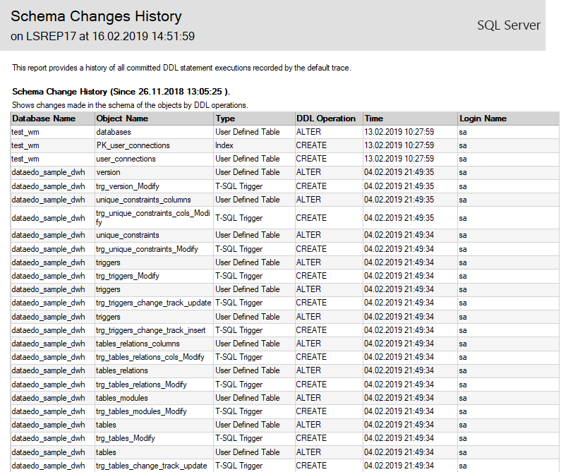

Figure 2 Schema Changes History Report Example(13)

Schema changes include:

* Creating or dropping objects
* Altering object names or attributes

A Schema Changes History report includes:

* Database name
* Object name
* Object type (Table, Trigger, Column, etc.)
* Type of change (CREATE, ALTER or DROP)
* Time of operation
* User who performed the change(13)

In order to generate a Schema Changes History report in SSMS, follow the instructions below:

1. Open object explorer
2. Right click on a database
3. Select Reports>Standard Reports>Schema Changes History (Figure 3 Generate Schema Changes History)

Figure 3 Generate Schema Changes History

# Documentation

## Entity Relationship Diagram

An Entity Relationship Diagram (ERD) provides a visual representation of the database’s tables, columns, relationships, keys, cardinalities, and modalities. These visuals serve as a quick reference for new employees or investigators. Figure 4 below is a small portion of the database, documented as an ERD. Expansion Guide contains information on creating ERDs for the rest of the database.

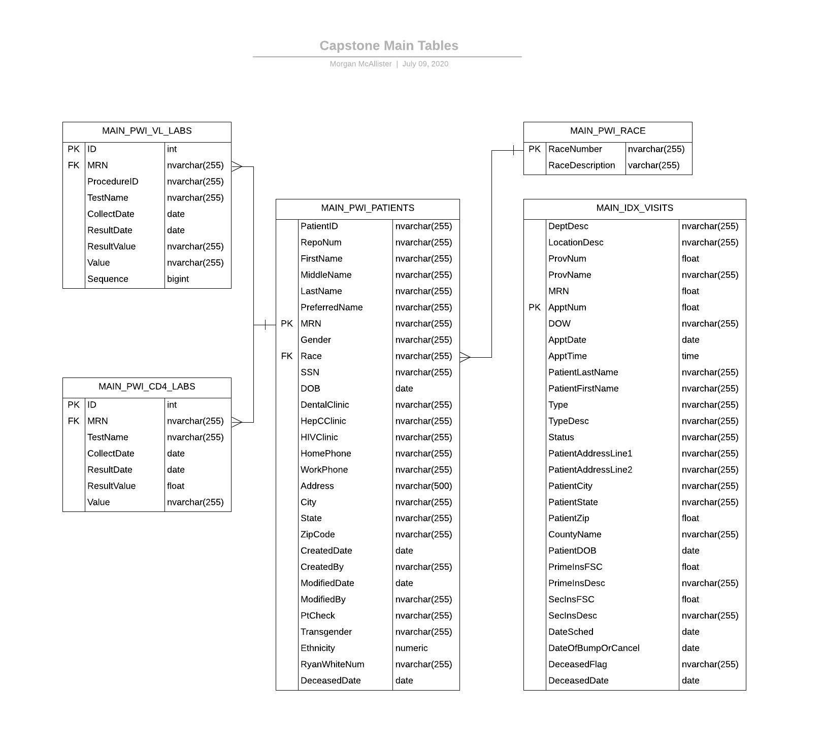

Figure 4 ERD

## 

## Data Dictionary

The data dictionary is an Excel spreadsheet file, housed in the shared department folder. It describes each column of each master table so that investigators and employees can gain a thorough understanding, beyond metadata, of data captured(13-15).

Data elements in the dictionary are described below:

|  |  |
| --- | --- |
| Column Name | Description |
| Column Name | The name of the column, as it appears in SSMS |
| Description | Field description |
| Constraint | Is this field a Primary Key (PK) or Foreign Key (FK) in this table? |
| Data Type | Designated data type in SQL |
| Data Format | Usual format of the data, if applicable |
| Allow Nulls | (Y/N) Can this element be NULL? |
| Example Value | An example that reflects the requirements of the data element |
| Acceptable Values | Specifies what range or type of data is acceptable |
| Notes | Miscellaneous notes pertaining to the field |
| **Data Classification** | Is this data Public, Restricted, or Sensitive? Refer to [UAB Data Classification](https://www.uab.edu/it/home/images/PDFs/DC_and_DP_overview_for_IT.pdf) and Appendix D |
| Date Added/Modified | Date this field was added or changed in its original source. Refer to the Schema Changes History Report for details |

Table 5 Data Dictionary Elements

Figure 5 Screenshot-Data Dictionary File

## Metadata

### Viewing Object Descriptions

Descriptions of database objects should also be stored directly in SSMS for **all tables** and for **columns in master tables**(16). This description should match the description in the Data Dictionary. After descriptions are added by following guidelines in Expansion Guide, they can be viewed by following the instructions below:

**Table** and **View descriptions** can be accessed by right clicking on a table or view in Object Explorer and selecting *Properties* > *Extended Properties*.

**Column descriptions** can be viewed right clicking on a table in Object Explorer and selecting *Design.* Click on a column name. *Description* can be found in the bottom pane under *Column Properties > Table Designer(17).*

### Viewing Metadata in Object Explorer Details

The Object Explorer Details view option in SSMS can be used to easily view other important metadata for objects in the database, without querying.(18, 19)

1. In SSMS, go to View > Object Explorer Details (Figure 6)

Figure 6 Screenshot- Object Explorer Details

1. Select an object in the Object Explorer
2. In the Object Explorer Details pane, right click on the column pane to customize the metadata you want to see. Some of the options can be seen in Figure 7 below.

Figure 7 Screenshot-Customize Metadata Selection

# Expansion Guide

## Master Tables

* Master tables are those designated by the MAIN categorization in the Table Prefixes section.
* Focus on a few tables at a time. Complete all documentation for that table before moving on to the next.
* The department should determine what fields are most commonly used and logically compile them into as few master tables as possible.
* Consult the team to make sure all current tables have a purpose.
* Continue gradually consolidating and reducing existing database clutter until all tables are fitted with a naming prefix and documentation

## Entity Relationship Diagram

* Follow these [instructions](https://sqlservermanagementstudio.org/how-to-generate-er-diagram-using-sql-server-management-studio) to create an ERD in SSMS
* For a printable version, follow this quick [tutorial](https://lucidchart.zendesk.com/hc/en-us/articles/207299756-Entity-Relationship-Diagrams-ERDs-) to import most recent SQL schema to Lucidchart.com
* Confirm cardinalities and modalities are correct
* Go to File>Export>JPEG/PDF>Download

## Data Dictionary

* As soon as a new master table has been created, a user should fill out the Data Dictionary for the new table and fields.
* Create a new sheet for each table, naming the sheet after the table.
* See Table 5 for dictionary element descriptions.

## Metadata

* Use descriptions from the Data Dictionary to fill in descriptions in SSMS for database objects.
* If a Data Dictionary description changes, make changes in the SSMS description as well.
* To add column name descriptions: right click on a table in Object Explorer and select *Design.* Click on a column name. *Description* can be found in the bottom pane under *Column Properties > Table Designer(17).* Click in the field to edit the description.
* To add Table or View descriptions: right click on a table or view in Object Explorer and select *Properties* > *Extended Properties*. You may have to add a new field named *Description*. Enter the table or view description in that field.(18)

## Known Issues

* Add problems to the Known Issues table as they come up. Include small improvement ideas as well as major ones.
* Bring these issues up in meetings, assign an owner to the improvement process, and work with the rest of the department to brainstorm solutions that work for everyone.
* Amend this document to reflect those solutions

# Appendix

Appendix A

PRO Detailed Table(2)

*Appendix B*

|  |  |
| --- | --- |
| {department} Data Request Form | |
| **Requesting person/entity:**  *(Request originator – include email)* |  |
| **Sponsor:**  *(Account number to be billed for request)* |  |
| **PI** *(for project, select most appropriate option below):*  *- UAB CFAR member, Other CFAR member, Non CFAR member and Other* |  |
| **Funding** *(for project, select most appropriate option below):*  *- NIH funded, Not funded and Other* |  |
| **Research location** *(Select one from below):*  *- UAB CFAR, Other CFAR, Non CFAR institution and Other* |  |
| **Purpose of request** *(Intended use of data)***:** | |
| **Has this request been run before? (If “yes” when?):** |  |
| **If applicable, has a digitized copy of the IRB approval been provided?** *(Applicable to all UAB {database}Studies)* |  |
| **Question(s):** *[Define question(s) project is designed to address. This will help us come up with alternatives that may allow us to optimize your data request]* | |
| **Clearly define population for this data request** *(Ex: All patients with first visit to {censored} primary care 1/1/08-1/1/09):* | |
| **Specify, define and period for all requested variables:** *(Ex: baseline CD4 = CD4 value +/- 6 months from 1st clinic visit date; 1/1/08-1/1/09* | |
| **Comments/Clarifications:** *[Use this space to clarify preferred method of delivery (ex: email, {censored} I-drive, UAB drop box, etc.), discuss any specific requests involving file type – data delivery, or other comments].* | |
| Please note the following:  1. We will do our best to accommodate specifications regarding data delivery, but we cannot accommodate all requests.  2. Data requests involving cohort research will not be processed until the project has been formally presented at a {database} Meeting.  3. Expect to be contacted within 48 hours of sending a formal request form first for clarification. Once clarified, requests will be placed in the New Request queue and you will be informed of the planned time of completion via email.  4. Once you receive data, please review carefully and ensure that it meets your needs. You will have 48 hours to contact us for clarifications/changes to request. Requests for changes received after this time period will result in your query returning to the bottom of the New Request queue. | |

Appendix C

|  |
| --- |
| {database} Change Request Form |
| Requestor(s): |
| Description of the change: |
| Reason for the change: |
| Impact of the change: |
| Proposed effective date: |
| Additional comments: |

Appendix D

UAB Data Classification Table(20)

References

1. Michener WK. Ten Simple Rules for Creating a Good Data Management Plan. PLoS Comput Biol. 2015;11(10):e1004525-e.

2. {department} CFAR Clinical Core {department} IT Poster 2016 [Available from: [https://www.uab.edu/research/home/images/documents/cores/uab-center-for-aids-research-clinical-core/CFAR_Clinical_Core-{department}_-IT_Poster_2016.pdf](https://www.uab.edu/research/home/images/documents/cores/uab-center-for-aids-research-clinical-core/CFAR_Clinical_Core-RISC_-IT_Poster_2016.pdf).

3. Great Sample Resume. List of Data Modeler Responsibilities and Duties 2016 [updated 2016-06-29. Available from: <https://www.greatsampleresume.com/job-responsibilities/data-modeler-responsibilities/>.

4. Hay J. EDW Strategic Positions [Internet]2011 2011-07-26. [cited 2020]. Available from: <https://justinhay.wordpress.com/2011/07/26/edw-roles-and-responsibilities-part-i/>.

5. Gaille B. 10 Database Naming Conventions Best Practices 2014 [updated 2014-12-18. Available from: <https://brandongaille.com/10-database-naming-conventions-best-practices/>.

6. Stack Overflow. Database, Table and Column Naming Conventions 2019 [Available from: <https://stackoverflow.com/questions/7662/database-table-and-column-naming-conventions>.

7. Factor P. Redgate Hub. 2019 2019-01-09. [cited 2020]. Available from: <https://www.red-gate.com/simple-talk/blogs/sql-naming-conventions/>.

8. Eder L. A Guide to SQL Naming Conventions: DZone Inc.; 2019 [Available from: <https://dzone.com/articles/a-guide-to-sql-naming-conventions>.

9. Kroenke D, Auer DJ. Database processing: fundamentals, design, and implementation: Boston: Pearson; 2012.

10. Lau E. Best Practices: Manage database schema changes with Database Migration (and version control): F5 Works; 2017 [updated 2017-05-17. Available from: <https://blog.f5.works/best-practices-manage-database-schema-changes-with-database-migration-and-version-control/>.

11. Masko M. SQL Territory [Internet]. SQL Territory2018 2018-11-20. [cited 2020]. Available from: <https://blog.sqlterritory.com/2018/11/20/5-ways-to-track-database-schema-changes-part-1-default-trace/>.

12. Dave P. SQL SERVER – SSMS: Schema Change History Report: SQL Authority; 2014 [updated 2014-07-07. Available from: <https://blog.sqlauthority.com/2014/07/07/sql-server-ssms-schema-change-history-report/>.

13. Kononow P. Dataedo. 2019. [cited 2020]. Available from: <https://dataedo.com/blog/different-types-of-tools-you-can-use-to-create-data-dictionary>.

14. Anderson C. Data Dictionary: a how to and best practices: Medium; 2018 [updated 2018-06-21. Available from: <https://medium.com/@leapingllamas/data-dictionary-a-how-to-and-best-practices-a09a685dcd61>.

15. Ag Data Commons. Manually creating a data dictionary | Ag Data Commons: The Pacific Northwest Forest Inventory and Analysis Database; 2020 [Available from: <https://data.nal.usda.gov/manually-creating-data-dictionary>.

16. Elias J. How to document SQL Server database objects: SQLShack; 2017 [updated 2017-06-14. Available from: <https://www.sqlshack.com/how-to-document-sql-server-database-objects/>.

17. Adamowicz A. 4 ways to edit column descriptions in SQL Server Management Studio: Dataedo; 2018 [Available from: <https://dataedo.com/kb/tools/ssms/how-to-view-and-edit-table-and-column-comments>.

18. Giercyk J. 2020. [cited 2020].

19. Knight M. Metadata Management Drives the Future of Data Management - DATAVERSITY: Dataversity; 2019 [updated 2019-12-19. Available from: <https://www.dataversity.net/metadata-management-drives-the-future-of-data-management/>.

20. The University of Alabama at Birmingham. Applying the Data Classification and Protection Rules 2018 [Available from: <https://www.uab.edu/it/home/images/PDFs/DC_and_DP_overview_for_IT.pdf>.