Test Report - Application No. 2

## ENVIRONMENT:

The tests were conducted on Ubuntu 22.04 by manual user testing

## AREA:

* Statistics Calculation Functions:
  + get_median → OK
  + get_standard_deviation → OK
  + get_coefficient_of_variation → ERROR
  + get_sessions → OK

## DEFECTS:

Statistics calculation functions (get_coefficient_of_variation) [fixed]:

Problem: Runtime error

IndexError: list index out of range

Exception: Not enough data

Reason

Wrong list indexing in draw_cov_table() function

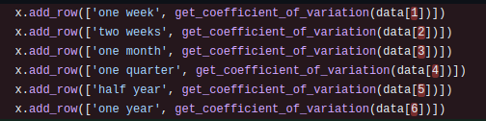

Solution

changed indexing to start from 0

