心臟內科病房工作規範
本月病房總醫師: Dr. (GSM )
- 病房工作分組
- 了解學習目標
- 你來心臟內科要學習什麼？
- 看過教學計畫了嗎？
- 學習「常見心臟病之主訴」、「常見心血管疾病基本處置」、「基本心血管檢查(超音波、影像導管、心肌酵素與血脂肪)」
- 科內教學活動
- 教學門診：每週一上午吳德朗教授/ 下午葉森洲副院長，週五賀萬靖醫師教學門診，請分配到的實習醫學生Intern/Clerk準時於上午八點二十分/下午一點二十分到復健大樓心內門診區報到，請穿著整齊。(不可穿值班服)
- 晨會：若無全院性演講或大內科教學活動，請準時於早上七點三十分準時至7A/7B討論室(依照後面的學術活動表)。
- 文獻導讀：依規定於7A or 7B討論室舉行， (日期與負責VS&學員請參考『CV學術活動表』；主治醫師事前會提供文獻，若無，可直接聯絡負責主治醫師，或心臟科秘書詢問)。
- 心電圖教學：每週四由吳德朗教授早上十點開始心電圖教學。每週三向雷藥師領取心電圖紙本，寫下判讀結果。
- 醫護討論會：第四週舉行，請被指定PGY事先與總醫師討論案例與討論內容。
- 每周一到五，下午二點到三點，會針對PGY/Intern/Clerk進行教學活動，晨會以外之表定教學活動（參閱：心臟科病房學術活動表）請clerk組長提早（至少前一日）電聯上課主治醫師，確定上課時間/地點，並完成會議記錄
- 需知:
- 各職級醫師需了解其訓練計劃、授權分級與需督導層級。需熟悉全院性與本科職前訓練內容。
- 需熟悉本科臨床常見技術(心電圖)與照護項目。執行心電圖時個人的能力分級與督導層級為何?
- 需按時完成學習手冊。病歷依規定書寫，結束前填寫「學員對臨床教師回饋表」與參加教學回饋座談會。
- 查房注意事項
- 大部分主治醫師都是早上九點查房，請前一晚或當日提早到醫院準備病人資料和巡視病人。
- 查房前務必掌握資料：病人最新vital signs，Lab data(Bun，Cr，Na，K，CBC，HbA1C，DM Lipid profiles: HDL， LDL，Cholesterol，TG，Uric acid)，檢查結果(EKG，X-ary，Treadmil，Holter，2D Echo，Cath)，現在藥物。另外，DM病人要有finger sugar結果，CHF病人要有I/O、BW。要掌握病人狀況。(診斷，計畫，何時檢查及結果，何時出院)。查房前病人檢查結果，要親自清楚跟病人與家屬解釋。
- 查房時輪到自己的病人時請在前帶路，開燈拉床簾，注意基本禮貌，跟病人介紹某某教授或某某主治醫師來查房。
- 查房時請站在病人左手邊，主治醫師對面，報告病患情況給所有參與查房的同仁聽。
- 報告Case的內容，請流暢、簡單、明瞭，有思考邏輯，需要反覆練習，用藥依照重要順序報告!!
  - CHF，etiology (IHD，VHD，DCM…)， EF%，Fc，rhythm，加重因子 => 現在體重及改變量和目標體重
  - ACS (STEMI/NSTEMI/Unstable angina)，Killip，wall (EKG，2D Echo)，onset，CATH結果，MI後第幾天，Drug
  - Effort/Atypical Angina，Tn-I/EKG/Treadmil /Tl-201，目前plan (+-CATH)
  - Atrial fibrillation (paroxysmal/persistent/long lasting/permanent)，CHADS2，LA size)，有無anti-coagulant (NOAC, warfarin dose)，目前PT/INR level
  - DM type 1/2，HbA1C，+-Proteinuria，Cr，目前finger sugar，控制藥物OHA/RI

- 病歷書寫與特別提醒事項
- 入院醫療評估需包含身體、專科問題、疼痛、營養等，另外功能、出院轉介，壓瘡與跌倒風險等由護理師評估，但有問題仍需於病歷中呈現，請帶入範本中的Measurable Goal。
- 病歷書寫尤其心臟理學檢查請詳細記錄，主治醫師comment與教學的請紀錄於病歷中。PE項目包括JVP(pressure，a，v wave)，PMI (location，sustained)， Heart murmur (Grading， location， radiation， character)，Carotid pulse，Peripheral pulse (ex: JVP 5cm above the sternal angle, with head of examining table raised to 30°. Carotid upstrokes brisk, without bruits. Apical impulse palpable at sixth intercostal space 2 cm lateral to midclavicular line. Normal S1, physiologically split S2. S4 heard at apex. A II/VI medium-pitched midsystolic murmur at the 2nd right interspace; does not radiate to the neck. No diastolic murmurs.)
- 辦出院請務必再recheck，需完成當天病程記錄、出院病摘（入出院診斷不可有縮寫，若有做CATH請附註” Coronary angiography indication: angina pectoris ”）、出院計劃書。
- 戒菸衛教：醫囑開立”戒菸衛教 (TEL: 2273) “(free tapping) ->填寫戒菸轉介單->請護理師電聯戒菸衛教
- SDM決策
- Heart Failure病患請採用結構化病歷: 確實評估 HF risk score『GWTG』『MAGGIC』並記載於progress note
的Assessment裡面！！！（每個星期四的note請務必確實記載！）
- 缺血性心臟病: 要有1.臨床診斷（如angina pectoris, unstable angina, acute STEMI…）2.解剖影像診斷（
Coronary artery disease, one vessel disease, /p LAD stenting）
- 心臟衰竭：1. 要區分Heart failure with preserved ejection fraction 或Heart failure with reduced ejection fraction 2. 要有etiology( ischemic heart disease, valvular heart disease, hypertensive cardiomyopathy…) 3. 要有LVEF % 4.要有NYHA Fc 5.要寫sinus rhythm, Af, pacemaker rhythm等
- 病房工作注意事項
- 如果可以辦理明日預出院的病患，請盡量開“今辦明出”或“今辦明結”醫囑，盡量於15:30以前開立。
- 若有病患臨時決定今天出院，請盡量於上午10點前開好出院醫囑，若查房時間太晚無法於上午10點前開好出院醫囑，請建議主治醫師開立“今辦明出”，以減少住院醫師小夜班接新病人。
- 當天出院的病患，請盡量讓病人在中午之前就把出院手續全部辦好。如果當天還有排抽血/檢查，請跟主治醫師確認該檢查有無出院前安排的必要性（可否回門診再安排）。
- ***交接班****請務必於下班前將手上病人完成交班。(不用交班的也要點無特殊交班) 請1700以前完成
- 接新病人請注意：HbA1c, lipid profile三個月/ uric acid, 2D echo六個月。
- 入院記錄務必點選範本(Family hx/Plan)，依病況做適度更改。
- 若病患當日接受導管、電燒、節律器置放等侵入性檢查，應於當日病患回到病房後再次訪視，追蹤後續病人vital signs、症狀、心電圖結果、導管或節律器的傷口狀況（有無流血、腫、紅）等。
- 若有Acute heart failure且EF<40%，請知會病房總醫師，看是否個管師收案，後續注意完成收案的抽血檢查。EF < 40% 或 AMI病人請照會復健科，以利安排心臟復健！(因疫情關係，減少復健科負擔，視情況會診)NOTE（admission, progress）上面請務必註明『NYHA Fc Class ＆ GWTG score(結構化病歷)』
- 本科施行戒煙衛教(請參閱電子檔案), 包括所有冠心病病患。
- 如有心律不整、嚴重心臟衰竭、AMI後或其他狀況不穩定的病患，可裝置Portable EKG (7A及7B有monitor在station供監控)，Order開立EKG MONITOR (附註wireless)即可。
- 主治醫師查房後，若有預計次日要做cath（心導管）或EP（cardioversion、電燒、節律器置放）的病患：
  - 一組請登錄於7A病房cath本或EP本。當日進來的new patient可不寫。
  - 二組請於下午2點以前至7A病房填寫 『每日病房回報表』，完成後請簽名or蓋章！
  - 紙本登錄完成後，將『個案』登錄電子排程系統
- 病房常用檢查開立方式
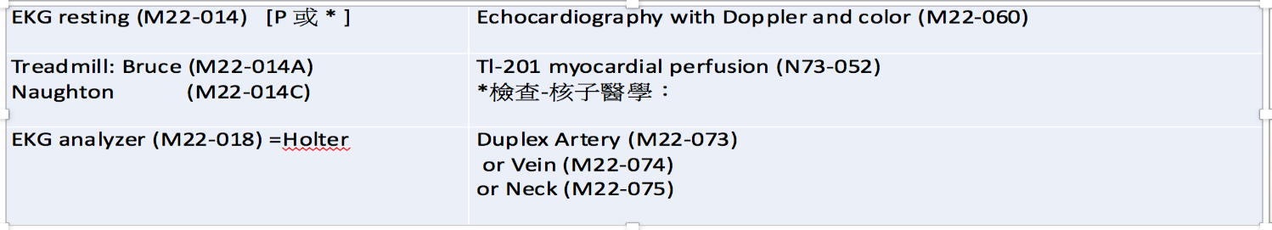
- 心臟科檢查單位分機
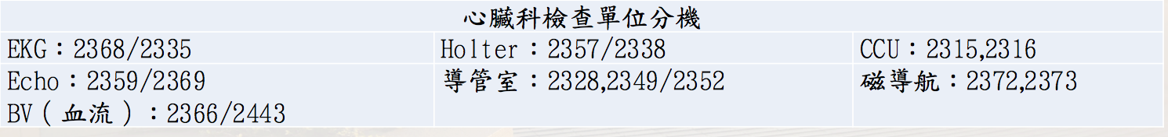
- 附錄：常用藥物
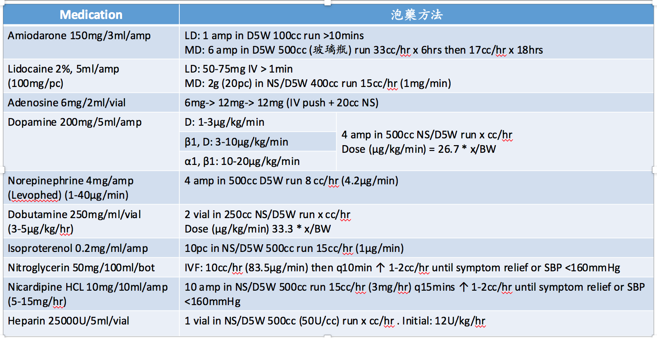
Clerk的工作
- 跟主治醫師和學長姐巡視病人，參與早上七點半的晨會和下午的教學活動。
- 照顧二個病人，查房時present case，完成照顧病人的病歷書寫及和接新病人1-2名。(值班隔天可不接新病人) 。
- 操作自己組別的EKG(輸入正確病人資料，務必上傳!!)、Foley、NG tube、ABG等procedures(須由師長監督下操作)，判讀後可找學長姊check結果。
- 星期三拿EKG回去判讀，星期四查房後練習判讀EKG和報告。

病房常用ICD 10編碼
參考資料
http://www.icd10data.com/ICD10CM/Codes

Ｖalvular heart diseases
I050 Rheumatic mitral stenosis | I051 Rheumatic mitral insufficiency
I052 Rheumatic mitral stenosis with insufficiency | I060 Rheumatic aortic stenosis
I061 Rheumatic aortic insufficiency | I062 Rheumatic aortic stenosis with insufficiency
I071 Rheumatic tricuspid insufficiency | I080 Rheumatic disorders of both mitral and aortic
I081 Rheumatic disorders of both mitral and tricuspid | I089 Rheumatic multiple valve diseases, unspecified
I340 Nonrheumatic mitral (valve) insufficiency | I341 Nonrheumatic mitral (valve) prolapse
I350 Nonrheumatic aortic (valve) stenosis | I351 Nonrheumatic aortic (valve) insufficiency
I361 Nonrheumatic tricuspid (valve) insufficiency | I371 Nonrheumatic pulmonary valve insufficiency
Hypertensive diseases
I10 Essential (primary) hypertension | I110 Hypertensive heart disease with heart failure
I119 Hypertensive heart disease without heart failure | I150 Renovascular hypertension
I152 Hypertension secondary to endocrine disorders | I159 Secondary hypertension, unspecified
Acute Ischemia heart diseases
I200 Unstable angina | I201 Angina pectoris with documented spasm
I2101 ST elevation (STEMI) myocardial infarction involving left main coronary artery | I2102 ST elevation (STEMI) myocardial infarction involving left anterior descending artery
I2111 ST elevation (STEMI) myocardial infarction involving right coronary artery | I2121 ST elevation (STEMI) myocardial infarction involving left circumflex coronary artery
I214 Non-ST elevation (NSTEMI) myocardial infarction | I241 Dressler's syndrome
Chronic Ischemia heart diseases
I2510 Atherosclerotic heart disease of native coronary artery without angina pectoris | I2511 Atherosclerotic heart disease of native coronary artery with angina pectoris
I252 Old myocardial infarction | I253 Aneurysm of heart
I255 Ischemic cardiomyopathy | I2541 Coronary artery aneurysm
I25708 Atherosclerosis of coronary artery bypass graft(s), unspecified, with other forms of angina pectoris | I2582 Chronic total occlusion of coronary artery
Heart failure and cardiomyopathy
I420 Dilated cardiomyopathy | I421 Obstructive hypertrophic cardiomyopathy
I422 Other hypertrophic cardiomyopathy | I425 Other restrictive cardiomyopathy
I426 Alcoholic cardiomyopathy | I427 Cardiomyopathy due to drug and ext. agent
I5021 Acute systolic (congestive) heart failure | I5022 Chronic systolic (congestive) heart failure
I5031 Acute diastolic (congestive) heart failure | I5032 Chronic diastolic (congestive) heart failure
I5023 Acute on chronic systolic heart failure | I5033 Acute on chronic diastolic heart failure
I5041 Acute combined systolic and diastolic heart failure | I5042 Chronic combined systolic and diastolic heart
I5043 Acute on chronic combined systolic and diastolic heart failure | I5181 Takotsubo syndrome
Paroxysmal tachycardia and conduction disorder
I441 Atrioventricular block, second degree | I442 Atrioventricular block, complete
I447 Left bundle-branch block, unspecified | I453 Trifascicular block
I456 Pre-excitation syndrome | I4581 Long QT syndrome
I471 Supraventricular tachycardia | I472 Ventricular tachycardia
I480 Paroxysmal atrial fibrillation | I481 Persistent atrial fibrillation
I482 Chronic atrial fibrillation | I483 Typical atrial flutter
I484 Atypical atrial flutter | I4901 Ventricular fibrillation
I491 Atrial premature depolarization | I493 Ventricular premature depolarization
I469 Cardiac arrest, cause unspecified | I495 Sick sinus syndrome
Diseases of pulmonary circulation
I2602 Saddle embolus of pulmonary embolism with acute cor pulmonale | I2692 Saddle embolus of pulmonary embolism without acute cor pulmonale
I2609 Other pulmonary embolism with acute cor pulmonale | I2699 Other pulmonary embolism without acute cor pulmonale
I270 Primary pulmonary hypertension | I272 Other secondary pulmonary hypertension
I2781 Cor pulmonale, chronic | I2782 Chronic pulmonary embolism
Pericardial disease, endocarditis, and myocarditis
I300 Acute nonspecific idiopathic pericarditis | I311 Chronic constrictive pericarditis
I313 Pericardial effusion (noninflammatory) | I314 Cardiac tamponade
I330 Acute and subacute infective endocarditis | I409 Acute myocarditis, unspecified
Peripheral artery diseases
I70211 Atherosclerosis of native arteries of extremities with intermittent claudication, right leg
I70212 Atherosclerosis of native arteries of extremities with intermittent claudication, left leg
I70213 Atherosclerosis of native arteries of extremities with intermittent claudication, bilateral legs
I70234 Atherosclerosis of native arteries of right leg with ulceration of heel and midfoot
I70234 Atherosclerosis of native arteries of left leg with ulceration of heel and midfoot
I70261 Atherosclerosis of native arteries of extremities with gangrene, right leg
I70262 Atherosclerosis of native arteries of extremities with gangrene, left leg
I70263 Atherosclerosis of native arteries of extremities with gangrene, bilateral legs
I743 Embolism and thrombosis of arteries of the lower extremites
Deep vein thrombosis
I82411 Acute thrombosis of right femoral vein | I82412 Acute thrombosis of left femoral vein
I82413 Acute thrombosis of femoral vein, bilateral | I82431 Acute thrombosis of right popliteal vein
I82432 Acute thrombosis of left popliteal vein | I82433 Acute thrombosis of popliteal vein, bilateral
I82511 Chronic thrombosis of right femoral vein | I82512 Chronic thrombosis of left femoral vein
I82513 Chronic thrombosis of femoral vein, bilateral | I82531 Chronic thrombosis of right popliteal vein
I82432 Chronic thrombosis of left popliteal vein | I82433 Chronic thrombosis of popliteal vein, bilateral
I8700 Postthrombotic syndrome without complications
Congenital malformations
Q210 Ventricular septal defect | Q211 Atrial septal defect
Q213 Tetralogy of Fallot | Q250 Patent ductus arteriosus
Q251 Coarctation of aorta | Q256 Stenosis of pulmonary artery
Q259 Congenital malformation of great arteries, unspecified

