In order to run the tool, user should run TMA.exe file. After running the program, a window as below is illustrated. This form comprises three major parts. 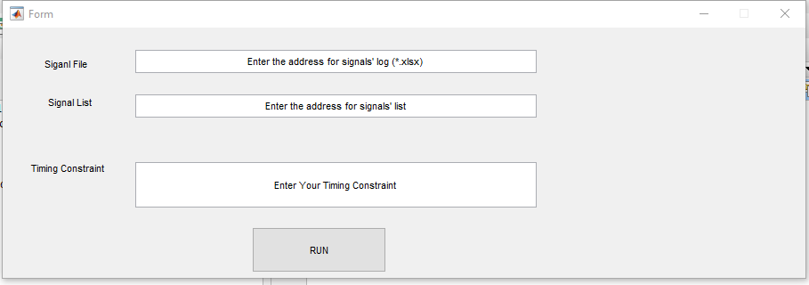

3

2

1

1. A textbox to define the Signals file. Signals file, Signal.xlsx, is an excel sheet file that contains the signal values log. The first column of the ‘Signals.xlsx’ with header of ‘t’, contains the timestamps at which the signals are sampled and the rest columns show the signal names (at the first row of ‘Signals.xlsx’) and their values. As an example below, the first column show the timestamps and we have three signals ‘s32’, ‘t3’, ‘y3’ and their values in their related columns. In the textbox number 1, the Signals.xlsx address should be defined.

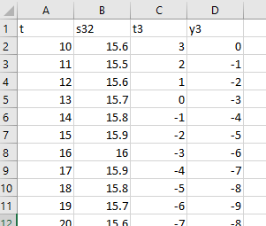

1. SignalList.txt file address shows the number and name of signals that should be monitored. In this file, each signal name should be separated with the next one by at least one space. As the image below shows, this file comprises the signal names and time ‘t’ as the same as ‘Signals.xlsx’. In the textbox number 2, the ‘signalList.txt’ address should be defined.

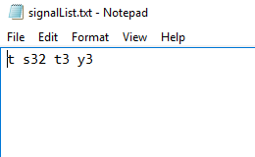

1. The textbox number 3 is dedicated to the timing constraint that is evaluated by TMA. Obviously, each timing constraint can be compound of several other constraint so that they should be well parenthesized. For instance, if a constraint is ‘t3>0’ we should write it ‘(t3>0)’. As another example, if *Until* operator on two signals is evaluated, it should be written as: ((t3>0)U[2,10](y3<5));

There are other example on the following that represent the correct expression of timing constraints with enough parentheses:

((L({s32,15.7,/},{t3,0,/},1))>23);

(E[0,5](((L({t3,0,/},{s32,15.7,/},1))>4)U[1,6](t3>1)));

(E[0,5](((L({s32,15.7,/},{t3,0,/},1))>1)|(t3>1)));

(E[0,5](((L({t3,0,/},{s32,15.7,/},1))>4)U[1,6](G[10,20](t3>1))));

((E[1,5](t3>0))U[1,6](E[2,7](s32>15.7)));

(((F({s32,15.7,/}))>0.075)U[10,20](!(t3>0)));

((P({t3,0,/},{y3,0,/},0.05,2))>1);

(S({t3,0,/},{t3,0,/},0);

(C({t3,0,/},{t3,1,/});

After adding two file addresses and the timing constraint that should be evaluated, by pressing the ‘RUN’ button, the tool is run and the results are shown on graphs.