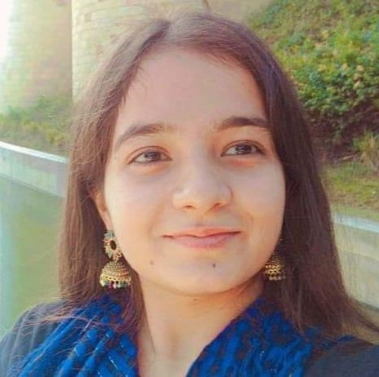
Education
Master of Applied Artificial Intelligence (Professional): Deakin, 2025 - Exp. Nov 2026
Bachelor of Software Engineering (Honours): Deakin, 2023 - 2024
Bachelor of Software Engineering (Honours): Global program in affiliation with Deakin (Chitkara University, India) , 2020 - 2022
Bio
Chaya Shiv is a Software Engineering (Honours) graduate from Deakin University and is currently pursuing a Master of Applied Artificial Intelligence (Professional), specialising in Data Science, at Deakin University. She has experience in software development, machine learning, deep learning, quality assurance, robotics and IoT through industry, research and university projects. She is currently learning and working on quantum machine learning, while her research interests include artificial intelligence, IoT and software engineering.
Github: chaya221071557 - Overview
From Chitkara: chaya2209 - Overview
LinkedIn: Chaya Shiv - DigiGround | LinkedIn
Email: chayashiv629@gmail.com

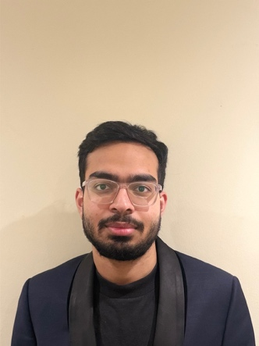
Krish Uppal
LinkedIn: https://www.linkedin.com/in/krish-uppal-a6011b239
GitHub: https://github.com/uppalkrish
Deakin University
Krish Uppal is a Bachelor of Software Engineering student at Deakin University with experience across software development, DevOps, cloud computing, embedded systems, robotics, and quantum machine learning. He has worked on industry and research projects involving backend development, networking, Linux, cloud infrastructure, machine learning, and hardware–software integration.
Krish is also involved in Quantum Machine Learning research at Deakin University, working with Qiskit, quantum neural networks, quantum kernels, QSVC, and hybrid quantum-classical machine-learning approaches. His broader technical interests include embedded systems, IoT, networking, cloud-native applications, robotics, artificial intelligence, and software engineering.
Education
Bachelor of Software Engineering, Deakin University, Melbourne
Expected Completion: 2027

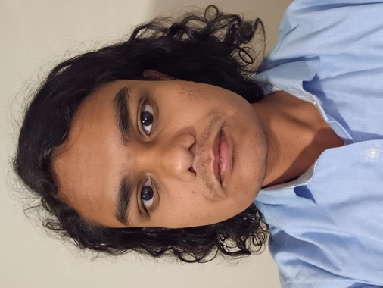
LinkedIn: www.linkedin.com/in/sheikh-ayatur-rahman-995613219
Email: ayat29112@gmail.com
Github: ayat29
Academic Qualifications:
1) Master of Applied Artificial Intelligence (Professional), Deakin University, Geelong, 2025-Present
2) Bachelor of Science in Computer Science, BRAC University, Dhaka, Bangladesh, 2020-2024
Bio: I am currently a Master’s student at Deakin University with a strong interest in Machine Learning research, particularly in applying Natural Language Processing techniques to address a wide range of problems across different domains. My previous research has been published in ACL workshops, and I have also gained industry research experience as a Research Scientist Intern at Pi School, Italy. I am always open to opportunities for collaboration and engaging with researchers working on interesting and impactful problems.


Bio:
An Nguyen is a Master of Applied AI (Professional) student at Deakin University and a member of the IoT and Software Engineering Lab. His research interests include large language models, quantum machine learning, satellite networking, natural language processing, and intelligent robotics. His current research explores a quantum-enhanced GPT architecture for BBR congestion control over Starlink networks. He has also worked on applied AI projects involving workflow automation, document intelligence, and conversational and manipulation capabilities for the Reachy humanoid robot. An has professional experience developing AI-powered and full-stack applications using Python, TypeScript, React, Next.js, FastAPI, PostgreSQL, and REST APIs.
Academic qualifications:
- Master of Applied AI (Professional), Deakin University, 2025–2027 (currently undertaking)
- Bachelor of Computer Science (Data Science), Swinburne University of Technology, 2022–2025
LinkedIn: An Nguyen - nimbl | LinkedIn
GitHub: AnthonyBnc - Overview
Email: 221522575@deakin.edu.au

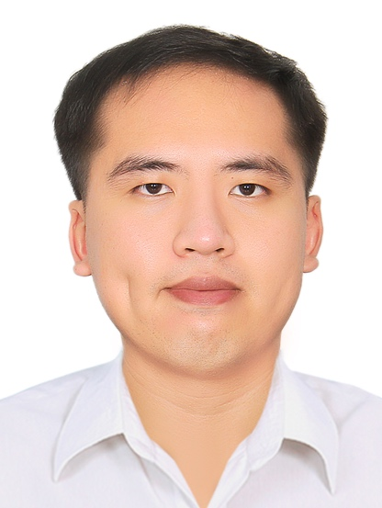
LinkedIn | GitHub | nguyentien2001.tn@gmail.com
Tien Nguyen is a Master of Data Science student at Deakin University, Melbourne, Australia, maintaining a High Distinction average. His research interests are in the areas of privacy-preserving systems, differential privacy, machine learning security, quantum deep reinforcement learning, and quantum-enhanced optimization. In his current studies, his research focus is on the development of privacy-preserving trajectory encoding systems and quantum-enhanced congestion control for satellite networks. Prior to his Master's, he completed a Bachelor of International Business at RMIT University, Vietnam, in 2024.
He is first author of two trajectory-privacy manuscripts prepared for IEEE Transactions on Information Forensics and Security, and lead author of a book chapter submitted to a Springer Nature volume on the sharing economy.
Tien also works as a Casual Research Assistant supporting research projects within the school.
Education
- Master of Data Science, 2025–2026
Deakin University, Australia
- Bachelor of International Business, 2020–2024
RMIT University, Vietnam

Alen Cherian is a Casual Research Assistant at Deakin University’s Melbourne Burwood campus and a Full Stack Developer with a Master of Computer Applications from Mahatma Gandhi University, Kottayam. He has strong technical and software development capabilities, with expertise in AI-driven networking, cloud computing, machine learning, and full-stack development. His current research focuses on integrating distilled Large Language Models with next-generation networking technologies to enable intelligent congestion control and improve network performance.
https://github.com/cherian-alen - GitHub
https://www.linkedin.com/in/alen-cherian - LinkedIn
Education
Master of Computer Applications (MCA), 2022–2024
Mahatma Gandhi University, Kottayam, India
Bachelor of Computer Applications (BCA), 2018–2021
Mahatma Gandhi University, Kottayam, India

