classify-raster-data

Michiel P. Veldhuis

21 juni 2016

## Classifying raster data

First import the necessary libraries

# load libraries  
library(raster)

## Loading required package: sp

library(rgdal)

## rgdal: version: 1.1-10, (SVN revision 622)  
## Geospatial Data Abstraction Library extensions to R successfully loaded  
## Loaded GDAL runtime: GDAL 2.0.1, released 2015/09/15  
## Path to GDAL shared files: C:/Users/p250929/Documents/R/win-library/3.3/rgdal/gdal  
## Loaded PROJ.4 runtime: Rel. 4.9.2, 08 September 2015, [PJ_VERSION: 492]  
## Path to PROJ.4 shared files: C:/Users/p250929/Documents/R/win-library/3.3/rgdal/proj  
## Linking to sp version: 1.2-3

## Import Canopy Height Model

chm_teak <- raster("../NEONdata/D17-California/TEAK/2013/lidar/TEAK_lidarCHM.tif")  
plot(chm_teak)

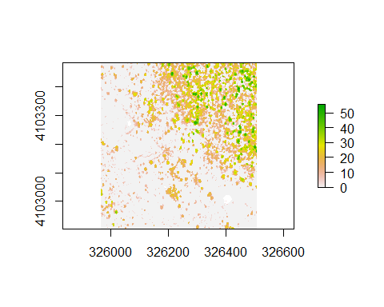

## Deal with 0 values

hist(chm_teak)

## Warning in .hist1(x, maxpixels = maxpixels, main = main, plot = plot, ...):  
## 32% of the raster cells were used. 100000 values used.

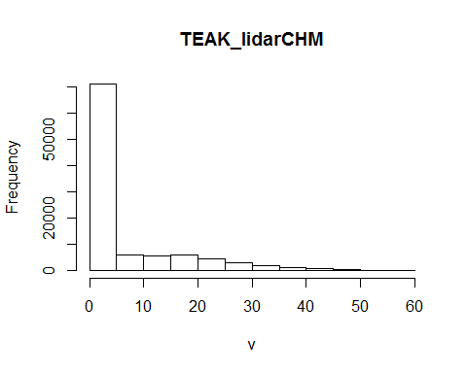

chm_teak[chm_teak==0] <- NA  
hist(chm_teak,  
 xlab="Tree Height (m)")

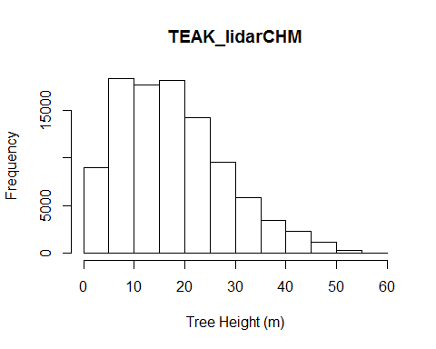

## Import aspect data

aspect_teak <- raster("../NEONdata/D17-California/TEAK/2013/lidar/TEAK_lidarAspect.tif")  
plot(aspect_teak,  
 main="Aspect data for Teakettle Field Site")

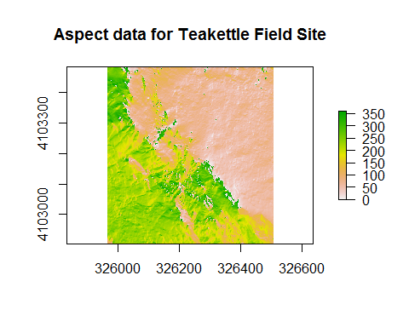

## Create classification Matrix

class.m <- c(0, 45, 1,  
 45, 135, NA,  
 135, 225, 2,  
 225, 315, NA,  
 315, 360, 1)  
rcl.m <- matrix(class.m,   
 ncol = 3,  
 byrow = TRUE)

## Reclassify raster

asp.ns <- reclassify(aspect_teak,  
 rcl.m)  
plot(asp.ns,   
 main="North and South Facing Slopes")

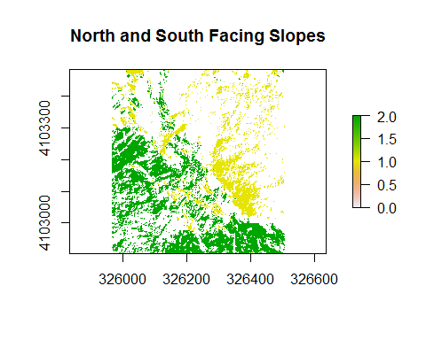

## Export Geotiff

writeRaster(asp.ns,  
 file = "../outputs/TEAK/Aspect_Teak.tif",  
 options = "COMPRESS=LZW",  
 NAflag = -9999)

## Mask Data

asp.ns

## class : RasterLayer   
## dimensions : 577, 543, 313311 (nrow, ncol, ncell)  
## resolution : 1, 1 (x, y)  
## extent : 325963, 326506, 4102905, 4103482 (xmin, xmax, ymin, ymax)  
## coord. ref. : +proj=utm +zone=11 +datum=WGS84 +units=m +no_defs +ellps=WGS84 +towgs84=0,0,0   
## data source : in memory  
## names : layer   
## values : 0, 2 (min, max)

ndvi <- raster("../NEONdata/D17-California/TEAK/2013/spectrometer/veg_index/TEAK_NDVI.tif")  
plot(ndvi)

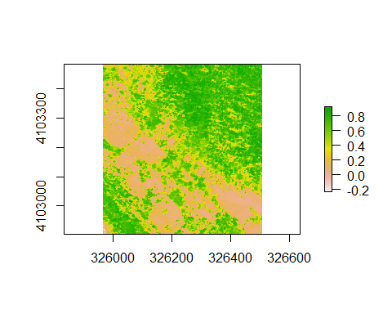

# mask data  
nFacing.ndvi <- mask(ndvi,   
 asp.ns)   
  
plot(nFacing.ndvi)

