Subhash Joshi
[Email address]
Oracle AI Database 26ai Free
Windows Setup Guide

This comprehensive, step-by-step guide is designed to help you set up, run, and interact with the Oracle AI Database 26ai Free (Full Edition) on Windows 11 using Podman Desktop and Oracle SQL Developer.

Prerequisites
Before starting the setup, ensure the following components are installed and ready on your system:
- Operating System: Windows 11 (Home, Pro, or Enterprise) with WSL2 enabled.
- Podman Desktop: Download and install the latest stable version of Podman Desktop for Windows.
- Database Client: Download and extract Oracle SQL Developer. Ensure you have a compatible Java JDK installed if required by SQL Developer.
- Shell Interface: Use Windows Terminal (running a PowerShell profile) or standard PowerShell as your default terminal. Do not use the legacy Command Prompt (cmd).

Step 1: Initialize and Start the Podman Machine
Podman on Windows executes Linux container images within an integrated Linux virtual machine (WSL2 backend). This virtual environment must be active before running any container operations.
- Open Windows PowerShell or Windows Terminal.
- Run the following command to boot the default Podman virtual machine:
podman machine start
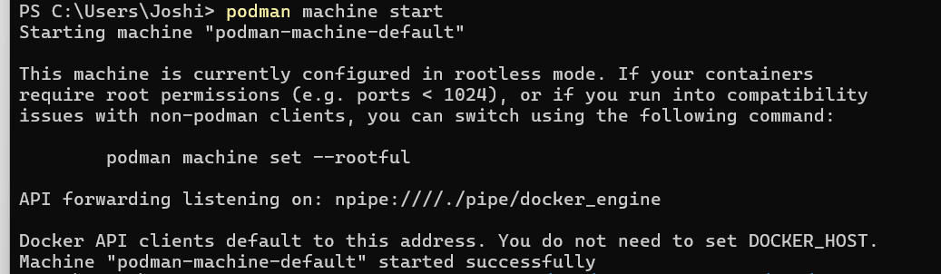
- Verification: If the machine is already running, you will see a message indicating so. If not, the console will output:
Starting machine "podman-machine-default"
Machine "podman-machine-default" started successfully
- Alternatively, you can verify this inside the Podman Desktop UI by checking the bottom-left corner of the application to ensure the VM's status badge is active/green.

Step 2: Configure Local Storage Persistence
To ensure your data survives container deletion, restarts, or Windows system reboots, you must store your data in a named Podman volume. This volume acts as a permanent vault mapped directly to the database inside the container.
- Create a persistent named volume by executing the following command in PowerShell:
podman volume create oracle_data_vol
- The Pre-built Advantage: By using a named volume rather than an empty host directory mount, Podman automatically populates it with the prebuilt database files configured in the Oracle image, shortening your first startup wait from 10 minutes to under 60 seconds.

Step 3: Launch the Oracle AI Database Container
Now, execute the run command to pull the Full container image and spin up the database.
- Copy and execute this multi-line container command in your PowerShell window:
podman run -d --name oracle-db-full `
-p 1521:1521 `
-e ORACLE_PWD=Test@1234 `
-v oracle_data_vol:/opt/oracle/oradata `
[container-registry.oracle.com/database/free:latest](https://container-registry.oracle.com/database/free:latest)
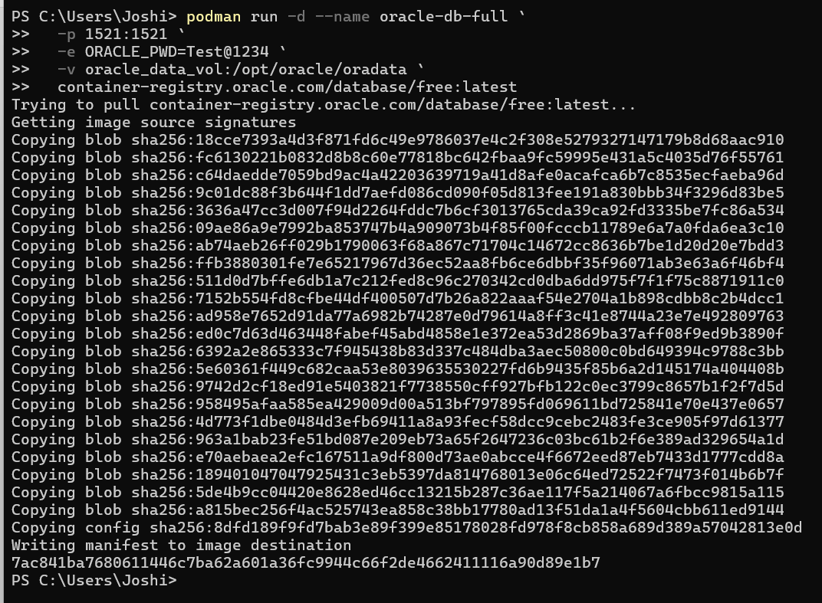
(Note: The backtick ` at the end of each line acts as the multi-line continuation character in PowerShell.)
- Understanding the Parameters:
  - -d: Runs the container in detached (background) mode.
  - --name oracle-db-full: Gives the container a recognizable reference name.
  - -p 1521:1521: Maps host port 1521 directly to the container's standard Oracle Listener port (1521).
  - -e ORACLE_PWD=Test@1234: Sets a unified admin password (Test@1234) for the critical accounts: SYS, SYSTEM, and PDBADMIN.
  - -v oracle_data_vol:/opt/oracle/oradata: Maps your persistent volume to the container's internal data directory.
  - container-registry.oracle.com/database/free:latest: Specifies the full Oracle AI Database 26ai Free edition.

- Pulling the Image: Because this is the Full edition, the download footprint is over 3.38 GB. The download will pull multiple layers. If the console progress bars appear to pause, do not close the terminal; Podman is extracting large layers in the background.

Step 4: Verify Container Health Status
Before connecting via a client, the database instance must finish its initial software start-up.
- Check the active status of your container by executing:
podman ps -a
- Locate the STATUS column in the terminal output or check the container list in the Podman Desktop GUI:
  - Wait until the status displays (healthy) before attempting to log in.
  - It will transition from (starting) to (healthy) in a minute or two depending on your system's hardware performance.

Step 5: Connect Using Oracle SQL Developer
Once the container reports as (healthy), open Oracle SQL Developer to connect to your Pluggable Database (PDB) workspace.
- Launch SQL Developer.
- Click the green + (New Connection) icon on the top-left of the Connections tab.
- Configure the connection dialog using the following parameters:
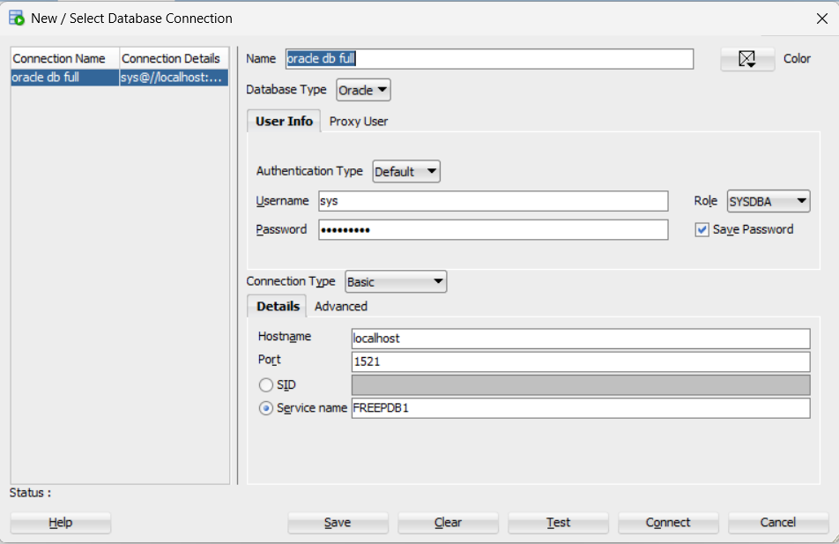
Field | Configuration Value | Note / Details
Connection Name | Oracle_26ai_Free | Choose any descriptive name you prefer.
Username | sys | The primary Database Administrator account.
Password | Test@1234 | The password specified during the podman run setup.
Role | SYSDBA | Mandatory when logging in using the sys account.
Connection Type | Basic | Default option.
Hostname | localhost | Identifies your local computer as the host machine.
Port | 1521 | Standard port mapped to your container database.
Service Name | FREEPDB1 | The default application Pluggable Database (PDB) service.
- Click the Test button in the bottom left of the window.
- If the status reports Success, click Connect. Save the connection details.

Step 6: Verify Database Operations & Test Persistence
Let's execute basic commands inside SQL Developer to verify that tables can be successfully created, updated, and persisted across sessions.

1. Create a Schema Table
In the SQL Worksheet connected to your Oracle_26ai_Free connection, execute the following script to build a CUSTOMERS table:
CREATE TABLE CUSTOMERS (
CUSTOMER_ID NUMBER GENERATED BY DEFAULT AS IDENTITY START WITH 1001 PRIMARY KEY,
FIRST_NAME VARCHAR2(50) NOT NULL,
LAST_NAME VARCHAR2(50) NOT NULL,
EMAIL VARCHAR2(100) UNIQUE,
ACCOUNT_TYPE VARCHAR2(20) DEFAULT 'SAVINGS',
CREATED_AT TIMESTAMP DEFAULT CURRENT_TIMESTAMP
);

2. Insert Records
Add test records into your table:
INSERT INTO CUSTOMERS (FIRST_NAME, LAST_NAME, EMAIL, ACCOUNT_TYPE)
VALUES ('Amit', 'Sharma', 'amit.sharma@example.com', 'CHECKING');
INSERT INTO CUSTOMERS (FIRST_NAME, LAST_NAME, EMAIL, ACCOUNT_TYPE)
VALUES ('Priyan', 'Joshi', 'priyan.j@example.com', 'SAVINGS');

3. Commit Your Changes (Crucial!)
In Oracle Database, transactions are isolated and temporary until explicitly written to disk. Run the commit command:
COMMIT;

4. Query and Retrieve Data
Verify the table's state by executing a select query:
SELECT * FROM CUSTOMERS;
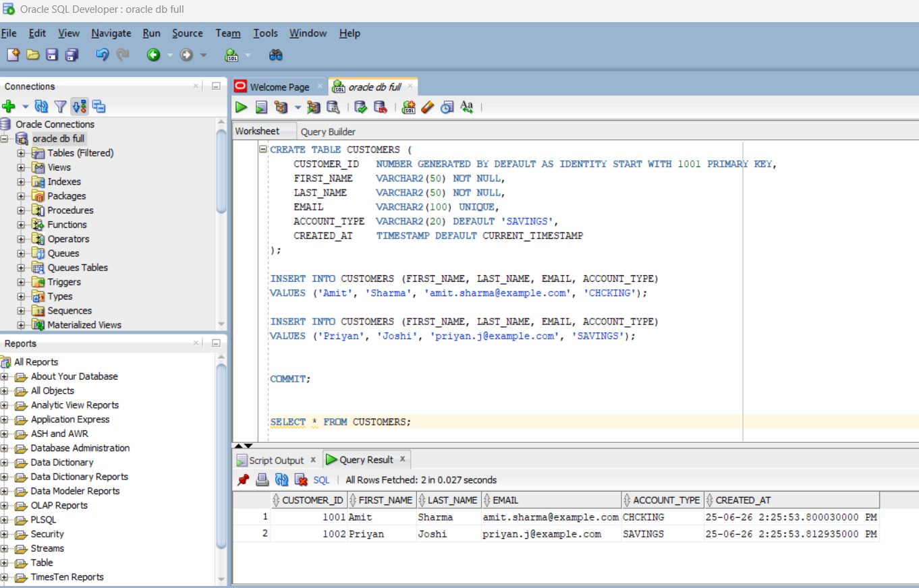

Step 7: How to Handle System Reboots & Maintenance
When you reboot Windows, Podman and your container will stop. Follow these steps to wake the database back up without losing any data or creating a duplicate container:
- Open your terminal or Podman Desktop.
- If Podman is completely shut down, start the VM:
podman machine start
- Wake up your existing database container directly:
podman start oracle-db-full
- Verify the container has finished starting up and is healthy (podman ps), then open SQL Developer and reconnect. Run your query (SELECT * FROM CUSTOMERS;) to confirm that all of your previous tables and records are fully intact!

