|  |  |  |
| --- | --- | --- |
|  | Facility for Rare Isotope Beams | msu.png |

ELog User Manual

|  |  |  |  |
| --- | --- | --- | --- |
|  | Name | Signature | Date |
| Prepared By | Robert Gaul III |  |  |
| Reviewed By |  |  |  |
| Approved By |  |  |  |

Revision History

|  |  |  |  |
| --- | --- | --- | --- |
| Version | Date | Author | Description |
| 1.0 | 9/1/2011 | Gaul | Initial |
|  |  |  |  |
|  |  |  |  |
|  |  |  |  |

Table of Contents

1 Introduction 5

2 Getting Started 5

3 Creating a New Log 6

4 Support 6

5 Glossary 7

List of Figures and Tables

# Introduction

Many departments and groups within the Facility for Rare Isotope Beams (FRIB) and the National Superconducting Cyclotron Laboratory (NSCL) maintain a log of their operational and experimental findings. Their existing method of doing so with pen and paper was insufficient and unreliable so an Electronic Logbook Application (ELog) was created to alleviate these issues. This manual details how to use the new application.

# Getting Started

Elog is currently located at the following URL: <https://intra.nscl.msu.edu/cakeapps/logbook/olog/logs>

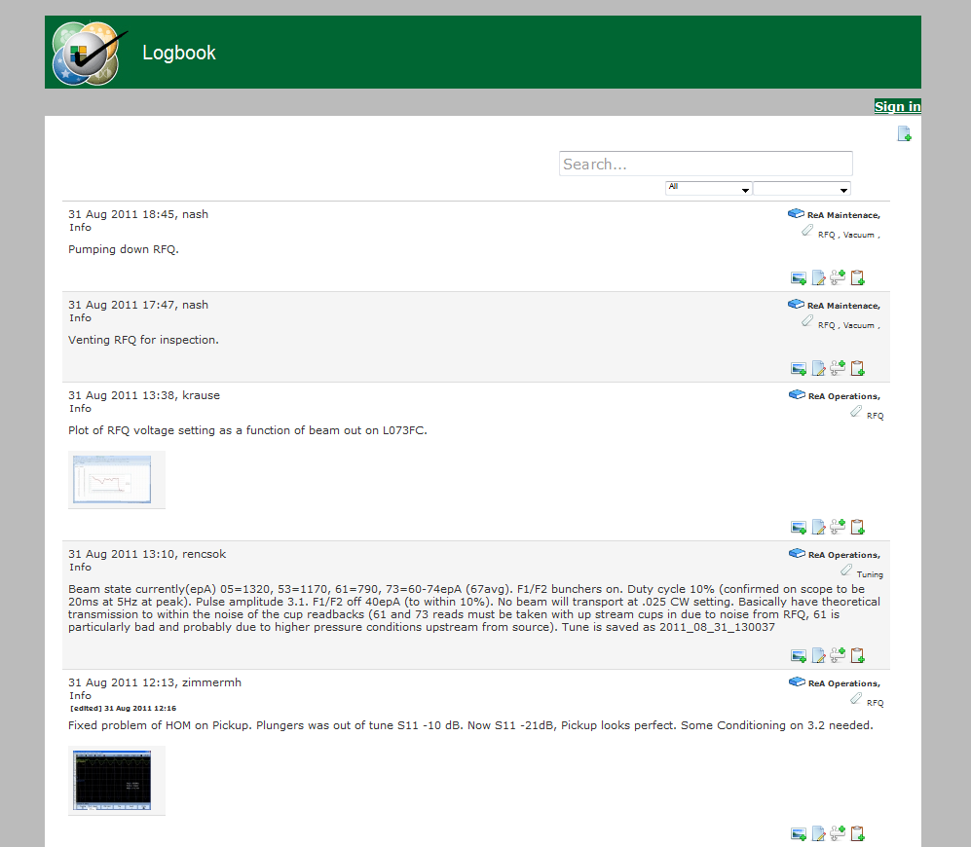

In order to use the functionality of Elog you must be signed in. Click on the “Sign in” link near the top right of the page and you will then be taken to a typical log-in screen where you will input your NSCL/FRIB username and UNIX password.

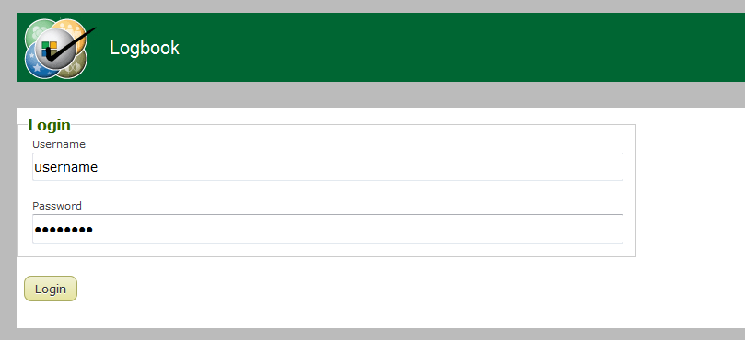

Upon successful authentication you will see your username next to a “Sign out” link near the top right of the page.

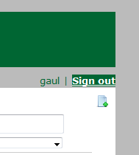

Please click the “Sign out” link when you are done using the application.

# Creating a New Log

Click on the following icon to create a new log:



This will expand a form that will be used to create your new log.

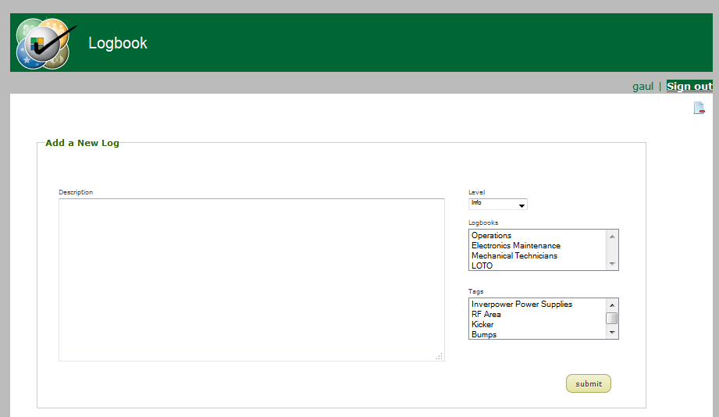

Here is an explanation of the editable fields:

* “Description” is the log entry
* “Level” is the type of log entry (is it general information, a problem, a request, etc?)
* “Logbooks” is a list of the available logbooks that your new log entry may go in. An entry may go into multiple logbooks, so the user may click on multiple logbook selections in this list.
* “Tags” is a list of identifiers that a log may be attributed with. A user may click on multiple selections here as well.

When you are done filling in the appropriate information click on the “submit” button. You will then see your new log entry on the index page.

# Attaching a File

You may attach a file (PDF, word, image, etc) to a logbook entry by clicking on the following button:

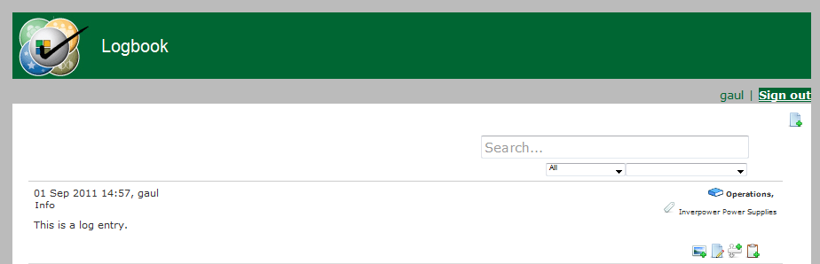

The standard operating system file browser will pop-up and you will be able to find and select the desired file. After completion you will see a link to the file below the log entry. Please note that this link will be a thumbnail for image uploads only.

# Pasting a Screen Capture

If you have a screen capture that you wish to attach to a log entry and do not want to have to save the image first then you may paste it into the web browser using a built-in Java applet. In order to do so click on the following button:



Please note: The applet might ask you to trust it, please ensure that you click the appropriate responses to do so.

Once the applet is loaded it has the following format:

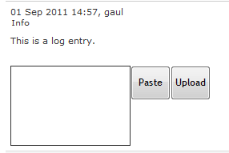

Clicking on the “Paste” button will take the item currently in your systems clipboard (the screen capture) and paste it into the white box. Once you verify that the image in the box is correct you may then click “Upload” which will upload the image and attach it to the log entry.

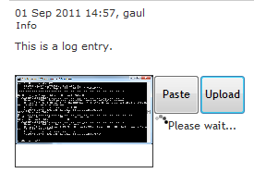

# Adding IRMIS Components

To add a component from IRMIS click on the following button:



Please note: The applet might ask you to trust it, please ensure that you click the appropriate responses to do so.

Upon successful loading you will be shown the following applet:

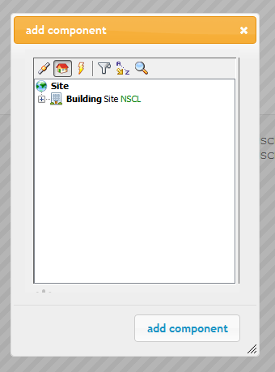

Whatever you see in this applet is what is currently in IRMIS. You CANNOT add any component to IRMIS via this applet! What you can do is browse the various hierarchies (housing, network, power) or search for a component. Use the buttons at the top of the applet to find the component you wish to attach to the current log, click on it, and then click “add component”.

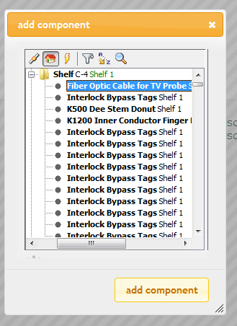

The page will refresh and you will see the component has been added to the log.

irmishierachy.png

# Editing an Existing Entry

In order to edit an existing logbook entry click on the following button:



You will be brought to a form where you can edit all of the following metadata:

* Change the Level
* Change the Description
* Change the Logbook(s)
* Change the Tag(s)
* Add new file attachments using the file browser
* Delete existing file attachments
* Remove existing IRMIS components

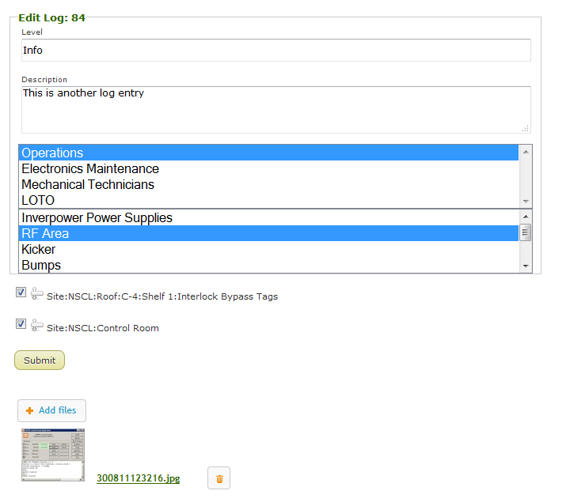

Click “submit” to save your changes.

# Sorting Existing Log Entries

There are two ways to sort log entries: by time span or by logbook.

To sort by a time span click on the following dropdown box and click on the time span you wish to sort by.

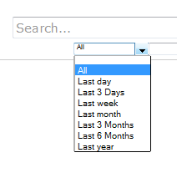

To view log entries from a given logbook click on the following dropdown and select the logbook you wish to view.

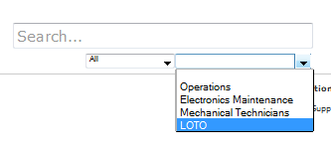

# Searching for Log Entries

To search for a log entries given a keyword use the search bar and type a keyword you are looking for and press “Enter” on your keyboard to view the results.

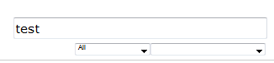

# Support

Contact the following if you need help using Elog:

|  |  |
| --- | --- |
| Name | Email |
| Eric Berryman | berryman@nscl.msu.edu |
| Robert Gaul | gaul@nscl.msu.edu |

# Glossary

|  |  |
| --- | --- |
| Item | Description |
| Elog | Electronic Logbook Application |
| FRIB | Facility for Rare Isotope Beams |
| NSCL | National Superconducting Cyclotron Laboratory |