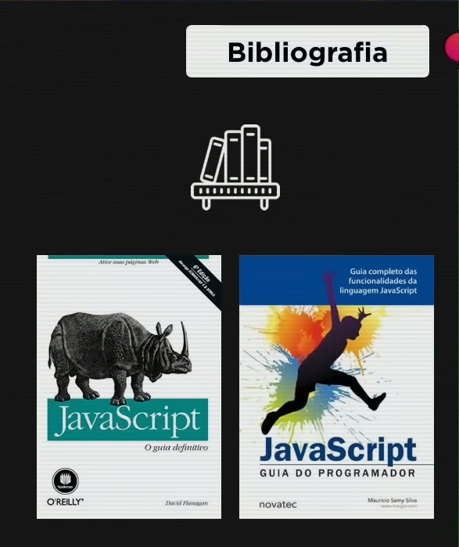
Guias de referência da mozila e ecma

https://developer.mozilla.org/pt-BR/docs/Web/JavaScript/Guide

https://ecma-international.org/publications-and-standards/standards/ecma-262/


