1. Export

Test process

Create a new folder fff, and then add the root folder / to the PATH. We try to use the echo command inside fff folder.

It works! 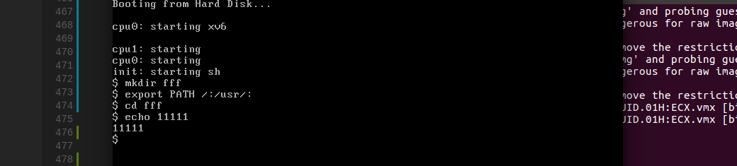

1. left and right navigation

first, we input abcd, then we use the right narrow. No effect, yes, that’s because it’s in the last character of current line.



Then we use left narrow key to move the cursor to left, and insert x before the character d, works

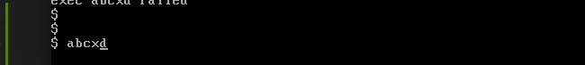

Finally we use right narrow to move back, and add y after d

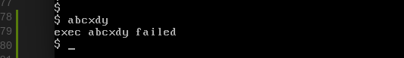

1. history command

first, we enter 10 command 1,2,3,4

run history command to command 1 and back to command 4

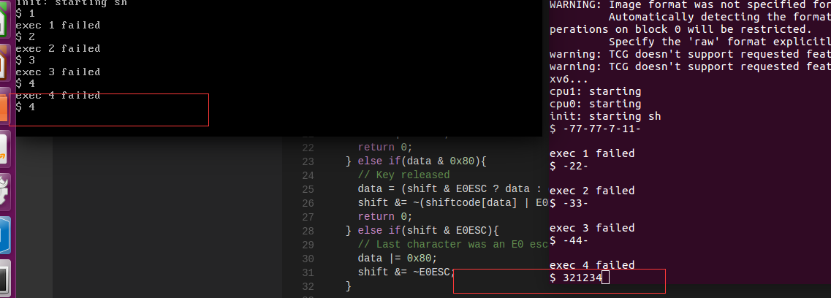

Run command 5,6, …. 17, and then run the history command

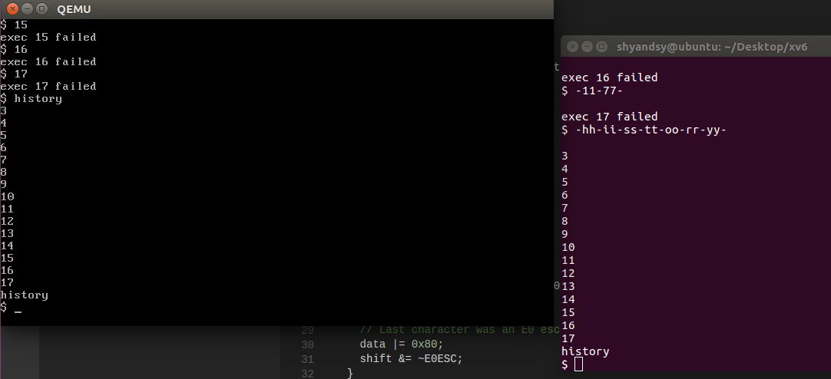

works

Problem:

Sometimes the xv6 automatically get 0x35 from keyboard!!!!

The following is screenshot for MIT original xv6

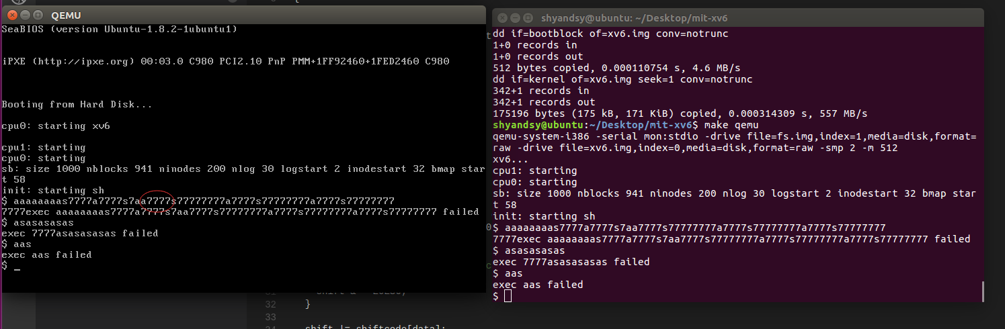

Guess it due to the QEMU.