**ZOMBIE - First Quick Response Game**

 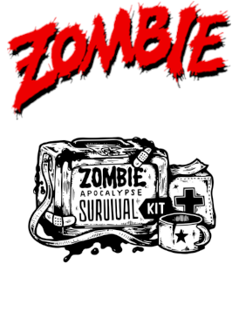

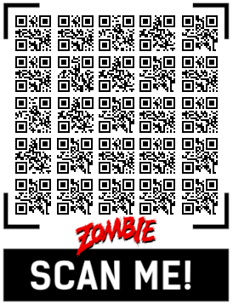 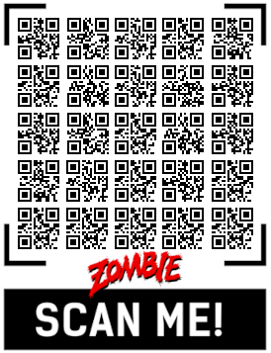

Game instructions on Telegram @ZOMBIE_QR

Cut and fold in half, this is just for a player