**Mateusz Piszczola**

**Student Number: 17418497**

**CSY1018 Web Development**

**Assignment 1**

<https://mpiszczola.github.io/csy1018-assign1MP/>

Part first: Work overview

To be completely honest I’ve started working on my assignment late, around late December. Because of that and lack of practise throughout the semester I had forgotten most of the knowledge that should have been inside my head already. What I decided to do is to buy a book called “Html & CSS design and build websites” by Jon Duckett, and slowly started remembering myself that I had been taught as well as learning some new tricks from the book. Unfortunately, my lack of experience in making websites manifested itself, and I haven’t thought about things like making wireframes that would make my work go smoother. I ended up redesigning my website twice, because I didn’t like the way it looked. I decided to upload 2 screenshots of my early projects below as well as screenshot of current version of the website. I’ve spend around 20-24 hours making this website in a 15 days period and I think the product of my work satisfactory. By the end of my work I focused more on structure, managed to make my site look ok on smaller devices and cleaned up the code.

Part two: Software used

Both of the pictures that I decided to include in my website were optimised by online software called Optimizilla.com. To change their colour, I used program that I was familiar with called Adobe Photoshop. Once I decided that I would like to have gradient as my websites background I used website called Colorzilla.com . At some point of website development I added to the footer clickable icons like facebook or twitter. To do that I’ve used website that we used during our lectures called fontawesome.io. I did also use 2 of the fonts available at fonts.google.com – open-sans and lobster. I wrote all my code using Atom program.

Part three: References

As mentioned before to created my website I relied heavily on the Jon’s Duckett Book, that helped me to refresh everything that I have learned throughout this semester.

Duckett, J. (2011) *HTML and CSS: Design and build Websites*. Indianapolis, IN: John Wiley & Sons.

To make a navigation bar I used and then modified code of XO PIXEL channel on Youtube.com platform that can be found here

XO PIXEL (2014) *CSS header & horizontal navigation menu (PART 2) | XO PIXEL*. Available at: https://www.youtube.com/watch?v=rKUIRO3UqGA (Accessed: 31 December 2016).

I did also read nearly all the resourced that could be found on universities’ NILE website

<https://nile.northampton.ac.uk>

Part four: Problems and obstacles

During the development of my webpage I encountered many problems. First one being the site not viewing as it should be on smaller devices. It was mostly caused by not using flex positioning. Once I started cleaning up the code I did make it so my site can be viewed on a smaller screen and still be readable.

At the beginning, I also had a huge issue with positioning items like pictures on the website. The pictures didn’t stay in the same line and the text was overlapping with other items. As I added more CSS rules everything started to get in line as it should be.

One of the problems I didn’t solve was making two pieces of text that happen to be in the same line, to be styled differently. I’ve managed to change the colour and size of the specific parts of the text, but unfortunately, I couldn’t make the text to change its position.

I also did struggle while making my contact page, and same as before the result I managed to achieve is not satisfying me. I did try to combine some of the methods that can be found inside “HTML & CSS” book, but didn’t manage to make it good enough for me.

Part five: What have been done

* 27 CSS rules
* Navigation bar, that changes colours on hover and click
* 2 pictures added, formatted and optimized
* All four pages – Index, bio, cv and contact
* 2 different fonts, taken from fonts.google.com
* Footer and a header
* 0 errors detected by Atom
* Footer includes icons taken from font-awesome
* The code was edited so it should be easy to read
* All the files can be found in root directory
* Doctype is correct (HTML5)
* Over 10 updates were done

Part six: 3 stages of website development

**Update number 3**

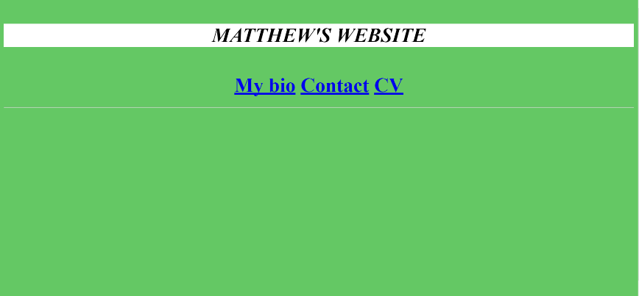

**Update number 6**

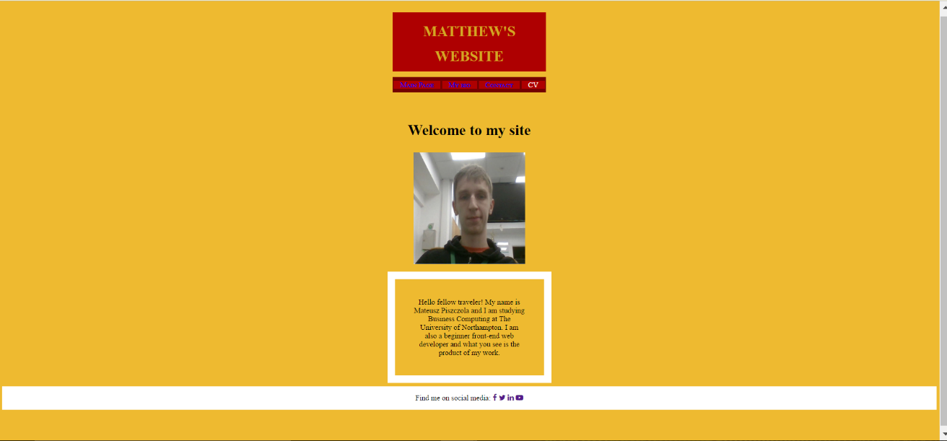

**Final version**

