**Calving Front Machine (CALFIN): Glacial Terminus Dataset for East/West Greenland, 1972-2019 Usage Notes**

Spatio-temporal Coverage

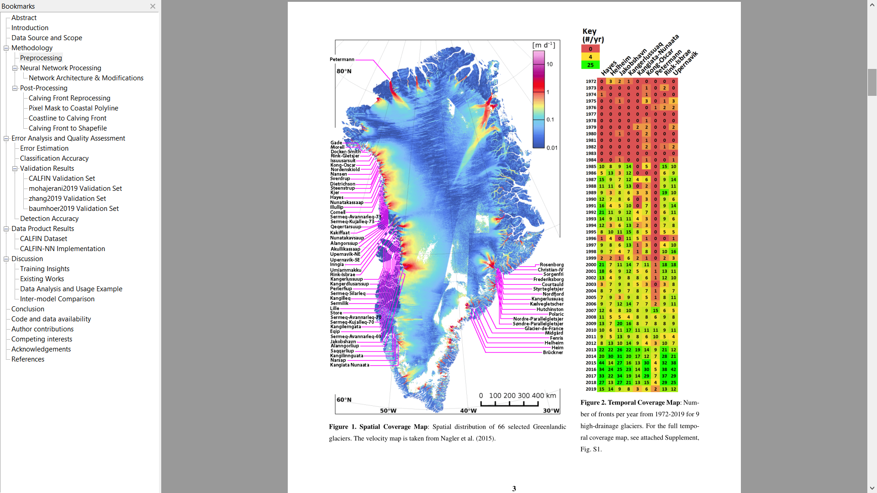

Data Product Description

We provide two levels of data products.

* Level 0 products consist of fjord boundary GeoTiff masks, the domain Shapefiles used for subsetting, a glacier names reference Shapefile, and the Landsat scene name ID list.
* Level 1 product consists of LineString Shapefiles with 22678 total features, and Polygon Shapefiles with 17,771 total features.
  + level-1_shapefiles-domain-termini-closed.zip
    - Polygon Shapefiles from 1972-2019, separated by glacial domain
  + level-1_shapefiles-domain-termini.zip
    - LineString Shapefiles from 1972-2019, separated by glacial domain
  + level-1_shapefiles-greenland-termini-closed.zip
    - Polygon Shapefiles from 1972-2019, containing all features in one file
  + level-1_shapefiles-greenland-termini.zip
    - LineString Shapefiles from 1972-2019, containing all features in one file
  + Both Shapefile types are separated by domain, and share the following schema with that used by [MEaSUREs](https://nsidc.org/data/nsidc-0642):
    - 'geometry': 'str' #'LineString', 'Polygon'
    - 'properties': {  
                  'GlacierID': 'int', #(as defined in MEaSUREs NSIDC-0642)  
                  'Center_X': 'float',  
                  'Center_Y': 'float',  
                  'Latitude': 'float',  
                  'Longitude': 'float',  
                  'QualFlag': 'int', #0: manually digitized; 3: manually digitized w/ L7SCE; 10: auto digitized; 13: auto digitized w/ L7SCE  
                  'Satellite': 'str', #LM01, LT05, LE07, LC08, etc  
                  'Date': 'str', #YYYY-MM-DD  
                  'ImageID': 'str',  
                  'GrnlndcN': 'str', #See Bjørk et al., 2015  
                  'OfficialN': 'str',  
                  'AltName': 'str',  
                  'RefName': 'str', #Non-authoritative CALFIN reference name

            'Author': 'str’}

* + - Spatial extent: 66 Greenlandic glacial basins, including Petermann, Upernavik, Rink Isbrae, Jakobshavn, Helheim, Kangerlussuaq, Kangiata Nunaata, Kong Oscar, Hayes, and other nearby basins.
    - Time Series: Sept. 1972 - June 2019
    - Temporal resolution: sub-seasonal
    - Spatial resolution: 30 meters
    - Spatial accuracy: <90 meters
    - Projection: EPSG:3413 (WGS 84 / NSIDC Sea Ice Polar Stereographic North)

Sample Data Record Usage

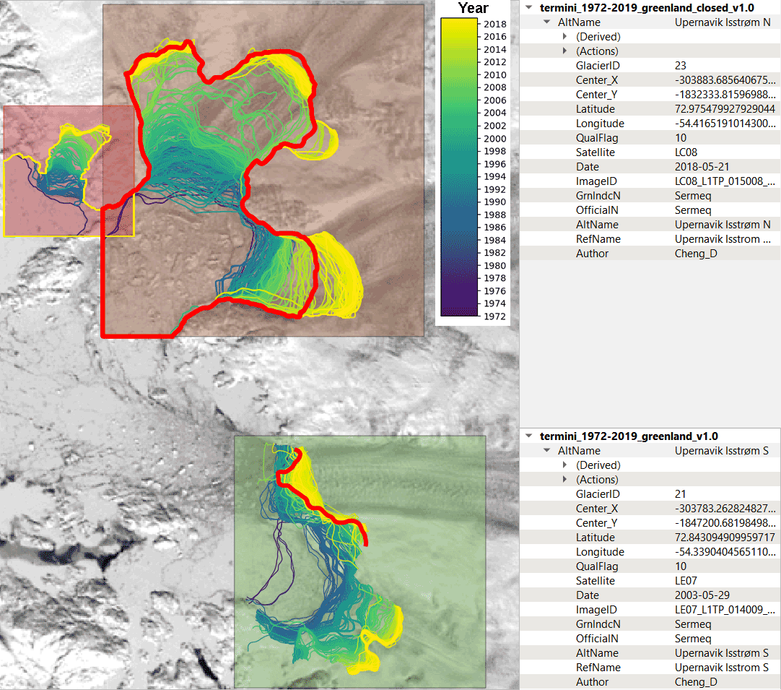

Example usage of the consolidated Polygon and LineString Shapefiles in QGIS.