ENGINEERING DESIGN SPECIFICATION: KINETIC THERMOCLINE INVERTER (KTI)
System Classification: Active Ocean Stratification Management / Wave-Driven Fluid Displacement

1. System Overview & Operation Principle
The Kinetic Thermocline Inverter (KTI) is a decentralized, zero-input mechanical pumping system deployed to selectively alter localized ocean thermal profiles. The device leverages the kinetic energy of ocean surface waves to continuously displace warm surface water down past the ocean thermocline into the deep ocean layer, suppressing localized cold-water upwelling.

2. Structural & Mechanical Blueprint (Dimensions)
The structural assembly consists of three primary concentric zones optimized for hydrodynamic stability and high-volume fluid flow.

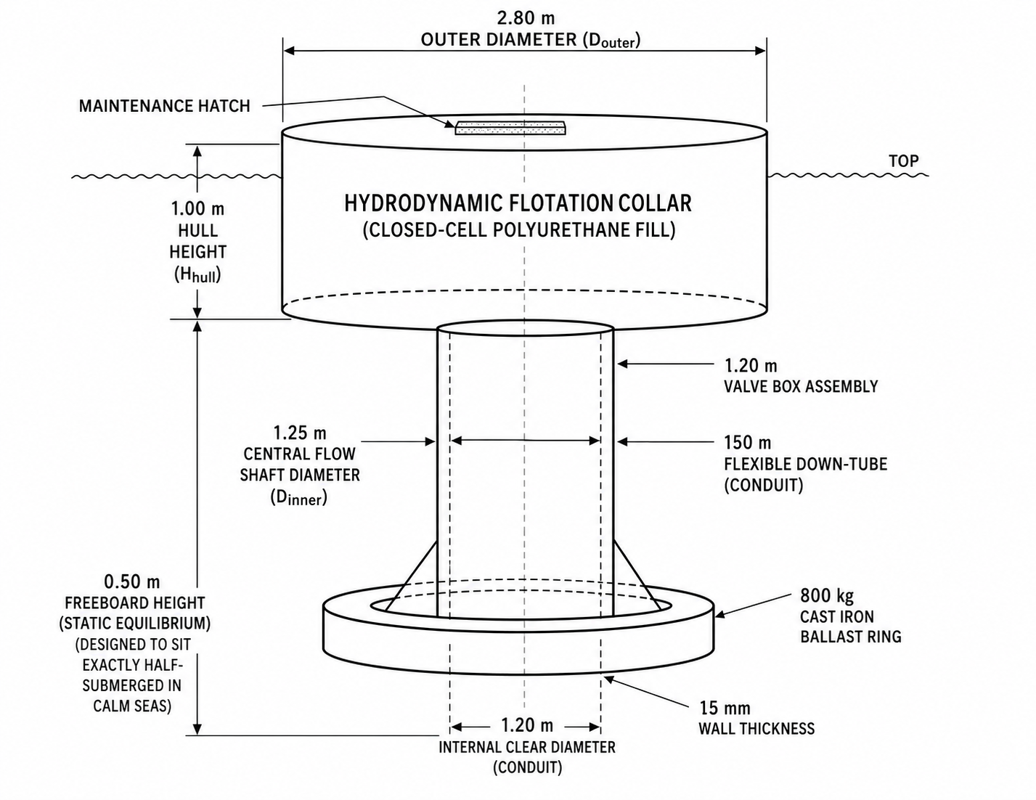

A. Surface Floating Hull
- Outer Diameter (Douter​): 2.80 m
- Central Flow Shaft Diameter (Dinner​): 1.25 m
- Total Hull Vertical Height (Hhull​): 1.00 m
- Freeboard Height (Static Equilibrium): 0.50 m (Designed to sit exactly half-submerged in calm seas).

B. Downward Displacement Tube (Conduit)
- Internal Clear Diameter: 1.20 m
- Wall Thickness: 15 mm
- Total Length (Lpipe​): 150.00 m (Sufficient to bypass the tropical Indian Ocean thermocline layer).
- Structural Profile: Helically corrugated walls to maximize lateral flexibility against shear currents while eliminating cross-sectional collapse under external pressure.

3. Comprehensive Material Specifications
Part Component | Specified Material | Engineering Standard / Grade | Justification
Outer Buoy Shell | High-Density Polyethylene (HDPE) | ASTM D3350 (UV-Stabilized Black) | Eliminates saltwater corrosion; high impact resilience against marine debris and wave friction.
Internal Hull Matrix | Closed-Cell Polyurethane (PUR) Foam | Density: 32–40 kg/m3 | Fills the internal cavity completely to guarantee unsinkable buoyancy even if the outer HDPE skin is punctured.
Flexible Conduit | EPDM Rubber with Embedded Spring Steel Wire Helix | Marine Grade, Anti-Ozone Treated | Permits 15∘ lateral bending under ocean currents without kinking, buckling, or throttling fluid velocity.
One-Way Flap Valve | Commercial Pure Titanium Base + Viton Seal | Titanium Grade 2 / DuPont Viton | Titanium prevents bio-corrosion and fatigue failure over millions of flexing cycles; Viton ensures a watertight seal against the valve seat.
Bottom Ballast Ring | Cast Iron coated with Zinc-Chomate and Anti-Fouling Epoxy | Grade G3000 Gray Iron | High-density weight anchor treated to resist marine micro-organism growth and chemical leaching.

4. Mechanical Valve Sub-Assembly
The valve box sits at the throat (0.5 m below the water surface) inside the core shaft. It controls the directional movement of fluid.
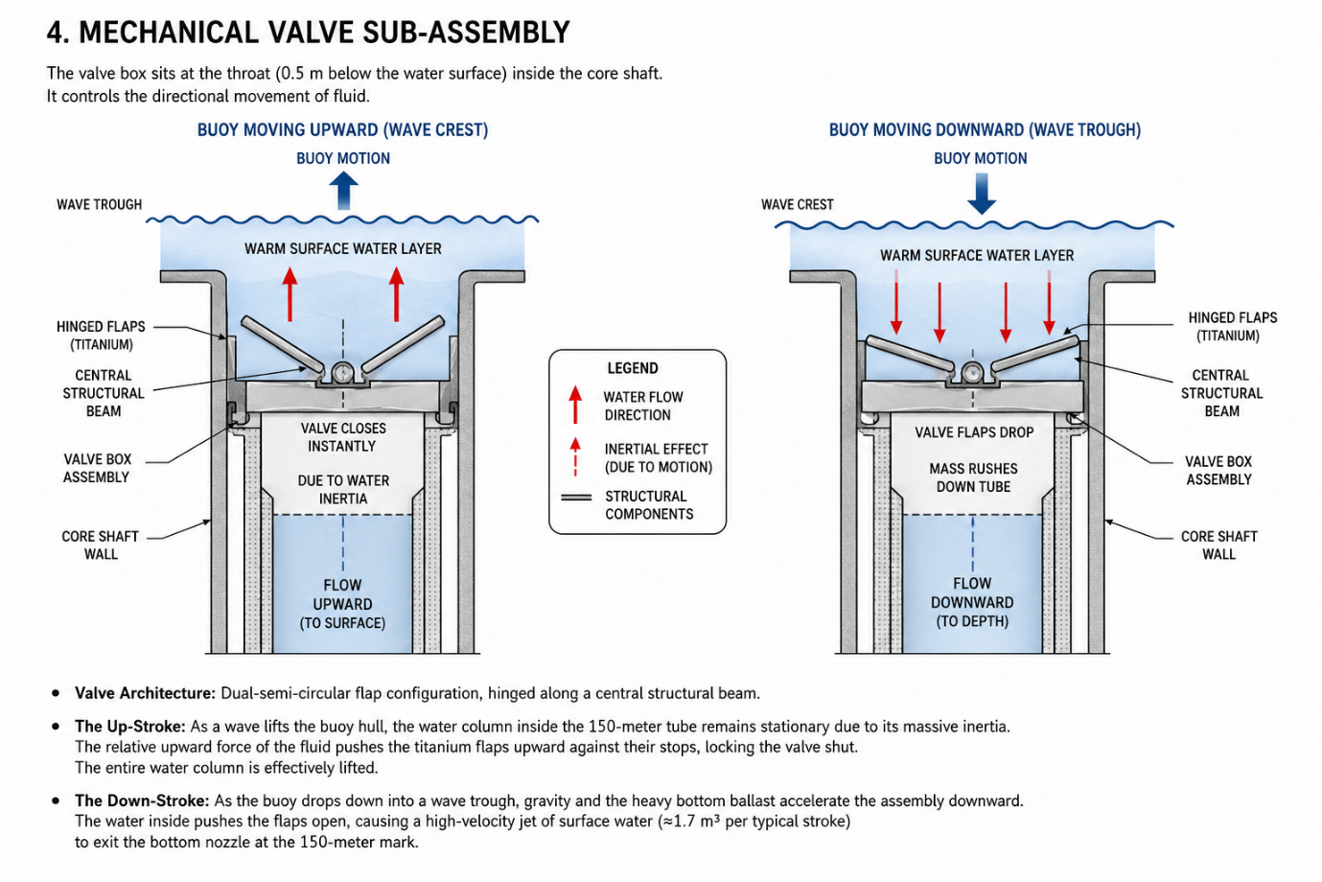
- Valve Architecture: Dual-semi-circular flap configuration, hinged along a central structural beam.
- The Up-Stroke: As a wave lifts the buoy hull, the water column inside the 150-meter tube remains stationary due to its massive inertia. The relative downward force of the fluid pushes the titanium flaps upward against their stops, locking the valve shut. The entire water column is effectively lifted.
- The Down-Stroke: As the buoy drops down into a wave trough, gravity and the heavy bottom ballast accelerate the assembly downward. The water inside pushes the flaps open, causing a high-velocity jet of surface water (≈1.7 m3 per typical stroke) to exit the bottom nozzle at the 150-meter mark.

5. Hydrodynamic & Mass Balance Equations
To ensure that the KTI unit does not tip over, capsize, or float horizontally, the Center of Gravity (CG) must remain below the Center of Buoyancy (CB).

A. Volumetric Displaced Buoyancy
The total volume (Vdisp​) of the flotation hull is calculated as:
Vdisp​=π⋅(Router2​−Rinner2​)⋅Hhull​
Vdisp​=π⋅(1.42−0.6252)⋅1.0≈5.03 m3
Total mass displacement capacity in seawater (ρ=1025 kg/m3):
Mmax​=Vdisp​⋅ρ=5.03⋅1025=5155.75 kg

B. Static Equilibrium Mass Matching
For the buoy to operate at exactly 50% submersion, the cumulative dry mass (Mdry​) of all components must equal half of the maximum displacement:
Mdry​=25155.75 kg​≈2577 kg

C. Distribution Profile for Metacentric Stability
- Surface Component Group (HDPE Hull + PUR Foam + Valve Housing): 650 kg
- Conduit Component Group (150m Conduit @ 7.5 kg/m): 1127 kg
- Sub-Surface Anchor Group (Lower Cast Iron Ballast Ring): 800 kg
- Total Realized System Mass: 2,577 kg
Result: The heavy 800 kg anchor resting at 150 meters deep provides a massive restoring moment arm, keeping the pitch and roll angles within a tight ±5∘ envelope, even during severe storm states.
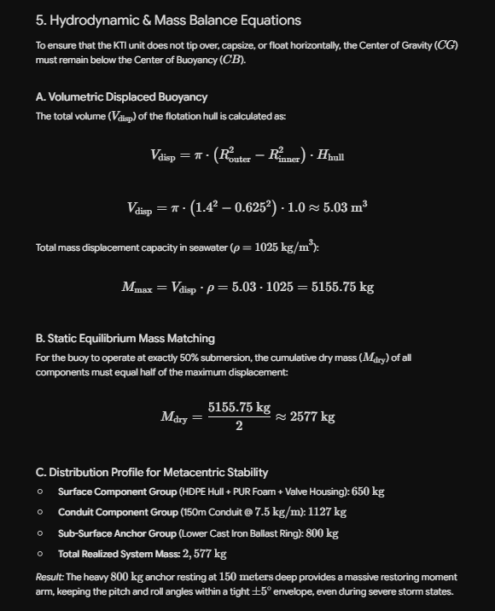

6. Deployment Logistics
- Configuration: Deployed in a matrix configuration (swarm network).
- Mooring: Tethered via a dynamic, loose three-point tension-leg mooring line to allow free vertical bobbing while restricting horizontal drift outside a designated 50-meter radius.
- Antifouling Cycle: Non-toxic silicone-based foul release coatings applied to internal pipe tracks to minimize mechanical friction and maintain fluid throughput performance over multi-year deployment runs.

