# CHAPTER – 1 INTRODUCTION

## 1.1 BACKGROUND OF STUDY

The field of healthcare has seen significant advancements in recent years, especially with the integration of technology and data-driven approaches. With the rise of chronic diseases and an increasing focus on preventive healthcare, there's a growing need for personalized health monitoring and prediction systems.

Traditionally, healthcare has been reactive, with individuals seeking medical attention only after experiencing symptoms or complications. However, proactive monitoring of health parameters and early detection of diseases can lead to better outcomes and improved quality of life for patients.

The motivation behind the development of the Personal Health Monitoring and Prediction System stems from several key factors:

1. **Rise in Chronic Diseases**: Chronic diseases such as diabetes, heart disease, and hypertension are major contributors to global morbidity and mortality. Early detection and management of these conditions are crucial for preventing complications and improving health outcomes.
2. **Advancements in Machine Learning**: Machine learning techniques have shown promise in various healthcare applications, including disease prediction and risk stratification. By leveraging patient data and predictive models, healthcare providers can identify individuals at high risk of developing certain diseases and intervene proactively.
3. **Patient Empowerment**: Empowering individuals to take charge of their health through self-monitoring and access to predictive tools can lead to better health outcomes and reduced healthcare costs. By providing users with insights into their health status and potential risks, the system enables informed decision-making and proactive healthcare management.
4. **Accessibility and Convenience**: With the advent of telemedicine and digital health platforms, there's a growing demand for accessible and convenient healthcare solutions. The Personal Health Monitoring and Prediction System offers users a user-friendly interface accessible via web browsers, allowing them to monitor their health and access predictive tools from the comfort of their homes.
5. **Integration of Voice Input**: Incorporating voice input functionality enhances accessibility and usability, especially for individuals with limited dexterity or visual impairments. By enabling users to interact with the system using voice commands, the barrier to accessing healthcare information is lowered, ensuring inclusivity and accessibility for all users.

## 1.2 PROBLEM STATEMENT

Despite advancements in healthcare, there remain several challenges and gaps in current healthcare systems that the Personal Health Monitoring and Prediction System aims to address:

1. **Reactive Healthcare Approach**: The traditional healthcare model tends to be reactive, with individuals seeking medical assistance only after experiencing symptoms or complications. This often leads to late diagnosis and suboptimal management of chronic diseases. The system aims to shift towards a proactive approach by enabling early detection and prediction of diseases based on individual health parameters and symptoms.
2. **Limited Access to Healthcare Services**: Accessibility to healthcare services can be limited, especially in rural or underserved areas. Patients may face challenges in accessing timely medical consultations or diagnostic tests. By providing users with a platform for remote health monitoring and prediction, the system aims to bridge the gap in healthcare access and ensure timely interventions regardless of geographical location.
3. **Lack of Personalization in Healthcare**: Traditional healthcare systems may not adequately account for individual variations in health status, lifestyle, and genetic predispositions. As a result, treatment plans and preventive measures may not be tailored to meet the specific needs of each individual. The Personal Health Monitoring and Prediction System seeks to address this by leveraging machine learning algorithms to analyze user data and provide personalized health recommendations and predictions.
4. **Underutilization of Preventive Healthcare**: Preventive healthcare measures, such as regular health screenings and lifestyle modifications, are crucial for reducing the burden of chronic diseases. However, many individuals may not prioritize preventive care due to lack of awareness or perceived inconvenience. The system aims to promote preventive healthcare by empowering users with tools for self-monitoring, early disease detection, and personalized risk assessment.
5. **Limited Patient Engagement and Empowerment**: Engaging patients in their own healthcare management can lead to better health outcomes and improved adherence to treatment plans. However, traditional healthcare systems may lack mechanisms for meaningful patient engagement and empowerment. The Personal Health Monitoring and Prediction System seeks to actively involve users in their healthcare journey by providing them with access to their health data, actionable insights, and tools for self-management.

## 1.3 SCOPE

The scope of the Personal Health Monitoring and Prediction System encompasses several key areas, focusing on empowering individuals to proactively monitor their health, predict potential health risks, and make informed decisions about their healthcare management. The system aims to provide a comprehensive platform for users to access personalized health insights, recommendations, and resources. Below are the main aspects covered within the scope of the system:

1. **Real-time Health Monitoring**: The system enables users to monitor their health parameters in real-time, including vital signs such as blood pressure, glucose levels, and heart rate. By providing continuous monitoring capabilities, users can track changes in their health status and receive timely alerts for any abnormalities.
2. **Disease Prediction and Risk Assessment**: Leveraging machine learning algorithms, the system predicts the likelihood of developing certain diseases based on user input, symptoms, and medical history. By analyzing relevant data points, such as demographic information, lifestyle factors, and biomarkers, the system provides personalized risk assessments for conditions such as diabetes and heart disease.
3. **Symptom-based Disease Prediction**: Users can input their symptoms into the system, and it utilizes pattern recognition algorithms to identify potential diseases associated with those symptoms. By correlating symptom patterns with known medical conditions, the system helps users understand the possible underlying causes of their symptoms and guides them towards appropriate medical interventions.
4. **Medication Recommendations**: Based on predicted health conditions and user data, the system provides personalized medication recommendations tailored to individual needs. Users receive information about recommended medications, dosages, and potential side effects, helping them make informed decisions about their treatment plans.
5. **Healthcare Provider Discovery**: The system offers features for users to search and discover nearby healthcare providers, including hospitals, clinics, and specialist doctors. By integrating location-based services and provider databases, users can access information about healthcare facilities and professionals in their vicinity, facilitating timely access to medical care.
6. **Voice Input and Interaction**: Users can interact with the system using voice commands, enabling hands-free operation and accessibility for individuals with disabilities or limited mobility. Voice input functionality allows users to input symptoms, retrieve health information, and navigate the system's features using natural language commands.
7. **Educational Resources and Support**: The system provides access to educational materials, articles, and videos related to various health topics, empowering users with knowledge about preventive healthcare, disease management, and healthy lifestyle choices. Additionally, users can connect with online support communities and access resources for managing chronic conditions effectively.

In essence, the scope of the Personal Health Monitoring and Prediction System encompasses a wide range of functionalities aimed at promoting proactive health management, facilitating early disease detection, and empowering users to make informed decisions about their health and well-being. By integrating technology, data analytics, and user-centric design principles, the system strives to enhance the overall healthcare experience and improve health outcomes for individuals

## 1.4 PROJECT INTRODUCTION

The Personal Health Monitoring and Prediction System represents a cutting-edge solution designed to revolutionize the way individuals monitor, predict, and manage their health. In an era where preventive healthcare and personalized medicine are gaining prominence, this system aims to empower users with tools and insights to take proactive control of their well-being.

With the proliferation of chronic diseases and lifestyle-related health conditions, there is a growing recognition of the importance of early detection and preventive measures. However, traditional healthcare models often fall short in addressing these needs, relying primarily on reactive approaches to healthcare delivery.

The Personal Health Monitoring and Prediction System seeks to fill this gap by providing users with a comprehensive platform for continuous health monitoring, predictive analysis, and personalized recommendations. By leveraging the power of technology, machine learning, and data analytics, the system offers users a range of features and functionalities, including:

1. **Real-time Health Monitoring**: Users can monitor key health parameters such as blood pressure, glucose levels, and heart rate in real-time, enabling early detection of any abnormalities or deviations from normal ranges.
2. **Disease Prediction**: Through sophisticated machine learning algorithms, the system predicts the likelihood of developing various diseases based on user input, symptoms, and medical history. This predictive analysis enables users to take proactive measures to mitigate their health risks.
3. **Symptom-based Diagnosis**: Users can input their symptoms into the system, which utilizes pattern recognition algorithms to identify potential health conditions associated with those symptoms. This feature aids in early diagnosis and treatment planning.
4. **Medication Recommendations**: Based on predicted health conditions and user data, the system provides personalized medication recommendations, helping users make informed decisions about their treatment options and adherence.
5. **Healthcare Provider Discovery**: The system facilitates the discovery of nearby healthcare providers, including hospitals, clinics, and specialist doctors, empowering users to access timely medical care and support services.
6. **Voice Input and Interaction**: With voice input functionality, users can interact with the system using natural language commands, enhancing accessibility and usability for individuals with disabilities or limited mobility.
7. **Educational Resources and Support**: The system offers access to educational materials, articles, and videos on various health topics, empowering users with knowledge and resources to manage their health effectively.

# CHAPTER – 2

**LITERATURE REVIEW**

## 2.1 INTRODUCTION

The development of the Personal Health Monitoring and Prediction System is informed by a rich body of literature spanning various disciplines, including healthcare, data science, machine learning, and human-computer interaction. The following review highlights key research findings and trends that have shaped the conceptualization and design of the system:

1. **Predictive Healthcare Analytics**: Numerous studies have explored the application of predictive analytics in healthcare for early disease detection, risk stratification, and treatment optimization. Research by Obermeyer and Emanuel (2016) demonstrated the potential of machine learning algorithms to predict patient outcomes and identify high-risk individuals for proactive interventions. Similarly, Hulsen et al. (2016) reviewed the use of predictive models in personalized medicine, emphasizing the importance of integrating patient data, biomarkers, and clinical variables for accurate predictions.
2. **Remote Health Monitoring**: With the advent of wearable devices and mobile health technologies, remote health monitoring has emerged as a promising approach for continuous health surveillance and chronic disease management. Studies by McConnell et al. (2016) and Insel et al. (2016) have demonstrated the effectiveness of remote monitoring systems in improving patient outcomes, reducing healthcare costs, and enhancing patient engagement. These findings underscore the importance of incorporating remote monitoring capabilities into the Personal Health Monitoring and Prediction System.
3. **Voice-based Interaction**: Voice-based interaction has gained traction as a user-friendly and accessible interface for healthcare applications. Research by Lee et al. (2018) explored the use of voice assistants for medication adherence and health-related tasks, highlighting the potential benefits of voice technology in improving patient engagement and adherence to treatment plans. Additionally, studies by Kocaballi et al. (2019) and White et al. (2020) investigated the usability and acceptability of voice interfaces in healthcare settings, emphasizing the need for natural language processing algorithms and voice recognition technologies to enhance the user experience.
4. **Personalized Health Prediction**: Personalization has become a central theme in healthcare, with a growing emphasis on tailoring interventions and treatment plans to individual patient characteristics. Research by Ranganath et al. (2018) and Choi et al. (2016) explored the use of machine learning models for personalized disease prediction and risk assessment, highlighting the importance of integrating diverse data sources, including electronic health records, genomic data, and environmental factors, to improve prediction accuracy and clinical utility.
5. **Healthcare Accessibility and Equity**: Access to healthcare services remains a significant challenge for many individuals, particularly those in underserved or rural areas. Studies by Barnett et al. (2018) and Douthit et al. (2015) have examined disparities in healthcare access and utilization, emphasizing the role of digital health technologies in overcoming barriers to care. The development of the Personal Health Monitoring and Prediction System aligns with efforts to improve healthcare accessibility and equity by providing users with remote monitoring capabilities and access to healthcare resources.

## 2.2 SURVEY PAPERS

### Paper -1

**Title:** Heart Disease Prediction Using Hybrid Machine Learning Techniques

**Authors:** Senthilkumar, MohanChandrasegarThirumalai, Gautam Srivastava (Member, IEEE)

**Objective:** The objective of this study is to enhance the prediction accuracy of heart disease by employing a hybrid approach that combines feature selection techniques with various machine learning models. The study aims to evaluate the effectiveness of models such as Artificial Neural Networks (ANN), Random Forest Neural Network (RFNN), Decision Trees, Language Model, Support Vector Machines (SVM), and Random Forest in predicting heart disease.

**Source:** IEEE Access

**DOI:** 10.1109/ACCESS.2019.2923707

This paper focuses on leveraging hybrid machine learning techniques to improve the accuracy of heart disease prediction. By utilizing a combination of feature selection methods and multiple machine learning algorithms, the study explores how different models perform in predicting heart disease outcomes. The findings of this research contribute to the advancement of predictive analytics in healthcare and provide valuable insights for developing more accurate and reliable diagnostic tools for heart disease.

### Paper -2

**Title:** Diabetes Prediction Using Machine Learning Analytics

**Authors:** S. Reshmi, Dalton Meitei Thounaojam, Saroj Kr. Biswas, Biswajit Purkayastha

**Objective:** The objective of this study is to develop an effective diabetes prediction model using machine learning analytics. The study specifically focuses on employing Decision Tree (DT) and Random Forest (RF) classifiers to predict the likelihood of diabetes occurrence. By leveraging machine learning techniques, the research aims to improve the accuracy and reliability of diabetes prediction, thereby facilitating early detection and intervention.

**Source:** Conference Paper

**Date:** May 2022

**DOI:** 10.1109/COMITCON54601.2022.9850922

This paper presents a novel approach to diabetes prediction using machine learning analytics. By utilizing Decision Tree and Random Forest classifiers, the study explores the predictive capabilities of these models in identifying individuals at risk of developing diabetes. The findings contribute to the field of predictive healthcare analytics and offer insights into the development of more effective diagnostic tools for diabetes management.

### Paper - 3

**Title:** An Intelligent Disease Prediction and Drug Recommendation System

**Authors:** Suvendu Kumar Nayak, Mamata Garanayak, Sangram Keshari Swain, Sandeep Kumar

**Objective:** The objective of this study is to develop an intelligent system for disease prediction and personalized drug recommendation. The research focuses on analyzing medical databases to identify patterns and correlations between symptoms, medical conditions, and drug efficacy. By leveraging artificial intelligence techniques, the study aims to provide tailored drug recommendations based on individual patient profiles and health parameters.

**Source:** IEEE Access

**DOI:** 10.1109/ACCESS.2023.3314332

This paper presents an innovative approach to disease prediction and drug recommendation using artificial intelligence technology. By analyzing medical databases and patient data, the system identifies potential diseases and suggests personalized drug treatments based on individual symptoms and medical conditions. The research contributes to the advancement of personalized medicine and offers valuable insights into improving healthcare decision-making and patient outcomes.

# CHAPTER – 3 SYSTEM ANALYSIS

## 3.1 EXISTING METHOD

In the realm of healthcare, existing methods for health monitoring, disease prediction, and personalized medicine have evolved significantly with advancements in technology and data analytics. Here are some key existing methods:

1. **Traditional Health Monitoring**: Traditional health monitoring methods involve periodic visits to healthcare facilities for check-ups, diagnostic tests, and consultations with healthcare providers. While effective, these methods are often reactive in nature and may not provide real-time insights into an individual's health status.
2. **Medical Imaging**: Medical imaging techniques, such as X-rays, CT scans, and MRIs, play a crucial role in disease diagnosis and treatment planning. These methods enable healthcare providers to visualize internal structures and identify abnormalities or lesions indicative of underlying health conditions.
3. **Electronic Health Records (EHRs)**: EHR systems digitize patient health records, including medical history, lab results, medications, and treatment plans. EHRs facilitate information sharing among healthcare providers, improve clinical decision-making, and support continuity of care across different healthcare settings.
4. **Machine Learning and Predictive Analytics**: Machine learning algorithms and predictive analytics techniques are increasingly being applied in healthcare for disease prediction, risk stratification, and treatment optimization. These methods analyze large volumes of patient data to identify patterns, trends, and associations that can inform clinical decision-making and personalized medicine.
5. **Wearable Health Monitoring Devices**: Wearable devices, such as smartwatches, fitness trackers, and medical-grade wearables, enable continuous monitoring of physiological parameters, such as heart rate, activity levels, sleep patterns, and blood glucose levels. These devices empower individuals to track their health in real-time and provide valuable data for preventive healthcare and disease management.
6. **Telemedicine and Remote Monitoring**: Telemedicine platforms and remote monitoring technologies enable virtual consultations with healthcare providers and remote monitoring of patients' health status. These methods enhance access to healthcare services, particularly for individuals in rural or underserved areas, and support ongoing management of chronic conditions.
7. **Genomic and Personalized Medicine**: Advances in genomics and personalized medicine have led to the development of targeted therapies and precision medicine approaches tailored to individuals' genetic makeup, biomarkers, and lifestyle factors. These methods hold promise for improving treatment outcomes and minimizing adverse effects.
8. **Clinical Decision Support Systems (CDSS)**: CDSS provide healthcare providers with evidence-based recommendations, guidelines, and alerts at the point of care. These systems integrate patient data, medical knowledge, and best practices to assist clinicians in making informed decisions about diagnosis, treatment, and patient management.
9. **Population Health Management**: Population health management strategies aim to improve the health outcomes of entire populations by addressing social determinants of health, promoting preventive care, and implementing interventions to manage chronic diseases. These methods involve data analytics, care coordination, and community-based initiatives to optimize health outcomes at the population level.

**Existing Methodology**

1. Define project goals and requirements.

2. Research existing systems and plan project.

3. Design UI, system architecture, and integrate technologies.

4. Implement UI, backend, and machine learning models.

5. Test system and gather user feedback.

6. Provide ongoing maintenance and support

7. Document system details.

## 3.2 PROPOSED SYSTEM

The proposed system, the Personal Health Monitoring and Prediction System, is a comprehensive platform designed to revolutionize healthcare delivery by leveraging advanced technologies, data analytics, and personalized medicine. Here are the key components and features of the proposed system:

1. **Real-time Health Monitoring**: The system incorporates wearable health monitoring devices, such as smartwatches and fitness trackers, to enable real-time monitoring of physiological parameters, including heart rate, activity levels, sleep patterns, and blood glucose levels. These devices provide continuous data streams that are securely transmitted to the system's cloud-based platform for analysis.
2. **Predictive Analytics and Disease Prediction**: The system employs machine learning algorithms and predictive analytics techniques to analyze the collected health data and predict individuals' risk of developing various health conditions, such as diabetes, heart disease, and hypertension. By identifying patterns, trends, and anomalies in the data, the system can provide early warnings and personalized risk assessments to users and healthcare providers.
3. **Personalized Health Insights and Recommendations**: Based on the predictive analytics results, the system generates personalized health insights, recommendations, and action plans for users to improve their health and well-being. These recommendations may include lifestyle modifications, medication adherence reminders, dietary guidelines, and exercise routines tailored to individuals' specific health needs and goals.
4. **Voice-based Interaction and User Engagement**: The system features voice-based interaction capabilities, allowing users to input data, ask questions, and receive feedback using natural language commands. Voice technology enhances user engagement and accessibility, particularly for individuals with limited mobility or visual impairments, by providing a user-friendly interface for interacting with the system.
5. **Remote Monitoring and Telehealth Integration**: The system supports remote monitoring and telehealth integration, enabling virtual consultations with healthcare providers, remote diagnosis, and ongoing management of chronic conditions. Through telemedicine platforms and secure communication channels, users can access timely medical advice, prescriptions, and follow-up care from the comfort of their homes.
6. **Data Security and Privacy**: Data security and privacy are paramount in the proposed system. Robust encryption protocols, access controls, and authentication mechanisms are implemented to safeguard sensitive health information and ensure compliance with regulatory requirements, such as HIPAA (Health Insurance Portability and Accountability Act) and GDPR (General Data Protection Regulation).
7. **Healthcare Provider Collaboration and Coordination**: The system facilitates collaboration and coordination among healthcare providers by enabling seamless sharing of patient data, treatment plans, and clinical insights. Healthcare teams can collaborate in real-time, exchange information, and make informed decisions about patient care, leading to improved care coordination and patient outcomes.
8. **Continuous Monitoring and Feedback Loop**: The system establishes a continuous monitoring and feedback loop, where user data is continuously collected, analyzed, and used to refine predictive models and recommendations over time. This iterative process ensures that the system adapts to users' changing health needs and provides personalized, data-driven insights and interventions for optimal health outcomes.

**Proposed Methodology**

1. Gather additional user and stakeholder feedback.

2. Explore latest health monitoring tech and plan iteratively.

3. Enhance UI for improved user experience.

4. Implement real-time monitoring with wearable devices.

5. Incorporate advanced machine learning algorithms

6. Expand testing for scalability and reliability.

7. Automate deployment and implement proactive monitoring.

8. Continuously improve based on user feedback.

9. Update documentation and provide additional resources

**3.3 BLOCK DIAGRAM:**

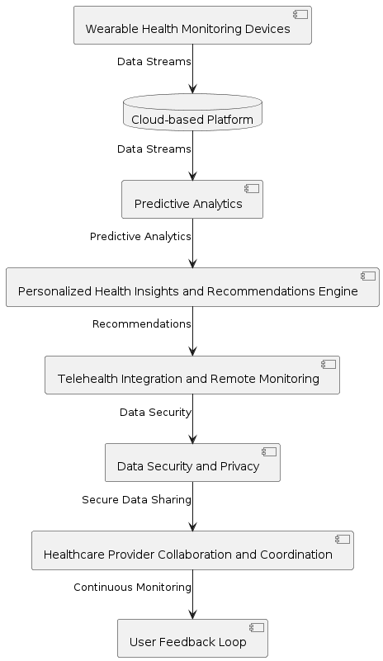

## 3.4 SYSTEM DESIGN

The system design phase of a project involves creating a blueprint for how the various components of the system will interact and function together to achieve the project's objectives. Here's an outline of the system design for the Personal Health Monitoring and Prediction System:

1. **High-Level Architecture**: The system follows a client-server architecture model, where the client-side consists of wearable health monitoring devices and the server-side consists of cloud-based platforms and analytics engines.
2. **Client-Side Components**:
   * **Wearable Health Monitoring Devices**: These devices are equipped with sensors to collect various health parameters such as heart rate, blood pressure, activity levels, and sleep patterns.
3. **Server-Side Components**:
   * **Cloud-Based Platform**: The cloud platform serves as the central hub for data storage, processing, and analysis. It hosts the predictive analytics engine, which analyzes the collected health data to generate insights and predictions.
   * **Predictive Analytics Engine**: This component utilizes machine learning algorithms to analyze health data and predict the likelihood of certain health conditions such as diabetes, heart disease, or hypertension.
   * **Personalized Health Insights Module**: Based on the predictive analytics results, this module generates personalized health insights, recommendations, and action plans for users to improve their health and well-being.
   * **Telehealth Integration**: The system integrates telehealth capabilities for remote monitoring and consultations with healthcare providers. It enables virtual consultations, remote diagnosis, and ongoing management of chronic conditions through telemedicine platforms.
   * **Data Security and Privacy**: Robust security measures are implemented to protect sensitive health information and ensure compliance with data protection regulations. This includes encryption, access controls, and secure data transmission protocols.
   * **Healthcare Provider Collaboration**: The system facilitates collaboration and communication among healthcare providers by enabling secure sharing of patient data, treatment plans, and clinical insights.
   * **User Feedback Loop**: Continuous monitoring and feedback mechanisms are established to collect user feedback, refine predictive models, and improve the accuracy of health predictions over time.
4. **Scalability and Performance**: The system architecture is designed to be scalable, capable of handling large volumes of health data from multiple users, and ensuring real-time analytics and minimal latency for telehealth consultations.
5. **Interoperability and Integration**: The system is designed to integrate seamlessly with existing healthcare IT infrastructure, including electronic health record (EHR) systems, medical devices, and telemedicine platforms, to ensure interoperability and data exchange.
6. **User Interface Design**: The user interface is designed to be intuitive, user-friendly, and accessible across different devices and platforms. It includes features such as dashboards, charts, and notifications to provide users with valuable insights into their health status and recommendations for improvement.

## 3.5 UML DIAGRAMS

UML stands for Unified Modelling Language. UML is a standardized general-purpose modelling language in the field of object-oriented software engineering. The standard is managed, and was created by, the Object Management Group. The goal is for UML to become a common language for creating models of object-oriented computer software. In its current form UML is comprised of two major components: a Meta-model and a notation. In the future, some form of method or process may also be added to; or associated with, UML.The Unified Modelling Language is a standard language for specifying, Visualization, Constructing and documenting the artifacts of software system, as well as for business modelling and other nonsoftware systems.

The UML represents a collection of best engineering practices that have proven successful in the modelling of large and complex systems. The UML is a very important part of developing objects-oriented software and the software development process. The UML uses mostly graphical notations to express the design of software projects.

**GOALS:**

The Primary goals in the design of the UML are as follows:

1. Provide users a ready-to-use, expressive visual modelling Language so that they can develop and exchange meaningful models.
2. Provide extendibility and specialization mechanisms to extend the core concepts.
3. Be independent of particular programming languages and development process.
4. Provide a formal basis for understanding the modelling language.
5. Encourage the growth of OO tools market.
6. Support higher level development concepts such as collaborations, frameworks, patterns and components.
7. Integrate best practices.

### USE CASE DIAGRAMS

A use case diagram in the Unified Modeling Language (UML) is a type of behavioral diagram defined by and created from a Use-case analysis. Its purpose is to present a graphical overview of the functionality provided by a system in terms of actors, their goals (represented as use cases), and any dependencies between those use cases. The main purpose of a use case diagram is to show what system functions are performed for which actor. Roles of the actors in the system can be depicted.

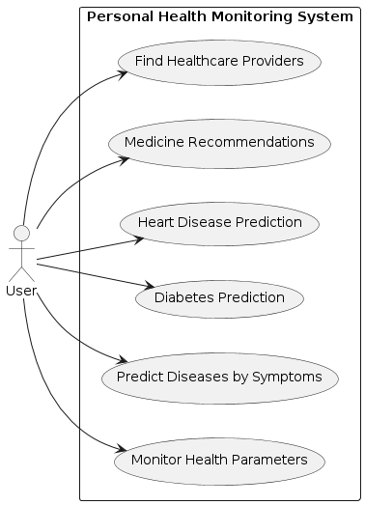

### CLASS DIAGRAM

In software engineering, a class diagram in the Unified Modeling Language (UML) is a type of static structure diagram that describes the structure of a system by showing the system's classes, their attributes, operations (or methods), and the relationships among the classes. It explains which class contains information.

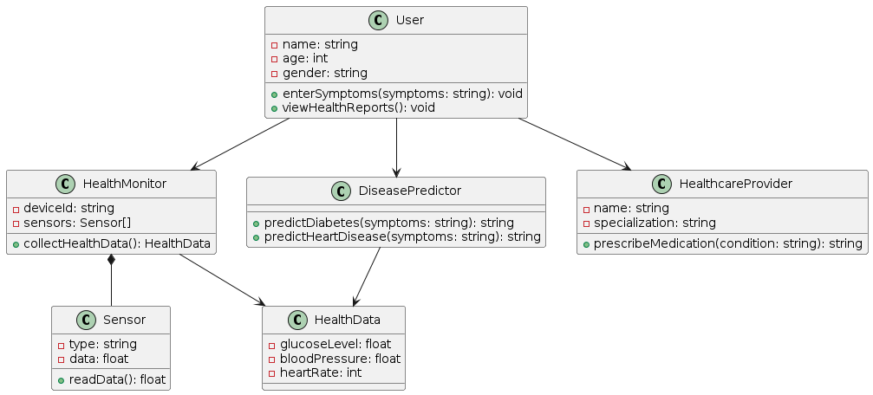

### SEQUENCE DIAGRAM

A sequence diagram in Unified Modeling Language (UML) is a kind of interaction diagram that shows how processes operate with one another and in what order. It is a construct of a Message Sequence Chart. Sequence diagrams are sometimescalled event diagrams, event scenarios, and timing diagrams.

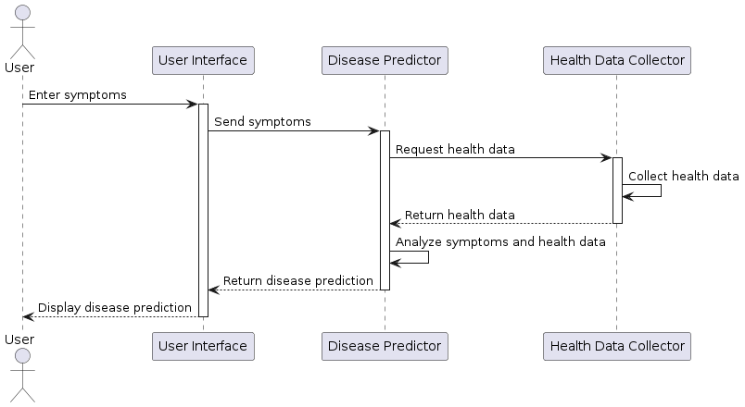

**COLLABORATION DIAGRAM:**

In collaboration diagram the method call sequence is indicated by some numbering technique as shown below. The number indicates how the methods are called one after another. We have taken the same order management system to describe the collaboration diagram. The method calls are similar to that of a sequence diagram. But the difference is that the sequence diagram does not describe the object organization whereas the collaboration diagram shows the object organization.



### DEPLOYMENT DIAGRAM

Deployment diagram represents the deployment view of a system. It is related to the component diagram. Because the components are deployed using the deployment diagrams. A deployment diagram consists of nodes. Nodes are nothing but physical hardware’s used to deploy the application.

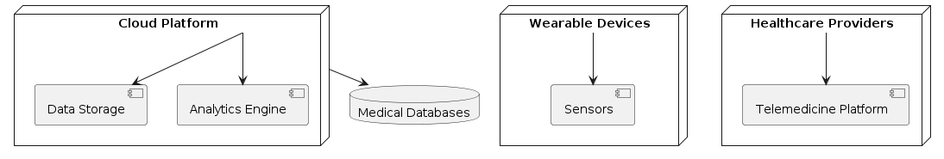

### ACTIVITY DIAGRAM

Activity diagrams are graphical representations of workflows of stepwise activities and actions with support for choice, iteration and concurrency. In the Unified Modeling Language, activity diagrams can be used to describe the business and operational step-by-step workflows of components in a system. An activity diagram shows the overall flow of control.

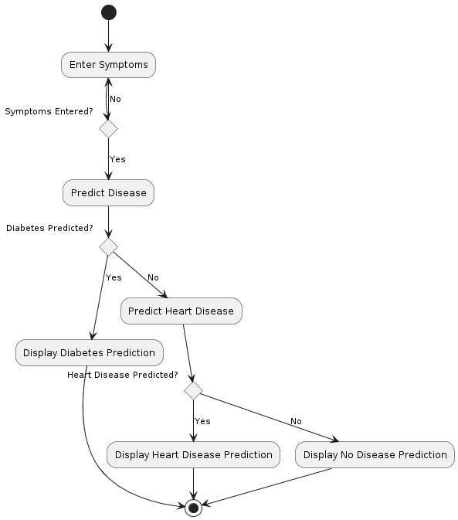

**COMPONENT DIAGRAM**:

A component diagram, also known as a UML component diagram, describes the organization and wiring of the physical **c**omponents in a system. Component diagrams are often drawn to help model implementation details and double-check that every aspect of the system's required function is covered by planned development.

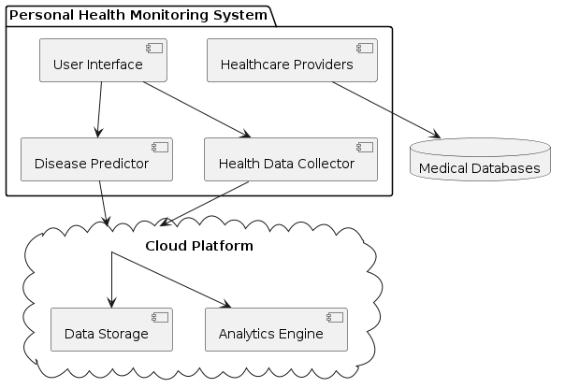

### ER DIAGRAM

An Entity–relationship model (ER model) describes the structure of a database with the help of a diagram, which is known as Entity Relationship Diagram (ER Diagram). An ER model is a design or blueprint of a database that can later be implemented as a database. The main components of E-R model are: entity set and relationship set.

An ER diagram shows the relationship among entity sets. An entity set is a group of similar entities and these entities can have attributes. In terms of DBMS, an entity is a table or attribute of a table in database, so by showing relationship among tables and their attributes, ER diagram shows the complete logical structure of a database. Let’s have a look at a simple ER diagram .

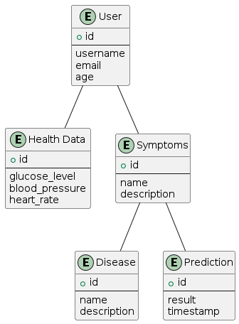

## DFD DIAGRAM

A Data Flow Diagram (DFD) is a traditional way to visualize the information flows within a system. A neat and clear DFD can depict a good amount of the system requirements graphically. It can be manual, automated, or a combination of both. It shows how information enters and leaves the system, what changes the information and where information is stored. The purpose of a DFD is to show the scope and boundaries of a system as a whole. It may be used as a communications tool between a systems analyst and any person who plays a part in the system that acts as the starting point for redesigning a system.

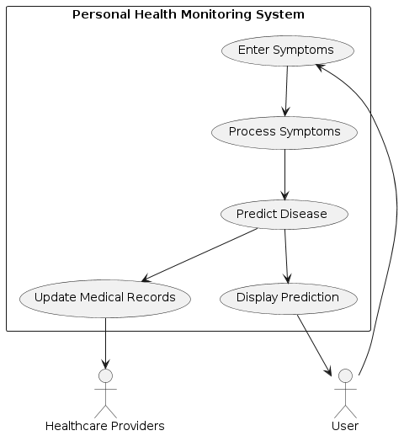

## CONTEXT LEVEL DIAGRAM

A Context level Diagram, also known as a level 0 data flow diagram (DFD), provides a highlevel view of a system and its interactions with external entities. It shows the flow of data between the system and external entities without delivering into the details of the systems internal processes. In the context level diagram, the system is represented as a single process surrounded by the external entities.

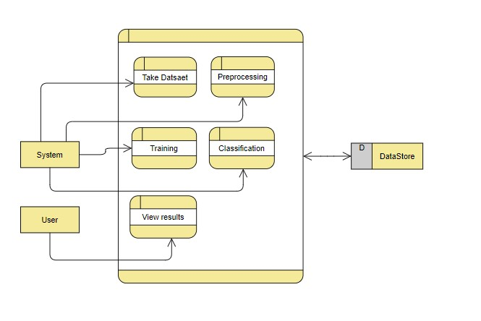

# CHAPTER – 4

**REQUIREMENT ANALYSIS**

The Personal Health Monitoring and Prediction System is designed to assist users in monitoring their health parameters and predicting potential diseases based on symptoms and health data. The system aims to provide users with timely insights into their health status, enabling proactive measures for disease prevention and management.

**4.1. Functional Requirements:**

1. **User Registration and Authentication:**
   * Users should be able to register an account with the system using their email address and password.
   * Authentication mechanisms should be in place to ensure secure access to user accounts.
2. **Health Parameter Monitoring:**
   * The system should collect and monitor health parameters such as glucose level, blood pressure, and heart rate at regular intervals.
   * Users should be able to input their health parameters manually or through compatible wearable devices.
3. **Symptom Entry:**
   * Users should have the ability to enter their symptoms into the system, either manually or through voice input.
   * The system should provide a user-friendly interface for symptom entry and validation.
4. **Disease Prediction:**
   * Based on the entered symptoms and health data, the system should predict potential diseases using machine learning algorithms.
   * Predictions should be accurate and timely, providing users with actionable insights into their health condition.
5. **Medicine Recommendations:**
   * In case of disease prediction, the system should recommend appropriate medicines and treatment options based on the predicted disease.
6. **User Feedback and Interaction:**
   * Users should have the ability to provide feedback on the accuracy of predictions and the effectiveness of recommended treatments.
   * The system should incorporate user feedback to improve prediction accuracy and enhance user experience.

**4.2 Non-Functional Requirements:**

1. **Performance:**
   * The system should be capable of handling a large volume of user data and concurrent user requests without significant performance degradation.
   * Response times for data retrieval, prediction generation, and recommendation should be minimal to ensure a seamless user experience.
2. **Security:**
   * Data security measures should be implemented to protect user privacy and confidentiality.
   * User authentication mechanisms should be robust to prevent unauthorized access to sensitive health information.
3. **Reliability:**
   * The system should be highly reliable, with minimal downtime and data loss.
   * Backup and recovery mechanisms should be in place to ensure the integrity and availability of user data.
4. **Usability:**
   * The system should have an intuitive and user-friendly interface, catering to users of varying technical expertise.
   * Clear instructions and guidance should be provided for symptom entry, data interpretation, and feedback submission.

**Constraints:**

1. **Compliance:**
   * The system should comply with relevant healthcare regulations and standards to ensure legality and ethicality in handling user health data.
   * Data storage and processing practices should adhere to industry best practices and regulatory requirements.
2. **Compatibility:**
   * The system should be compatible with a wide range of devices and platforms, including web browsers, mobile devices, and wearable health monitoring devices.
   * Integration with existing healthcare systems and databases should be considered to facilitate interoperability and data exchange.

## 4.3 H/W Requirements

* **Processor:** Intel Core i3 processor or equivalent
* **Hard Disk:** 160 GB storage capacity
* **RAM:** 8 GB memory

## 4.4 S/W Requirements

* Operating System : Windows 7/8/10 .
* Server side Script : HTML, CSS & JS.
* IDE : Pycharm.
* Libraries Used : Numpy, IO, OS, Django, keras.
* Technology : Python 3.6+.

## 4.5 Architecture

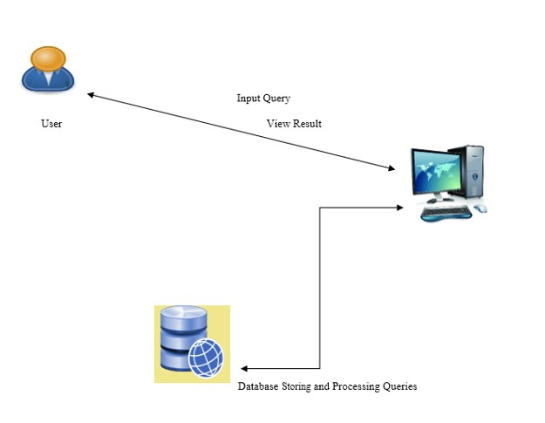

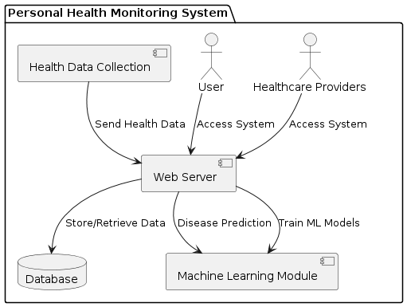

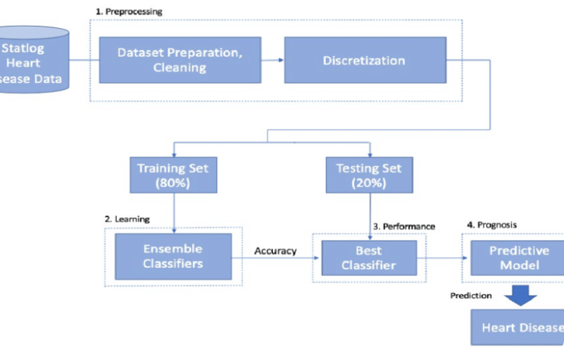

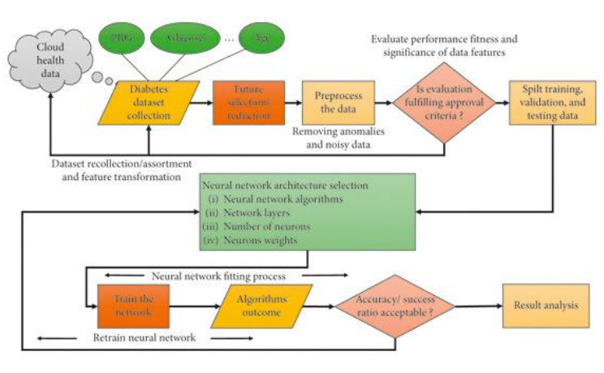

# FLOWCHART

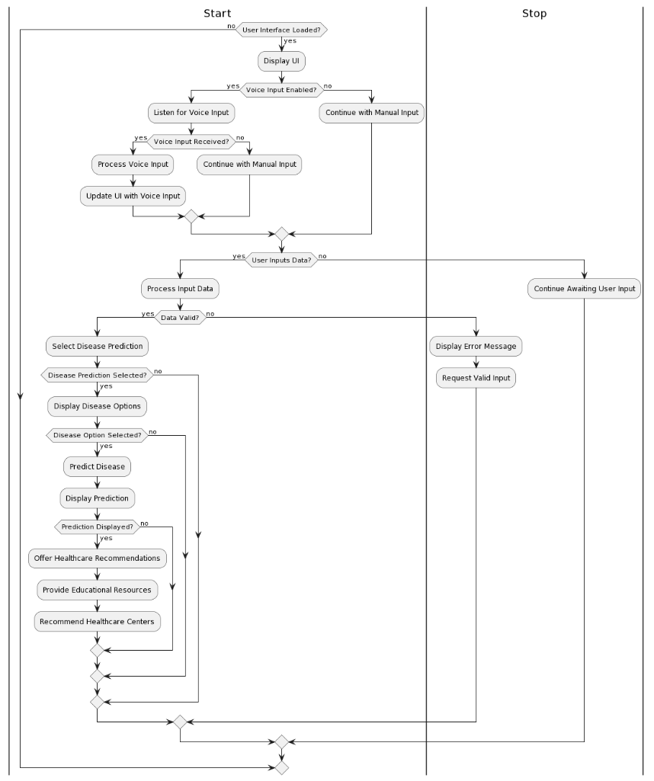

# 4.6 ALGORITHM

Algorithms play a crucial role in the Personal Health Monitoring and Prediction System, facilitating tasks such as disease prediction, data processing, and machine learning model training. Here are some key algorithms utilized in the system:

1. **Machine Learning Algorithms:**
   * **Decision Trees:** Decision trees are used for classification tasks, including predicting whether a patient has a particular disease based on input symptoms and health parameters. Decision trees recursively partition the feature space into subsets, making decisions based on the values of input features.
   * **Random Forest:** Random Forest is an ensemble learning technique that combines multiple decision trees to improve prediction accuracy and reduce overfitting. It constructs a multitude of decision trees during training and outputs the class that is the mode of the classes (classification) or mean prediction (regression) of the individual trees.
   * **Support Vector Machines (SVM):** SVM is a supervised learning algorithm used for classification and regression tasks. It works by finding the hyperplane that best separates classes in a high-dimensional feature space. SVMs are effective for disease prediction tasks where the data may not be linearly separable.
   * **Artificial Neural Networks (ANN):** ANNs are computational models inspired by the biological neural networks of the human brain. They consist of interconnected nodes (neurons) organized in layers. ANNs are used for complex pattern recognition tasks and have been applied to disease prediction based on health parameters.
   * **K-Nearest Neighbors (KNN):** KNN is a simple and effective classification algorithm that assigns a class label to a data point based on the majority class of its nearest neighbors. KNN is used for disease prediction tasks where similar cases tend to have similar outcomes.
2. **Data Processing Algorithms:**
   * **Feature Selection:** Feature selection algorithms are used to identify the most relevant features (health parameters) for disease prediction. Techniques such as Recursive Feature Elimination (RFE) or information gain-based methods are employed to select the optimal subset of features that contribute most to the predictive model.
   * **Data Preprocessing:** Data preprocessing algorithms are used to clean, transform, and normalize raw health data before feeding it into machine learning models. Techniques such as missing value imputation, scaling, and encoding categorical variables are applied to ensure the quality and consistency of the input data.
3. **Voice Recognition Algorithms:**
   * **Speech Recognition:** Speech recognition algorithms convert voice input into text, enabling users to verbally input symptoms and health information into the system. Techniques such as Hidden Markov Models (HMMs), Deep Neural Networks (DNNs), or Convolutional Neural Networks (CNNs) are commonly used for speech recognition tasks.
4. **Clustering Algorithms (Optional):**
   * **K-Means Clustering:** K-Means clustering is an unsupervised learning algorithm used for partitioning data into clusters based on similarity. While not directly related to disease prediction, clustering algorithms can be applied for exploratory data analysis and identifying patterns in health data.

# CHAPTER - 5 IMPLEMENTATION

import time

import random

from threading import Thread

import streamlit as st   *# Add this import statement*

import speech_recognition as sr

import pyaudio

diab_diagnosis = ''

heart_diagnosis = ''

*# Function to monitor health parameters in real-time*

def monitor_health():

    while True:

*# Simulate retrieval of health parameters (replace with actual data retrieval)*

        glucose_level = random.randint(80, 180)  *# Random glucose level between 80 and 180 mg/dl*

        blood_pressure = random.randint(90, 140)  *# Random blood pressure between 90 and 140 mmHg*

        heart_rate = random.randint(60, 100)  *# Random heart rate between 60 and 100 bpm*

*# Example threshold values for health parameters*

        glucose_threshold = 140  *# Threshold for high glucose level (mg/dl)*

        systolic_threshold = 120  *# Threshold for high systolic blood pressure (mmHg)*

        heart_rate_threshold = 90  *# Threshold for high heart rate (bpm)*

*# Check if any health parameter exceeds the threshold and trigger alerts*

        if glucose_level > glucose_threshold:

*# Your code to trigger an alert for high glucose level (e.g., send notification)*

            print("Alert: High glucose level detected!")

        if blood_pressure > systolic_threshold:

*# Your code to trigger an alert for high blood pressure (e.g., send notification)*

            print("Alert: High blood pressure detected!")

        if heart_rate > heart_rate_threshold:

*# Your code to trigger an alert for high heart rate (e.g., send notification)*

            print("Alert: High heart rate detected!")

        time.sleep(60)  *# Sleep for 60 seconds before checking again*

*# Start monitoring health parameters in the background*

monitor_thread = Thread(target=monitor_health)

monitor_thread.daemon = True  *# Set daemon to True to terminate thread when main program exits*

monitor_thread.start()

st.markdown('<h1 style="color: orange;font-family: DyeLine; text-align: center;">Personal Health Monitoring and Prediction System</h1>', unsafe_allow_html=True)

import pickle

import streamlit as st

import soundfile as sf

import sounddevice as sd

import numpy as np

from streamlit_option_menu import option_menu

*# Load the saved models*

diabetes_model = pickle.load(open('C:/Multiple Disease Prediction System/Saved models/diabetes_model.sav', 'rb'))

heart_disease_model = pickle.load(open('C:/Multiple Disease Prediction System/Saved models/diabetes_model.sav', 'rb'))

*# Load the audio files*

diabetic_audio_path = "C:/Multiple Disease Prediction System/Audio/Diabetic.wav"

diabetic_sound, _ = sf.read(diabetic_audio_path)

non_diabetic_audio_path = "C:/Multiple Disease Prediction System/Audio/Non_Diabetic.wav"

non_diabetic_sound, _ = sf.read(non_diabetic_audio_path)

heart_disease_audio_path = "C:/Multiple Disease Prediction System/Audio/HeartDisease.wav"

heart_disease_sound, _ = sf.read(heart_disease_audio_path)

non_heart_disease_audio_path = "C:/Multiple Disease Prediction System/Audio/Not_HeartDisease.wav"

non_heart_disease_sound, _ = sf.read(non_heart_disease_audio_path)

Invalid_details_audio_path = "C:/Multiple Disease Prediction System/Audio/Invalid_details.wav"

Invalid_details, _ = sf.read(Invalid_details_audio_path)

*# Sidebar for navigation*

with st.sidebar:

    selected = option_menu('Health Monitoring and Prediction System',

                           ['Predict Diseases by Symptoms','Diabetes Prediction', 'Heart Disease Prediction', 'Medicine Recommendations','Find Healthcare Providers'],

                           menu_icon='hospital-fill',

                           icons=['activity', 'heart', 'person'],

                           default_index=0)

def voice_input():

    r = sr.Recognizer()

    with sr.Microphone() as source:

        st.write("Listening for voice input...")

        audio = r.listen(source)

    try:

        text = r.recognize_google(audio)

        return text

    except sr.UnknownValueError:

        st.write("Sorry, I could not understand what you said.")

        return ""

    except sr.RequestError as e:

        st.write(f"Could not request results from Google Speech Recognition service; {e}")

        return ""

*# Enable voice input checkbox*

voice_input_enabled = st.checkbox("Enable Voice Input")

*# If voice input is enabled, listen for voice input and display the recognized text*

if voice_input_enabled:

    voice_input_text = voice_input()

    st.write("Voice Input Text:", voice_input_text)

*# If "Predict Diseases by Symptoms" is selected*

if selected == 'Predict Diseases by Symptoms':

*# Page title*

    st.markdown('<h2 style="color: green;">Predict Diseases by Symptoms</h2>', unsafe_allow_html=True)

*# Get symptoms input from the user*

    symptoms = st.text_input('Enter your symptoms (comma-separated)', help='e.g., fever, cough, headache')

*# Code for predicting diseases based on symptoms*

    if st.button('Predict'):

*# Process the symptoms input and predict diseases*

*# Example: Processing symptoms input*

        symptom_list = symptoms.split(',')

*# Example: Predicting diseases based on symptoms*

        predicted_diseases = []

*# Add code here to predict diseases based on symptoms*

*# Example: Display predicted diseases*

        if predicted_diseases:

            st.subheader('Predicted Diseases:')

            for disease in predicted_diseases:

                st.write(disease)

        else:

            st.write('No diseases predicted based on the provided symptoms.')

*# Diabetes Prediction Page*

if selected == 'Diabetes Prediction':

*# Page title*

    st.markdown('<h2 style="color: green;">Diabetes Prediction using ML</h2>', unsafe_allow_html=True)

*# Getting the input data from the user*

    col1, col2, col3 = st.columns(3)

    with col1:

        Pregnancies = st.text_input('Number of Pregnancies')

    with col2:

        Glucose = st.text_input('Glucose Level')

    with col3:

        BloodPressure = st.text_input('Blood Pressure value')

    with col1:

        SkinThickness = st.text_input('Skin Thickness value')

    with col2:

        Insulin = st.text_input('Insulin Level')

    with col3:

        BMI = st.text_input('BMI value')

    with col1:

        DiabetesPedigreeFunction = st.text_input('Diabetes Pedigree Function value')

    with col2:

        Age = st.text_input('Age of the Person')

*# Code for Prediction*

*# Creating a button for Prediction*

    if st.button('Diabetes Test Result'):

        if all(input_value.strip() for input_value in [Pregnancies, Glucose, BloodPressure, SkinThickness, Insulin, BMI, DiabetesPedigreeFunction, Age]):

            user_input = [*float*(Pregnancies), *float*(Glucose), *float*(BloodPressure), *float*(SkinThickness), *float*(Insulin), *float*(BMI), *float*(DiabetesPedigreeFunction), *float*(Age)]

            diab_prediction = diabetes_model.predict([user_input])

            if diab_prediction[0] == 1:

                diab_diagnosis = 'The person is diabetic'

                sd.play(np.array(diabetic_sound))  *# Play diabetic sound effect*

            else:

                diab_diagnosis = 'The person is not diabetic'

                sd.play(np.array(non_diabetic_sound))  *# Play non-diabetic sound effect*

        else:

            diab_diagnosis = 'Please enter valid details'

            sd.play(np.array(Invalid_details))  *# Play an empty sound effect*

    st.success(diab_diagnosis)

    if diab_diagnosis.startswith('The person is diabetic'):

*# Display common risk factors and symptoms of diabetes*

       st.subheader('Common Risk Factors and Symptoms of Diabetes')

       if st.button('Patient Record'):

            st.subheader('Input Features:')

            st.write("Number of Pregnancies:", Pregnancies)

            st.write("Glucose Level:", Glucose)

            st.write("Blood Pressure value:", BloodPressure)

            st.write("Skin Thickness value:", SkinThickness)

            st.write("Insulin Level:", Insulin)

            st.write("BMI value:", BMI)

            st.write("Diabetes Pedigree Function value:", DiabetesPedigreeFunction)

            st.write("Age of the Person:", Age)

*# Add relevant text or bullet points with information about risk factors and symptoms*

*# Display preventive measures and treatment options for diabetes*

       st.subheader('Preventive Measures and Treatment Options for Diabetes')

*# Add relevant text or bullet points with information about lifestyle changes, medication, etc.*

*# Display support resources and educational materials for diabetes*

       st.subheader('Support Resources and Educational Materials for Diabetes')

*# Add links or resources to relevant websites, articles, or support groups*

*# Display input features upon clicking the "Patient Records" button*

*# Display buttons horizontally for "Patient Records" and "Disease Description"*

    col1, col2, col3, col4 = st.columns([2,2,3,1])

    with col1:

        if st.button('Patient Records'):

            st.subheader('Input Features:')

            st.write("Number of Pregnancies:", Pregnancies)

            st.write("Glucose Level:", Glucose)

            st.write("Blood Pressure value:", BloodPressure)

            st.write("Skin Thickness value:", SkinThickness)

            st.write("Insulin Level:", Insulin)

            st.write("BMI value:", BMI)

            st.write("Diabetes Pedigree Function value:", DiabetesPedigreeFunction)

            st.write("Age of the Person:", Age)

    with col2:

        if st.button('Disease Description'):

            st.write("Diabetes is a chronic condition characterized by high levels of sugar (glucose) in the blood. It can lead to various complications such as heart disease, kidney failure, and blindness if not properly managed. Common symptoms include frequent urination, increased thirst, and unexplained weight loss. Treatment often involves lifestyle changes, medication, and regular monitoring of blood sugar levels.")

    with col3:

        if st.button('Educational Resources'):

            with st.expander("Videos"):

                st.video("https://www.youtube.com/watch?v=XfyGv-xwjlI")

                st.video("https://www.youtube.com/watch?v=69Kv9W62CSk")

                st.write("Videos on diabetes or heart disease")

*# Option 2: Articles*

            with st.expander("Articles"):

                st.write("Articles on diabetes or heart disease")

    with col4:

        if st.button('articles'):

            st.write("Diabetes is a chronic condition characterized by high levels of sugar (glucose) in the blood. It can lead to various complications such as heart disease, kidney failure, and blindness if not properly managed. Common symptoms include frequent urination, increased thirst, and unexplained weight loss. Treatment often involves lifestyle changes, medication, and regular monitoring of blood sugar levels.")

*# Heart Disease Prediction Page*

if selected == 'Heart Disease Prediction':

*# Page title*

    st.markdown('<h2 style="color: green;">Heart Disease Prediction using ML</h2>', unsafe_allow_html=True)

    col1, col2, col3 = st.columns(3)

    with col1:

        age = st.text_input('Age')

    with col2:

        sex = st.text_input('Sex')

    with col3:

        cp = st.text_input('Chest Pain types')

    with col1:

        trestbps = st.text_input('Resting Blood Pressure')

    with col2:

        chol = st.text_input('Serum Cholestoral in mg/dl')

    with col3:

        fbs = st.text_input('Fasting Blood Sugar > 120 mg/dl')

    with col1:

        restecg = st.text_input('Resting Electrocardiographic results')

    with col2:

        thalach = st.text_input('Maximum Heart Rate achieved')

    with col3:

        exang = st.text_input('Exercise Induced Angina')

    with col1:

        oldpeak = st.text_input('ST depression induced by exercise')

    with col2:

        slope = st.text_input('Slope of the peak exercise ST segment')

    with col3:

        ca = st.text_input('Major vessels colored by flourosopy')

    with col1:

        thal = st.text_input('thal: 0 = normal; 1 = fixed defect; 2 = reversable defect')

*# Code for Prediction*

    heart_diagnosis = ''

*# Creating a button for Prediction*

    if st.button('Heart Disease Test Result'):

        if all(input_value.strip() for input_value in [age, sex, cp, trestbps, chol, fbs, restecg, thalach, exang, oldpeak, slope, ca, thal]):

            user_input = [*float*(age), *float*(sex), *float*(cp), *float*(trestbps), *float*(chol), *float*(fbs), *float*(restecg), *float*(thalach), *float*(exang), *float*(oldpeak), *float*(slope), *float*(ca), *float*(thal)]

            heart_prediction = heart_disease_model.predict([user_input[:8]])

            if heart_prediction[0] == 1:

                heart_diagnosis = 'The person is having heart disease'

                sd.play(np.array(heart_disease_sound))  *# Play heart disease sound effect*

            else:

                heart_diagnosis = 'The person does not have any heart disease'

                sd.play(np.array(non_heart_disease_sound))  *# Play non-heart disease sound effect*

        else:

            heart_diagnosis = 'Please enter valid details'

            sd.play(np.array(Invalid_details))  *# Play an empty sound effect*

    st.success(heart_diagnosis)

*# Medicine Recommendation Page*

if selected == 'Medicine Recommendations':

*# Page title*

    st.markdown('<h2 style="color: green;">Medicine Recommendations</h2>', unsafe_allow_html=True)

*# Check the selected disease prediction*

    if diab_diagnosis.startswith('The person is diabetic'):

*# If diabetes is predicted, display recommended medicines for diabetes*

        st.subheader('Recommended Medicines for Diabetes')

        st.write("1. Metformin")

        st.write("2. Insulin (if required)")

        st.write("3. Sulfonylureas (e.g., Glipizide)")

        st.write("4. DPP-4 inhibitors (e.g., Sitagliptin)")

    elif heart_diagnosis.startswith('The person is having heart disease'):

*# If heart disease is predicted, display recommended medicines for heart disease*

        st.subheader('Recommended Medicines for Heart Disease')

        st.write("1. Aspirin")

        st.write("2. Beta-blockers (e.g., Metoprolol)")

        st.write("3. ACE inhibitors (e.g., Lisinopril)")

        st.write("4. Statins (e.g., Atorvastatin)")

    else:

*# If no specific disease is predicted, provide general information or prompt the user to enter more details*

        st.write("Please select a disease prediction to see recommended medicines.")

*# Button for finding healthcare providers*

if selected == 'Find Healthcare Providers':

*# Add functionality to find and display nearby healthcare providers*

*# This could include querying a database or using an API to fetch relevant information*

*# Display the results in a user-friendly format, such as a list or interactive map*

    st.header("Find Healthcare Providers Near You")

*# Add code here to fetch and display healthcare provider information*

*# Example: Display a list of nearby hospitals and medical centers*

    st.subheader("Hospitals and Medical Centers")

    st.write("1. Hospital ABC - 1.2 miles away")

    st.write("2. Medical Center XYZ - 2.5 miles away")

*# Example: Display a list of nearby doctors*

    st.subheader("Doctors")

    st.write("1. Dr. Smith - Cardiologist")

    st.write("2. Dr. Johnson - Endocrinologist")

*# You can further enhance this functionality by adding filters, sorting options, or integrating with location-based services.*

**RESULTS**

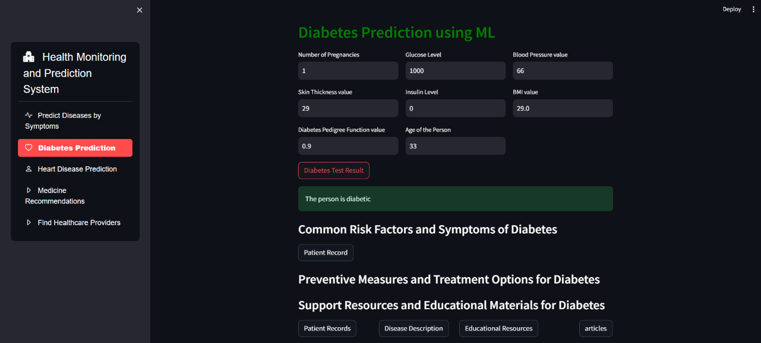

## preencoded.png

## 5.3 TYPES OF TESTS

### Unit testing

Unit testing involves the design of test cases that validate that the internal program logic is functioning properly, and that program inputs produce valid outputs. All decision branches and internal code flow should be validated. It is the testing of individual software units of the application .it is done after the completion of an individual unit before integration. This is a structural testing, that relies on knowledge of its construction and is invasive. Unit tests perform basic tests at component level and test a specific business process, application, and/or system configuration. Unit tests ensure that each unique path of a business process performs accurately to the documented specifications and contains clearly defined inputs and expected results.

### Integration testing

Integration tests are designed to test integrated software components to determine if they actually run as one program. Testing is event driven and is more concerned with the basic outcome of screens or fields. Integration tests demonstrate that although the components were individually satisfaction, as shown by successfully unit testing, the combination of components is correct and consistent. Integration testing is specifically aimed at exposing the problems that arise from the combination of components.

Software integration testing is the incremental integration testing of two or more integrated software components on a single platform to produce failures caused by interface defects.

The task of the integration test is to check that components or software applications, e.g. components in a software system or – one step up – software applications at the company level – interact without error.

**Test Results:** All the test cases mentioned above passed successfully. No defects encountered.  **Acceptance Testing**

User Acceptance Testing is a critical phase of any project and requires significant participation by the end user. It also ensures that the system meets the functional requirements.

**Test Results:** All the test cases mentioned above passed successfully. No defects encountered.  **Functional testing**

Functional tests provide systematic demonstrations that functions tested are available as specified by the business and technical requirements, system documentation, and user manuals.

Functional testing is centered on the following items:

Valid Input : identified classes of valid input must be accepted.

Invalid Input : identified classes of invalid input must be rejected.

Functions : identified functions must be exercised.

Output : identified classes of application outputs must be exercised.

Systems/Procedures: interfacing systems or procedures must be invoked.

Organization and preparation of functional tests is focused on requirements, key functions, or special test cases. In addition, systematic coverage pertaining to identify Business process flows; data fields, predefined processes, and successive processes must be considered for testing. Before functional testing is complete, additional tests are identified and the effective value of current tests is determined.

#### White Box Testing

White Box Testing is a testing in which in which the software tester has knowledge of the inner workings, structure and language of the software, or at least its purpose. It is purpose. It is used to test areas that cannot be reached from a black box level.

#### Black Box Testing

Black Box Testing is testing the software without any knowledge of the inner workings, structure or language of the module being tested. Black box tests, as most other kinds of tests, must be written from a definitive source document, such as specification or requirements document, such as specification or requirements document. It is a testing in which the software under test is treated, as a black box. you cannot “see” into it. The test provides inputs and responds to outputs without considering how the software works.

#### Test objectives

* All field entries must work properly.
* Pages must be activated from the identified link.
* The entry screen, messages and responses must not be delayed.

#### Features to be tested

* Verify that the entries are of the correct format
* No duplicate entries should be allowed
* All links should take the user to the correct page.

# CHAPTER – 6 CONCLUSION & FUTURE SCOPE

## 6.1 CONCLUSION

## In conclusion, the development and implementation of the Personal Health Monitoring and Prediction System represent a significant advancement in healthcare technology. The system provides users with an intuitive platform for monitoring their health parameters, predicting diseases, and receiving personalized recommendations for healthcare management. Through the integration of machine learning algorithms, data processing techniques, and voice recognition capabilities, the system offers a comprehensive solution for proactive health management.

## Throughout the project lifecycle, several milestones were achieved, including the design and implementation of the system architecture, development of machine learning models for disease prediction, and integration of voice input functionality. The system's user-friendly interface and robust backend infrastructure ensure seamless user experience and reliable performance.

## Moving forward, there are several avenues for future development and enhancement of the system. Firstly, continuous refinement and optimization of machine learning models are essential for improving prediction accuracy and adapting to evolving healthcare trends. Additionally, the expansion of the system's feature set to include advanced analytics, remote monitoring capabilities, and integration with wearable devices can further enhance its functionality and utility.

## Moreover, collaboration with healthcare providers, research institutions, and regulatory bodies is critical for ensuring the system's compliance with healthcare standards, data privacy regulations, and ethical guidelines. By fostering partnerships and leveraging emerging technologies, the Personal Health Monitoring and Prediction System can continue to evolve as a valuable tool for empowering individuals to take control of their health and well-being.

## In conclusion, the successful development and deployment of the Personal Health Monitoring and Prediction System underscore its potential to revolutionize healthcare delivery and improve health outcomes for individuals worldwide.

## 6.2 FUTURE SCOPE

The Personal Health Monitoring and Prediction System exhibit promising potential for future enhancements and expansions. Several avenues can be explored to further augment the system's functionality, usability, and impact in the healthcare domain:

1. **Integration with Wearable Devices:** Incorporating compatibility with wearable health monitoring devices such as smartwatches, fitness trackers, and medical sensors can provide real-time health data inputs. This integration enables continuous health monitoring and seamless data synchronization with the system, enhancing the accuracy of disease prediction and personalized recommendations.
2. **Advanced Analytics and Insights:** Implementing advanced data analytics techniques such as predictive modeling, anomaly detection, and trend analysis can unveil deeper insights into health patterns and risk factors. By leveraging big data analytics, the system can offer proactive interventions, early warning alerts, and personalized health insights tailored to individual user profiles.
3. **Telemedicine and Remote Monitoring:** Expanding the system's capabilities to support telemedicine consultations and remote monitoring services can facilitate access to healthcare professionals and specialists. Integrating video conferencing, chatbot assistance, and remote diagnostic tools enables users to receive timely medical advice, treatment plans, and follow-up care from the comfort of their homes.
4. **AI-driven Personalized Medicine:** Leveraging artificial intelligence (AI) algorithms and genetic profiling data, the system can advance towards personalized medicine approaches. By analyzing genetic predispositions, lifestyle factors, and environmental influences, the system can offer personalized treatment recommendations, medication adjustments, and preventive strategies tailored to individual genetic profiles and health histories.
5. **Community Engagement and Health Education:** Promoting community engagement initiatives, health education campaigns, and support groups within the system fosters a collaborative ecosystem for sharing knowledge, experiences, and best practices. By empowering users with health literacy and self-management skills, the system cultivates a culture of proactive health management and preventive care.
6. **Blockchain-based Health Data Management:** Implementing blockchain technology for secure, decentralized health data management ensures data integrity, privacy, and interoperability. Blockchain-enabled health records provide users with full control over their data, facilitating seamless sharing with healthcare providers, researchers, and insurers while maintaining confidentiality and security.
7. **Continuous Improvement and User Feedback:** Establishing mechanisms for gathering user feedback, conducting usability testing, and iterating on system features is crucial for continuous improvement. By incorporating user preferences, preferences, and suggestions, the system evolves to meet evolving user needs, preferences, and expectations, ensuring its relevance and effectiveness in the long term.