Name: **Prasanth Kumar Malleboina**

Roll No: **20A41A0531**

College: **Loyola Institute of Technology and Management**

**STEP-1: Purpose and Usage of SQLMap:**

Certainly! Let’s delve into the world of **SQLMap**—a powerful tool that plays a crucial role in the realm of **web security**. Buckle up, because we’re about to embark on a journey through its purpose, features, and practical applications.

## SQLMap: Unraveling the Mystery

### 1. ****What Is SQLMap?****

SQLMap is an **open-source penetration testing tool** designed to **automate the detection and exploitation** of **SQL injection vulnerabilities** in web applications. Its primary goal is to identify security weaknesses related to SQL injection and provide a means to exploit them. Let’s break down its purpose and usage:

### 2. ****Why SQL Injection Matters?****

Before we dive into SQLMap, let’s understand why SQL injection is a critical concern. SQL injection occurs when an attacker manipulates input data to inject malicious SQL code into an application’s database query. If successful, this can lead to unauthorized access, data leakage, and potentially catastrophic consequences.

### 3. ****Key Features of SQLMap:****

Let’s explore the features that make SQLMap a must-have tool for security professionals:

#### a. ****Detection Engine:****

* SQLMap boasts a robust detection engine that scans web applications for SQL injection vulnerabilities.
* It identifies vulnerable parameters, URLs, and other attack vectors.

#### b. ****Exploitation Capabilities:****

* Once a vulnerability is detected, SQLMap can exploit it to gain unauthorized access to the database server.
* It automates the process of extracting sensitive information from the database.

#### c. ****Database Support:****

* SQLMap supports various database management systems, including:
  + MySQL
  + Oracle
  + PostgreSQL
  + Microsoft SQL Server
  + And more!

#### d. ****SQL Injection Techniques:****

* SQLMap covers six primary SQL injection techniques:
  + Boolean-based blind
  + Time-based blind
  + Error-based
  + UNION query-based
  + Stacked queries
  + Out-of-band (OOB) techniques

#### e. ****User Enumeration:****

* It can enumerate:
  + Usernames
  + Password hashes
  + Privileges
  + Roles
  + Databases
  + Tables
  + Columns

#### f. ****File System Access:****

* SQLMap allows downloading and uploading files from the database server’s underlying file system.
* This feature is handy for extracting sensitive files.

#### g. ****Command Execution:****

* It can execute arbitrary commands on the operating system via out-of-band connections.
* This extends its capabilities beyond SQL injection.

#### h. ****Metasploit Integration:****

* SQLMap integrates with Metasploit, enabling user privilege escalation using Metasploit’s Meterpreter getsystem command.

### 4. ****Practical Applications:****

SQLMap finds its place in various scenarios:

#### a. ****Security Audits:****

* Security professionals use SQLMap during security audits to identify and fix SQL injection vulnerabilities.
* It helps ensure robust web application security.

#### b. ****Penetration Testing:****

* Penetration testers leverage SQLMap to simulate real-world attacks.
* By exploiting vulnerabilities, they demonstrate potential risks to clients.

#### c. ****Educational Purposes:****

* Beginners learn about SQL injection by experimenting with SQLMap.
* It provides hands-on experience in a controlled environment.

### 5. ****Conclusion:****

SQLMap is a powerful ally in the ongoing battle against web vulnerabilities. Whether you’re a seasoned security expert or a curious learner, understanding SQLMap’s purpose and capabilities is essential. Remember, with great power comes great responsibility—use SQLMap ethically and responsibly to enhance web security.

**STEP-2 INSTALLATION OF SQLMap:**



Explore

Certainly! Let’s explore how to install **SQLMap** on various operating systems using the terminal and GitHub.

## Installation of SQLMap on Different Operating Systems

### 1. ****Linux (Ubuntu/Debian):****

1. Open the terminal.
2. Update the package repositories:
3. sudo apt-get update
4. Install SQLMap:
5. sudo apt-get install sqlmap
6. Verify the installation by checking the version:
7. sqlmap --version

### 2. ****Windows:****

1. Download the latest version of SQLMap from the [official website](https://sqlmap.org/).
2. Extract the downloaded zip file to a desired location.
3. Rename the extracted folder to “sqlmap.”
4. Move the “sqlmap” folder to your PC’s C drive.
5. Open Command Prompt from the start menu.
6. Navigate to the “sqlmap” directory:
7. cd C:\sqlmap
8. Run SQLMap:
9. sqlmap.py

### 3. ****macOS:****

1. Install Homebrew package manager by running the following command in the terminal:
2. /usr/bin/ruby -e "$(curl -fsSL https://raw.githubusercontent.com/Homebrew/install/master/install)"
3. Install SQLMap:
4. brew install sqlmap
5. Verify the installation:
6. Sqlmap

**STEP-3: Identifying a Vulnerable Web Application:**

Certainly! Let’s explore how to identify a vulnerable web application for practicing SQL injection attacks. Here are some steps you can follow:

1. **OWASP Juice Shop:**
   * OWASP Juice Shop is another intentionally vulnerable web application.
   * It focuses on modern web security issues and includes challenges related to SQL injection, XSS, CSRF, and more.
   * You can access OWASP Juice Shop online without the need for local installation.
   * Visit the OWASP Juice Shop website and start exploring its challenges.

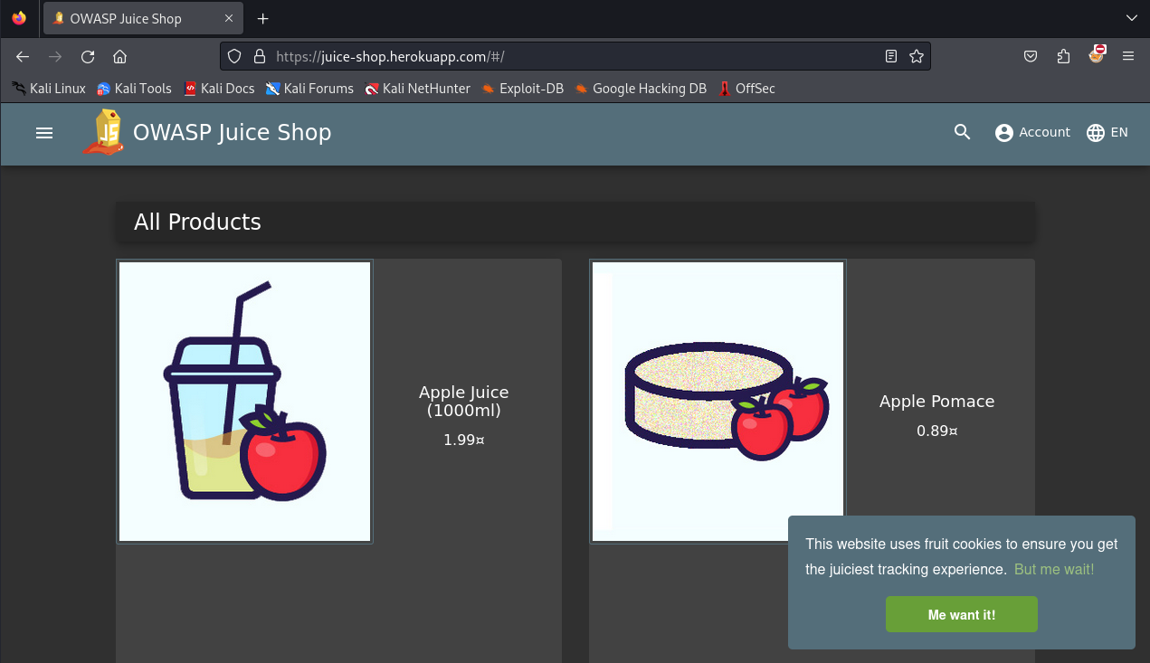

**STEP-4: Performing a Basic SQL Injection Attack:**

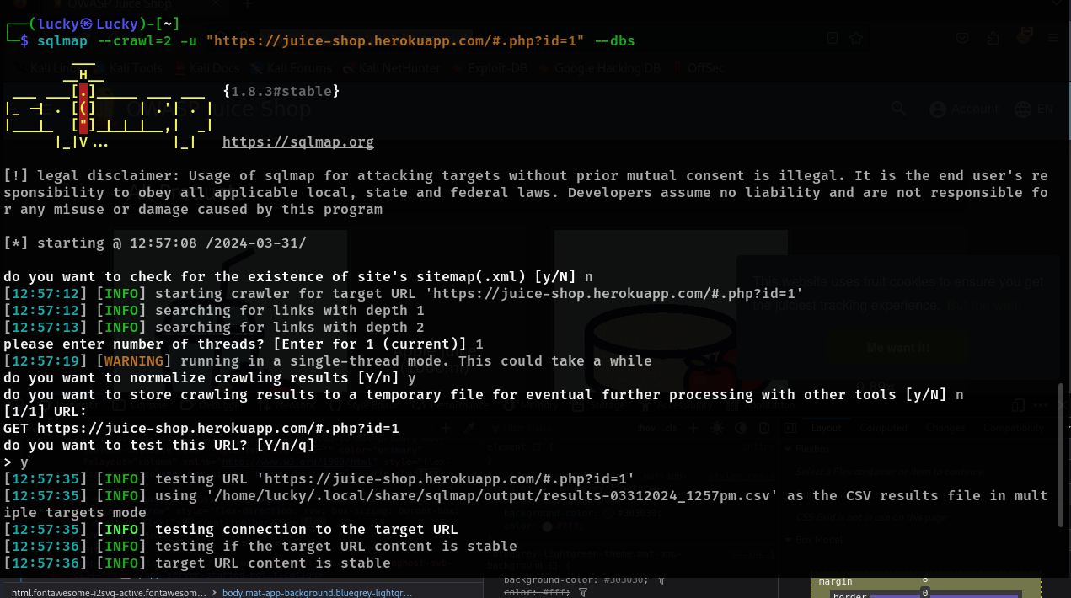

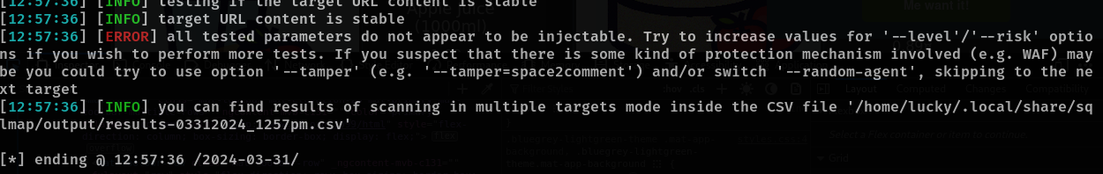

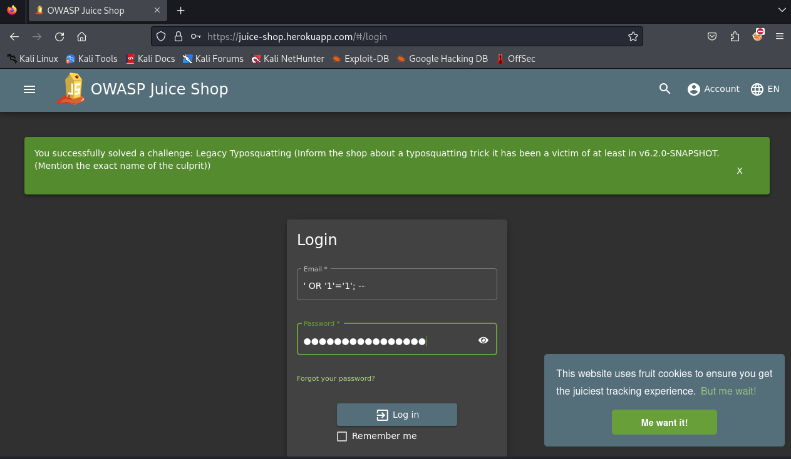

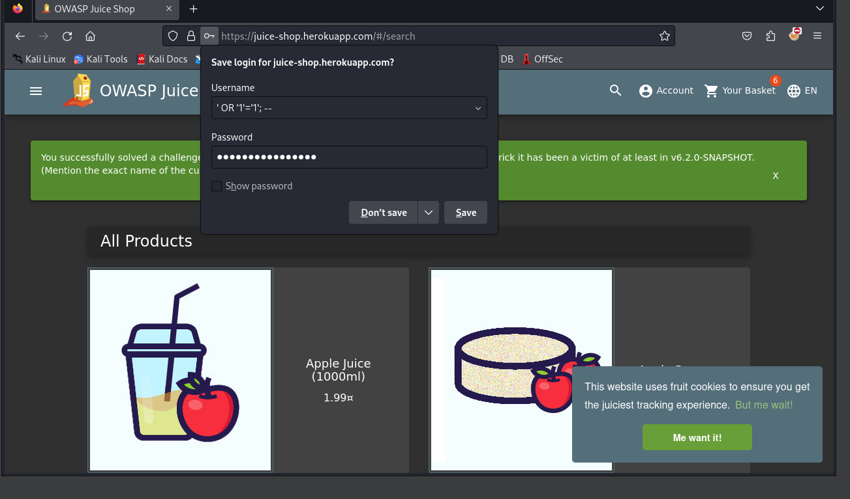

1. **Payload: Retrieving Usernames and Passwords**
   * Inject the following payload:
   * Username: ' UNION SELECT username, password FROM users; --
   * Password: (leave empty)
     + Explanation:
       - The injected query becomes:
       - SELECT * FROM users WHERE username = '' UNION SELECT username, password FROM users; --' AND password = '';
       - This retrieves all usernames and passwords from the users table.

**STEP-5 Documenting the Steps**

Certainly! Let’s break down the steps for identifying and exploiting SQL injection vulnerabilities, along with mitigation strategies:

## Documenting the Steps for SQL Injection Testing

1. **Identify the Target:**
   * Choose a web application that you suspect might be vulnerable to SQL injection. For practice, use intentionally vulnerable applications like **DVWA** or **OWASP Juice Shop**.
2. **Explore Input Fields:**
   * Identify input fields (such as login forms, search boxes, or URL parameters) where user input is processed.
   * Focus on fields that interact with a database (e.g., username, password, search queries).
3. **Test for Vulnerability:**
   * Inject payloads into input fields to test for SQL injection.
   * Common payloads include:
     + ' OR '1'='1'; -- (to bypass authentication)
     + ' UNION SELECT username, password FROM users; -- (to retrieve data)
     + Other variations based on the context.
4. **Observe Responses:**
   * Pay attention to application responses:
     + If an error message reveals database-related information (e.g., SQL syntax error), it indicates a potential vulnerability.
     + Unexpected behavior (e.g., bypassing login) also suggests a vulnerability.
5. **Exploit the Vulnerability:**
   * Once a vulnerability is confirmed, exploit it:
     + Retrieve data (e.g., usernames, passwords).
     + Modify data (e.g., change account details).
     + Execute arbitrary SQL commands.
6. **Document Commands Used:**
   * Record the payloads you injected.
   * Note the URLs, parameters, and responses encountered during testing.

## Potential Impact of SQL Injection Vulnerabilities

1. **Data Exposure:**
   * Attackers can extract sensitive information from databases (user credentials, personal data, financial records).
   * Impact: Privacy breaches, identity theft, financial losses.
2. **Data Manipulation:**
   * Attackers can modify or delete data in the database.
   * Impact: Data corruption, unauthorized changes.
3. **Application Takeover:**
   * Successful exploitation can lead to complete control over the application.
   * Impact: Unauthorized access, defacement, disruption of services.

## Mitigation Strategies

1. **Prepared Statements (Parameterized Queries):**
   * Use parameterized queries in your code to separate user input from SQL commands.
   * This prevents direct concatenation of user input into SQL queries.
2. **Input Validation and Sanitization:**
   * Validate and sanitize user input before processing it.
   * Reject input that doesn’t conform to expected patterns.
3. **Least Privilege Principle:**
   * Limit database user privileges to only what’s necessary.
   * Avoid using root/administrator accounts in application code.
4. **Web Application Firewalls (WAFs):**
   * Deploy WAFs to detect and block SQL injection attempts.
   * Regularly update WAF rules.
5. **Security Testing and Code Reviews:**
   * Regularly test your application for vulnerabilities.
   * Conduct code reviews to identify and fix issues.