**CANCER PREDICTION IN EARLY SATGES USING MACHINE LEARNING**

**OBJECTIVE**

The main objective of this research is to classify cancer prediction in early stages using machine learning. Here we are going to predict the stages of cancer levels whether high , low , Medium .

**ABSTRACT**

Cancer is a disease characterized by the uncontrolled growth and spread of abnormal cells. Early detection and diagnosis of cancer are essential for successful treatment and management of the disease. Machine learning (ML) is a promising approach that can assist in predicting cancer at an early stage, which can lead to better patient outcomes. Several ML algorithms have been applied to predict cancer in its early stages, including decision trees, support vector machines, neural networks, and random forests. These algorithms can be trained on various types of data, including genomic, proteomic, and imaging data. Genomic data can provide important information about gene expression patterns, DNA mutations, and other molecular features of cancer cells. Proteomic data can provide insights into the protein expression patterns that may be indicative of cancer. Imaging data, such as CT and MRI scans, can also provide valuable information about the presence and extent of cancerous lesions. Overall, ML has shown promise as a tool for predicting cancer in its early stages. As the field of ML continues to evolve and improve, it is likely that these algorithms will become even more accurate and reliable in predicting cancer.

**Keywords**: Machine Learning, Random Forest, Logistic Regression, Decision Tree, ML techniques, evaluation.

**EXISTING SYSTEM**

In the existing system, implementation of machine learning algorithms is bit complex to build due to the lack of information about the data visualization. Machine learning has been widely used in the medical field to improve the diagnosis and treatment of various diseases, including cancer. Early detection of cancer is crucial for successful treatment, and machine learning models have been developed to predict cancer in its early stages. To overcome all this, we use machine learning packages available in the scikit-learn library.

**Disadvantages:**

* High complexity.
* Time consuming.

**PROPOSED SYSTEM**

Proposed several machine learning models to classify cancer stages . These machine learning systems have the potential to greatly improve the early detection of cancer and ultimately save lives. By analyzing large amounts of patient data, these systems can identify patterns and trends that may not be immediately apparent to human doctors. This allows for earlier detection and more effective treatment of cancer. Therefore, we propose a Random Forest, Logistic Regression and Decision Tree machine Classifier to predict the cases.

**Advantages**:

* Highest accuracy
* Reduces time complexity.
* Easy to use

**PROPOSED METHOD**

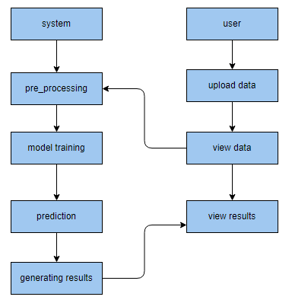

**HARDWARE AND SOFTWARE REQUIREMENTS**

**H/W Configuration:**

Operating system : Windows 7 or 7+

RAM : 8 GB

Hard disc or SSD : More than 500 GB

Processor : Intel 3rd generation or high or Ryzen with 8 GB Ram

**S/W Configuration:**

Software’s : Python 3.6 or high version

IDE : PyCharm.

Framework : Djangos, pandas, numpy and Scikit-Learn