Name: Micah Perkins

EECE.2650 Logic Design

Assignment 4

**State Diagram:**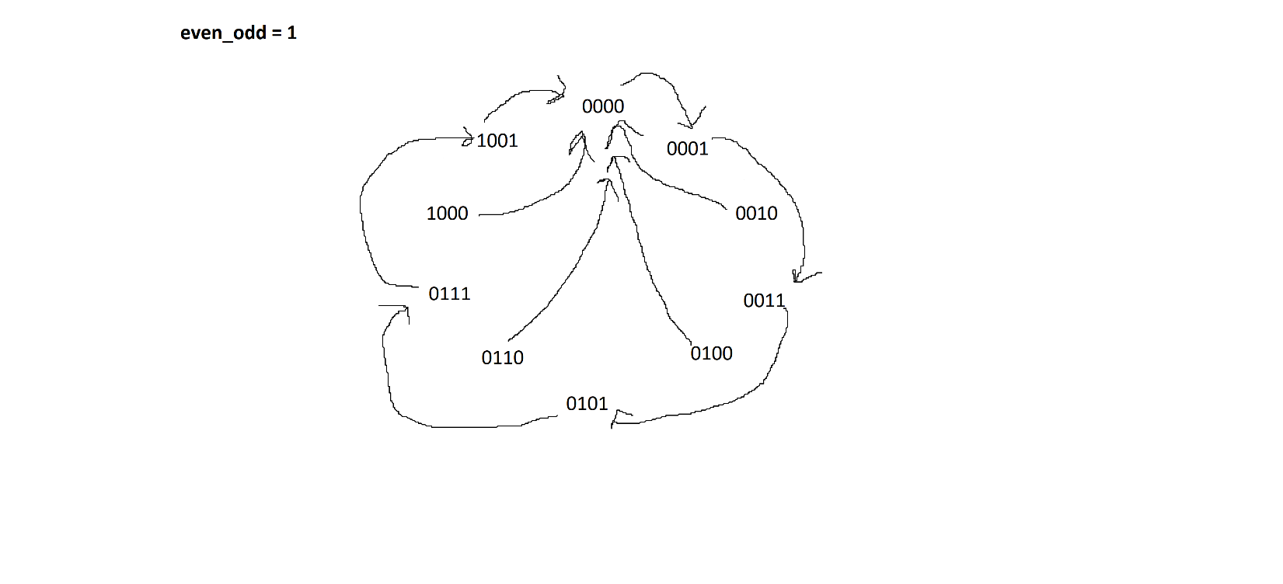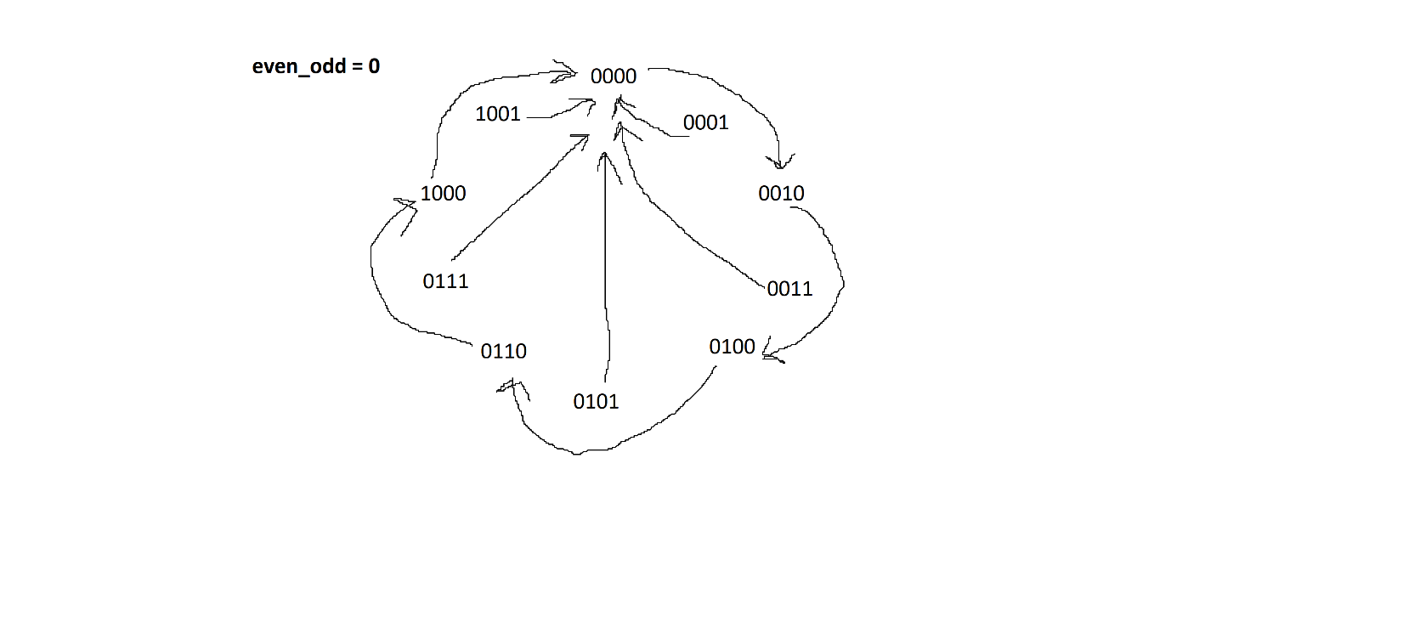

10-15 are don’t-care conditions

**State/Transition Table:**

|  |  |  |
| --- | --- | --- |
| PS (Q3Q2Q1Q0) | NS (Q3+Q2+Q1+Q0+) | |
|  | even_odd = 0 | even_odd = 1 |
| 0000 | 0 0 1 0 | 0 0 0 1 |
| 0001 | 0 0 0 0 | 0 0 1 1 |
| 0010 | 0 1 0 0 | 0 0 0 1 |
| 0011 | 0 0 0 0 | 0 1 0 1 |
| 0100 | 0 1 1 0 | 0 0 0 1 |
| 0101 | 0 0 0 0 | 0 1 1 1 |
| 0110 | 1 0 0 0 | 0 0 0 1 |
| 0111 | 0 0 0 0 | 1 0 0 1 |
| 1000 | 0 0 0 0 | 0 0 0 1 |
| 1001 | 0 0 0 0 | 0 0 0 1 |
| 1010 | 0000 (Don’t care) | 0001 (Don’t care) |
| 1011 | 0000 (Don’t care) | 0001 (Don’t care) |
| 1100 | 0000 (Don’t care) | 0001 (Don’t care) |
| 1101 | 0000 (Don’t care) | 0001 (Don’t care) |
| 1110 | 0000 (Don’t care) | 0001 (Don’t care) |
| 1111 | 0000 (Don’t care) | 0001 (Don’t care) |

**Q3+ even_odd = 0  = SUMOF m(6) + d(14)**

**Q3+ even_odd = 1 = SUMOF m(7) + d(15)**

**Q2+ even_odd = 0 = SUMOF m(2, 4) + d(10, 12)**

**Q2+ even_odd = 1 = SUMOF m(3, 5) + d(11, 13)**

**Q1+ even_odd = 0 = SUMOF m(0, 4)**

**Q1+ even_odd = 1 = SUMOF m(1, 5)**

**Q0+ even_odd = 0 = 0**

**Q0+ even_odd = 1 = SUMOF m(0, 1, 2, 3, 4, 5, 6, 7, 8, 9) + d(10, 11, 12, 13, 14, 15) = 1**

KMAPS:

**Q3+**

00

01

10

11

00

01

10

11

Q3Q2

Q1Q0

00

01

10

11

00

01

10

11

Q3Q2

Q1Q0

0 0 0 0

0 0 1 0

d d d d

0 0 d d

0 0 0 0

0 0 0 1

d d d d

0 0 d d

even_odd = 0 even_odd = 1

**Q2+**

00

01

10

11

00

01

10

11

Q3Q2

Q1Q0

00

01

10

11

00

01

10

11

Q3Q2

Q1Q0

0 0 1 0

0 1 0 0

d d d d

0 0 d d

0 0 0 1

1 0 0 0

d d d d

0 0 d d

even_odd = 0 even_odd = 1

**Q1+**

00

01

10

11

00

01

10

11

Q3Q2

Q1Q0

00

01

10

11

00

01

10

11

Q3Q2

Q1Q0

0 1 0 0

0 1 0 0

d d d d

0 0 d d

1 0 0 0

1 0 0 0

d d d d

0 0 d d

even_odd = 0 even_odd = 1

**Q0+**

00

01

10

11

00

01

10

11

Q3Q2

Q1Q0

00

01

10

11

00

01

10

11

Q3Q2

Q1Q0

1 1 1 1

1 1 1 1

d d d d

1 1 d d

0 0 0 0

0 0 0 0

d d d d

0 0 d d

even_odd = 0 even_odd = 1

**Minimal SOP for DFFs:**

**Q3+ = (Q2 AND Q1) AND (even_odd XNOR Q0)**

**Q2+ = (Q2 XOR Q1) AND (even_odd XNOR Q0)**

**Q1+ = ( NOT(Q3) AND NOT(Q1) ) AND (even_odd XNOR Q0)**

**Q0+ = even_odd**

**Block Diagram and Simulation Result: (make sure your filename path is readable in your screenshots)**

