**Snake venom protein activity assays**

**Background:** Many snake venoms cause blood to clot. For those animals (including humans) that are unlucky enough to be bitten, this is a big problem. However, compounds that cause clotting could also have important medical applications. Watch <https://youtu.be/BtJ0g_78i6I> where UQ researchers show and discuss these properties of snake venoms; the data that you will be examining is based on their research program. Venoms include many chemical compounds. An important tool for trying to identify which specific enzymes in the venom cause a specific effect uses fluorometry where, when a specific reaction occurs, a florescent reaction (light) is generated. For example, in the diagram below, if the venom activates a specific compound, that compound releases a “quenched” florescent molecule from a target substrate and this activity is detected as light.

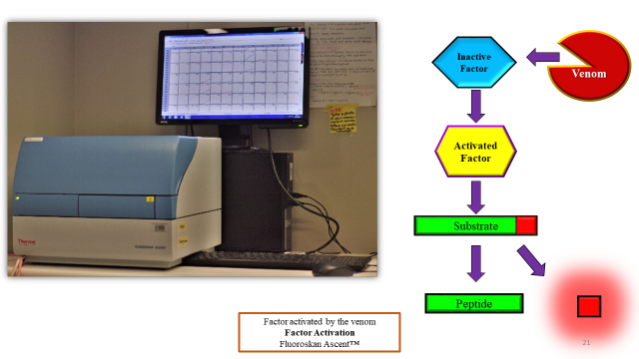

A typical experimental design includes:

* Blanks: no venom, negative control
* Activated factors: “FX activated factor”, a positive control
* Experimental wells: venom + FX
* Venom only: gives the baseline florescent of the venom

**Acknowledgments:** Data and information from Abhinandan Chowdhury and Dr. Christina Zdenek, working in the group of A/Prof Bryan Fry

**Original data file formats**:

* ***210309__Experiment_PlateLayout.xlsx*** – This input takes the visual form of a 386 well plate. This is a standard configuration in molecular biology whereby one axis is labelled by numbers (1-12) and the other axis by rows (A-P). It is very common for molecular workers to make a visual representation of their experimental plan because they need to keep track of which liquids are pipetted into which wells. The wells that contain samples are labelled. You will notice that sets of wells have identical names. This is because researchers will typically repeat an assay several times in order to estimate the variance associated laboratory procedures and instrument sensitivity.

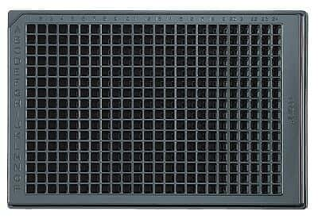

* ***210309_flourometer_readings.csv*** - this is the raw output from the fluorometer. Import into excel to understand layout.
  + Row 3 has names reflecting the well position (e.g. A1, B1, C1, etc.) and repeats periodically with new well position names (see row 305, etc). Well ID’s will need to be connected to sample names from the 210309__Experiment_PlateLayout.xlsx.
  + The first column has information about the time of activity reading.
  + The values that fall under each header give the florescence of that sample at that time point.

**Project remit to make the data tidy (part 1)**

* Your script will need to be able to read in the raw files, as is. (No manual conversion of xlsx to txt)
* Sample name information will need to reflect the names provided by the investigators. (That is, M:A1, M:B1 etc will need to be replaced by the real name) but you will also want to retain a variable that reports the original well position (A1, B1, etc) for verification.
* The replicate identity will need to be tracked.
* The final data should conform with tidy data standards (see assignment sheet for details). Hint: Long format preferable with these data! Hand draw your final planned format and show/email to Cynthia before you start coding.
* Remember to keep your coding flexible so that if there are new data files that have a similar format but different number of samples or that measured florescent activity for a different period of time, then the code would still work.

*The reproducible report assignment will build on these data to undertake specific analyses, graphs, and interpretation.*

**Good luck and happy coding!**