FAMILY LAW ACT 1975 DIVORCE ORDER

IN THE FEDERAL CIRCUIT COURT OF AUSTRALIA

IN THE MARRIAGE BETWEEN:


Party 1 [husband]
File No:-/2020

AND

BEFORE:
DATE OF ORDER: MADE AT:

Party 2 [wife]

DEPUTY REGISTRAR-
Monday, 08 Febmary 2021
SYDNEY

XYZ

The application of for a divorce order in relation to the marriage of the above named parties, which was solemnised on twelfth day of May 2002, was heard on the eighth day of Febmary 2021.
THE COURT FINDS:
- The marriage is proved.
- The parties were at all material times domiciled in Australia.

- The ground for the application for a divorce order - namely that the marriage has broken down irretrievably - is proved.

THE COURT, BY ORDER, DECLARES THAT IT IS SATISFIED:
- The only child/ren of the marriage, as that expression is defined in section 55A(3), who has/have not

attained the age of eighteen years is/are the child/ren:

child 2

child 1

August 2006
born 20 September 2004, born 04

- The Court by order declared that it was satisfied that the only child/children of the marriage who has/have not attained the age of 18 years is/are the child/children specified in the order and that proper arrangements in all the circumstances have been made for the care, welfare and development of the child/children.

THE COURT ORDERS:
- A divorce order be made, such divorce order to take effect and thereby tenninate the marriage on the ninth day of March 2021
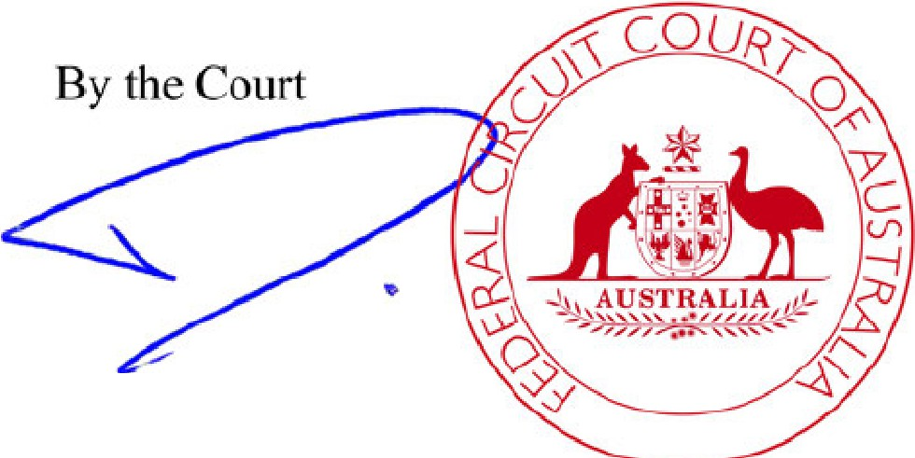
Registrar

[signature] [round stamp of the Federal Circuit Court of Australia]

See page 2 for Certificate and Notes

- 2 -

FILE NO: (P)SYC2553/2020

CERTIFICATE THAT THE DIVORCE ORDER HAS TAKEN EFFECT
I certify that the divorce order made in relation to the application of took effect on the ninth day of March 2021, thereby terminating the marriage between
and .

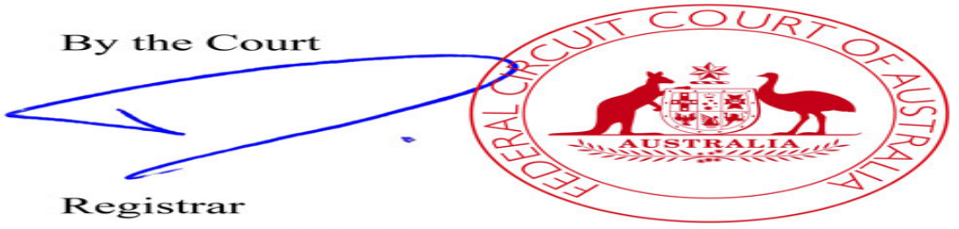

NOTES:

- If a party to the marriage proposes to make an application to a court exercising jurisdiction under the Family Law Act 1975 as to property or as to the maintenance of that party, such application must be made within 12 months from the date upon which this divorce order takes effect. After that time such an application cannot be made without first obtaining the leave of the court to do so.
- A divorce order which has taken effect may revoke, or otherwise affect the operation of, the Will of a party. Parties should seek legal advice about their position under the law of the State or Territory concerned.
- A party to a marriage who marries again before this divorce order takes effect (unless the other party has died) commits the offence of bigamy.
- If, before this divorce order takes effect, it comes to the notice of a party to the marriage that the other party has died, he or she should file an affidavit or certificate in the office of the court giving particulars of the date and place of death.

家族法（1975年制定）（FAMILY LAW ACT 1975）
離婚命令

連邦巡回裁判所（FEDERAL CIRCUIT COURT OF AUSTRALIA）ファイル番号：xxxxxx/2020
下記当事者間の婚姻について
XXxxxxxxxxxxX 当事者 １（夫）
および
XXxxxxxxxxxxX 当事者 ２（妻）

担当者： XxxxxxxxxxxXX副登録官
命令日： 2021年2月8日（月）
場所： シドニー

2002年5月12日に執り行われた両者間の婚姻に関する離婚命令にかかるXYZ申請について、2021年2月8日に審理が行われた。
裁判所による判断
- 婚姻は証明された。
- 当事者両名は該当期間中オーストラリアに居住していた。
- 婚姻関係は修復不可能なほどに破綻しているという離婚命令の申請に関する根拠は証明された。

裁判所は命令により下記事項が確認できたことを宣言する。
- 第55A条3項に定義されている通り、この婚姻における18歳未満の子供（たち）は次の通りである。
第一子2004年9月20日誕生、第二子2006年8月4日誕生
- 裁判所は命令により婚姻における18歳未満の子供（たち）は、命令によって特定された子供（たち）であり、養育、福祉、発達に関する全ての状況において適切な取り決めがなされている子供（たち）であることを確認したと宣言した。

裁判所による命令
- 離婚命令は発令され、当該離婚命令の発効により婚姻関係は2021年3月9日に解消となる。

裁判所

（署名）（赤い丸型スタンプ；内部：連邦巡回裁判所（Federal Circuit Court of Australia））

登録官

証明書と注記については次頁参照
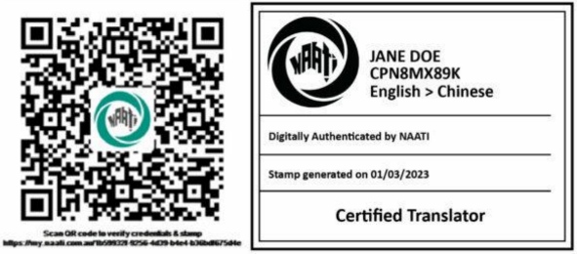
- 2 -
ファイル番号：(P)SYC2553/2020

離婚命令発効証明書
2021年3月9日、XYZ申請に関する離婚命令の発効により、xxxxxxxxxxxxxおよびxxxxxxxxxxxxx間の婚姻の終了をここに証明する。

裁判所

（署名）（赤い丸型スタンプ；内部：連邦巡回裁判所（Federal Circuit Court of Australia））


登録官

翻訳者による注記
（電子コピーを翻訳）

Annotations
According to Mayoral Asensio (2014), the source text and target text must be comparable. To follow this principle, I wanted to replicate the layout as closely as possible. On the other hand, AUSIT (2024) suggests including additional information, such as the heading, page number (including the total page count), translator’s notes, translator’s certificate, and so on. Although these two approaches might seem contradictory, I included the following elements in my translation: “英語からの抜粋翻訳” (Extract translation from English), “1/2” or “2/2 pages,” “電子コピーを翻訳” (translated from an electronic copy), and my fictitious NAATI digital stamp.

1Since AUSIT (2024) states that translators should retain the name of the court in the original language, use a transliteration, or include it alongside the translation, I provided both the Japanese translation and the original English term, such as “連邦巡回裁判所” (Federal Circuit Court of Australia).

2Regarding “for the care, welfare and development of the child/children,” my draft was “ケア、福祉、発達に関する,” but I found that “ケア” seemed inappropriate in terms of register and the Japanese legal context. Although the English-Japanese dictionary defines “care” as “世話” or “保護,” these terms also felt awkward. While searching for synonyms, I came across “養う.” Finally, my translation is “養育、福祉、発達に関する,” which is more suitable in the Japanese legal context. I believe this translation effectively conveys the idea of nurturing child(ren), including the nuance of "care."

3I initially described the image of the stamp simply as “スタンプ.” However, Mayoral Asensio (2014) states that both simple and detailed descriptions of stamps are acceptable. Upon reconsideration, I believed a detailed rendering would be more suitable for my client. Then, I consulted his examples, including color specifications. Additionally, I found another example in AUSIT (2024): “[stamp;
within: Mayor’s Office, received 14 August 2014.]” Based on these references, I described the stamp as “(赤い丸型スタンプ; 内部: 連邦巡回裁判所 (FEDERAL CIRCUIT COURT OF AUSTRALIA)).”

References
AUSIT. (2024, November). Best practices for the translation of official and legal documents. https://ausit.org/wp-content/uploads/2024/11/AUSIT-Best-Practices-Translation-Official-and-Legal-Documents.pdf

Mayoral Asensio, R. (2014). Common Problems and Frequent Solutions. In Translating Official Documents. Taylor & Francis Group.


