FAMILY LAW ACT 1975 DIVORCE ORDER

IN THE FEDERAL CIRCUIT COURT OF AUSTRALIA

IN THE MARRIAGE BETWEEN:


Party 1 [husband]
File No:-/2020

AND

BEFORE:
DATE OF ORDER: MADE AT:

Party 2 [wife]

DEPUTY REGISTRAR-
Monday, 08 Febmary 2021
SYDNEY

XYZ

The application of for a divorce order in relation to the marriage of the above named parties, which was solemnised on twelfth day of May 2002, was heard on the eighth day of Febmary 2021.
THE COURT FINDS:
- The marriage is proved.
- The parties were at all material times domiciled in Australia.

- The ground for the application for a divorce order - namely that the marriage has broken down irretrievably - is proved.

THE COURT, BY ORDER, DECLARES THAT IT IS SATISFIED:
- The only child/ren of the marriage, as that expression is defined in section 55A(3), who has/have not

attained the age of eighteen years is/are the child/ren:

child 2

child 1

August 2006
born 20 September 2004, born 04

- The Court by order declared that it was satisfied that the only child/children of the marriage who has/have not attained the age of 18 years is/are the child/children specified in the order and that proper arrangements in all the circumstances have been made for the care, welfare and development of the child/children.

THE COURT ORDERS:
- A divorce order be made, such divorce order to take effect and thereby tenninate the marriage on the ninth day of March 2021
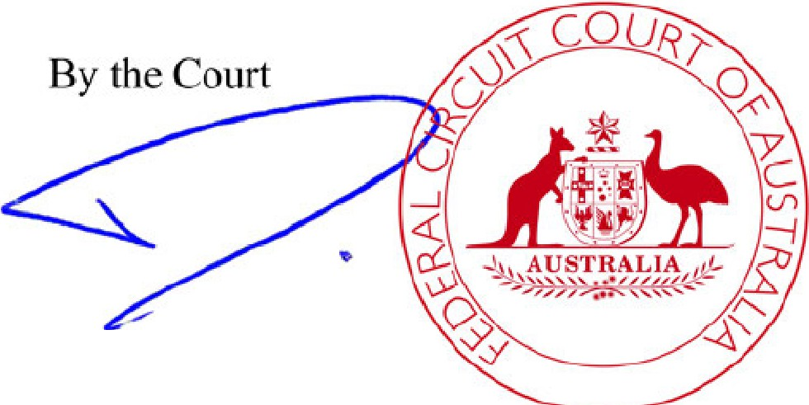
Registrar

[signature] [round stamp of the Federal Circuit Court of Australia]

See page 2 for Certificate and Notes

- 2 -

FILE NO: (P)SYC2553/2020

CERTIFICATE THAT THE DIVORCE ORDER HAS TAKEN EFFECT
I certify that the divorce order made in relation to the application of took effect on the ninth day of March 2021, thereby terminating the marriage between
and .



NOTES:

- If a party to the marriage proposes to make an application to a court exercising jurisdiction under the Family Law Act 1975 as to property or as to the maintenance of that party, such application must be made within 12 months from the date upon which this divorce order takes effect. After that time such an application cannot be made without first obtaining the leave of the court to do so.
- A divorce order which has taken effect may revoke, or otherwise affect the operation of, the Will of a party. Parties should seek legal advice about their position under the law of the State or Territory concerned.
- A party to a marriage who marries again before this divorce order takes effect (unless the other party has died) commits the offence of bigamy.
- If, before this divorce order takes effect, it comes to the notice of a party to the marriage that the other party has died, he or she should file an affidavit or certificate in the office of the court giving particulars of the date and place of death.

FAMILY LAW ACT 1975

DIVORCE ORDER

(가정법 1975)
(이혼 판결)

호주 연방순회법원 사건번호: _______/2020
혼인 당사자
당사자 1(남편)
및
당사자 2(아내)

담당: 부등록관
판결일자: 2021년 2월 8일 (월요일)
법원 소재지: 시드니

2002년 5월 12일에 법적으로 성립된 위 당사자 간의 혼인에 관하여, 신청인 의 이혼명령 신청 사건은 2021년 2월 8일에 심리되었다.

법원은 다음과 같이 판단한다.
- 혼인 사실이 입증되었다.
- 당사자들은 모든 관련 시점에서 호주 내에 주소를 두고 있었다.
- 혼인관계가 회복 불가능할 정도로 파탄되었음이 입증되었다.

법원은 다음과 같이 선언한다.
- 「가정법」 제55A(3)조에 정의된 바에 따라, 만 18세 미만인 혼인 중 자녀는 다음과 같다.
자녀 1: ____________________ (2004년 9월 20일 출생)
자녀 2: ____________________ (2006년 8월 4일 출생)
- 법원은 만 18세 미만의 자녀가 본 명령서에 명시된 자녀임을 확인하였으며, 해당 자녀의 양육, 복지 및 발달에 관하여 모든 사정을 고려한 적절한 조치가 이루어졌다고 인정하였다.

법원은 다음과 같이 명한다.
- 법원은 이혼판결을 선고하며, 본 판결은 2021년 3월 9일부터 효력이 발생함으로써 혼인이 종료된다.

이혼판결 효력증명서
본인은 신청인 의 이혼명령이 2021년 3월 9일부터 효력이 발생하였으며, 이에 따라 와(과) 간의 혼인이 종료되었음을 증명한다.

I, YY, NAATI Certified Translator English <> Korean (Practitioner ID: CPNXXXXXX), certify that this is a true and accurate Korean translation of the English text of the Divorce Order provided to me electronically, to the best of my ability and skills and in accordance with the AUSIT Code of Ethics. Date: 10 October 2025

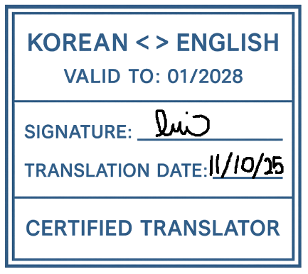
Translator’s Note: All seals, stamps, and signatures in the original document have been described but not reproduced in this translation.

